Supplementary Data

Variable | Definition
Injection drug use (IDU)  Persons who inject drugs (PWID) | Injection drug use and/or persons who inject drugs were identified with the following manual keyword searches within individual patient VHA electronic health records:  - “IVDU”; OR  - “IDU”; OR  - “IV drug use”; OR  - “IV heroin”; OR  - “IV fentanyl”; OR  - “IV cocaine”; OR  - “IV methamphetamine”; OR  - “Intravenous drug use”; OR  - “Intravenous heroin”; OR  - “Intravenous fentanyl”; OR  - “Intravenous methamphetamine”; OR  - “Intravenous cocaine”; OR  - Additional text evidence of “injection” or “IVDU” or “IDU”.
Supplement Table 1.1. Keyword search used to identify Veterans with injection drug use from electronic health records. VHA, Veterans Health Affairs

ICD | Diagnosis | Codes
ICD9 | Opioid-type dependence  Opioid abuse  Nondependent opioid abuse | 304.0x  305.5x
ICD10 | Opioid abuse | F11.10, or F11.20 with concomitant F11.10
Supplement Table 1.2. Opioid use disorder diagnosis codes

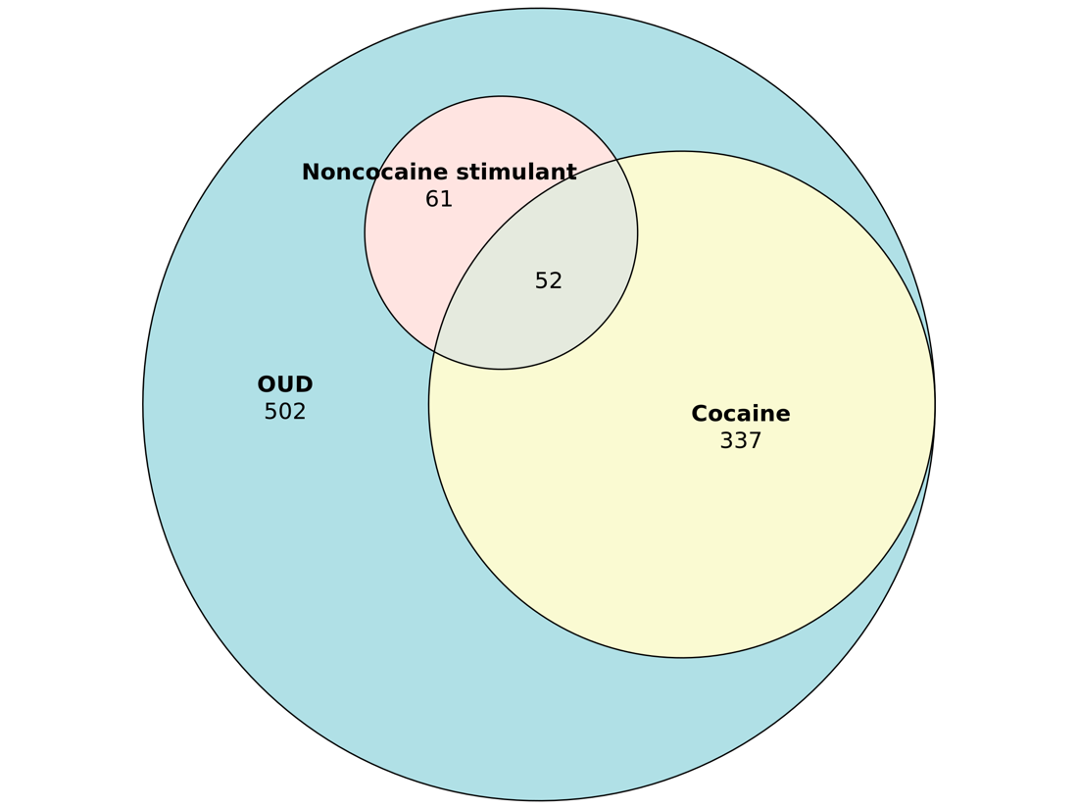

Supplemental Figure 1. Proportion of US Veterans with OUD who used cocaine or non-cocaine stimulants. Areas of overlap represent US Veterans who used both cocaine and non-cocaine stimulants. OUD, Opioid Use Disorder.

