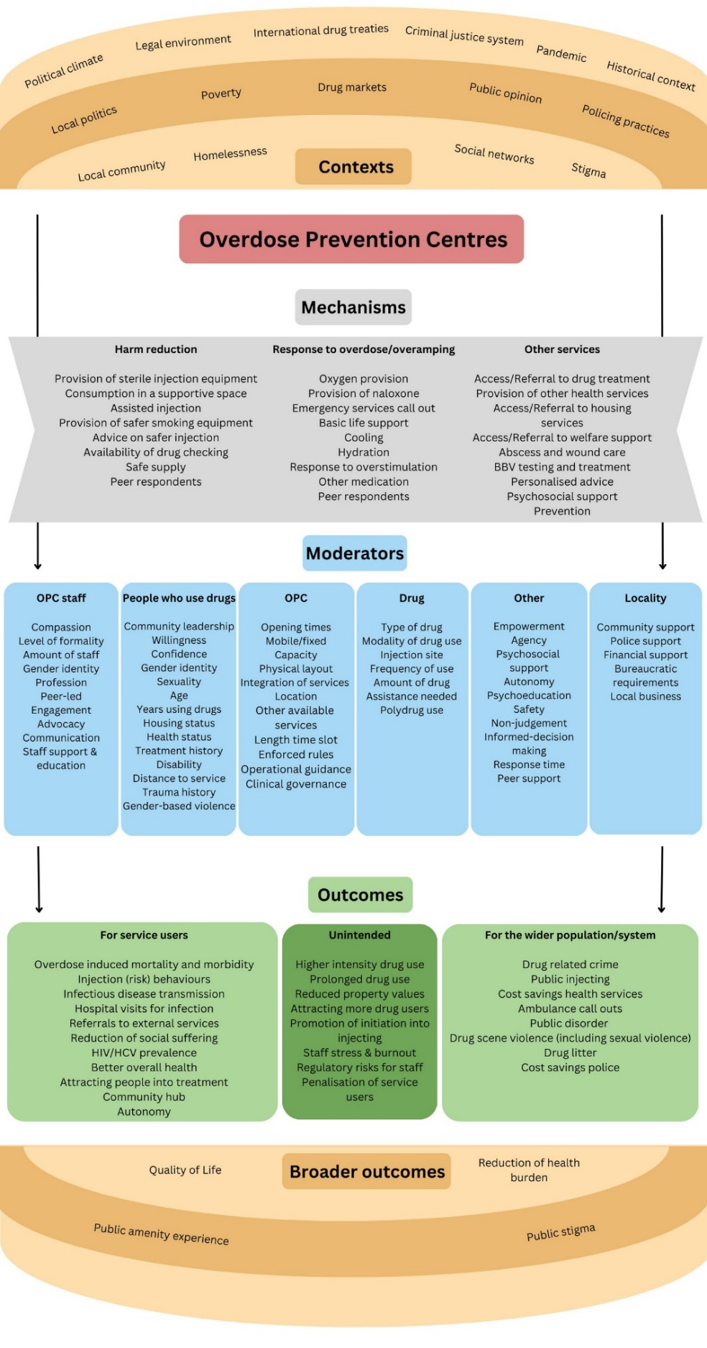
Supplementary material: Appendix 1: A diagram of the initial rough programme theory, showing posited contexts, mechanisms, and outcomes of OPCs.

