Supplementary 1 : Reference Standards

Supplementary Table 1: Reference standards used in this study divided by drug class. Reference standards were obtained from LGC Standards (Middlesex, UK) Cayman Chemicals (Ann Arbor, MI, USA), Chiron AS (Trondheim, Norway), Lipomed AG (Arlesheim, Switzerland), MP Biomedicals (Santa Ana, CA, USA), Sigma Aldrich (Poole, UK), Thermo Scientific Chemicals (TCC) (UK), Tokyo Chemical Industry (TCI) Co Ltd (Tokyo, Japan) or VWR Chemicals (UK) or synthesized by the Sutcliffe Group at Manchester Metropolitan University (MMU), Manchester, UK ( > 98% purity) as described previously (Antonides et al. 2021¹).

Drug Class | Compound | Formulation | Supplier | Purity
Non-Nitazene Opioids | Fentanyl HCl | Neat | MMU | >98%
Non-Nitazene Opioids | Acetylfentanyl HCL | Neat | MMU | >98%
Non-Nitazene Opioids | Acryloylfentanyl HCl | Neat | MMU | >98%
Non-Nitazene Opioids | Benzoylfentanyl HCl | Neat | MMU | >98%
Non-Nitazene Opioids | Butyrylfentayl HCl | Neat | MMU | >98%
Non-Nitazene Opioids | Carfentanil HCl | 1000 𝜇g/mL in MeOH | Chiron | >97.8%
Non-Nitazene Opioids | Crotonylfentanyl HCl | 1000 𝜇g/mL in MeOH | Chiron | >97.8%
Non-Nitazene Opioids | Cyclopropylfentanyl | 1000 𝜇g/mL in MeOH | Chiron | >97.8%
Non-Nitazene Opioids | 4-fluorobutyrylfentanyl HCl | 1000 𝜇g/mL in MeOH | Chiron | >97.8%
Non-Nitazene Opioids | 2-Fluorofentanyl (o-fluorofentanyl) HCl | 1000 𝜇g/mL in MeOH | Chiron | >97.8%
Non-Nitazene Opioids | 4-Fluorofentanyl (p-fluorofentanyl) HCl | 1000 𝜇g/mL in MeOH | Chiron | >97.8%
Non-Nitazene Opioids | 4-fluoroisobutyrylfentanyl HCl | 1000 𝜇g/mL in MeOH | Chiron | >97.8%
Non-Nitazene Opioids | Furanylfentanyl HCl | 1000 𝜇g/mL in MeOH | Chiron | >97.8%
Non-Nitazene Opioids | Isovalerylfentanyl HCl | Neat | MMU | >98%
Non-Nitazene Opioids | Methoxyacetylfentanyl HCl | 1000 𝜇g/mL in MeOH | Chiron | >97.8%
Non-Nitazene Opioids | Norfentanyl | 1000 𝜇g/mL in MeOH | Chiron | >97.8%
Non-Nitazene Opioids | Ocfentanil HCl | 1000 𝜇g/mL in MeOH | Chiron | >97.8%
Non-Nitazene Opioids | Tetrahydrofuranylfentanyl (THFF) HCl | Neat | MMU | >98%
Non-Nitazene Opioids | Valerylfentanyl HCl | Neat | MMU | >98%
Non-Nitazene Opioids | Buprenorphine | 1000 𝜇g/mL in MeOH | Chiron | >97.8%
Non-Nitazene Opioids | Brorphine | 1000 𝜇g/mL in MeOH | Chiron | >97.8%
Non-Nitazene Opioids | Codeine HCl | Neat | Lipomed | >97%
Non-Nitazene Opioids | Diamorphine | Neat | Sigma | >98%
Non-Nitazene Opioids | Methadone Hydrochloride | Neat | Sigma | >98%
Non-Nitazene Opioids | 6-Acetylcodeine Hydrochloride | Neat | Lipomed | >97%
Non-Nitazene Opioids | 6-Monoacetyl morphine | Neat | Cayman | >98%
Non-Nitazene Opioids | Noscapine | Neat | Sigma | 97%
Non-Nitazene Opioids | Papaverine Hydrochloride | Neat | TCC | 99%

Drug Class | Compound | Formulation | Supplier | Purity
Nitazene Analogs | Isotonitazene | 1000 𝜇g/mL in ACN | Chiron | >97.8%
Nitazene Analogs | Metonitazene HCl | Neat | Chiron | 97.5%
Nitazene Analogs | Protonitazene HCl | 1000 𝜇g/mL in MeOH | Chiron | >97.8%
Nitazene Analogs | Metodesnitazene HCl | 1000 𝜇g/mL in MeOH | Chiron | >97.8%
Nitazene Analogs | N-pyrrolidinoetonitazene | 1000 𝜇g/mL in MeOH | Chiron | >97.8%
Nitazene Analogs | N-desethylisonitazene HCl | 1000 𝜇g/mL in MeOH | Chiron | >97.8%
Nitazene Analogs | Etazene HCl | 1000 𝜇g/mL in MeOH | Chiron | >97.8%
Nitazene Analogs | Butonitazene | 1000 𝜇g/mL in MeOH | Chiron | >97.8%
Nitazene Analogs | Fluonitazene HCl | 1000 𝜇g/mL in MeOH | Chiron | >97.8%
Nitazene Analogs | 3-methoxymetodesnitazene citrate | Neat | Cayman | >98%
Nitazene Analogs | Protodesnitazene | Neat | Cayman | >98%
Nitazene Analogs | n-pyrrolidinometonitazene citrate | Neat | Cayman | >98%
Nitazene Analogs | 4-hydroxynitazene | Neat | Cayman | >98%
Nitazene Analogs | n-piperidinyl metonitazene citrate | Neat | Cayman | >98%
Nitazene Analogs | menitazene citrate | Neat | Cayman | >98%
Nitazene Analogs | n-pyrrolidinoisotonitazene citrate | Neat | Cayman | >98%
Nitazene Analogs | n-desethylmetonitazane hydrochloride | Neat | Cayman | >98%
Nitazene Analogs | n-piperidinyl 4'-hydroxynitazene citrate | Neat | Cayman | >98%
Nitazene Analogs | n-pyrrolidino metodesnitazene citrate | Neat | Cayman | >98%
Nitazene Analogs | n-desethylprotonitazene hydrochloride | Neat | Cayman | >98%
Nitazene Analogs | 5-methyl etazene citrate | Neat | Cayman | >98%
Nitazene Analogs | n-pyrrolidino 4'-hydroxynitazene citrate | Neat | Cayman | >98%
Nitazene Analogs | n-piperidinyl isotonitazene citrate | Neat | Cayman | >98%
Nitazene Analogs | n-pyrrolidinofluetonitazene citrate | Neat | Cayman | >98%
Nitazene Analogs | n-piperidinyl protonitazene citrate | Neat | Cayman | >98%
Nitazene Analogs | methylenedioxynitazene citrate | Neat | Cayman | >98%
Nitazene Analogs | ethyleneoxynitazene citrate | Neat | Cayman | >98%
Nitazene Analogs | 5-methylmetodesnitazene citrate | Neat | Cayman | >98%
Nitazene Analogs | sec-butonitazene | Neat | Cayman | >98%
Nitazene Analogs | n-desethyletonitazene | Neat | Cayman | >98%
Nitazene Analogs | Ethylene etonitazene citrate | Neat | Cayman | >98%

Drug Class | Compound | Formulation | Supplier | Purity
Nitazene Analogs | Fluetonitazene citrate | Neat | Cayman | >98%
Nitazene Analogs | Propylnitazene citrate | Neat | Cayman | >98%
Nitazene Analogs | Clonitazene | Neat | Cayman | >98%
Nitazene Analogs | Etonitazene | Neat | Cayman | >98%
Nitazene Analogs | 5-aminoisotonitazene | 1000 𝜇g in 100 𝜇L ACN | Cayman | >98%
Synthetic Cannabinoids | 4F-ABUTINACA | Neat | Chiron | 99.9%
Synthetic Cannabinoids | 4F-MDMB-BUTICA | Neat | Cayman | >98%
Synthetic Cannabinoids | 5F-3,5-AB-PFUPPYCA | Neat | Chiron | 98.2%
Synthetic Cannabinoids | 5F-ADB-PINACA | Neat | Chiron | 97.8%
Synthetic Cannabinoids | 5F-BZO-POXIZID | Neat | Chiron | 99.9%
Synthetic Cannabinoids | 5F-EMB-PICA | Neat | Cayman | >98%
Synthetic Cannabinoids | 5F-MDMB-PICA | Neat | Chiron | 99.9%
Synthetic Cannabinoids | 5F-MDA-19 | Neat | MMU | >98%
Synthetic Cannabinoids | 5F-MPP-PICA | Neat | Cayman | >98%
Synthetic Cannabinoids | 5F-PB-22 | 1000 𝜇g/mL in ACN | Chiron | >97.8%
Synthetic Cannabinoids | AB-CHMINACA | Neat | MMU | >98%
Synthetic Cannabinoids | ADB-4en-PINACA | Neat | MMU | >98%
Synthetic Cannabinoids | ADB-5'Br-BUTINACA | Neat | Chiron | 98.9%
Synthetic Cannabinoids | ADB-5'Br-INACA | Neat | Chiron | 99.8%
Synthetic Cannabinoids | ADB-BUTINACA | Neat | MMU | >98%
Synthetic Cannabinoids | ADB-FUBIATA | Neat | Chiron | 99.4%
Synthetic Cannabinoids | ADB-HEXINACA | Neat | MMU | >98%
Synthetic Cannabinoids | AMB-CHMICA | Neat | Chiron | 95.9%
Synthetic Cannabinoids | AMB-FUBINACA | Neat | MMU | >98%
Synthetic Cannabinoids | BZO-4en-POXIZID | Neat | Chiron | 96.7%
Synthetic Cannabinoids | BZO-HEXOXIZID (MDA-19) | Neat | Chiron | 97.4%
Synthetic Cannabinoids | CH-PIATA | Neat | Chiron | 97.5%
Synthetic Cannabinoids | Cumyl-4CN-BINACA | 1000 𝜇g/mL in MeOH | Chiron | >97.8%
Synthetic Cannabinoids | MDMB-4en-PINACA | Neat | MMU | >98%
Synthetic Cannabinoids | MDMB-5'Br-INACA | Neat | Chiron | 99.6%
Synthetic Cannabinoids | MDMB-B(enz)ICA | Neat | MMU | >98%
Synthetic Cannabinoids | MDMB-CHMICA | Neat | MMU | >98%
Synthetic Cannabinoids | PB-22 | 1000 𝜇g/mL in ACN | Chiron | >97.8%
Synthetic Cannabinoids | MDMB-INACA | Neat | Cayman | >98%
Benzodiazepine-type substances | Alprazolam | 1000 𝜇g/mL in MeOH | Chiron | >97.8%
Benzodiazepine-type substances | Bromazolam | 1000 𝜇g/mL in MeOH | Chiron | >97.8%
Benzodiazepine-type substances | Clonazepam | Neat | Sigma | >98%
Benzodiazepine-type substances | Clonazolam | Neat | Chiron | 98.5%
Benzodiazepine-type substances | Clobromazolam | Neat | Chiron | 99.9%

Drug Class | Compound | Formulation | Supplier | Purity
Benzodiazepine-type substances | Desalkylgidazepam | Neat | Chiron | 98.8%
Benzodiazepine-type substances | Diazepam | Neat | Sigma | >98%
Benzodiazepine-type substances | Diclazepam | Neat | Chiron | 99.0%
Benzodiazepine-type substances | Etizolam | Neat | Chiron | 99.4%
Benzodiazepine-type substances | Flualprazolam | Neat | Chiron | 99.4%
Benzodiazepine-type substances | Flubromazepam | Neat | Chiron | 99.6%
Benzodiazepine-type substances | Flubromazolam | Neat | Chiron | 99.1%
Benzodiazepine-type substances | Midazolam | 1000 𝜇g/mL in MeOH | Chiron | >97.8%
Benzodiazepine-type substances | Nitrazepam | Neat | Sigma | >98%
Benzodiazepine-type substances | Phenazepam | Neat | Sigma | 99.3%
Cutting Agents and Adulterants | Benzocaine | Neat | Sigma | >99%
Cutting Agents and Adulterants | Caffeine anhydrous | Neat | Sigma | >99%
Cutting Agents and Adulterants | Diphenhydramine HCl | Neat | Sigma | >98%
Cutting Agents and Adulterants | Levamisole HCl | Neat | Sigma | >98%
Cutting Agents and Adulterants | Lidocaine HCl | Neat | Sigma | >99.8%
Cutting Agents and Adulterants | Paracetamol (Acetominophen) | Neat | Sigma | >98%
Cutting Agents and Adulterants | Phenacetin | Neat | VWR | >99%
Cutting Agents and Adulterants | Glucose | Neat | Sigma | >99.5%
Cutting Agents and Adulterants | Magnesium Sulphate | Neat | VWR | >99%
Cutting Agents and Adulterants | Sodium bicarbonate | Neat | Sigma | >99%
Cutting Agents and Adulterants | Citric acid (monohydrate) | Neat | TCC | >99%
Steroids | Methylandrostanolone | Neat | TCI | 98.8%
Steroids | Stanozolol | Neat | LGC | 99.52%
Steroids | Methyltestosterone | Neat | Sigma | 99%
Steroids | Oxymetholone | Neat | Chiron | 98%
Steroids | Methandienone | Neat | TCI | 97.5%
Other | Cocaine HCl | Neat | Sigma | >98%
Other | Cocaine (Base) | 1mg/mL in ACN | Sigma | >99%
Other | Gabapentin | Neat | Sigma | >98%
Other | Ketamine HCl | Neat | Sigma | >98%
Other | MDMA HCl | Neat | Sigma | >98%
Other | Methamphetamine HCl | Neat | Sigma | >98%
Other | Pregabalin | Neat | Lipomed | >97%
Other | Delta-9-THC | Neat | Lipomed | >97%
Other | Dimethylpentylone | Neat | Chiron | 98.2 %

1. Antonides LH, Cannaert A, Norman C, NicDáeid N, Sutcliffe OB, Stove CP, et al. Shape matters: The application of activity-based in vitro bioassays and chiral profiling to the pharmacological evaluation of synthetic cannabinoid receptor agonists in drug-infused papers seized in prisons. Drug Testing and Analysis. 2021;13(3):628-43.

Supplementary 2: Nitazene Analog Chemical Structures

Supplementary Table 3: Chemical structures of nitazene analogs used in this study.

Metonitazene  Test Strip Result: Positive | Etonitazene  Test Strip Result: Positive | Protonitazene  Test Strip Result: Positive | Butonitazene  Test Strip Result: Positive
 | 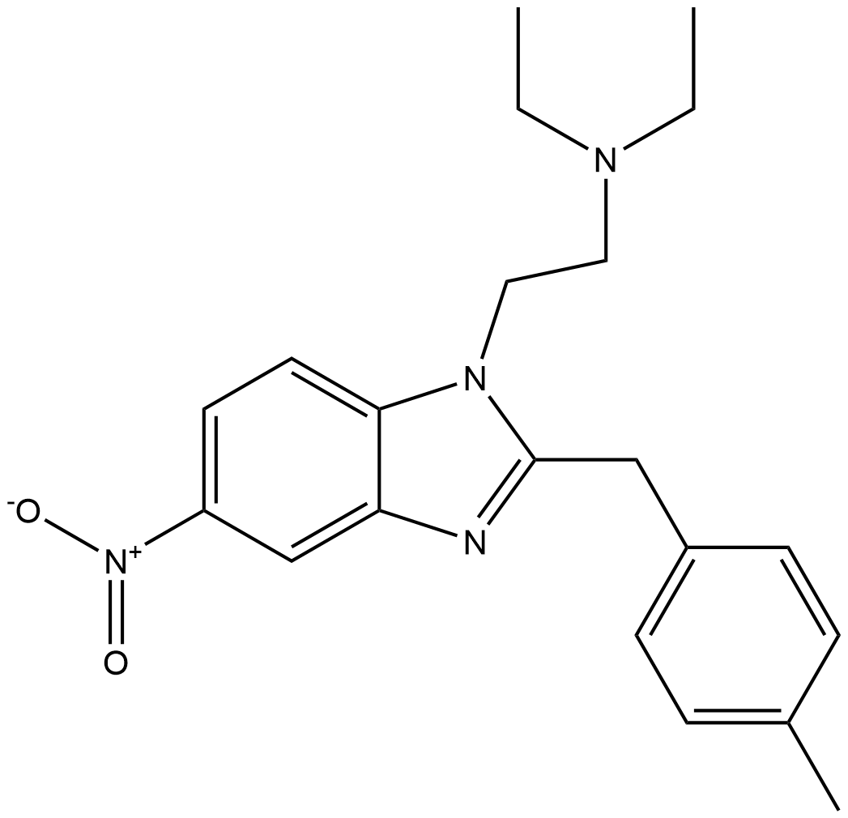
Isotonitazene  Test Strip Result: Positive | Menitazene  Test Strip Result: Positive | Clonitazene  Test Strip Result: Positive | Flunitazene  Test Strip Result: Positive
Propylnitazene  Test Strip Result: Positive | Sec- butonitazene  Test Strip Result: Positive | Methylenedioxy nitazene  Test Strip Result: Positive | Ethylene oxynitazane  Test Strip Result: Positive
Ethylene etonitazene  Test Strip Result: Negative | Metodesnitazene  Test Strip Result: Negative | Etazene  Test Strip Result: Negative | Protodesnitazene  Test Strip Result: Negative
5-methyl etazene  Test Strip Result: Negative | 5-methyl metodesnitazene  Test Strip Result: Positive | 3-methoxy metodesnitazene  Test Strip Result: Negative | Fluetonitazene  Test Strip Result: Positive
4’-hydroxy nitazene  Test Strip Result: Positive | n-desethyl metonitazene  Test Strip Result: Positive | n-desethyl etonitazene  Test Strip Result: Positive | n-desethyl protonitazene  Test Strip Result: Positive
n-desethyl isotonitazene  Test Strip Result: Positive | n-piperidinyl 4'-hydroxynitazene  Test Strip Result: Positive | n-piperidinyl metonitazene  Test Strip Result: Positive | n-piperidinyl protonitazene  Test Strip Result: Positive
n-piperidinyl isotonitazene  Test Strip Result: Positive | N-pyrrolidino etonitazene  Test Strip Result: Positive | N-pyrrolidino isotonitazene  Test Strip Result: Positive | n-pyrrolidino fluetonitazene  Test Strip Result: Positive
n-pyrrolidino 4'-hydroxy nitazene  Test Strip Result: Positive | n-pyrrolidino metonitazene  Test Strip Result: Positive | n-pyrrolidino metodesnitazene  Test Strip Result: Negative | 5-aminoisotonitazene  Test Strip Result: Negative

Supplementary 3: Cross Reactivity Testing

Supplementary Table 3: Results of cross reactivity testing.

Compound Class | Compound (100 ug/mL) | Test Strip Result
Non-Nitazene Opioids | 2-fluorofentanyl (o-fluorofentanyl) HCl | Negative
Non-Nitazene Opioids | 4-fluorobutyrylfentanyl HCl | Negative
Non-Nitazene Opioids | 4-fluorofentanyl (p-fluorofentanyl) HCl | Negative
Non-Nitazene Opioids | 4-fluoroisobutyrylfentanyl HCl | Negative
Non-Nitazene Opioids | 6-monoacetylmorphine | Negative
Non-Nitazene Opioids | Acetylfentanyl HCL | Negative
Non-Nitazene Opioids | Acryloylfentanyl HCl | Negative
Non-Nitazene Opioids | Benzoylfentanyl HCl | Negative
Non-Nitazene Opioids | Brorphine | Negative
Non-Nitazene Opioids | Buprenorphine | Negative
Non-Nitazene Opioids | Butyrylfentayl HCl | Negative
Non-Nitazene Opioids | Carfentanil HCl | Negative
Non-Nitazene Opioids | Codeine HCl | Negative
Non-Nitazene Opioids | Crotonylfentanyl HCl | Negative
Non-Nitazene Opioids | Cyclopropylfentanyl | Negative
Non-Nitazene Opioids | Diamorphine | Negative
Non-Nitazene Opioids | Fentanyl HCl | Negative
Non-Nitazene Opioids | Furanylfentanyl HCl | Negative
Non-Nitazene Opioids | Isovalerylfentanyl HCl | Negative
Non-Nitazene Opioids | Methadone | Negative
Non-Nitazene Opioids | Methoxyacetylfentanyl HCl | Negative
Non-Nitazene Opioids | Norfentanyl | Negative
Non-Nitazene Opioids | Ocfentanil HCl | Negative
Non-Nitazene Opioids | Tetrahydrofuranylfentanyl (THFF) HCl | Negative
Non-Nitazene Opioids | Valerylfentanyl HCl | Negative
Synthetic Cannabinoids | 4F-ABUTINACA | Negative
Synthetic Cannabinoids | 4F-MDMB-BUTICA | Negative
Synthetic Cannabinoids | 5F-3,5-AB-PFUPPYCA | Negative
Synthetic Cannabinoids | 5F-ADB-PINACA | Negative
Synthetic Cannabinoids | 5F-BZO-POXIZID | Negative
Synthetic Cannabinoids | 5F-EMB-PICA | Negative
Synthetic Cannabinoids | 5F-MDA-19 | Negative
Synthetic Cannabinoids | 5F-MDMB-PICA | Negative
Synthetic Cannabinoids | 5F-MPP-PICA | Negative
Synthetic Cannabinoids | 5F-PB-22 | Negative
Synthetic Cannabinoids | AB-CHMINACA | Negative
Compound Class | Compound (100 ug/mL) | Test Strip Result
Synthetic Cannabinoids | ADB-4en-PINACA | Negative
Synthetic Cannabinoids | ADB-5'Br-BUTINACA | Negative
Synthetic Cannabinoids | ADB-5'Br-INACA | Negative
Synthetic Cannabinoids | ADB-BUTINACA | Negative
Synthetic Cannabinoids | ADB-FUBIATA | Negative
Synthetic Cannabinoids | ADB-HEXINACA | Negative
Synthetic Cannabinoids | AMB-CHMICA | Negative
Synthetic Cannabinoids | AMB-FUBINACA | Negative
Synthetic Cannabinoids | BZO-4en-POXIZID | Negative
Synthetic Cannabinoids | BZO-HEXOXIZID (MDA-19) | Negative
Synthetic Cannabinoids | CH-PIATA | Negative
Synthetic Cannabinoids | Cumyl-4CN-BINACA | Negative
Synthetic Cannabinoids | MDMB-4en-PINACA | Negative
Synthetic Cannabinoids | MDMB-5'Br-INACA | Negative
Synthetic Cannabinoids | MDMB-B(enz)ICA | Negative
Synthetic Cannabinoids | MDMB-CHMICA | Negative
Synthetic Cannabinoids | MDMB-INACA | Negative
Synthetic Cannabinoids | PB-22 | Negative
Benzodiazepine-type substances | Alprazolam | Negative
Benzodiazepine-type substances | Bromazolam | Negative
Benzodiazepine-type substances | Clobromazolam | Negative
Benzodiazepine-type substances | Clonazepam | Negative
Benzodiazepine-type substances | Clonazolam | Negative
Benzodiazepine-type substances | Desalkylgidazepam | Negative
Benzodiazepine-type substances | Diazepam | Negative
Benzodiazepine-type substances | Diclazepam | Negative
Benzodiazepine-type substances | Etizolam | Negative
Benzodiazepine-type substances | Flualprazolam | Negative
Benzodiazepine-type substances | Flubromazepam | Negative
Benzodiazepine-type substances | Flubromazolam | Negative
Benzodiazepine-type substances | Midazolam | Negative
Benzodiazepine-type substances | Nitrazepam | Negative
Benzodiazepine-type substances | Phenazepam | Negative
Cutting Agents and Adulterants | Benzocaine | Negative
Cutting Agents and Adulterants | Caffeine | Negative
Cutting Agents and Adulterants | Citric acid | Negative
Cutting Agents and Adulterants | Diphenhydramine HCl | Negative
Cutting Agents and Adulterants | Glucose | Negative
Cutting Agents and Adulterants | Levamisole HCl | Negative

Compound Class | Compound (100 ug/mL) | Test Strip Result
Cutting Agents and Adulterants | Lidocaine HCl | Negative
Cutting Agents and Adulterants | Magnesium Sulphate | Negative
Cutting Agents and Adulterants | Paracetamol | Negative
Cutting Agents and Adulterants | Phenacetin | Negative
Cutting Agents and Adulterants | Sodium bicarbonate | Negative
Steroids | Methylandrostanolone | Negative
Steroids | Methandienone | Negative
Steroids | Methyltestosterone | Negative
Steroids | Oxymetholone | Negative
Steroids | Stanozolol | Negative
Other | Cocaine (Base) | Negative
Other | Cocaine HCl | Negative
Other | Delta-9-THC | Negative
Other | Dimethylpentylone | Negative
Other | Gabapentin | Negative
Other | Ketamine HCl | Negative
Other | MDMA HCl | Negative
Other | Methamphetamine HCl | Negative
Other | Pregabalin | Negative

Supplementary 4: GC-MS Analysis of Seized Samples

Methods and Materials

Materials

LC-MS grade methanol was purchased from Fisher Scientific, UK; bupivacaine was obtained from Sigma-Aldrich (Poole, UK).

Reference Standards

All reference standards used are listed above in Supplementary 1.

Methods

Extraction of Seized Samples

All samples were powders. Approximately 5 mg of the powders were extracted in 1 mL of 0.25 mg/mL bupivacaine (internal standard) in methanol and sonicated (5 min) and the supernatants were qualitatively analyzed by GC-MS.

Preparation of Caffeine Reference Standard (1mg/mL)

A 1 mg/mL caffeine reference standard was prepared by weighing 5 mg of caffeine reference standard into a 5 mL volumetric flask on a calibrated balance. 5 mL of 0.25 mg/mL bupivacaine (internal standard) in methanol was added to the flask and the solution was transferred to a vial and sealed immediately.

Instrumental Analysis

GC-MS analysis of sample extracts was performed using a 7820 A gas chromatograph coupled to a 5977E mass spectrometer (Agilent technologies, Santa Clara, CA, USA). Injection mode: 1 μL sample injection was used with a 20:1 split into a 4 mm internal diameter deactivated glass liner pre-packed with quartz wool, injection port temperature: 200ºC, carrier gas: He, flow: 1 mL/min. Column: HP-5MS, 0.33 μm, 0.2 mm × 25 m (Agilent Technologies). GC oven: 80ºC held for 3 min; 40ºC/min to 300ºC held for 6 min; total run time: 14.5 min; transfer line: 295ºC. The mass spectrometer operated in electron ionization (EI) mode. Ionization conditions: 70 eV in full scan mode (50–550 amu), ion source: 230ºC, quadrupole: 150ºC.

Compound identification by GC-MS was carried out by comparison of the mass spectra in seized samples the SWGDRUG mass spectral library (version 3.12, released 16 January 2023). A reverse match (RMatch) factor, which measures the difference between the mass spectrum of the unknown chromatographic peak to spectra held in the spectra library, was required to be greater than 850/1,000 for positive identification.

Calculation of Approximate Caffeine Concentration

The caffeine concentration of each seized sample was estimated using a single point calibration (1 mg/mL). Each seized sample and the caffeine reference standard were analysed on the same day using the GC-MS method described above. The estimated caffeine concentration was subsequently calculated using Equation 1.

$$\frac{Peak Area of Reference Standard}{Peak Area of Unknown}= \frac{Concentration of Standard}{Concentration of Unknown}$$

Equation 1 : Calculation of approximate caffeine concentration using single point calibration

Results

Caffeine 1mg/mL Reference Standard

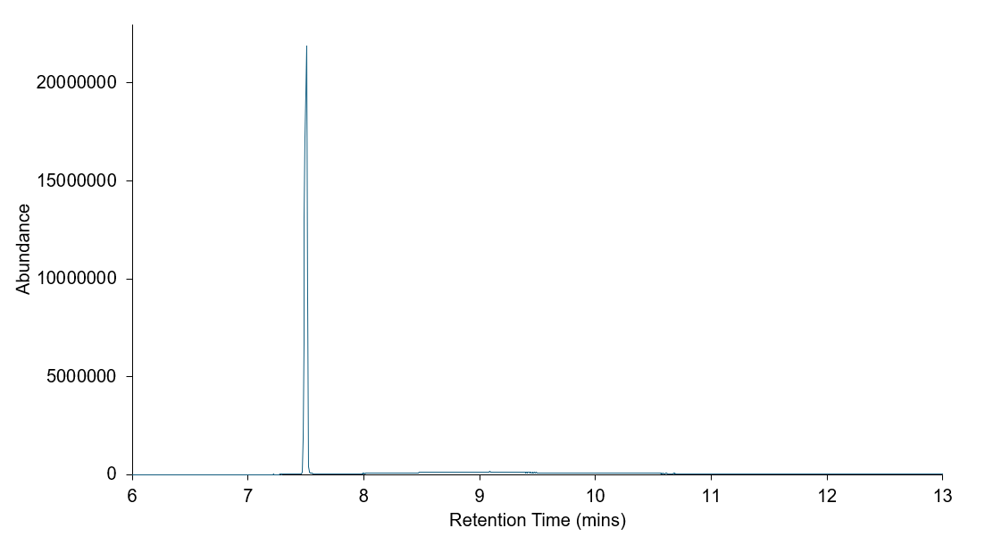
Supplementary Figure 1: GC-MS Chromatogram, caffeine reference standard (1mg/mL)

Supplementary Table 5: Analytical data relating to caffeine reference standard (1mg/mL)

Retention Time  (mins) | Identification | Reverse Match Factor (RMF) | Peak Area
7.508 | Caffeine | 961 | 383418011

Seized Sample (A)

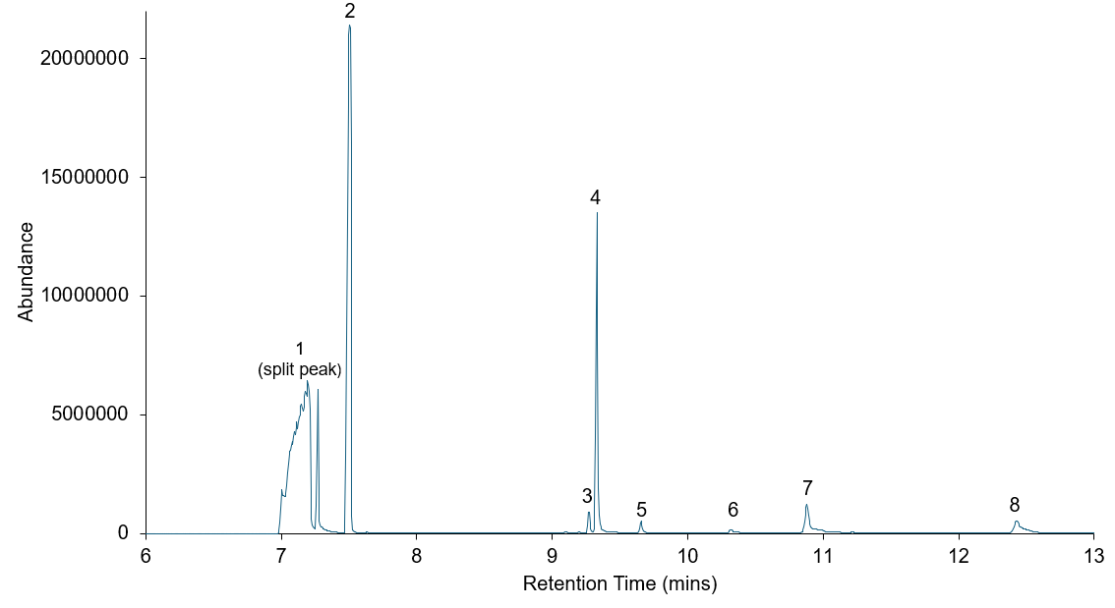
Supplementary Figure 2: GC-MS Chromatogram, seized sample (a).

Supplementary Table 6: Analytical data relating to seized sample (a)

Weight of powder: 4.5 mg in 1mL
Peak Number | Retention Time  (mins) | Identification | Reverse Match Factor (RMF) | Peak Area | Estimated  Caffeine  Concentration (mg) mL | Estimated Caffeine Concentration  (%)
1 | 7.195 | Paracetamol | 959 | 607144614
2 | 7.507 | Caffeine | 963 | 424896006 | 1.11 | 24.7
3 | 9.272 | 6-Acetylcodeine | 918 | 9118535
4 | 9.332 | 6-monoacetylmorphine | 957 | 137913095
5 | 9.657 | Diacetylmorphine | 939 | 5823441
6 | 10.321 | Papaverine | 863 | 2725457
7 | 10.882 | Sucrose Octaacetate | 903 | 22473003
8 | 12.431 | Noscapine | 916 | 21506595

Supplementary Table 7: Estimated Caffeine Concentration (µg/mL) in Test Strip Solution (seized sample (a)
Weight of Seized Sample in 1 mL  (mg) | Estimated Caffeine Concentration  (As calculated from GC-MS)  (%) | Estimated Caffeine Concentration in Test Strip Solution  (µg/mL)
1.3 | 24.7 | 321

Seized Sample (B)

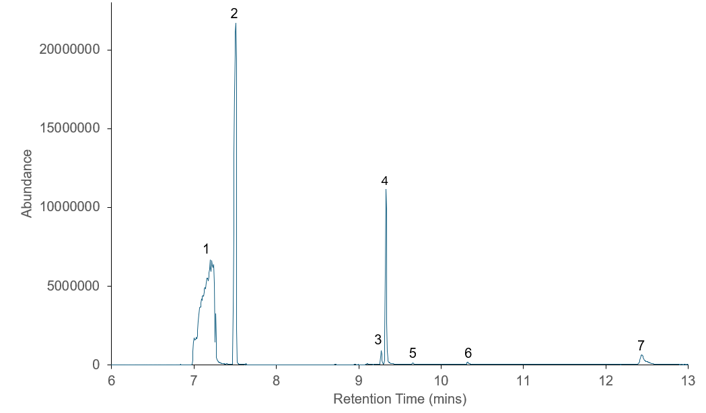
Supplementary Figure 3: GC-MS Chromatogram, seized sample (b).

Supplementary Table 8: Analytical data relating to seized sample (b)
Weight of powder: 5.2 mg
Peak Number | Retention Time  (mins) | Identification | Reverse Match Factor (RMF) | Peak Area | Estimated  Caffeine  Concentration (mg/ mL) | Estimated Caffeine Concentration(%)
1 | 7.195 | Paracetamol | 960 | 699341909
2 | 7.510 | Caffeine | 960 | 437123278 | 1.14 | 21.9
3 | 9.276 | 6-Acetylcodeine | 931 | 8542247
4 | 9.334 | 6-monoacetylmorphine | 959 | 115380413
5 | 9.658 | Diacetylmorphine | 851 | 1049392
6 | 10.326 | Papaverine | 873 | 3007398
7 | 12.439 | Noscapine | 908 | 26992570

Supplementary Table 9: Estimated Caffeine Concentration (µg/mL) in Test Strip Solution (seized sample (a)
Weight of Seized Sample in 1 mL | Estimated Caffeine Concentration  (As calculated from GC-MS)  (%) | Estimated Caffeine Concentration in Test Strip Solution  (µg/mL)
1.2 | 21.9 | 262

Seized Sample (C)

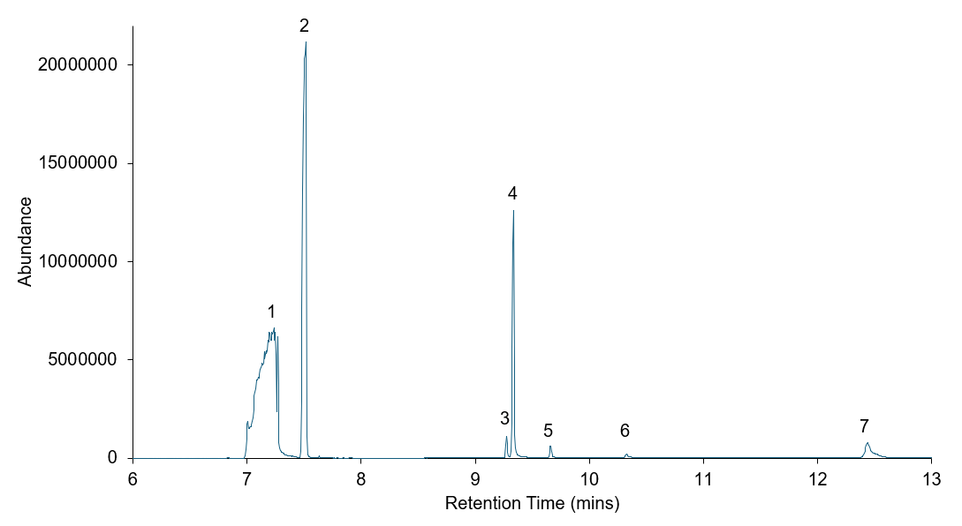
Supplementary Figure 3: GC-MS Chromatogram, seized sample (c).

Supplementary Table 10: Analytical data relating to seized sample (c)

Weight of powder: 5.5 mg
Peak Number | Retention Time  (mins) | Identification | Reverse Match Factor (RMF) | Peak Area | Estimated  Caffeine  Concentration (mg/ mL) | Estimated Caffeine Concentration  (%)
1 | 7.235 | Paracetamol | 956 | 748766911
2 | 7.515 | Caffeine | 962 | 488739153 | 1.27 | 23.2
3 | 9.275 | 6-Acetylcodeine | 902 | 10391872
4 | 9.336 | 6-monoacetylmorphine | 957 | 133569428
5 | 9.661 | Diacetylmorphine | 943 | 7096682
6 | 10.326 | Papaverine | 880 | 3747467
7 | 12.438 | Noscapine | 915 | 33052419

Supplementary Table 11: Estimated Caffeine Concentration (µg/mL) in Test Strip Solution (seized sample (a)

Weight of Seized Sample in 1 mL | Estimated Caffeine Concentration  (As calculated from GC-MS)  (%) | Estimated Caffeine Concentration in Test Strip Solution  (µg/mL)
1.3 | 23.2 | 301

