.Supplementary table 1: CARE Checklist of information to include when writing a case report (67)
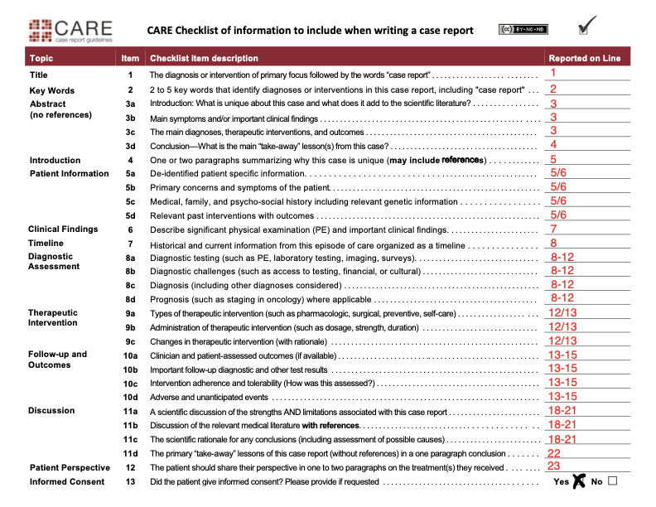

Supplementary Table 2 Longitudinal laboratory and other investigations
Investigation | Date
 | 24.08.23 | 11.09.23 | 30.10.23 | 29.01.24 | 04.03.24 | 26.03.24 | 16.05.24
Blood pressure (mmHg) | 160/81 | 149/71 | 133/67 |  |  |  | 147/78
24h blood pressure (mmHg) |  | 154/77*** |  | 116/65****
Height (cm) | 192 | 192 | 192 |  |  |  | 192
Weight (kg) | 125 | 120 | 113 |  |  |  | 107
BMI | 33.91 | 32.55 | 30.65 |  |  |  | 29.03
Hematology
RCC (10e6/uL) (4.6-6.2) | 5.81 | 6.25 | 5.46 | 4.88 | 4.86 |  | 5.32
WCC 10e3/uL) (4-10) | 5.8 | 4.9 | 6.7 | 5.9 | 8.6 |  | 4.3
Hemoglobin (Hb) (g/dL) (14-18) | 17.9 | 19 | 17.4 | 15.4 | 15.5 |  | 17
Hematocrit (HCT) (%) (43-49) | 52.8 | 56.9 | 50 | 43.1 | 44.4 |  | 48.1
Chemistry
Triglycerides (mmol/l) (0.56-1.68) | 1.55 |  |  |  |  |  | 1.61
Cholesterol (mmol/l) (3.88-5.66) | 3.96 |  |  |  |  |  | 3.68
HDL-Cholesterol (mmol/l) (>1) | 0.73 |  |  |  |  |  | 1.11
LDL-Cholesterol (mmol/l) (<3) | 2.53 |  |  |  |  |  | 1.84
GGT (U/l) (16-73) | 19 | 15 | 19 | 19 | 15 |  | 18
ALAT (U/l) (4-44) | 81 | 62 | 57 | 47 | 70 |  | 60
ASAT (U/l) (8-38) | 68 | 39 | 46 | 41 | 75 |  | 47
Creatinine (umol/l) (53-97) | 106 | 110 | 107 | 97 | 92 |  | 85
Natrium (mmol/l) (136-149) | 144 |  |  |  |  |  | 139
Kalium (mmol/l) (3.5-5.1) | 4.2 |  |  |  |  |  | 3.6
Creatin-Kinase (U/l) (24-190) | 2188 | 803 | 1012 | 661 | 2559 |  | 820
Random glucose test (mmol/l) (3.9-6.1) | 4.9 |  |  |  |  |  | 5.5
TSH (mIU/l) (0.30-3.18) | 2.4 |  |  |  |  |  | 2.23
Prolactin (mcg/l) (4.0-15.2) | 16.6 |  |  |  |  |  | 11.9
FSH (IU/l) (1.5-12.4) | 0.3 |  |  |  |  |  | < 0.3
LH (IU/L) (1.7-8.6) | 0.3 | < 0.3 | 0.3 | 9.4 | 9.2 |  | < 0.3
total Testosterone (tT) (nmol/l) (8.6 – 29.0) | 43.6 | 8.3 | 44.5 | 6.5 | 8.2 | 7.7
free Testosterone* (fT) (pmol/l) (16.7 – 77.8) | 166.2 | 27.4
free Testosterone** (fT) (pmol/l) (198-619) |  |  | 1140 | 108 | 108 | 112
SHGB (nmol/l) (18.3-54.1) | 12 | 15.1 | 35.2 | 40 | 57.4 | 50.8
Estradiol (pmol/l) (41.4-159) | 258 | 29 | 176 | 55 | 23
Cystatin C (mg/l) (0.61 – 0.95) | 0.95 | 0.81 | 0.73 | 0.75 | 0.77 |  | 0.82
eGFRcystatinC (ml/min) | 91 | 112 | 120 | 118 | 116 |  | 111
NT-proBNP (N-Terminal Pro-B-Type Natriuretic Peptide) (ng/l) (< 86) |  |  |  |  |  |  | 15
Urine examination
(Micro)albumin (mg/l) (< 20) | 135 |  |  |  |  |  | 26
Microalbumin/Creatinine (mg/mmol) (< 2.3) | 8.28 |  |  |  |  |  | 3.17
* Determination of bioactive testosterone by direct measurement.
** Determination of free testosterone by calculation with formula of Vermeulen.
***24h blood pressure measurement conducted 21.09.2023
****24h blood pressure measurement conducted 08.01.2024

Supplementary information: Detailed consumption history on AAS and IPED use
A detailed history on consumption of anabolic steroid use was taken. The initiated AAS use at 30 years, and they have been used over a duration of 8 years. Consumption patterns were very complex. A list of past use of AAS and other image- and performance-enhancing drugs are listed in supplementary table 3. Most often more than one AAS compound was used during one application (“stacking”) with changes in dosages (“Pyramiding”), as well as weekly dosages of testosterone compounds normally approximately up to 1000mg per week that were administered, but sometimes higher dosages were reported. He was using AAS in cyclic consumption patterns (with clear onset and stop). At presentation he reported approximately 20 cyclic applications in the past most often used over 20-24 weeks per application. He followed safer-use practices when using AAS. Substances for use were acquired from non-medical sources (i.e., peers at the gym). Motivation to use these substances were improving physical appearance and body image was well as increasing strengths and muscle mass. He engaged in heavy recreational work out routines during 6 days/week and had 13 years of experience at the gym. He was not competing in any physique or athletic competitions.
Supplementary table 3: Current and past medication history (patient-reported) during first clinical visit
AAS used | Other anabolic agents used | Other IPEDs used | Other adjunctive treatments used
- Boldenone  - Metandienon  - Nandrolone Decanoate  - Nandrolone Phenylpropionate  - Oxandrolone  - Stanozolol  - Testosterone blends  - Testosterone Enanthate  - Testosterone Propionate  - Trenbolone | - Human growth hormone  - Insulin | - Human chorionic gonadotropin | - Clomiphene

Supplementary table 4: Possible effects of non-medical AAS use on the cardiovascular system and possibly underlying pathophysiology.
Pathology | Pathophysiology | Reference
Atherosclerosis and Dyslipidemia | Hypertriglyceridemia, increased circulation of LDL, enhanced HDL catabolism, downregulation of Apoprotein Apo-A1 and Apo-D, hyperhomocysteinemia, vascular inflammation; possible dose-dependent effects observed with increased doses of AAS used. | (6, 11, 68-71)
Thrombosis | Modification in vascular tone, increased production of platelets, promotion of hematopoiesis, increased blood viscosity, upregulated synthesis of thromboxane A2 and TXA2 receptors on endothelial cells, higher incidence of arterial and intracardial embolism, pulmonary embolism and deep vein thrombosis. | (11, 68, 69)
Polycythemia and blood stasis | Increased production of hematopoietic cells, stimulating EPO, upregulation of EPO receptors, activating androgen receptors on bone marrow cells lineages, polycythemia; elevated hematocrit, possible suppression of hepcidin; increased absorption of iron in the gut. | (68, 71)
Vasospasm or Vascular dysfunction | Physiological concentrations cause dilatation of blood vessels; enhanced blood flow, supraphysiological concentrations lead to vasoconstriction; increased concentration of NE, Angiotensin II and thromboxane, inhibition of NO and other vasodilatory factors. | (11, 68)
Hypertension | Limited knowledge, possible inhibition of postexercise hypotension, persistent blood pressure elevation potentially due to ASS-induced atherosclerosis, increased endothelin-1 and norepinephrine synthesis, upregulation of the RAAS system. | (69, 71)
Left ventricular hypertrophy | Increased left ventricular thickness, RAAS activation; hyperactivation ACE, elevated Angiotensin II concentrations, binding to AT-1 receptors muscle cells; myocardial hypertrophy without increased contractility, number of cardiomyocytes or improved performance, cardiac remodeling; fibrosis, inflammation and oxidative stress, accompanied diastolic dysfunction, reduced ejection fraction, prolonged isovolumetric relaxation due to decreased LV compliance and increased stiffness, wall thickness of over 13 mm suspicious for ASS use, persist effects; reduced inotropy, diastolic dysfunction and myocardial scaring. | (6, 11, 68, 69, 71, 72)
Dilated cardiomyopathy | Possible correlation, unclear; most dilated cardiomyopathies are autosomal dominant disease. | (6, 69)
Heart Failure | Potential advance heart failure with biventricular dysfunction; mechanical and electrophysiological dysregulation. | (11)
Cardiac remodeling | Cause local or diffuse fibrosis, thickening of the LV posterior wall/interventricular septum, extent of cardiac remodeling vastly dependent on the substance and timeframe, suggested enhanced risk of cardiovascular events with combination of exercise; possible downregulation of VEGF. | (68)
Right ventricular strain | Molecular mechanisms not understood, similar effect on diastolic function in right ventricle as in left, worsen effects with exercise. | (11)
Reduction of left ventricular ejection fraction | Seem to lower the ejection fraction both in the left and right ventricle; characterized by hypokinesis and left ventricular stiffness. | (11, 70, 73)
Arrythmia | Induce electrical abnormalities; QRS-wave delay, extension of QRS time > 114 ms, atrial or ventricular fibrillation (VF), tachycardia, (supra)ventricular ectopic beats, prolonged repolarization, cardiac autonomic disorder; affecting neurotransmitter systems such as dopaminergic system, 5-hydroxythyptophan system, GABA system, increasing the risk for sudden cardiac arrest. | (6, 69, 72)
Acute myocardial infarction (AMI) or myocardial apoptosis with sudden cardiac death (SCD) | Resulting because of atherosclerosis, hypercoagulability, coronary vasospasm and increased thrombogenesis SCD manly with cardiomyopathy, apoptosis of hearth muscle, inhibiting re-uptake of catecholamine; combination with exercise overstimulation of sympathetic system, susceptibility for ventricular fibrillation. | (68, 69)

