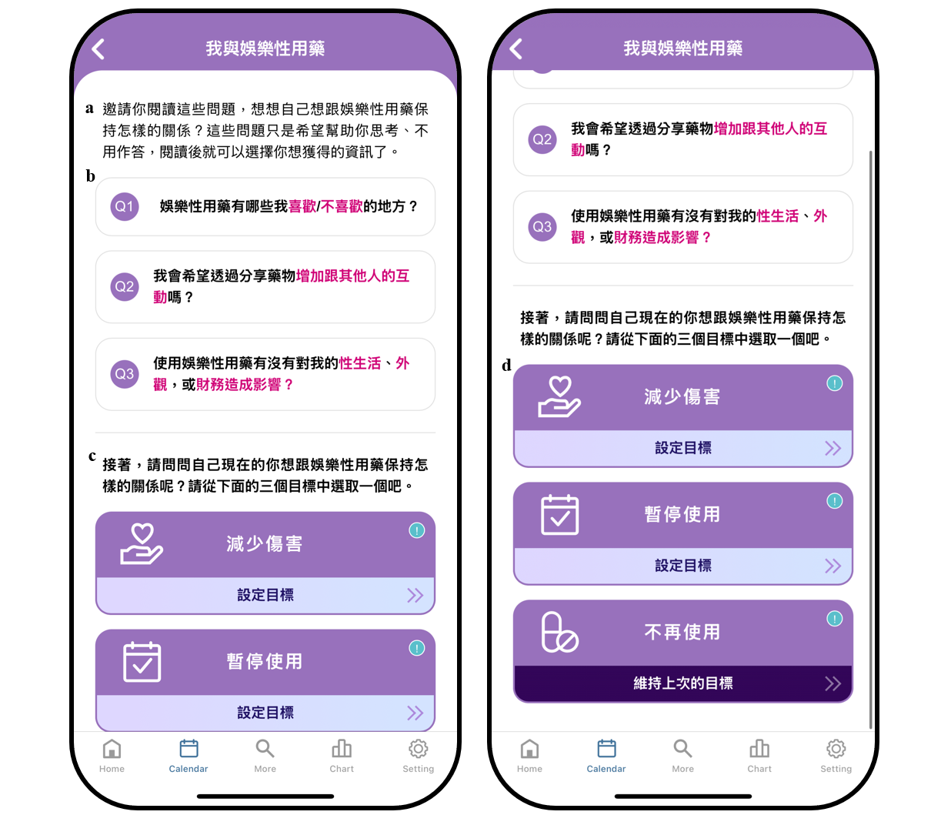
Supplementary File 1: Goal setting feature of UPrEPU
- These questions are not meant to judge you but to help you think about your recreational drug use and whether it aligns with your goals. There are no right or wrong answers, and you don’t have to answer if you don’t feel comfortable.
- Q1: Are there aspects of recreational drug use that you dislike or find unpleasant?
Q2: Do you hope to share your experiences to increase interaction with others?
Q3: Has recreational drug use affected your sex life, relationships, or financial situation?
- Next, please consider how you currently want to manage your recreational drug use. Select one of the three goal options below.
- (from top to bottom) harm reduction, temporary cessation, abstinence

