Appendix- Supplemental Tables, Figures and Forms

,Supplemental Table S1. Variables used in comparisons of the two neighborhood groups at baseline.
Variable name | Variable details/categories/notes | % missing at baseline
Neighborhood | Neighborhood:  - Neighborhood A (received intervention during Cycle I)  - Neighborhood B (served as control during Cycle I and received intervention during Cycle II) | -
Gender | Self-reported gender:  - Male  - Female  Note. “Other gender” was also an available category, but no participant selected this response. | -
Age at baseline | Age at the time of the baseline interview, in years, as self-reported. For two missing responses on this variable, age was calculated based on the participant’s reported birthdate and the date of interview. | -
Race | Self-reported race (one response only), in the following categories:  - Biracial/Multiracial  - “Taino (Indio)”  - Black  Note. “White” and “other race” were also available options but were not selected by any participant. | -
Place of birth | Self-reported birthplace:  - Puerto Rico  - Other (recoded from any other response, whether NYC, another location in the US, or another country) | -
Years lived in Puerto Rico | Self-reported number of years lived in Puerto Rico during the participant’s lifetime. Participants were able to respond in years or months, and the quantity of months was re-coded into quantity of years by dividing number of months by 12. | -
Educational attainment | Self-reported highest level of education completed, re-coded in the following categories:  - Less than high school  - High school or GED (General Education Development)  - Some college or higher | -
Marital status | Self-reported marital status, re-coded in the following categories:  - Single, never married  - Married or living as married  - Separated, divorced, or widowed | -
Employment status | Self-reported current employment status, re-coded in the following categories:  - Odd jobs or part time employment  - Unemployed  - “Disabled for work”  Note. Available responses also included “employed full time,” but no participant selected this response. | -
Ever been homeless | Whether the participant reported ever experiencing homelessness (including living on the street, in a shelter, in a subsidized room rental or single room occupancy hotel, in a car, or temporarily staying with friends or relatives):  - Yes  - No | -
Current homelessness | Whether the participant reported “currently” (at the time of interview) experiencing homelessness (including living on the street, in a shelter, in a subsidized room rental or single room occupancy hotel, in a car, or temporarily staying with friends or relatives):  - Yes  - No  Note. Participants who reported never experiencing homelessness in the previous question were not asked about current homelessness but were coded as “no” current homelessness. | -
Arrested or detained in past 30 days | Whether the participant reported being arrested or detained by the police in the past 30 days (re-coded from a question asking the number of times the participant was arrested or detained in the past 30 days):  - Yes  - No | -
Ever incarcerated stateside | Whether the participant reported ever being incarcerated stateside in the US (including time in jail or prison, serving a sentence or awaiting charges, trial, or sentencing, etc.):  - Yes  - No | -
Ever incarcerated in Puerto Rico | Whether the participant reported ever being incarcerated in Puerto Rico (including time in jail or prison, serving a sentence or awaiting charges, trial, or sentencing, etc.):  - Yes  - No  Note. Participants who reported never living in Puerto Rico were not asked this question and were coded as “no” incarceration in Puerto Rico. | -
Past 30-day use of heroin | Whether the participant reported using heroin in the past 30 days, by any route of administration:  - Yes  - No | -
Past 30-day use of fentanyl | Whether the participant reported using fentanyl (by itself) in the past 30 days, by any route of administration:  - Yes  - No | -
Past 30-day use of cocaine | Whether the participant using cocaine in the past 30 days, by any route of administration:  - Yes  - No | -
Past 30-day use of “combo” | Whether the participant reported using “combo” (cocaine and heroin/fentanyl, purchased as a mixture) in the past 30 days, by any route of administration:  - Yes  - No | -
Past 30-day use of crack | Whether the participant reported using crack in the past 30 days, by any route of administration:  - Yes  - No | -
Past 30-day use of speedball | Whether the participant reported using speedball (injection of heroin/fentanyl mixed with cocaine/crack) in the past 30 days:  - Yes  - No | -
Past 30-day use of xylazine | Whether the participant reported using xylazine (alone or mixed with another drug) in the past 30 days, by any route of administration:  - Yes  - No | -
Past 30-day use of cannabis | Whether the participant reported using cannabis in the past 30 days, by any route of administration:  - Yes  - No | -
Past 30-day use of methadone | Whether the participant reported using methadone not prescribed to them in the past 30 days, by any route of administration:  - Yes  - No | -
Past 30-day use of prescription opioids | Whether the participant reported using prescription opioids not prescribed to them in the past 30 days, by any route of administration:  - Yes  - No | -
Past 30-day use tranquilizers or sedatives | Whether the participant reported using prescription tranquilizers or sleeping pills not prescribed to them in the past 30 days, by any route of administration:  - Yes  - No | -
Past 30-day use of synthetics | Whether the participant reported using “synthetics” (e.g., bath salts, K2, spice), in the past 30 days, by any route of administration:  - Yes  - No | -
Past 30-day use of methamphetamine | Whether the participant reported using methamphetamine in the past 30 days, by any route of administration:  - Yes  - No | -
Injected daily in the past 30 days | Whether the participant indicated that they injected daily in the past 30 days:  - Yes  - No  Note. This was coded from a question which asked the participant how many days in the past 30 days they had injected drugs. All respondents who indicated 30 days were coded “yes” for daily injection. | -
# Injections/day in past 30 days | Self-reported average number of injections per day, in past 30 days (on the days the participant injected) – continuous measure. | -
Frequency of reusing own syringe | Self-reported frequency of own syringe reuse, past 30 days, in the following categories:  - Never  - Rarely  - Sometimes  - Often  - Very Often | -
# Gancheros used in past 30 days | Self-reported number of different Gancheros the participant reported using in the past 30 days, recoded into:  - one  - two or three  Note. No participants indicated that they used more than three Gancheros. | 1.7% missing- 1 response of “i” was coded as missing because it was not a numeric value.
Usual method of paying Ganchero, past 30 days | Self-reported usual method of paying Ganchero in the past 30 days, re-coded into:  - drugs  - cash or other payment  Note. The original options participants were given were “drugs,” “cash,” or “other,” yet “other” and “cash” were combined due to low frequencies and the observation that several write-in responses under “other” were cash amounts. | -
Main reason for using Ganchero in past 30 days | Self-reported primary reason for using the services of a Ganchero in the past 30 days:  - To inject in the neck  - State of desperation  Fear of missing the shot  - Deteriorated veins  - Other | -
Ever overdosed in NYC | Whether the participant reported ever experiencing an overdose in NYC:  - Yes  - No  Note. Response to the question, “Here in New York City, have you ever overdosed to the point where you lost consciousness, stopped breathing or were unresponsive?” | -
Had an overdose, past 30 days | Whether the participant reported having an overdose in the past 30 days:  - Yes  - No  Note. Participants who answered “no” to “Here in New York City, have you ever overdosed…?” were not asked this question and were coded as “no” past-30-day overdose. | -
Ever trained to use Narcan | Whether the participant reported ever being training in how to use naloxone (“Narcan”):  - Yes  - No | -
Currently possesses Narcan | Whether the participant reported currently possessing naloxone (“Narcan”) “at the place where you live, stashed somewhere safe, etc.”:  - Yes  - No
# days/week carrying Narcan | Number of days a week, on average in the past 30 days, that participant reports carrying naloxone (“Narcan”) “on your person (e.g., in a backpack, fanny pack, pocket, etc.)”  - Continuous measure with responses from 0 to 7 considered valid  Note. Values have a logical range of 0 to 7 days a week. Any value out of range (1 participant) was recoded as “missing.” | 3.45% missing, due to one response that was out of the logical range (e.g., 30 days per week) re-coded as missing, and a second response missing altogether
Frequency of visiting SSP, past 30 days | Self-reported frequency of visits to a syringe service program in the past 30 days, re-coded in categories of:  - Never  - 1-2 times  - At least once a week  Note. From the question, “In the past 30 days, how often have you visited a Syringe Services Program?” | -
Frequency of mobile SSP use, past 30 days | Self-reported frequency of utilization of a mobile syringe service program in the past 30 days, re-coded in categories of:  - Never  - 1-2 times  - At least once a week  Note. From the question, “In the past 30 days, how often have you used a mobile SSP (e.g., van or outreach worker on foot) that came to you?” | -
Ever received drug use treatment | Whether participant reported ever receiving drug treatment:  - Yes  - No | -
Received drug treatment in past 30 days | Whether participant reported participating in any type of drug treatment in the past 30 days:  - Yes  - No  Note. Participants who had indicated in a previous question that they had never received treatment were not asked this question and coded as “no.” | -

Supplemental Table S2. Baseline characteristics of participants who did, or did not, complete at least one follow-up assessment (T2 and/or T3) during Cycle I
 | Completed at least one follow-up  (n=30) | Did not complete a follow-up  (n=28) | P value
Neighborhood, % |  |  | 0.799
Neighborhood A | 50.0 | 46.4
Neighborhood B | 50.0 | 53.6
Gender, % |  |  | 0.665
Female | 93.3 | 89.3
Male | 6.7 | 10.7
Age at baseline in years, median [IQR] | 44.5 [41.0, 51.0] | 47 [41.5, 54.5] | 0.455
Race, self-identified, % |  |  | 0.326
Mixed/Biracial/Multiracial | 63.3 | 78.6
“Taino” | 30.0 | 14.3
Black | 6.7 | 7.1
Place of birth, % |  |  | 0.561
Puerto Rico | 76.7 | 67.9
Other | 23.3 | 32.1
Years lived in Puerto Rico, median [IQR] | 21.5 [15.0, 30.0] | 18 [7.0, 23.5] | 0.190
Educational attainment, % |  |  | 0.430
Less than high school | 43.3 | 35.7
High school/GED | 33.3 | 25.0
Some college/higher | 23.3 | 39.3
Marital status, % |  |  | 0.390
Single/never married | 56.7 | 64.3
Married/living as if married | 10.0 | 17.9
Separated/Divorced/Widowed | 33.3 | 17.9
Employment status, % |  |  | 0.593
Odd jobs or employed part time | 20.0 | 25.0
Unemployed | 70.0 | 57.1
“Disabled for work” | 10.0 | 17.9
Ever been homeless, % | 83.3 | 75.0 | 0.525
Current living situation, %: |  |  | 0.475
Street homelessness | 53.3 | 42.9
SRO, shelter, halfway, treatment | 13.3 | 7.1
House (parent, own, relative, partner) | 33.3 | 50.0
Any family members currently in NYC, % | 70.0 | 53.6 | 0.280
Arrested/detained, past 30 days, % | 23.3 | 3.6 | 0.053
Ever incarcerated stateside, % | 70.0 | 78.6 | 0.554
Ever incarcerated in Puerto Rico, % | 50.0 | 28.6 | 0.114
Past 30-day use of, %:
Heroin (alone or with fentanyl) | 23.3 | 14.3 | 0.508
Fentanyl alone | 3.3 | 7.1 | 0.605
Cocaine (alone or with fentanyl) | 26.7 | 17.9 | 0.534
“Combo” ¹ | 36.7 | 17.9 | 0.146
Crack | 16.7 | 17.9 | 1.000
Speedball² | 93.3 | 96.4 | 1.000
Xylazine | 16.7 | 17.9 | 1.000
Cannabis | 30.0 | 14.3 | 0.212
Methadone (non-prescribed) | 13.3 | 10.7 | 1.000
RX opioids (non-prescribed) | 3.3 | 0.0 | 1.000
Tranquilizers/sedatives (non-prescribed) | 16.7 | 14.3 | 1.000
Synthetics (bath salts, K2, spice) | 36.7 | 21.4 | 0.255
Methamphetamine | 3.3 | 7.1 | 0.605
Injected daily in past 30 days, % | 86.7 | 96.4 | 0.354
# injections/day, past 30 days, median [IQR] | 5.0 [4.0, 5.0] | 4.5 [3.0, 10.0] | 0.763
Frequency of reusing own syringe, % |  |  | 0.309
Never | 40.0 | 50.0
Rarely | 16.7 | 3.6
Sometimes | 20.0 | 17.9
Often | 20.0 | 14.3
Very often | 3.3 | 14.3
Injected in the street or park, past 30 days, % | 93.3 | 82.1 | 0.246
Injected alone, past 30 days, % | 53.3 | 57.1 | 0.798
# times sharing cookers, past 30 days, median [IQR] | 30.0 [5.0, 90.0] | 60.0 [12.5, 90.0] | 0.248
# times “backloading,” past 30 days, median [IQR] | 15.0 [0.0, 60.0] | 17.5 [1.5, 42.5] | 0.682
# times engaging in “Caballo,” past 30 days, median [IQR] | 27.5 [6.0, 60.0] | 30.0 [5.0, 75.0] | 0.948
# people known who inject drugs, median [IQR] | 20.0 [10.0, 30.0] | 16.0 [10.0. 30.0] | 0.671
Number of Gancheros used, past 30 days, %: |  |  | 0.178
One | 73.3 | 55.6
Two or three | 26.7 | 44.4
Usual method of paying Ganchero, past 30 days, %: |  |  | 1.000
Drugs | 90.0 | 92.9
Cash or other | 10.0 | 7.1
Main reason for using Ganchero in past 30 days, %: |  |  | 0.738
To inject in the neck | 20.0 | 17.9
State of desperation | 13.3 | 10.7
Fear of missing the shot | 36.7 | 28.6
Deteriorated veins | 26.7 | 42.9
Other | 3.3 | 0.0
Ever had an overdose in NYC, % | 70.0 | 57.1 | 0.414
Had an overdose, past 30 days, % | 10.0 | 10.7 | 1.000
Ever trained to use Narcan, % | 86.7 | 100.0 | 0.113
Currently possesses Narcan, % | 36.7 | 28.6 | 0.583
# days/week carrying Narcan, % |  |  | 0.694
0 | 34.5 | 33.3
1 | 10.3 | 18.5
2 | 6.9 | 11.1
3 | 3.5 | 0.0
5 | 3.5 | 7.4
6 | 10.3 | 3.7
7 | 31.0 | 25.9
Frequency of visiting SSP, past 30 days, % |  |  | 0.638
Never | 30.0 | 25.0
1-2 times | 26.7 | 39.3
1x/week + | 43.3 | 35.7
Frequency of mobile SSP use, past 30 days, % |  |  | 0.155
Never | 16.7 | 3.6
1-2 times | 36.7 | 57.1
1x/week + | 46.7 | 39.3
Ever received drug use treatment, % | 93.3 | 96.4 | 1.000
Received drug use treatment in past 30 days, % | 40.0 | 46.4 | 0.791
Perceived importance of obtaining drug treatment now, %: |  |  | 0.622
Not at all important | 23.3 | 14.3
Slightly important | 3.3 | 0.0
Moderately important | 6.7 | 10.7
Considerably important | 13.3 | 7.1
Extremely important | 53.3 | 67.9
# times tested for HIV in NYC, median [IQR] | 10.0 [4.0, 20.0] | 10.0 [3.0, 20.0] | 0.829
# times tested for Hep C in NYC, median [IQR] | 5.0 [2.0, 10.0] | 3.0 [2.0, 20.0] | 0.857
Self-rated health, %: |  |  | 0.709
Excellent | 16.7 | 10.7
Very good | 10.0 | 10.7
Good | 33.3 | 35.7
Fair | 23.3 | 35.7
Poor | 16.7 | 7.1
Has seen medical provider, past year, % | 73.3 | 53.6 | 0.172
Outcome 1 (proportion of injections with sterile syringe in past 30 days), median [IQR] | 0.82 [0.55, 1.00] | 0.90 [0.56, 1.00] | 0.854
Outcome 2 (days per week carrying naloxone, past 30 days), median [IQR] | 2.0 [0.0, 7.0] | 1.0 [0.0, 7.0] | 0.694
Notes. For categorical measures, p values are from Fisher’s exact tests; for continuous measures, p values are from exact Mann-Whitney U-tests. ¹The drug “combo” category denotes “cocaine and heroin/fentanyl, purchased as a mixture.” ²Speedball denotes injection of heroin or fentanyl, mixed with cocaine/crack. Abbreviations: IQR, interquartile range; NYC, New York City; RX, prescription; SSP, syringe services program; HIV, human immunodeficiency virus; hep, hepatitis.

Supplemental Table S3. Results of supplemental linear regression models predicting past 30-day sterile syringe use (proportion of injections that were with a sterile syringe) based on group, time, and the interaction of group and time during Cycle I, using participant-clustered standard errors, with maximum likelihood available case analysis versus full information maximum likelihood.
 | Estimation with maximum likelihood available case analysis |  | Estimation with full information maximum likelihood
N observations | 97 |  | 174
N unique participants | 56 |  | 58
 | b (SE) | P value | b (SE) | P value
Intercept | 0.85 (0.04) | <0.001 | 0.85 (0.04) | <0.001
Group
Neighborhood A [intervention] | -0.18 (0.07) | 0.006 | -0.18 (0.07) | 0.006
Neighborhood B [control] | Reference | — | Reference | —
Time period
Time 1 | Reference |  | Reference | —
Time 2 | 0.00 (0.11) | 0.978 | 0.00 (0.11) | 0.978
Time 3 | 0.12 (0.04) | 0.002 | 0.12 (0.04) | 0.002
Group × Time
Neighborhood A × Time 2 | 0.23 (0.13) | 0.065 | 0.23 (0.13) | 0.065
Neighborhood A × Time 3 | 0.18 (0.07) | 0.008 | 0.18 (0.07) | 0.008
Note. Responses outside of the range of plausible values were excluded. Abbreviations. SE, standard error.

Supplemental Table S4. Results of negative binomial regression models predicting the two outcomes of interest based on group, time, and the interaction of group and time during Cycle I, using participant-clustered standard errors, with out-of-range values entered at their highest logical value.
 | Outcome 1:  Number of new syringes used per number of injections (past 30 days) |  | Outcome 2:  Number of days per week carrying Narcan (in past 30 days)
N observations | 101 |  | 100
N unique participants | 58 |  | 57
 | IRR [95% CI] | P value | IRR [95% CI] | P value
Intercept | 0.85 [0.78, 0.93] | 0.001 | 3.47 [2.55, 4.71] | <0.001
Group
Neighborhood A [intervention] | 0.83 [0.70, 0.98] | 0.027 | 0.80 [0.47, 1.35] | 0.408
Neighborhood B [control] | 1.00 [Reference] | — | 1.00 [Reference] | —
Time period
Time 1 | 1.00 [Reference] |  | 1.00 [Reference] | —
Time 2 | 1.04 [0.84, 1.28] | 0.736 | 1.81 [1.29, 2.54] | 0.001
Time 3 | 1.14 [1.04, 1.26] | 0.007 | 1.92 [1.37, 2.69] | <0.001
Group × Time
Neighborhood A × Time 2 | 1.24 [0.95, 1.61] | 0.115 | 1.18 [0.69, 2.02] | 0.549
Neighborhood A × Time 3 | 1.20 [1.01, 1.43] | 0.040 | 0.99 [0.54, 1.83] | 0.973
Abbreviations. IRR, Incidence Rate Ratio; CI, Confidence Interval. Note. In this supplemental analysis, responses outside of the range of plausible values were re-coded at their highest plausible value because all out-of-range responses were higher than plausible. For example, a response of carrying naloxone “30” days per week had not been included in main analyses but was re-coded here as “7” days per week, the maximum possible value.

Supplemental Figure S1. Distribution of participant responses regarding sterile syringe use (in the prior 30 days), by timepoint and neighborhood.
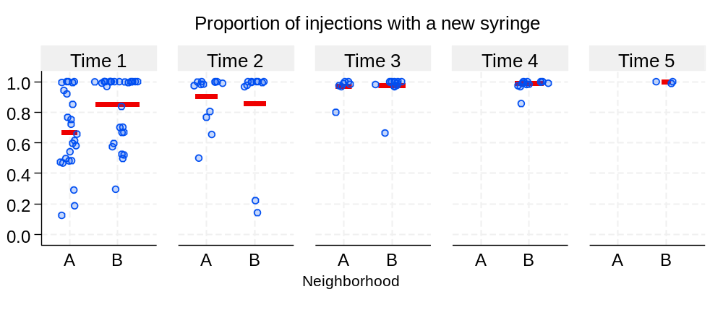Note. Responses outside of the range of plausible values were excluded. The observations (dots) include a random jitter to reduce overplotting and enhance visual clarity. The reference/red bar represents the mean value for each group and time point.

Supplemental Figure S2. Percent of participants who reported that they “never” re-use their own syringes, by timepoint and neighborhood.
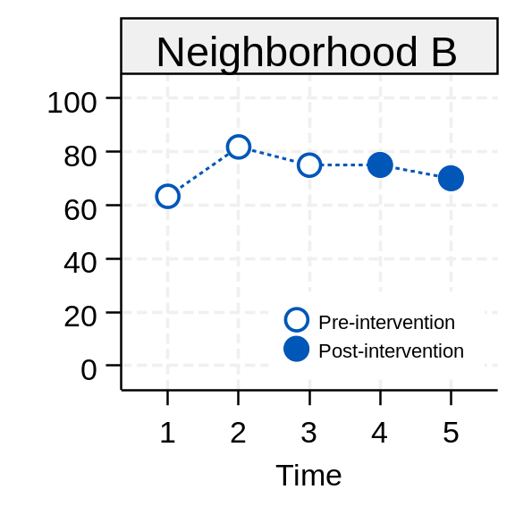
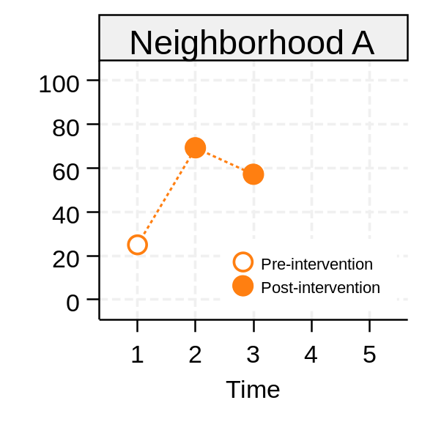

Supplemental Figure S3. Distribution of participant responses regarding number of days per week carrying naloxone (in the prior 30 days), by timepoint and neighborhood.
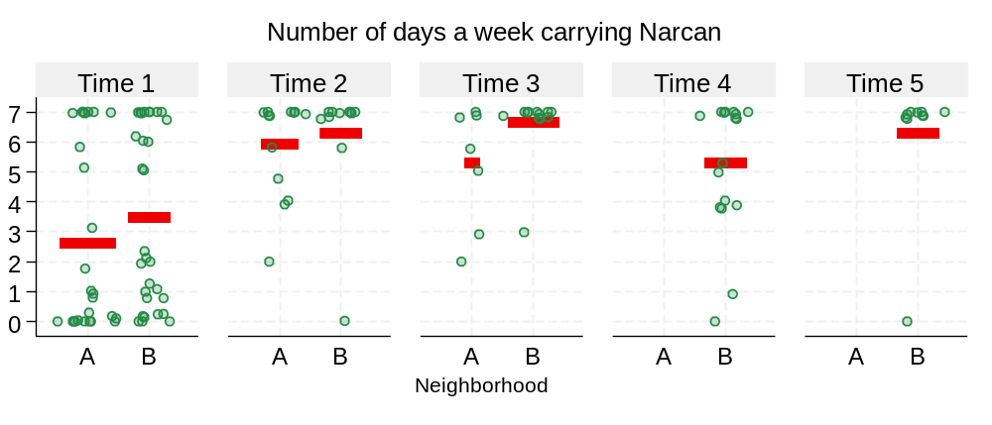
Note. Responses outside of the range of plausible values were excluded. The observations (dots) include a random jitter to reduce overplotting and enhance visual clarity. The reference/red bar represents the mean value for each group and time point.

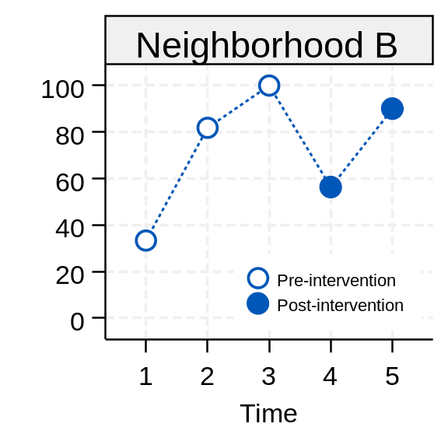
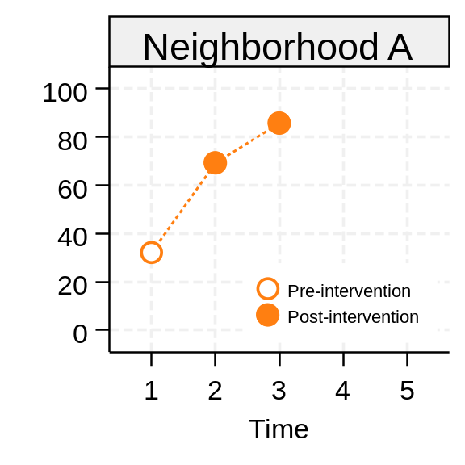
Supplemental Figure S4. Percent of participants who reported that they currently possess Narcan, by timepoint and neighborhood

Supplemental Form SA
 |  | session 1 | session 2 | session 3 | session 4 | session 5 | session 6
1 | ET1 | 8/21/24 | 8/22/24 | 8/23/24 | 8/28/24 | 8/29/24 | 8/30/24
2 | ET2* | 9/2/24 | 9/2/24 | 9/3/24 | 9/3/24 | 9/4/24 | 9/4/24
3 | ET3 | 8/21/24 | 8/22/24 | 8/23/24 | 8/28/24 | 8/29/24 | 8/30/24
4 | ET5 | 8/21/24 | 8/22/24 | 8/23/24 | 8/28/24 | 8/29/24 | 8/30/24
5 | HUB2 | 6/16/25 | 6/17/25 | 6/18/25 | 6/23/25 | 6/24/25 | 6/25/25
6 | HUB3 | 6/16/25 | 6/17/25 | 6/18/25 | 6/23/25 | 6/24/25 | 6/25/25
 | * Ganchero was hospitalized, returned and individualized training was provided.

Supplemental Form SB1
Date: ______________ Weekly Outreach Form Ganchero ID CODE:________

Interventionist: complete this paper report each Friday for each Ganchero in the intervention.

1a. In the past week, how many clients you referred to us did you serve (people you gave injection services to)?
____ ____ [Enter number]

1b. With how many of these referred clients did you discuss HIV, HCV or OD risk reduction?
____ ____ [Enter number]

1c. With how many of these referred clients did you use new needles each time you served them?
____ ____ [Enter number]

1d. To how many of these referred clients did you give Narcan?
____ ____ [Enter number]

2a. In the past week, how many clients NOT referred to us did you serve (people you gave injection services to)?
____ ____ [Enter number]

2b. With how many of these NOT referred clients did you discuss HIV, HCV or OD risk reduction?
____ ____ [Enter number]

2c. With how many of these NOT referred clients did you use new needles each time you served them?
____ ____ [Enter number]

2d. To how many of these NOT referred clients did you give Narcan?
____ ____ [Enter number]

3a. In the past week, with how many other migrant PWID (NON-clients) did you interact without the injection services?
____ ____ [Enter number]

3b. With how many of these NON-clients did you discuss HIV, HCV or OD risk reduction?
____ ____ [Enter number]

3c. To how many of these NON-clients did you give Narcan?
____ ____ [Enter number]

4. Open-ended items
4.a. Barriers to increasing your own sterile syringe use and naloxone carrying: __________________________________________________________________________________________________________________________________________________________________________________________________
4.b. Barriers to increasing sterile syringe use and naloxone carrying with clients: _______________________________________________________________________________________________________________________________________________________________________________________________

4.c. Any strategies used to reduce barriers? _
________________________________________________________________________________________________________________________________________________________________________________________________

Other comments, ideas or important information:_________________________________________________________
________________________________________________________________________________________________
______________________________________________________________________________________________
Supplemental Form SB2