Appendix 3. Change in PedsQL scores from baseline to event visit by clinical disease status based on proteinuria remission status at event visit.
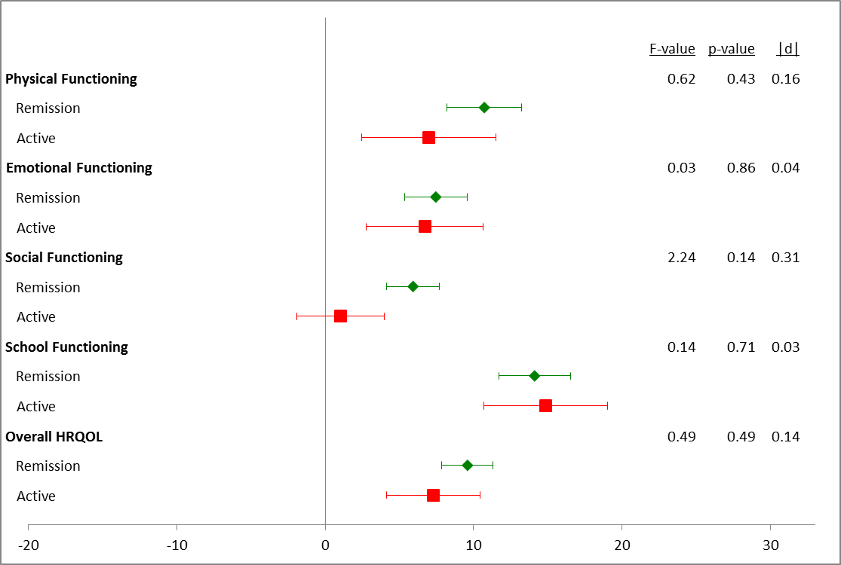
All participants were disease active at baseline. Remission was defied as normalization of urinary protein excretion and complete resolution of edema. Results are shown as mean change with 95% confidence intervals. Sample sizes: Remission=75, Active=37

