Additional file 1: Figure S1 Linear correlation of gross motor aptitude with age
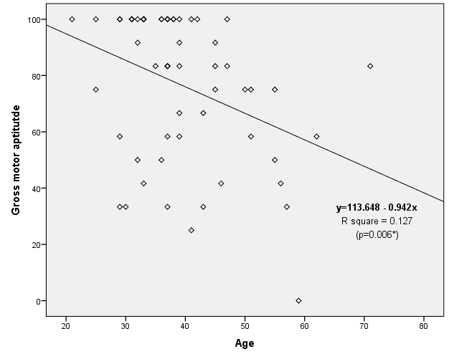

- Age showed to be a predictor for gross motor aptitudes, where older age was correlated with worse gross motor aptitudes (Beta = -0.356, p=0.006)

