Additional file 5

Scatterplots of observed vs predicted HSVs
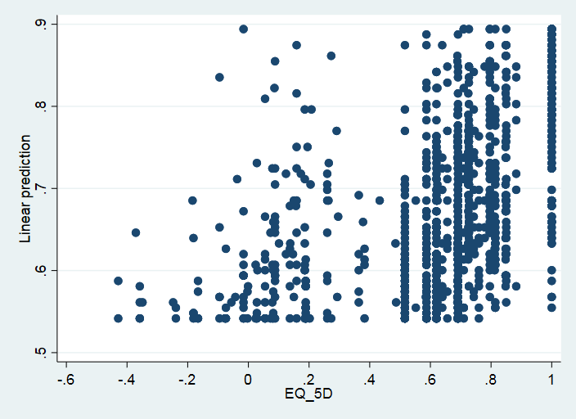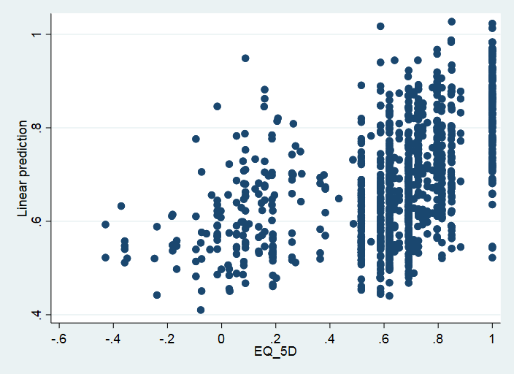
Observed EQ-5D vs EQ-5D estimated using CLAD A Observed EQ-5D vs EQ-5D estimated using CLAD C

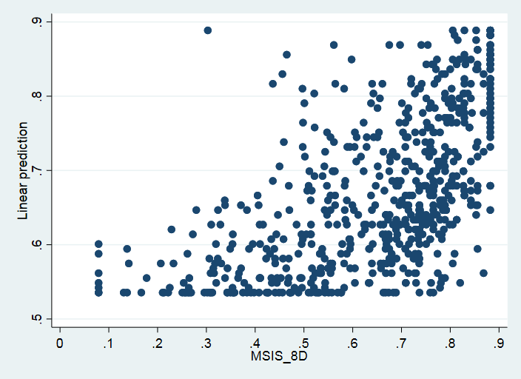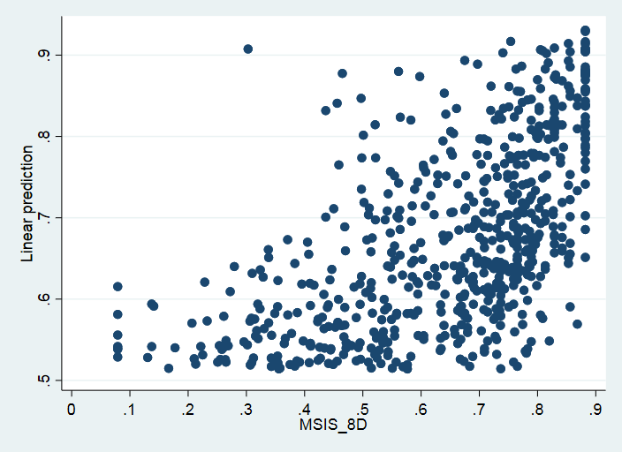
Observed MSIS-8D vs MSIS-8D estimated using CLAD A Observed MSIS-8D vs MSIS-8D estimated using CLAD C
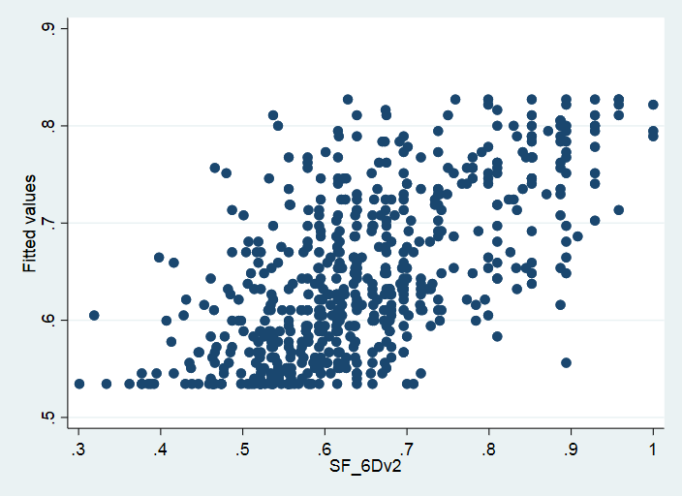
Observed SF-6D vs SF-6D estimated using OLS A

