Table S-1 Confirmatory Factor Loadings of EORTC-CLL17 with item 16 and item 17
 | Estimate | Standard error
SB
CLL1 | 0.305*** | 0.032
CLL2 | 0.299*** | 0.032
CLL3 | 0.274*** | 0.03
CLL4 | 0.378*** | 0.037
CLL5 | 0.279*** | 0.033
CLL6 | 0.497*** | 0.051
PC
CLL7 | 0.31*** | 0.032
CLL8 | 0.155*** | 0.02
CLL9 | 0.232*** | 0.026
CLL10 | 0.177*** | 0.024
WF
CLL11 | 0.229*** | 0.027
CLL12 | 0.256*** | 0.028
CLL13 | 0.244*** | 0.028
CLL14 | 0.347*** | 0.039
CLL15 | 0.209*** | 0.025
CLL16 | 0.678*** | 0.065
CLL17 | 0.693*** | 0.068

Table S-2 Confirmatory Factor Loadings of EORTC-CLL17 without item 16 and item 17
 | Estimate | Standard error
SB
CLL1 | 0.271*** | 0.024
CLL2 | 0.292*** | 0.026
CLL3 | 0.299*** | 0.027
CLL4 | 0.344*** | 0.029
CLL5 | 0.258*** | 0.027
CLL6 | 0.48*** | 0.041
PC
CLL7 | 0.269*** | 0.024
CLL8 | 0.161*** | 0.017
CLL9 | 0.22*** | 0.021
CLL10 | 0.181*** | 0.019
WF
CLL11 | 0.224*** | 0.022
CLL12 | 0.224*** | 0.022
CLL13 | 0.223*** | 0.022
CLL14 | 0.342*** | 0.032
CLL15 | 0.213*** | 0.021

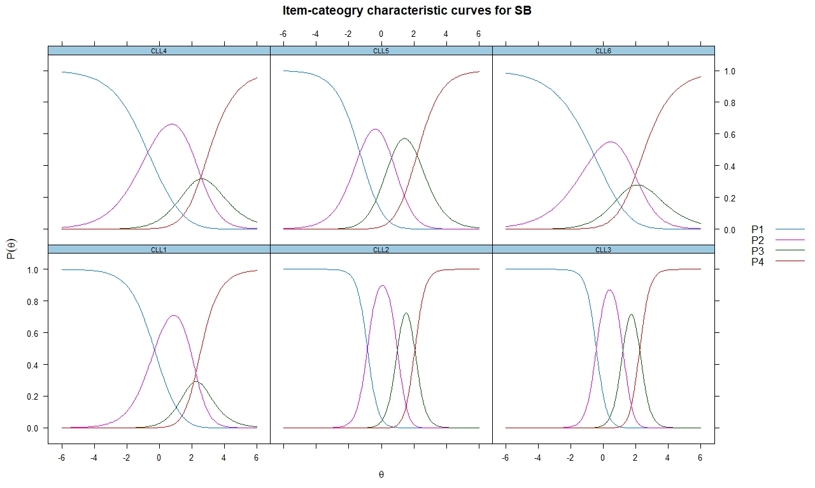
Fig S-1 ICC for subscale of SB

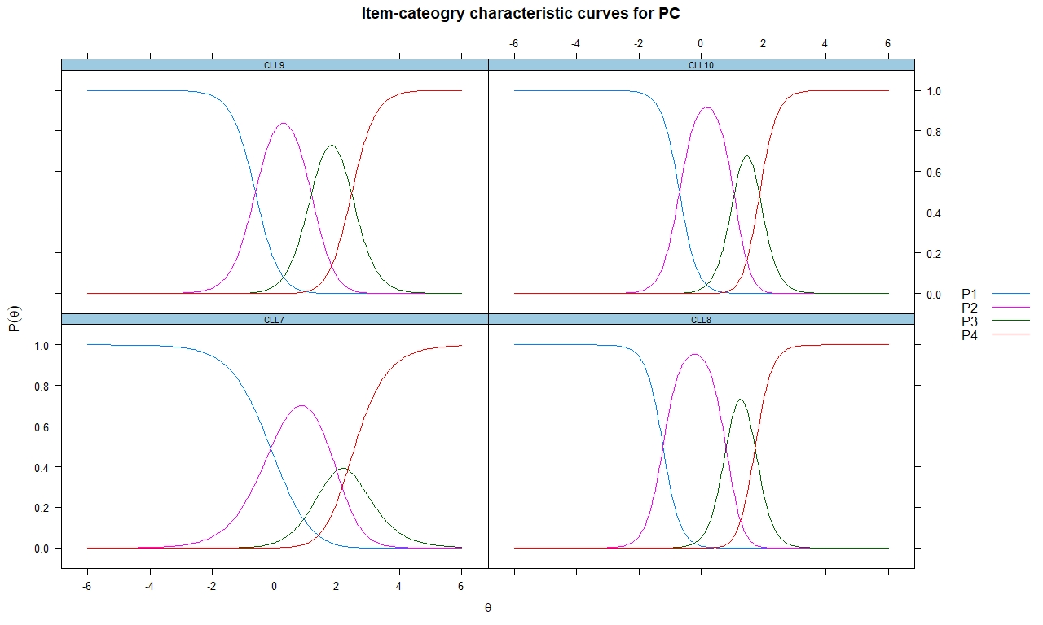

Fig S-2 ICC for subscale of PC

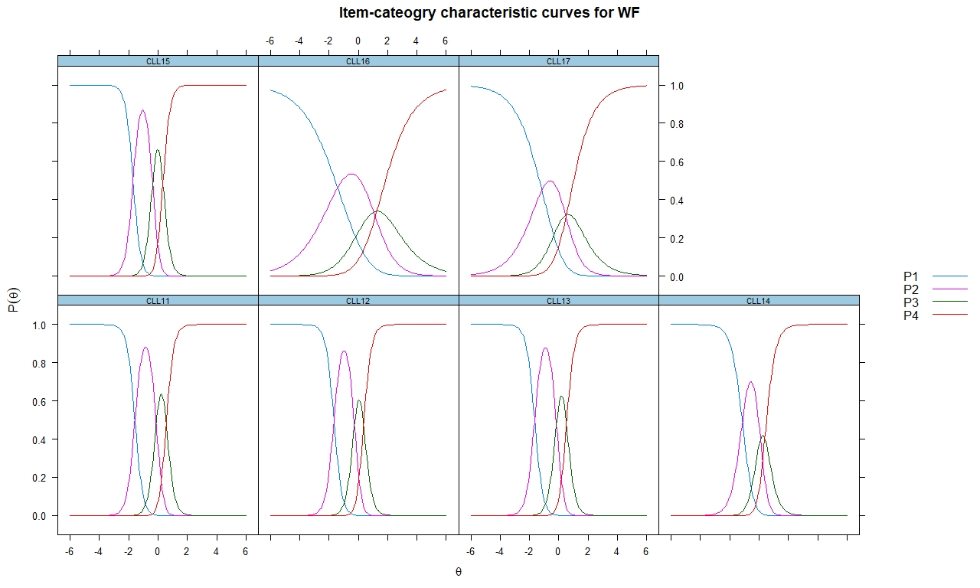
Fig S-3 ICC for subscale of WF

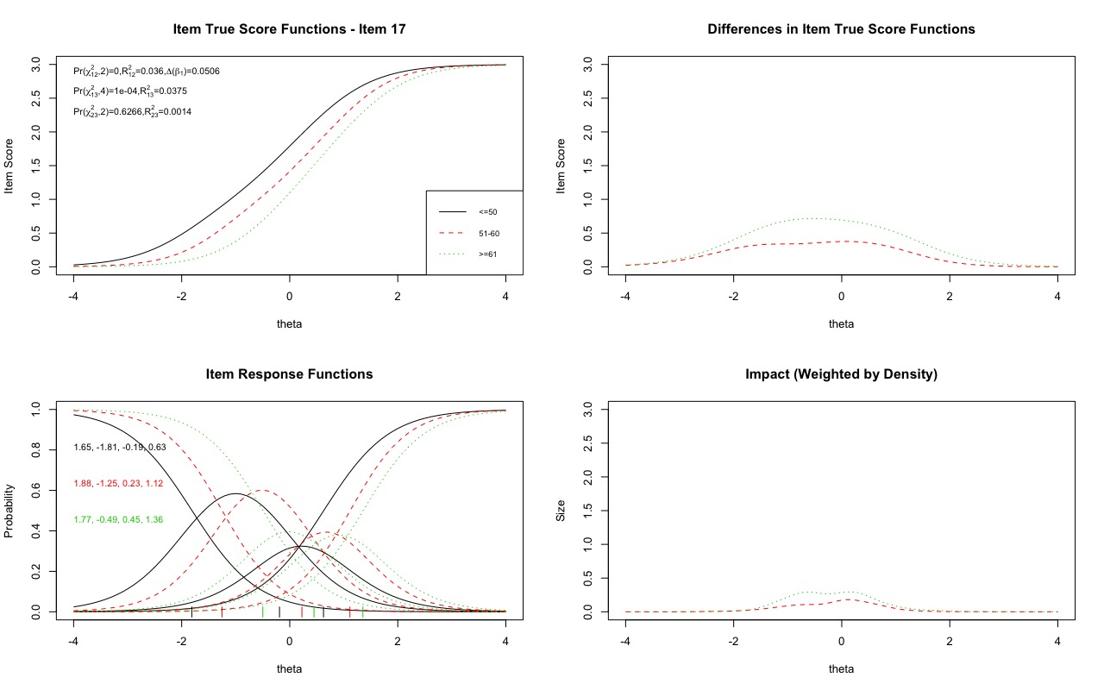
Fig S-4 Graphically display of item 17 of QLQ-CLL17 that shows DIF based on age

The introduction of the House086

House086 is a registered national patient organization. It has 10 full-time staff, all of whom are patients or family members of patients with lymphomas. House086 is also a member of the Lymphoma Coalition and the Union for International Cancer Control. All registered members of House086 must submit a copy of their diagnosis along with proof of their identity information (e.g., national ID) when register. House086 also has a medical board which oversees the clinical information and request submitted by the members.

