Additional file 4.
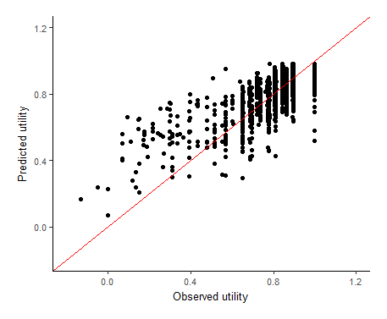  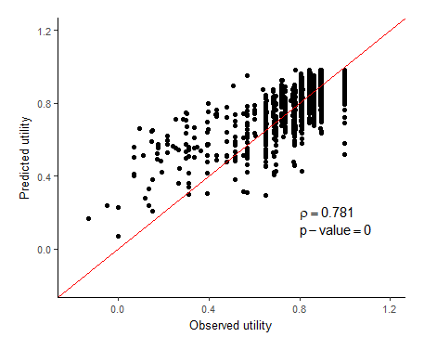  a) | 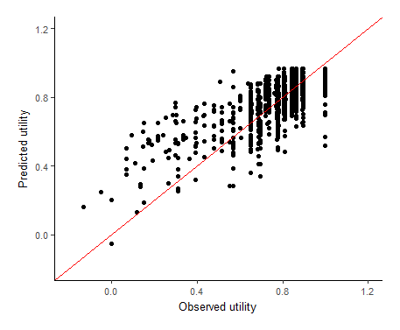  b)
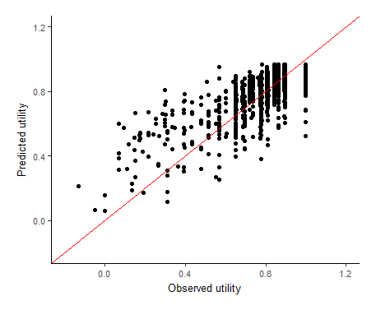  c) | 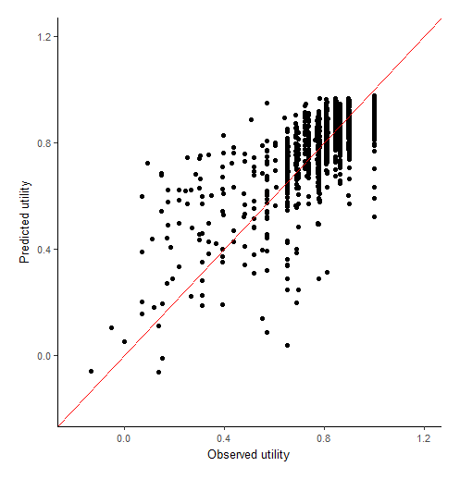  d)
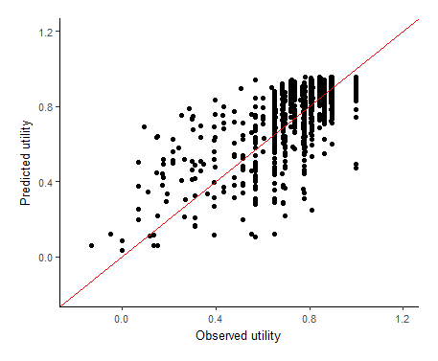  e) | 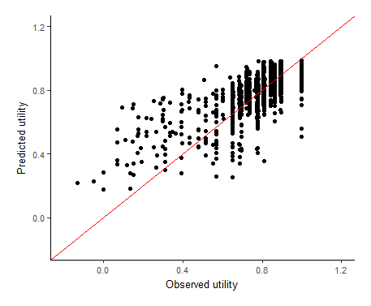  f)
Figure 2. Predicted EQ-5D-3L utility versus the observed utility for a) the RE model with QLQ-C30 domain scores (preferred model 1); b) the RE model with continuous QLQ-C30 questions (model 2); c) the RE model with QLQ-C30 dummy questions (model 3); d) the ordered logit model on the EQ-5D-3L domains (model 4); e) beta regerssion (model 5) and; f) the separate equations subgroup approach (model 6).
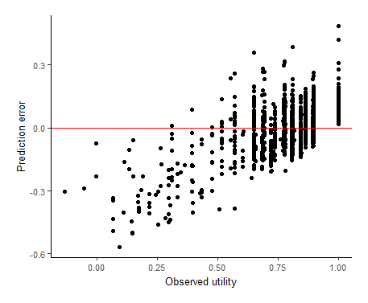  a) | 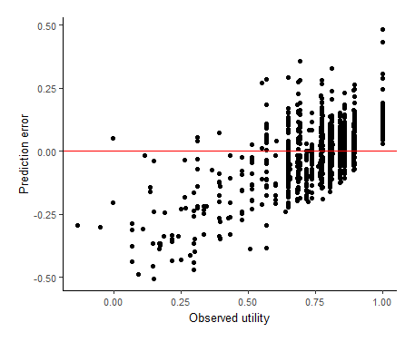  b)
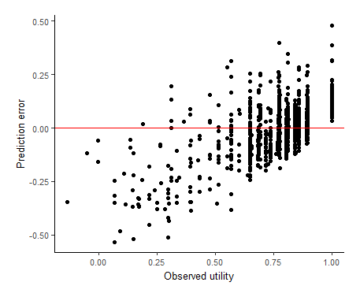  c) | 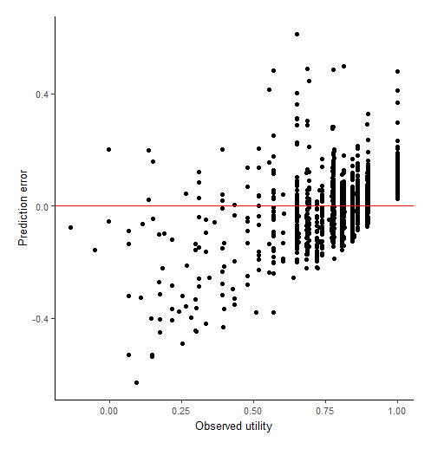  d)
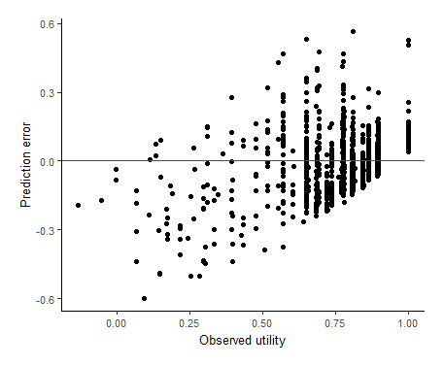  e) | 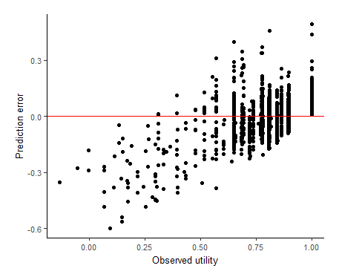  f)
Figure 3. Prediction error (observed – predicted EQ-5D-3L uility) for a) the RE model with QLQ-C30 domain scores (preferred model 1); b) the RE model with continuous QLQ-C30 questions (model 2); c) the RE model with QLQ-C30 dummy questions (model 3); d) the ordered logit model on the EQ-5D-3L domains (model 4); e) beta regerssion(model 5) and; f) the separate equations subgroup approach (model 6).

