ONLINE SUPPLEMENT

Title: Construct validity of the Post-COVID-19 Functional Status Scale in adult subjects with COVID-19

Authors’ full names: Felipe V. C. Machado^{1,2,3,4}, Roy Meys^{1,2,3}, Jeannet M. Delbressine¹, Anouk W. Vaes¹, Yvonne M. J. Goertz^{1,2,3}, Maarten Van Herck^{1,2,3,5}, Sarah Houben-Wilke¹, Gudula J.A.M. Boon⁶, Stefano Barco^{7,8}, Chris Burtin⁵, Alex van ’t Hul⁹, Rein Posthuma^{1,2,3}, Frits M.E. Franssen^{1,2,3}, Yvonne Spies¹⁰, Herman Vijlbrief¹⁰, Fabio Pitta⁴, Spencer A. Rezek¹¹, Daisy J.A. Janssen^{1,12}, Bob Siegerink^{13,14}, Frederikus A. Klok⁶, Martijn A. Spruit^{1,2,3,5}

Authors’ affiliations:
¹Department of Research and Development, CIRO+, Horn, The Netherlands.
²NUTRIM School of Nutrition and Translational Research in Metabolism, Maastricht, The Netherlands.
³Department of Respiratory Medicine, Maastricht University Medical Center (MUMC+), Maastricht, The Netherlands.
⁴Laboratory of Research in Respiratory Physiotherapy (LFIP), Department of Physiotherapy, State University of Londrina (UEL), Londrina, Brazil.
⁵REVAL Rehabilitation Research Center, BIOMED Biomedical Research Institute, Faculty of Rehabilitation Sciences, Hasselt University, Diepenbeek, Belgium.
⁶Department of Medicine – Thrombosis and Hemostasis, Leiden University Medical Center, Leiden, The Netherlands.
⁷Center for Thrombosis and Haemostasis (CTH), University Medical Center of the Johannes Gutenberg University Mainz, Mainz, Germany.
⁸Clinic of Angiology, University Hospital Zurich, Zurich, Switzerland.
⁹Department of Pulmonary Diseases, Radboud University Medical Center, 6525 GA, Nijmegen, The Netherlands.
¹⁰Lung Foundation Netherlands, Amersfoort, The Netherlands.
¹¹Institute of Therapies and Rehabilitation, Kantonsspital Winterthur, Winterthur, Switzerland.
¹²Department of Health Services Research, Care and Public Health Research Institute, Faculty of Health, Medicine and Life Sciences, Maastricht University, Maastricht, The Netherlands.
¹³Center for Stroke research Berlin, Charité Universitätsmedizin Berlin, Berlin, Germany.
¹⁴Department of Clinical Epidemiology, Leiden University Medical Center, Leiden, The Netherlands.

Corresponding author:
Felipe V. C. Machado
Dept. of Research and Development, Ciro
PO Box 4080
6080 AB HAELEN
The Netherlands
T +31 (0)475 587 600
felipemachado@ciro-horn.nl

Pre-existing comorbidities |  | Post-COVID-19 Functional Status Scale
Pre-existing comorbidities | All Sample | Grade = 0 | Grade = 1 | Grade = 2 | Grade = 3 | Grade = 4
Pre-existing comorbidities | (n=1939) | (n=58) | (n=157) | (n=643) | (n=1011) | (n=70)
Anxiety, n (%) | 46 (2.4) | 1(1.7) | 3(1.9) | 8 (1.2) | 28 (2.8) | 6 (8.6)
Arthrosis, rheumatoid arthritis, n (%) | 101 (5.2) | 2(3.4) | 9(5.7) | 29(4.5) | 55(5.4) | 6(8.6)
Burn-out, n (%) | 58(3.0) | 0(0) | 3(1.9) | 17(2.6) | 33(3.3) | 5(7.1)
Cancer, n (%) | 12(0.6) | 1(1.7) | 0(0) | 7(1.1) | 4(0.4) | 0(0)
Depression, n (%) | 63(3.3) | 0(0) | 4(2.5) | 17(2.6) | 40(4) | 3(3.4)
Diabetes, n (%) | 27(1.4) | 0(0) | 2(1.3) | 7(1.1) | 14(1.4) | 4(5.7)
Heart diseases, n (%) | 52(2.7) | 2(3.4) | 1(0.6) | 17(2.6) | 26(2.6) | 6(8.6)
Hypertension, n (%) | 137(7.1) | 4(6.9) | 14(8.9) | 49(7.6) | 64(6.3) | 6(8.6)
Kidney diseases, n (%) | 7(0.4) | 0(0) | 1(0.6) | 3(0.5) | 2(0.2) | 1(1.4)
Lung diseases, n (%) | 217(11.2) | 4(6.9) | 16(10.2) | 60(9.3) | 124(12.3) | 13(18.6)
Migraine, n (%) | 67(3.5) | 3(5.2) | 4(2.5) | 23(3.6) | 31(3.1) | 6(8.6)
Obesity, n (%) | 27(1.4) | 1(1.7) | 3(1.9) | 8(1.2) | 14(1.4) | 1(1.4)
Osteoporosis, n (%) | 15(0.8) | 0(0) | 0(0) | 3(0.5) | 10(1.0) | 2(2.9)
Other, n (%) | 302(15.6) | 8(13.8) | 13(8.3) | 94(14.6) | 166(16.4) | 21(30.0)
Parkinson’s disease , n (%) | 0(0) | 0(0) | 0(0) | 0(0) | 0(0) | 0(0)
Stroke, n (%) | 6(0.3) | 0(0) | 0(0) | 4(0.6) | 2(0.2) | 0(0)
Online Table 1. Pre-existing comorbidities of the subjects with COVID-19 stratified according to the level of impairment in functional status.

Online Figure 1. Associations between baseline characteristics and the likelihood of being classified with a higher level of impairment in functional status assessed by the PCFS Scale. OR: Odds ratio [95% confidence intervals] reported. OB: obese; OW: overweight; NW: normal weight; UW: underweight
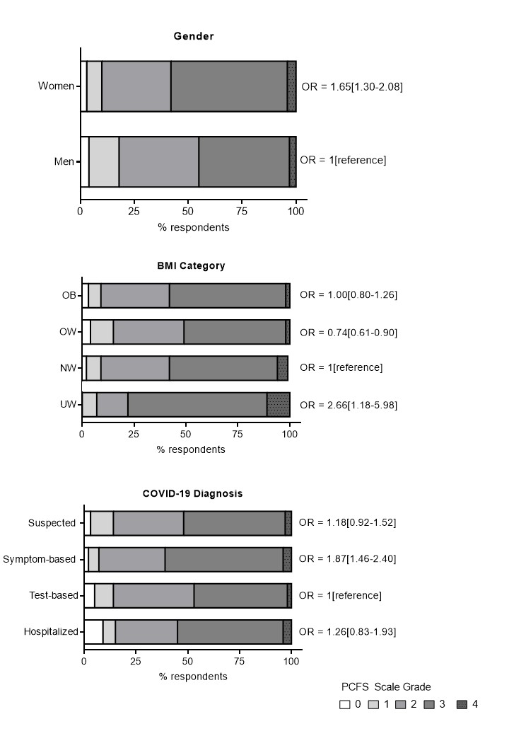
Online Figure 1 (continued).

