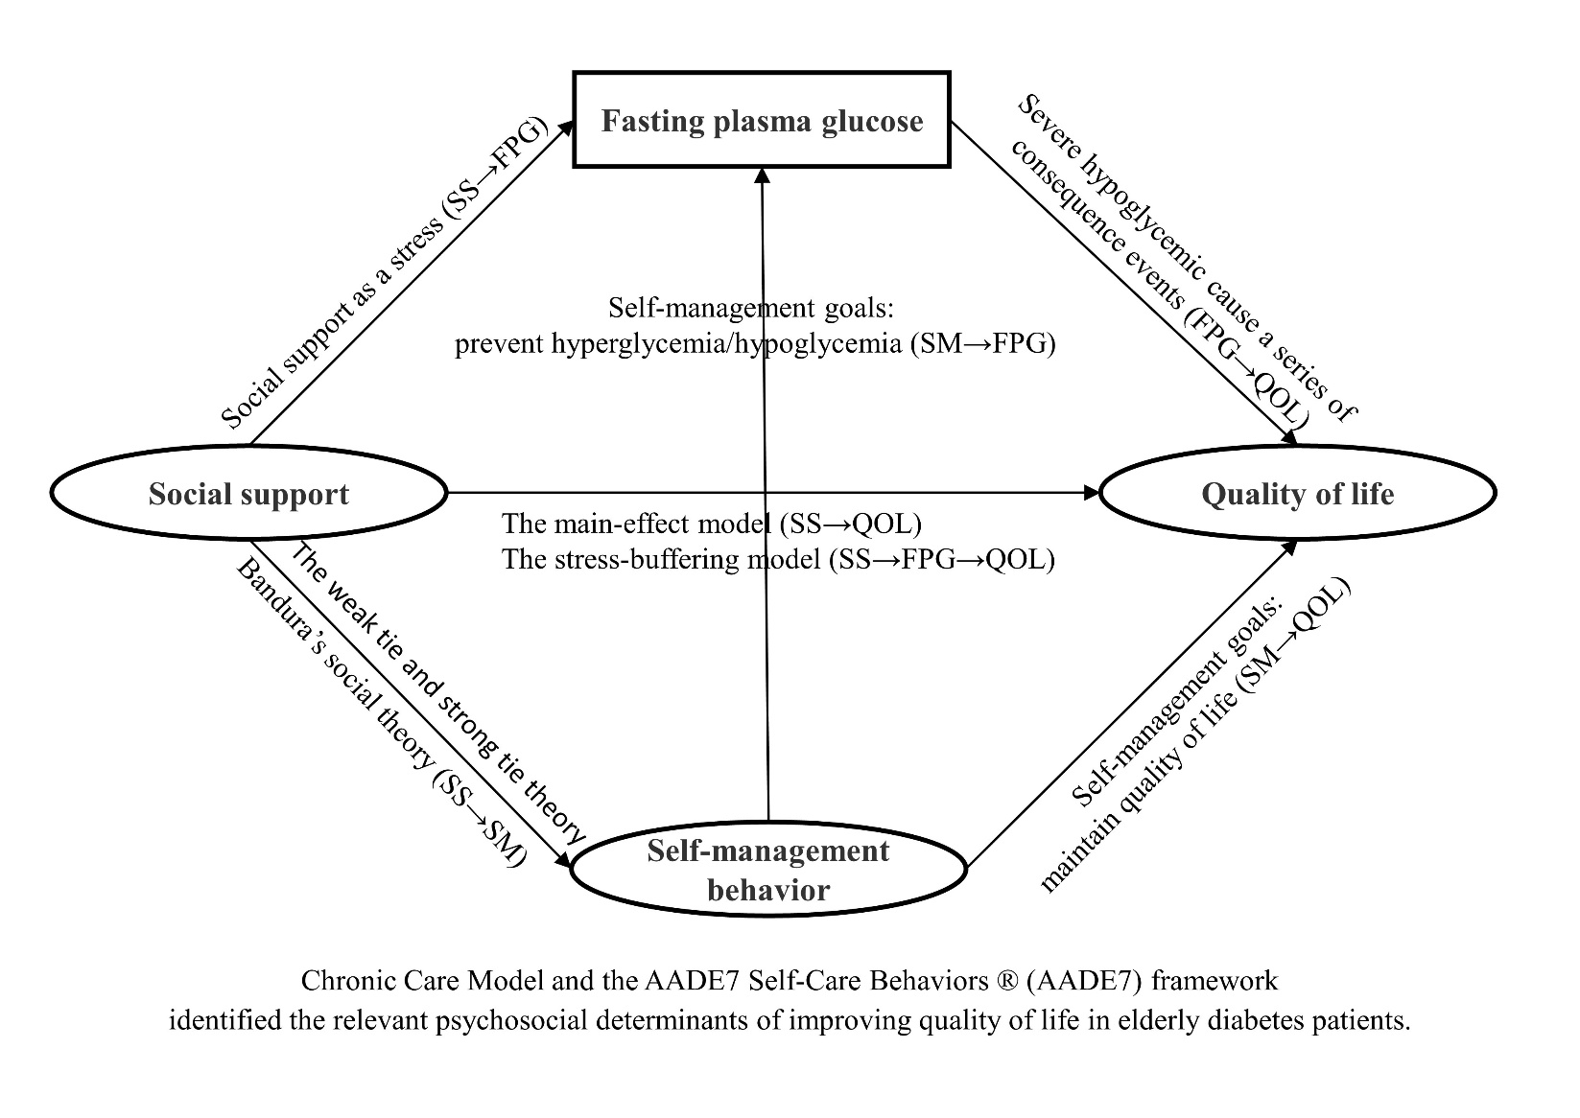
efigure 1. The conceptual and theoretical explanation of the association between SS, SM, FPG, and QOL in elderly type 2 diabetes patients.

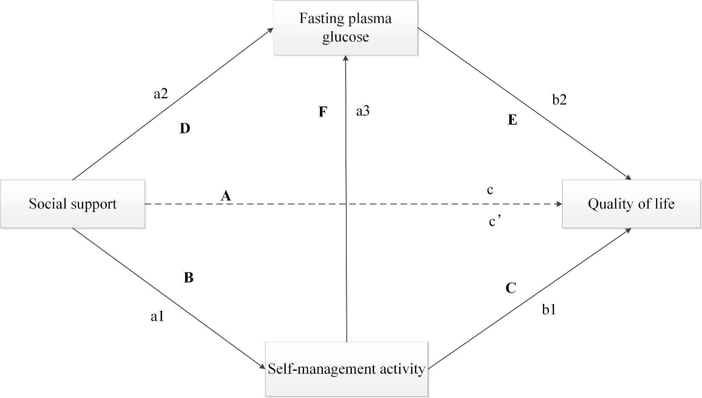
eFigure 2. The conceptual path model for the affection of social support to quality of life; In a simple mediation model, the impact of X on Y is considered a total effect (path c), interpreted as the expected amount by which two cases that differ by one unit on X are expected to differ on Y, which may occur directly or indirectly. Bias-corrected confidence intervals that did not include 0 were considered significant for the indirect effect of the X on Y was a mediator. The direct effect of X (path c′) is interpreted as the part of the effect of X on Y that is independent of the pathway through M. The indirect effect (a*b) is interpreted as the amount by which two cases who differ by one unit on X are expected to differ on Y through X’s effect on M, which in turn affects Y. This is the test of mediation (the effect of X on Y through M) or the difference between the total and direct effects. a1 and a2 = specific indirect effects of X on M1 and M2; a3 = specific indirect effect of M1 on M2; b1 and b2 = specific indirect effects of M1 and M2 on Y; c′ = direct effect of X on Y controlling for M1 and M2; a1*b1 and a2*b2 = specific indirect effects of M1 and M2; a1*a3*b2 = conditional indirect effect of M1 and M2.
c´ = c – (a1*b1 + a1*a3*b2+ a2*b2).

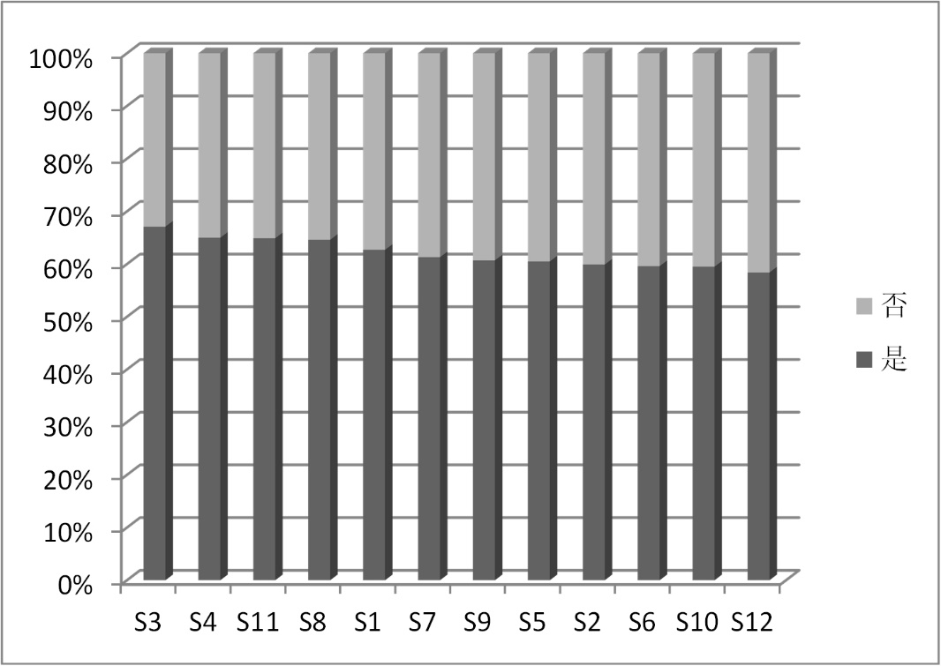
eFigure 3. Selections of specific Social Support.

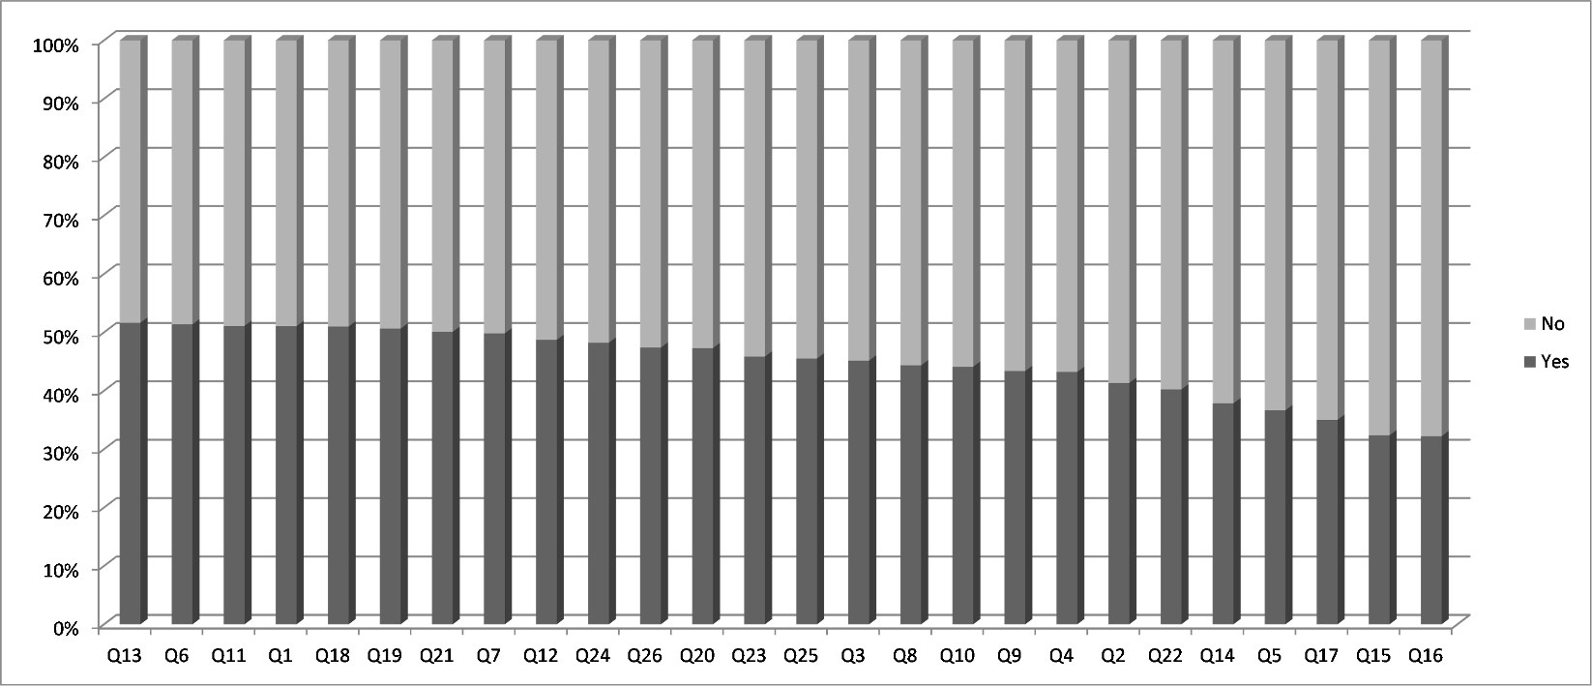
eFigure 4. Selections of specific self-management items.

eTable 1 Self-management and social support ratings.
 |  | Mean | Bad | Medium | Good
Self-management behavior |  | 66.32±13.47 | 192(33.62%) | 288(50.44%) | 91(15.94%)
SM_A | Diet control management | 66.66±17.32## | 219(38.4%) | 260(45.5%) | 92(16.1%)
SM_B | Exercise management | 66.50±17.88## | 347(60.8%) | 191(33.5%) | 33(5.8%)
SM_C | Medication management | 68.82±17.78## | 207(36.3%) | 146(25.6%) | 218(38.2%)
SM_D | blood glucose monitoring management | 63.31±15.90## | 286(50.1%) | 174(30.5%) | 111(19.4%)
SM_E | Foot Care | 65.79±15.02## | 224(39.2%) | 228(39.9%) | 119(20.8%)
SM_F | Hypo/hyper glycaemia management | 67.41±16.32## | 233(40.8%) | 159(27.8%) | 179(31.3%)
Social support
SS_A | Family support | 14.75±2.99 | 122(21.4%) | -- | 449(78.6%)
SS_B | Friend support | 14.34±2.98 | 137(24.0%) | -- | 434(76.0%)
SS_C | Else support | 14.31±3.01 | 145(25.4%) | -- | 426(74.6%)
Notes: ## deal with the score index and the standard score, and the value stands for the standard score of each dimensive.

eTable 2 Correlation matrix and distribution of study variables (Predictor, Mediating, and Criterion Variables, N=571).
 | QOL | QOL_A | QOL_B | QOL_C | QOL_D | QOL_E | SM | SM_A | SM_B | SM_C | SM_D | SM_E | SM_F | FPG | SS | SS_A | SS_B | SS_C
QZ | 1
SM | 0.369** | 0.344** | 0.307** | 0.333** | 0.284** | 0.286** | 1
FPG | -0.451** | -0.394** | -0.405** | -0.395** | -0.345** | -0.378** | -0.322** | -0.272** | -0.247** | -0.189** | -0.241** | -0.303** | -0.287** | 1
SS | 0.390** | 0.342** | 0.330** | 0.355** | 0.297** | 0.330** | 0.323** | 0.370** | 0.248** | 0.229** | 0.177** | 0.237** | 0.240** | -0.289** | 1
M | -29.25 | -6.36 | -6.12 | -8.67 | -4.76 | -3.34 | 86.21# | 20.00# | 13.30# | 10.32# | 12.66# | 16.45# | 13.48# | 7.38 | 43.40 | 14.75 | 14.34 | 14.31
SD | 24.41 | 6.84 | 6.21 | 7.62 | 4.45 | 3.32 | 17.51 | 5.20 | 3.58 | 2.67 | 3.18 | 3.75 | 3.26 | 2.51 | 8.41 | 2.99 | 2.98 | 3.01
Note. SM_A = diet control management, SM_B = exercise management, SM_C = medication management, SM_D = blood glucose monitoring management, SM_E = foot Care, and SM_F = hypo/hyper glycaemia management; QOL_A = activity domain, QOL_B = emotion domain, QOL_C = psychological feeling domain, QOL_D = family burden domain, and QOL_E = diet domain; SS_A = family support, SS_B = friend support, and SS_C = else support; # stands for the actual total score of each dimension of self-management behavior; ** stands for p < 0.001.

eTable 3 Regression Results for Mediation (Model 1).
Path | B | SE | t | P
a1 | 0.329 | 0.043 | 7.664 | < 0.001
a2 | -0.186 | 0.040 | -4.662 | < 0.001
a3 | -0.260 | 0.043 | -5.995 | < 0.001
b1 | 0.422 | 0.093 | 4.532 | < 0.001
b2 | -0.697 | 0.090 | -7.747 | < 0.001
c’ | 0.496 | 0.085 | 5.834 | < 0.001
c | 0.824
Note. c=c’+a1b1+a2b2+a1a3b2, ***p<0.001.

etable 4 Bootstrap test results (completely sandardized indirect effects of X on Y).
Mediation path | Effect | Boot SE | P | 95% CI, lower limit | 95% CI, upper limit
SS→SM→QOL (a1*b1) | 0.0611 | 0.0148 | <0.0001 | 0.0353 | 0.0930
SS→SM→FPG→QOL (a1*a3*b2) | 0.0265 | 0.0063 | <0.0001 | 0.0158 | 0.0421
SS→FPG→QOL (a2*b2) | 0.0665 | 0.0147 | <0.0001 | 0.0406 | 0.0978
SS→QOL (c-c’) | 0.1541 | 0.0198 | <0.0001 | 0.1173 | 0.1953
Abbreviations. CI = confidence interval; FPG = fasting plasma glucose; SE = standardized estimate; SM = self-management behavior; SS = social support; QOL = quality of life;. Notes. SS was the independent variable (X), SM (M1) and FPG (M2) were the mediators, and QOL (Y) was the outcome. a1*b1 and a2*b2 = indirect effects of X on Y through M1 and M2; a1*a3*b2 = indirect effect of X on Y through M1 and M2; and c´ = direct effect of X on Y. The 95% CIs for indirect effects were obtained by bootstrapping with 5,000 resamples. 95% CI, lower limit = lower bound of a 95% CI; 95% CI, upper limit = upper bound of a 95% CI. → = “affects.”

etable 5 Ratio of indirect to total effect of SS to QOL.
Mediation path | Effect proportion | Boot SE | p | 95% CI, lower limit | 95% CI, upper limit
SS→SM→QOL (a1*b1) | 0.1569 | 0.0398 | 0.0001 | 0.0899 | 0.2510
SS→SM→FPG→QOL (a1*a3*b2) | 0.0681 | 0.0174 | 0.0001 | 0.0392 | 0.1101
SS→FPG→QOL (a2*b2) | 0.1707 | 0.0384 | <0.0001 | 0.1049 | 0.2523
SS→QOL (c) | 0.3957 | 0.0573 | <0.0001 | 0.2957 | 0.5140
Abbreviations. CI = confidence interval; FPG = fasting plasma glucose; SE = standardized estimate; SM = self-management behavior; SS = social support; QOL = quality of life;. Notes. SS was the independent variable (X), SM (M1) and FPG (M2) were the mediators, and QOL (Y) was the outcome. c = the total effect of X on Y. The 95% CIs for indirect effects were obtained by bootstrapping with 5,000 resamples. 95% CI, lower limit = lower bound of a 95% CI; 95% CI, upper limit = upper bound of a 95% CI. → = “affects.”

