Supplementary Figure 1: Bar charts of the response distributions for positively and negatively phrased items of GHQ-12. Graphs showing the differential response patterning of positive and negative statement items.

Supplementary Figure 2: Mean and 95% confidence interval (CI) of latent dimensions of mental health based on Three-Dimensional model across their constituent items and sum score of GHQ. The positively phrased items were GHQ1 to GHQ6 (with response scale including more than usual; same as usual; less than usual and much less than usual as response scale). The negatively phrased items were GHQ7 to GHQ12 (with response scale including not at all; no more than usual; rather more than usual and much more than usual).
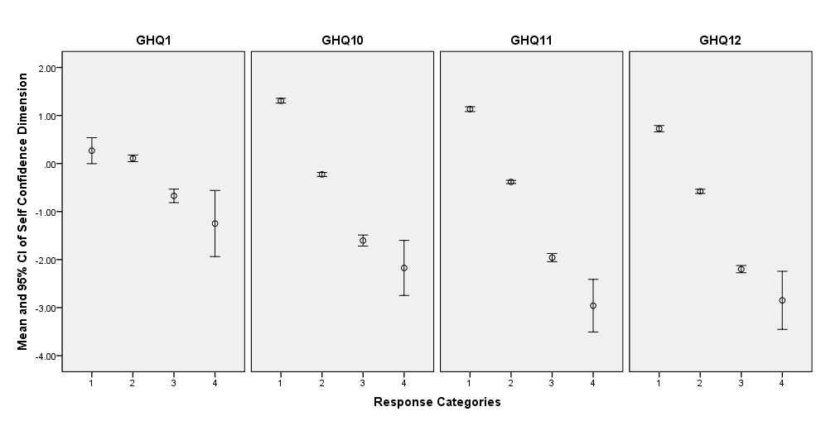

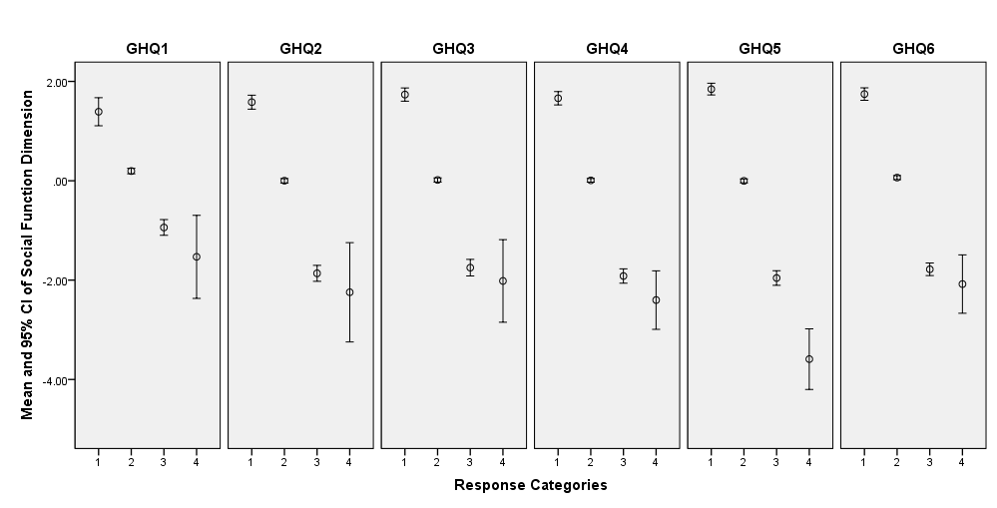

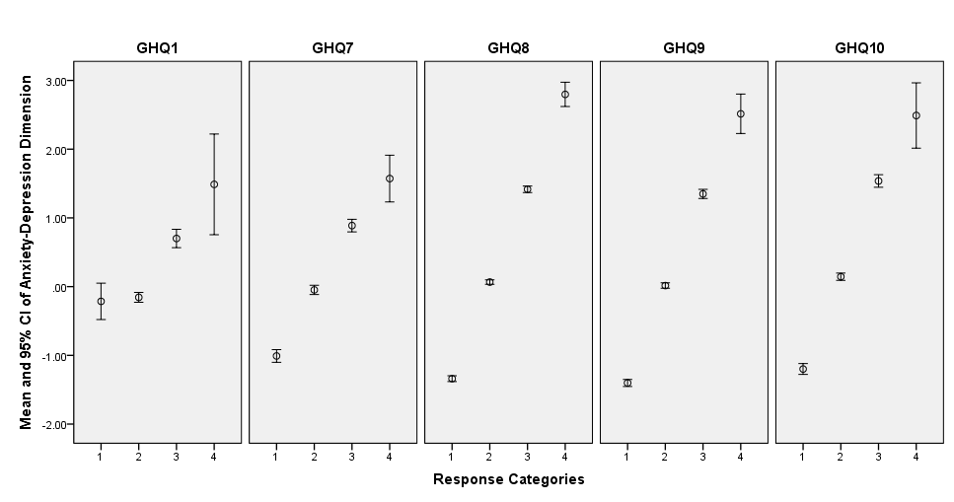

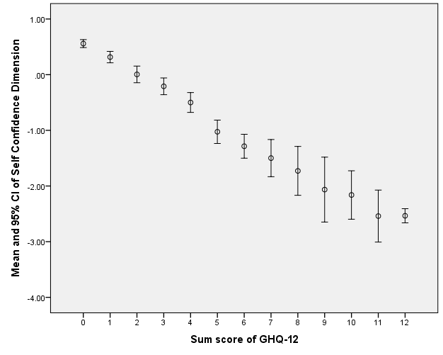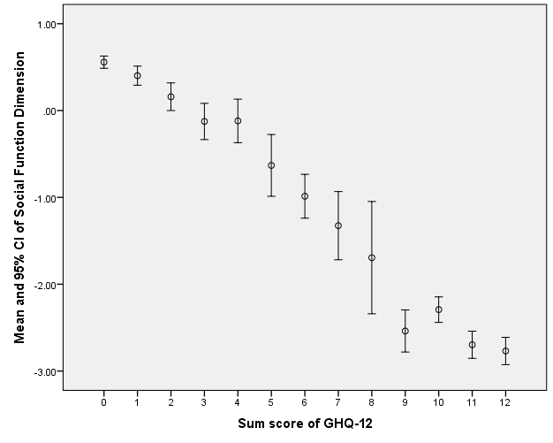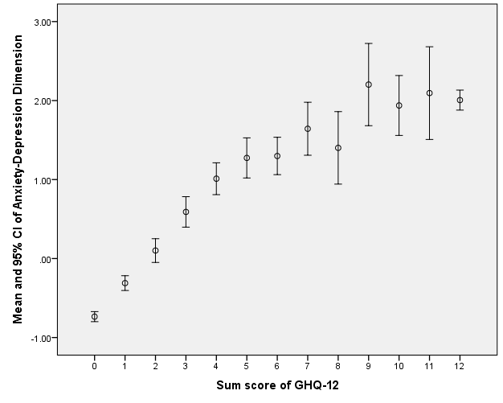

Items |  | Latent dimensions of mental health |  |  | Item-scale  correlations**
 |  | Self Confidence | Social Function | Anxiety/Depression | Item-scale  correlations**
GHQ1 | Been able to concentrate on whatever you are doing | -0.28 | -0.49 | 0.31 | -0.23 ^{SC}, -0.45 ^{SF}, 0.27 ^{A/D}
GHQ2 | Felt that you are playing a useful part in things | -0.39 | -0.67 | 0.28 | -0.65 ^{SF}
GHQ3 | Enjoyed normal day-to-day activities | -0.43 | -0.67 | 0.33 | -0.67 ^{SF}
GHQ4 | Been able to face up to your problems | -0.39 | -0.71 | 0.27 | -0.68 ^{SF}
GHQ5 | Felt capable of making decisions about things | -0.43 | -0.70 | 0.30 | -0.72 ^{SF}
GHQ6 | Felt reasonably happy, all things considered | -0.46 | -0.73 | 0.37 | -0.67 ^{SF}
GHQ7 | Lost much sleep over worry | -0.55 | -0.33 | 0.69 | 0.56 ^{A/D}
GHQ8 | Been feeling unhappy and depressed | -0.74 | -0.47 | 0.92 | 0.79 ^{A/D}
GHQ9 | Felt constantly under strain | -0.75 | -0.46 | 0.88 | 0.76 ^{A/D}
GHQ10 | Felt you could not overcome your difficulties | -0.81 | -0.56 | 0.77 | -0.67 ^{SC}, 0.68 ^{A/D}
GHQ11 | Been losing confidence in yourself | -0.87 | -0.59 | 0.69 | -0.73 ^{SC}
GHQ12 | Thinking of yourself as a worthless person | -0.78 | -0.53 | 0.57 | -0.63 ^{SC}
Physical health domain of QOL |  | 0.35 | 0.27 | -0.32 | ----
Psychological domain of QOL |  | 0.39 | 0.33 | -0.35 | ----
Social relationships domain of QOL |  | 0.32 | 0.27 | -0.28 | ----
Environment domain of QOL |  | 0.30 | 0.24 | -0.25 | ----
Overall score of QOL |  | 0.39 | 0.32 | -0.34 | ----
Supplementary Table 1: Correlation coefficients between GHQ-12’s latent dimensions and domains of quality of life and GHQ-12’s items

SC: Self Confidence dimension; SF: Social Function dimension; A/D: Anxiety/Depression dimension
All P-values were <0.001.
Correlation coefficients of latent dimensions and individual GHQ-12’s items and quality of life domains were obtained from Spearman's rho test.
** Pearson’s correlation coefficients between each item and its own extracted latent dimension (superscript name) corrected for overlap (with item removed).

