Supplementary File

Assessment of Health-Related Quality of Life and Health Status in Patients with Treatment-Resistant Depression Treated with Esketamine Nasal Spray plus an Oral Antidepressant

Carol Jamieson¹*, Vanina Popova², Ella Daly³, Kimberly Cooper⁴, Wayne C. Drevets⁵, Heather M. Rozjabek⁶, Jaskaran Singh^{4,7}

¹Janssen Research & Development, LLC, Milpitas, CA, USA
²Janssen Research & Development, Beerse, BE, Belgium
³Janssen Scientific Affairs, LLC, Titusville, NJ, USA
⁴Janssen Research & Development, LLC, Spring House, PA, USA
⁵Janssen Research & Development, LLC, San Diego, CA, USA
⁶Janssen Research & Development, LLC Raritan, NJ, USA
⁷ Present Address: Neurocrine Biosciences, San Diego, CA, USA

*Corresponding Author:
Carol Jamieson, BSc, FIBMS
Janssen Research & Development, LLC
Milpitas, CA 95035
Tel: (650) 804 0224
Email: cjamies2@its.jnj.com

Supplementary Table 1: Baseline characteristics

 | ESK+AD  (n=114) | AD+PBO  (n=109) | Total  (N=223)
Age, years (mean [SD]) | 44.9 (12.58) | 46.4 (11.14) | 45.7 (11.89)
Age groups, n (%)
18-44 years | 54 (47.4) | 40 (36.7) | 94 (42.2)
45-64 years | 60 (52.6) | 69 (63.3) | 129 (57.8)
Sex, n (%)
Women | 75 (65.8) | 63 (57.8) | 138 (61.9)
Race, n (%)
White | 106 (93.0) | 102 (93.6) | 208 (93.3)
Black/African American | 6 (5.3) | 5 (4.6) | 11 (4.9)
Asian | 1 (0.9) | 1 (0.9) | 2 (0.9)
Multiple | 1 (0.9) | 1 (0.9) | 2 (0.9)
Weight, kg (mean [SD]) | 79.30 (20.140) | 82.67 (19.468) | 80.95 (19.842)
Height, cm (mean [SD]) | 169.23 (10.179) | 169.81 (9.953) | 169.51 (10.051)
BMI, kg/m² (mean [SD]) | 27.5 (5.84) | 28.6 (6.24) | 28.1 (6.05)
BMI category, kg/m² (n [%])
Underweight<18.5 | 1 (0.9) | 2 (1.8) | 3 (1.3)
Normal 18.5-<25 | 41 (36.0) | 28 (25.7) | 69 (30.9)
Overweight 25-<30 | 41 (36.0) | 36 (33.0) | 77 (34.5)
Obese 30-<40 | 28 (24.6) | 39 (35.8) | 67 (30.0)
Morbidly obese ≥40 | 3 (2.6) | 4 (3.7) | 7 (3.1)
Employment status*, n (%)
Employed | 68 (59.6) | 63 (57.8) | 131 (58.7)
Unemployed | 34 (29.8) | 35 (32.1) | 69 (30.9)
Other | 12 (10.5) | 11 (10.1) | 23 (10.3)
Hypertension**, n (%) | 18 (15.8) | 27 (24.8) | 45 (20.2)
Country, n (%)
Czech Republic | 30 (26.3) | 28 (25.7) | 58 (26.0)
Germany | 10 (8.8) | 10 (9.2) | 20 (9.0)
Poland | 20 (17.5) | 18 (16.5) | 38 (17.0)
Spain | 9 (7.9) | 9 (8.3) | 18 (8.1)
United States | 45 (39.5) | 44 (40.4) | 89 (39.9)
Region, n (%)
Europe | 69 (60.5) | 65 (59.6) | 134 (60.1)
North America | 45 (39.5) | 44 (40.4) | 89 (39.9)
Class of oral antidepressant, n (%)
SNRI | 77 (67.5) | 75 (68.8) | 152 (68.2)
SSRI | 37 (32.5) | 34 (31.2) | 71 (31.8)
Oral Antidepressants, n (%)
Duloxetine | 60 (52.6) | 61 (56.0) | 121 (54.3)
Escitalopram | 21 (18.4) | 17 (15.6) | 38 (17.0)
Sertraline | 16 (14.0) | 16 (14.7) | 32 (14.3)
Venlafaxine extended release (XR) | 17 (14.9) | 15 (13.8) | 32 (14.3)
Psychiatric History
Age at MDD diagnosis (years)
Mean (SD) | 32.1 (12.53) | 35.3 (13.04) | 33.7 (12.86)
No. of previous antidepressant medications***, n (%)
1 | 9 (7.9) | 18 (16.5) | 27 (12.1)
2 | 69 (60.5) | 54 (49.5) | 123 (55.2)
3 | 24 (21.1) | 22 (20.2) | 46 (20.6)
4 | 7 (6.1) | 13 (11.9) | 20 (9.0)
5 | 3 (2.6) | 1 (0.9) | 4 (1.8)
6 | 1 (0.9) | 1 (0.9) | 2 (0.9)
9 | 1 (0.9) | 0 | 1 (0.4)
No. of major depressive episodes including current episode, n (%)
1 | 15 (13.2) | 14 (12.8) | 29 (13.0)
2-5 | 81 (71.1) | 78 (71.6) | 159 (71.3)
6-10 | 16 (14.0) | 15 (13.8) | 31 (13.9)
>10 | 2 (1.8) | 2 (1.8) | 4 (1.8%)
Family history, n (%)
Depression | 51 (44.7) | 56 (51.4) | 107 (48.0)
Anxiety Disorder | 10 (8.8) | 16 (14.7) | 26 (11.7)
Bipolar Disorder | 8 (7.0) | 11 (10.1) | 19 (8.5)
Schizophrenia, | 6 (5.3) | 4 (3.7) | 10 (4.5)
Alcohol Abuse | 18 (15.8) | 20 (18.3) | 38 (17.0)
Substance Abuse | 8 (7.0) | 4 (3.7) | 12 (5.4)
AD, antidepressant; BMI, body mass index; ESK, esketamine; n, number of patients; PBO, placebo; SD, standard deviation; SNRI, serotonin and norepinephrine reuptake inhibitors; SSRI, selective serotonin reuptake inhibitors.
*Any type of employment includes: any category containing “Employed”, sheltered work, housewife or dependent husband, and student; any type of unemployment includes: any category containing “Unemployed”; Other include retired and no information available.
**Hypertension status is classified as Yes if hypertension is recorded in medical history.
*** Number of antidepressant medications with non-response (defined as <=25% improvement) taken for at least 6 weeks during the current episode as obtained from the MGH-ATRQ, Massachusetts General Hospital – Antidepressant Treatment Response Questionnaire.
Supplementary Figure 1: Study design
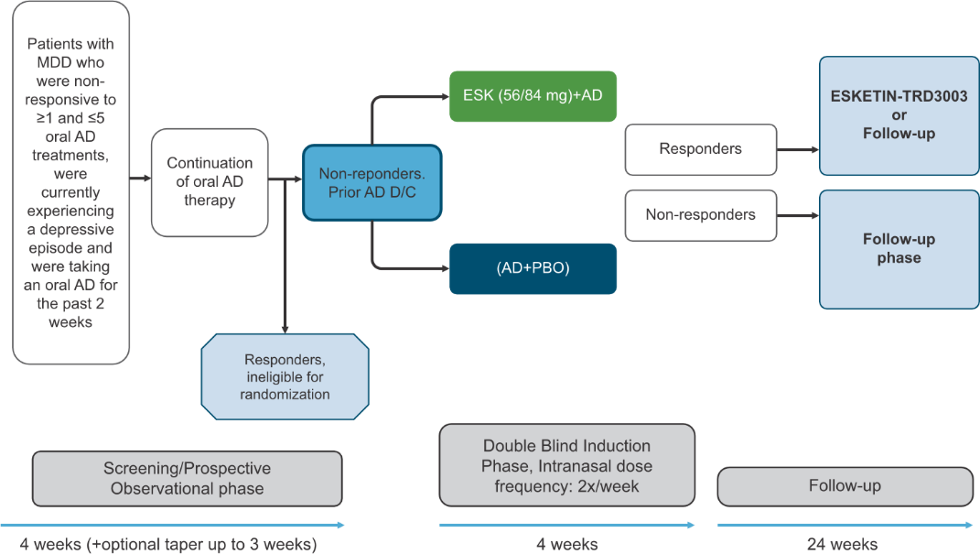
AD, antidepressants; D/C, discontinuation; ESK, esketamine; MDD, major depressive disorder; PBO, placebo.

