Supplementary Information
Supplementary Table S1: Subscale-level characteristics for the CSQ-SCD among adults with SCD
Supplementary Table S2: Subscale correlations for the CSQ-SCD
Supplementary Figure S1: Scree plot and parallel analysis based on sample eigenvalues
Supplementary Table S3: Standardized factor loadings and fit statistics from item-level CFAs of the 13 subscales for the CSQ-SCD (Tables S3a – S3m)
Supplementary Table S4: Item means, standard deviations, and correlations (Pearson and polychoric) for the CSQ-SCD (Tables S4a – S4c)
MPlus and SPSS code
Supplementary Table S1: Subscale-level characteristics for the CSQ-SCD among adults with SCD
 | N | Missing | Mean (SD) | Skewness |  | Kurtosis |  | Cronbach’s Alpha
 |  |  |  | Statistic | Std. error | Statistic | Std. error
Diverting attention (DA) | 196 | 0 | 3.362 (1.370) | -0.196 | 0.174 | -0.587 | 0.346 | 0.813
Reinterpreting pain sensations (RPS) | 193 | 3 | 1.442 (1.269) | 0.889 | 0.175 | 0.399 | 0.348 | 0.842
Calming self-statements (CSS) | 193 | 3 | 4.134 (1.063) | -0.198 | 0.175 | -0.588 | 0.348 | 0.760
Ignoring pain sensations (IPS) | 192 | 4 | 2.421 (1.161) | 0.128 | 0.175 | -0.361 | 0.349 | 0.741
Increasing behavioral activity (IBA) | 195 | 1 | 3.081 (1.014) | 0.164 | 0.174 | -0.094 | 0.346 | 0.557
Praying and hoping (PH) | 194 | 2 | 4.134 (1.097) | -0.693 | 0.175 | 0.842 | 0.347 | 0.627
Catastrophizing (CA) | 194 | 2 | 2.809 (1.380) | 0.226 | 0.175 | -0.634 | 0.347 | 0.849
Fear self-statements (FS) | 193 | 3 | 3.237 (1.311) | 0.111 | 0.175 | -0.540 | 0.348 | 0.824
Anger self-statements (AS) | 196 | 0 | 3.024 (1.224) | -0.118 | 0.174 | -0.663 | 0.346 | 0.766
Isolation (IS) | 196 | 0 | 3.491 (1.262) | -0.254 | 0.174 | -0.290 | 0.346 | 0.829
Taking fluids (TF) | 196 | 0 | 4.732 (1.072) | -1.094 | 0.174 | 1.396 | 0.346 | 0.792
Resting (RS) | 194 | 2 | 4.437 (0.980) | -0.830 | 0.175 | 1.324 | 0.347 | 0.712
Heat/cold/massage (HCM) | 196 | 0 | 4.057 (1.002) | -0.581 | 0.174 | 0.128 | 0.346 | 0.634

Supplementary Table S2: Subscale correlations for the CSQ-SCD

 | DA | RPS | CSS | IPS | PH | CA | FS | AS | IBA | IS | TF | RS | HCM
DA | 1 | .449** | .432** | .335** | .440** | .356** | .344** | .250** | .517** | .279** | .216** | .251** | .382**
RPS | .449** | 1 | .319** | .587** | .361** | .403** | .309** | .325** | .453** | .260** | .094 | .074 | .302**
CSS | .432** | .319** | 1 | .493** | .291** | .110 | .172* | .183* | .586** | .150* | .191** | .187** | .337**
IPS | .335** | .587** | .493** | 1 | .193** | .206** | .120 | .243** | .485** | .153* | .023 | .024 | .216**
PH | .440** | .361** | .291** | .193** | 1 | .287** | .252** | .190** | .244** | .052 | .102 | .230** | .367**
CA | .356** | .403** | .110 | .206** | .287** | 1 | .758** | .689** | .172* | .395** | -.009 | -.010 | .292**
FS | .344** | .309** | .172* | .120 | .252** | .758** | 1 | .643** | .115 | .338** | .087 | .057 | .292**
AS | .250** | .325** | .183* | .243** | .190** | .689** | .643** | 1 | .118 | .504** | .047 | .017 | .236**
IBA | .517** | .453** | .586** | .485** | .244** | .172* | .115 | .118 | 1 | .070 | .151* | .165* | .421**
IS | .279** | .260** | .150* | .153* | .052 | .395** | .338** | .504** | .070 | 1 | .126 | .231** | .047
TF | .216** | .094 | .191** | .023 | .102 | -.009 | .087 | .047 | .151* | .126 | 1 | .353** | .266**
RS | .251** | .074 | .187** | .024 | .230** | -.010 | .057 | .017 | .165* | .231** | .353** | 1 | .196**
HCM | .382** | .302** | .337** | .216** | .367** | .292** | .292** | .236** | .421** | .047 | .266** | .196** | 1

Notes: See Supplementary Table S1 for subscale abbreviations; these are Pearson correlations; pairwise deletion was used for missing subscale scores; **Correlation is significant at the 0.01 level (2-tailed); *Correlation is significant at the 0.05 level (2-tailed).

Supplementary Figure S1: Scree plot and parallel analysis based on sample eigenvalues

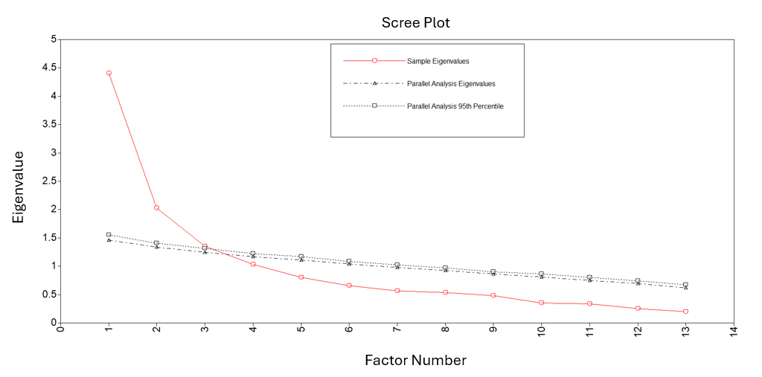

Supplementary Table S3: Standardized factor loadings and fit statistics from item-level CFAs of the 13 subscales for the CSQ-SCD (Tables S3a – S3m)
Note: For each of the 13 CSQ-SCD subscales, a separate confirmatory factor analysis (CFA) was conducted on the six items comprising each subscale. Because the items are ordered categorical variables with limited response options, the CFAs were conducted using robust weighted least squares estimation (i.e., the WLSMV estimator in Mplus). Below are the results of the 13 CFAs.

*The item numbers refer to the CSQ-SCD questionnaire developed by Gil et al. (1989)

Table S3a: CFA of Subscale – Diverting Attention
Item Number* | Standardized Factor Loadings (SE)
Item 4 | 0.817 (0.033)
Item 10 | 0.744 (0.047)
Item 28 | 0.533 (0.060)
Item 34 | 0.561 (0.059)
Item 36 | 0.755 (0.036)
Item 61 | 0.775 (0.039)
CFI: 0.975; TLI: 0.958; RMSEA: 0.110; SRMR: 0.028

Table S3b: CFA of Subscale – Reinterpreting Pain Sensations
Item Number* | Standardized Factor Loadings (SE)
Item 2 | 0.726 (0.049)
Item 31 | 0.717 (0.041)
Item 47 | 0.739 (0.038)
Item 56 | 0.832 (0.037)
Item 63 | 0.813 (0.037)
Item 78 | 0.641 (0.054)
CFI: 0.998; TLI: 0.996; RMSEA: 0.037; SRMR: 0.018

Table S3c: CFA of Subscale – Calming Self-Statements
Item Number* | Standardized Factor Loadings (SE)
Item 37 | 0.682 (0.042)
Item 39 | 0.581 (0.055)
Item 45 | 0.707 (0.039)
Item 72 | 0.607 (0.049)
Item 73 | 0.772 (0.043)
Item 75 | 0.553 (0.060)
CFI: 0.972; TLI: 0.954; RMSEA: 0.107; SRMR: 0.030

Table S3d: CFA of Subscale – Ignoring Pain Sensations
Item Number* | Standardized Factor Loadings (SE)
Item 14 | 0.321 (0.066)
Item 41 | 0.749 (0.042)
Item 44 | 0.603 (0.049)
Item 49 | 0.766 (0.044)
Item 58 | 0.673 (0.053)
Item 68 | 0.625 (0.057)
CFI: 0.918; TLI: 0.863; RMSEA: 0.163; SRMR: 0.049

Table S3e: CFA of Subscale – Praying and Hoping
Item Number* | Standardized Factor Loadings (SE)
Item 5 | 0.309 (0.075)
Item 27 | 0.809 (0.039)
Item 42 | 0.331 (0.073)
Item 59 | 0.904 (0.038)
Item 67 | 0.268 (0.073)
Item 77 | 0.866 (0.042)
CFI: 0.935; TLI: 0.891; RMSEA: 0.157; SRMR: 0.057

Table S3f: CFA of Subscale – Catastrophizing
Item Number* | Standardized Factor Loadings (SE)
Item 15 | 0.651 (0.052)
Item 21 | 0.768 (0.035)
Item 46 | 0.752 (0.038)
Item 57 | 0.807 (0.039)
Item 60 | 0.832 (0.032)
Item 76 | 0.685 (0.055)
CFI: 0.967; TLI: 0.944; RMSEA: 0.145; SRMR: 0.035

Table S3g: CFA of Subscale – Fear Self-Statements
Item Number* | Standardized Factor Loadings (SE)
Item 20 | 0.652 (0.049)
Item 29 | 0.827 (0.033)
Item 51 | 0.779 (0.036)
Item 54 | 0.804 (0.039)
Item 65 | 0.523 (0.059)
Item 71 | 0.605 (0.052)
CFI: 0.991; TLI: 0.986; RMSEA: 0.064; SRMR: 0.025

Table S3h: CFA of Subscale – Anger Self-Statements
Item Number* | Standardized Factor Loadings (SE)
Item 8 | 0.747 (0.038)
Item 17 | 0.747 (0.041)
Item 23 | 0.751 (0.040)
Item 38 | 0.418 (0.078)
Item 43 | 0.763 (0.041)
Item 48 | 0.672 (0.047)
CFI: 0.896; TLI: 0.827; RMSEA: 0.223; SRMR: 0.071

Table S3i: CFA of Subscale – Increasing Behavioral Activities
Item Number* | Standardized Factor Loadings (SE)
Item 6 | 0.339 (0.082)
Item 18 | 0.372 (0.081)
Item 40 | 0.240 (0.078)
Item 53 | 0.335 (0.072)
Item 62 | 0.676 (0.069)
Item 69 | 0.837 (0.079)
CFI: 0.728; TLI: 0.547; RMSEA: 0.184; SRMR: 0.061

Table S3j: CFA of Subscale – Isolation
Item Number* | Standardized Factor Loadings (SE)
Item 7 | 0.574 (0.051)
Item 9 | 0.655 (0.046)
Item 24 | 0.695 (0.042)
Item 26 | 0.890 (0.026)
Item 30 | 0.787 (0.033)
Item 35 | 0.656 (0.043)
CFI: 0.970; TLI: 0.950; RMSEA: 0.131; SRMR: 0.033

Table S3k: CFA of Subscale – Taking Fluids
Item Number* | Standardized Factor Loadings (SE)
Item 11 | 0.407 (0.058)
Item 13 | 0.851 (0.033)
Item 16 | 0.710 (0.041)
Item 19 | 0.901 (0.029)
Item 50 | 0.734 (0.044)
Item 64 | 0.824 (0.036)
CFI: 0.986; TLI: 0.977; RMSEA: 0.099; SRMR: 0.030

Table S3l: CFA of Subscale – Resting
Item Number* | Standardized Factor Loadings (SE)
Item 1 | 0.493 (0.054)
Item 25 | 0.676 (0.052)
Item 52 | 0.456 (0.061)
Item 55 | 0.683 (0.049)
Item 66 | 0.775 (0.045)
Item 70 | 0.775 (0.045)
CFI: 0.887; TLI: 0.811; RMSEA: 0.200; SRMR: 0.062

Table S3m: CFA of Subscale – Heat/Cold/Massage
Item Number* | Standardized Factor Loadings (SE)
Item 3 | 0.838 (0.039)
Item 12 | 0.850 (0.043)
Item 22 | 0.828 (0.037)
Item 32 | 0.789 (0.041)
Item 33 | 0.168 (0.076)
Item 74 | 0.366 (0.064)
CFI: 0.878; TLI: 0.797; RMSEA: 0.296; SRMR: 0.106
Supplementary Table S4: Item means, standard deviations, and correlations (Pearson and polychoric) for the CSQ-SCD (Tables S4a – S4c)
Note: The item numbers (i.e., C1-C78) refer to items in CSQ-SCD questionnaire developed by Gil et al. (1989)

Table S4a: Item means and standard deviations
Items | Mean | Std. Deviation | N
C1 | 3.72 | 1.662 | 194
C2 | 1.37 | 1.746 | 193
C3 | 4.00 | 1.817 | 196
C4 | 3.52 | 1.891 | 194
C5 | 2.84 | 2.257 | 193
C6 | 2.55 | 1.959 | 195
C7 | 3.88 | 1.594 | 195
C8 | 2.95 | 1.880 | 196
C9 | 2.82 | 1.700 | 195
C10 | 4.54 | 1.557 | 195
C11 | 3.77 | 2.094 | 195
C12 | 5.20 | 1.344 | 194
C13 | 5.22 | 1.105 | 196
C14 | 2.56 | 1.904 | 194
C15 | 4.04 | 1.611 | 195
C16 | 4.44 | 1.637 | 196
C17 | 3.66 | 1.973 | 194
C18 | 4.77 | 1.486 | 195
C19 | 5.17 | 1.292 | 196
C20 | 2.09 | 1.731 | 195
C21 | 3.03 | 1.786 | 191
C22 | 4.23 | 1.840 | 192
C23 | 3.40 | 1.822 | 192
C24 | 3.60 | 1.757 | 192
C25 | 4.17 | 1.525 | 193
C26 | 3.89 | 1.679 | 192
C27 | 4.99 | 1.623 | 193
C28 | 2.57 | 2.068 | 191
C29 | 3.47 | 1.777 | 193
C30 | 2.86 | 1.806 | 192
C31 | 1.74 | 1.759 | 192
C32 | 4.84 | 1.471 | 192
C33 | 1.07 | 1.777 | 193
C34 | 2.91 | 1.911 | 193
C35 | 3.90 | 1.708 | 193
C36 | 2.97 | 1.968 | 192
C37 | 4.49 | 1.410 | 191
C38 | .35 | 1.104 | 191
C39 | 4.83 | 1.423 | 191
C40 | 2.15 | 1.690 | 190
C41 | 2.51 | 1.701 | 188
C42 | 3.44 | 1.878 | 190
C43 | 3.83 | 1.896 | 191
C44 | 2.82 | 1.752 | 190
C45 | 4.45 | 1.457 | 191
C46 | 3.23 | 1.927 | 191
C47 | 1.39 | 1.641 | 191
C48 | 4.03 | 1.746 | 188
C49 | 1.86 | 1.584 | 191
C50 | 4.80 | 1.516 | 191
C51 | 3.70 | 1.754 | 184
C52 | 3.71 | 1.463 | 185
C53 | 4.59 | 1.345 | 185
C54 | 2.85 | 2.059 | 184
C55 | 5.10 | 1.143 | 185
C56 | 1.63 | 1.777 | 185
C57 | 1.72 | 1.670 | 185
C58 | 1.92 | 1.781 | 185
C59 | 5.13 | 1.519 | 184
C60 | 3.20 | 1.796 | 185
C61 | 3.51 | 1.823 | 182
C62 | 2.44 | 1.893 | 182
C63 | 1.41 | 1.740 | 182
C64 | 5.04 | 1.337 | 181
C65 | 4.10 | 1.502 | 181
C66 | 5.03 | 1.201 | 181
C67 | 3.23 | 1.775 | 182
C68 | 2.76 | 1.657 | 182
C69 | 1.63 | 1.761 | 181
C70 | 5.25 | 1.072 | 180
C71 | 3.18 | 1.781 | 181
C72 | 4.21 | 1.535 | 181
C73 | 4.00 | 1.538 | 181
C74 | 5.04 | 1.324 | 181
C75 | 2.71 | 1.803 | 181
C76 | 1.24 | 1.706 | 180
C77 | 5.21 | 1.374 | 180
C78 | .95 | 1.415 | 181
Table S4b: Pearson correlations among the items (pairwise deletion was used for missing item scores)
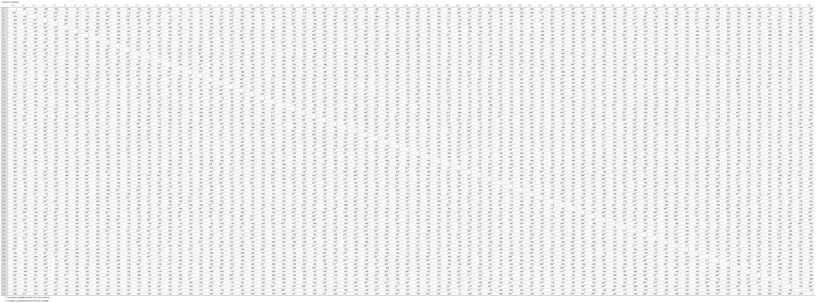

Table S4c: Polychoric correlations among the items (pairwise deletion was used for missing item scores)
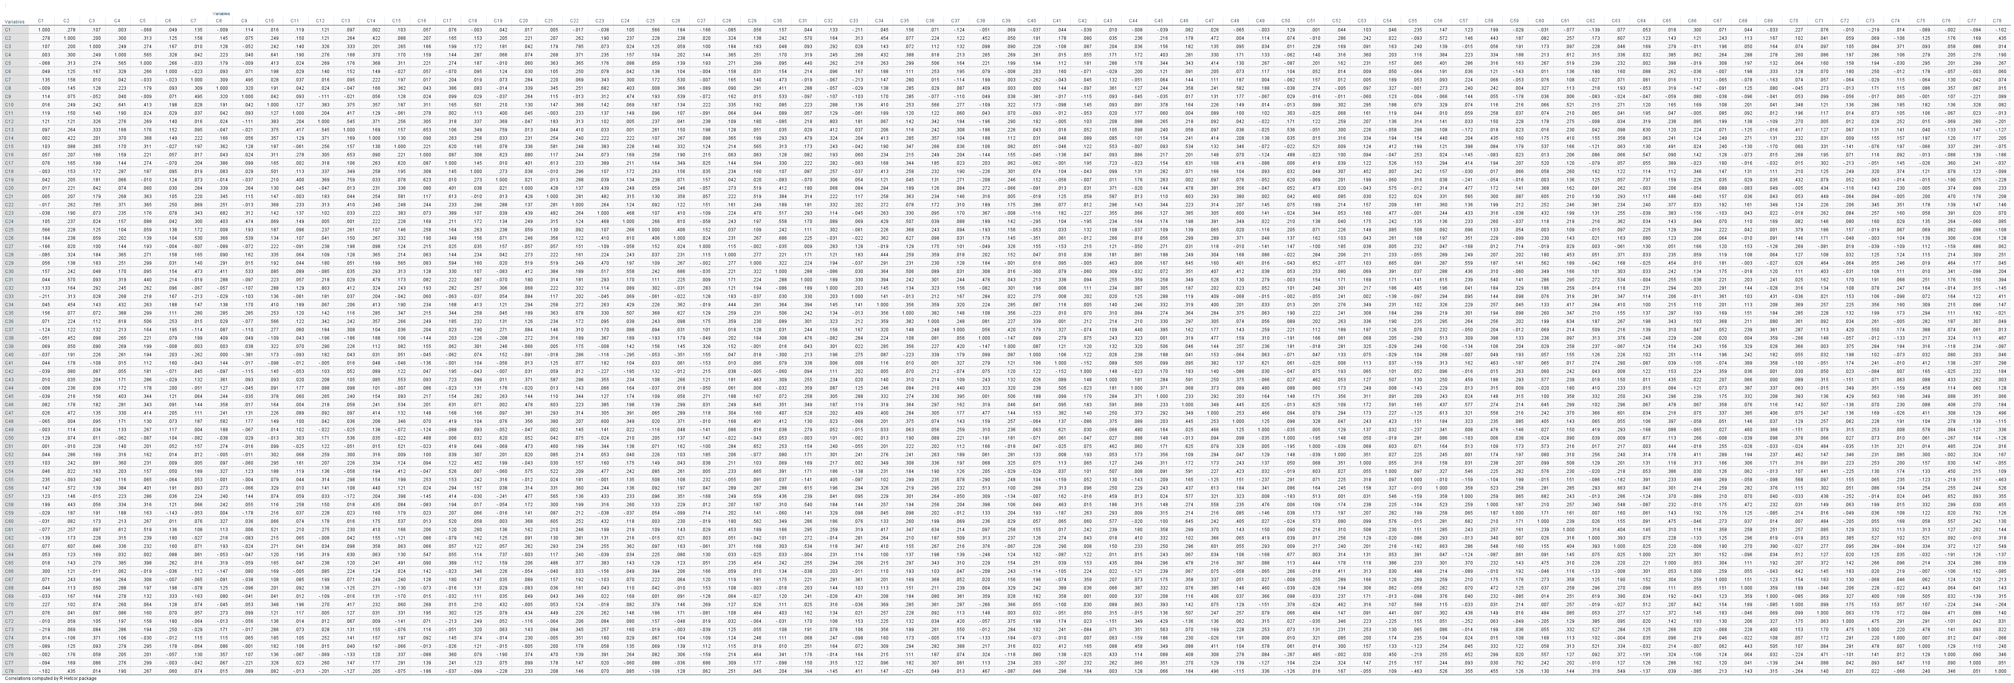

MPlus and SPSS Code

Mplus code for Table 2 in the manuscript: Summary of model fit indices for the CSQ-SCD confirmatory factor models
AND
Mplus code for Table 3 in the manuscript: Standardized factor loadings for the final three-factor model of coping for the CSQ-SCD among adults with SCD

TITLE: CFA of 3-FACTOR MODEL OF CSQ-SCD
DATA: FILE IS XYZ;
VARIABLE: NAMES ARE !Names of variables have been fully
spelled out rather than the
abbreviated names used in Mplus
C1-C78
average_diverting_attention
average_reinterpreting_pain_sensations
average_calming_self_statements
average_ignoring_pain_sensations
average_praying_hoping
average_catastrophizing
average_fear_self_statements
average_anger_self_statements
average_increasing_behavioral_activity
average_isolation
average_taking_fluids
average_resting
average_heat_cold_massage;

USEVARIABLES ARE
average_diverting_attention
average_reinterpreting_pain_sensations
average_calming_self_statements
average_ignoring_pain_sensations
average_praying_hoping
average_catastrophizing
average_fear_self_statements
average_anger_self_statements
average_increasing_behavioral_activity
average_isolation
average_taking_fluids
average_resting
average_heat_cold_massage;
MISSING ARE ALL (-99);

ANALYSIS: ESTIMATOR=ML;

MODEL:
ACTIVE_COPING BY average_diverting_attention
average_reinterpreting_pain_sensations
average_calming_self_statements
average_ignoring_pain_sensations
average_increasing_behavioral_activity;

AFFECTIVE_COPING BY average_praying_hoping
average_catastrophizing
average_fear_self_statements
average_anger_self_statements
average_isolation;

PASSIVE_COPING BY average_resting
average_taking_fluids
average_heat_cold_massage;

OUTPUT: SAMPSTAT STAND TECH4;

TITLE: CFA of 2-FACTOR MODEL OF CSQ-SCD
DATA: FILE IS XYZ;
VARIABLE: NAMES ARE !Names of variables have been fully
spelled out rather than the
abbreviated names used in Mplus
C1-C78
average_diverting_attention
average_reinterpreting_pain_sensations
average_calming_self_statements
average_ignoring_pain_sensations
average_praying_hoping
average_catastrophizing
average_fear_self_statements
average_anger_self_statements
average_increasing_behavioral_activity
average_isolation
average_taking_fluids
average_resting
average_heat_cold_massage;

USEVARIABLES ARE
average_diverting_attention
average_reinterpreting_pain_sensations
average_calming_self_statements
average_ignoring_pain_sensations
average_praying_hoping
average_catastrophizing
average_fear_self_statements
average_anger_self_statements
average_increasing_behavioral_activity
average_isolation
average_taking_fluids
average_resting
average_heat_cold_massage;
MISSING ARE ALL (-99);

ANALYSIS: ESTIMATOR=ML;

MODEL:
COPING_ATTEMPTS BY average_diverting_attention
average_reinterpreting_pain_sensations
average_calming_self_statements
average_ignoring_pain_sensations
average_praying_hoping
average_increasing_behavioral_activity;

NEGATIVE_THINKING BY average_catastrophizing
average_fear_self_statements
average_anger_self_statements
average_isolation
average_taking_fluids
average_resting
average_heat_cold_massage;

OUTPUT: SAMPSTAT STAND TECH4;

Mplus code for Table 4 in the manuscript: Discriminant validity (i.e., tests of perfect correlations) assessed by Wald’s Chi-square test

TITLE: DISCRIMINANT VALIDITY OF 3-FACTOR CSQ-SCD
DATA: FILE IS XYZ;
VARIABLE: NAMES ARE !Names of variables have been fully
spelled out rather than the
abbreviated names used in Mplus
C1-C78
average_diverting_attention
average_reinterpreting_pain_sensations
average_calming_self_statements
average_ignoring_pain_sensations
average_praying_hoping
average_catastrophizing
average_fear_self_statements
average_anger_self_statements
average_increasing_behavioral_activity
average_isolation
average_taking_fluids
average_resting
average_heat_cold_massage;

USEVARIABLES ARE
average_diverting_attention
average_reinterpreting_pain_sensations
average_calming_self_statements
average_ignoring_pain_sensations
average_praying_hoping
average_catastrophizing
average_fear_self_statements
average_anger_self_statements
average_increasing_behavioral_activity
average_isolation
average_taking_fluids
average_resting
average_heat_cold_massage;
MISSING ARE ALL (-99);

ANALYSIS: ESTIMATOR=ML;
ITERATIONS=5000;
MODEL:

ACTIVE_COPING BY average_diverting_attention*
average_reinterpreting_pain_sensations
average_calming_self_statements
average_ignoring_pain_sensations
average_increasing_behavioral_activity;

AFFECTIVE_COPING BY average_praying_hoping*
average_catastrophizing
average_fear_self_statements
average_anger_self_statements
average_isolation;

PASSIVE_COPING BY average_resting*
average_taking_fluids
average_heat_cold_massage;

ACTIVE_COPING WITH AFFECTIVE_COPING (a1);
AFFECTIVE_COPING WITH PASSIVE_COPING (a2);
ACTIVE_COPING WITH PASSIVE_COPING (a3);

ACTIVE_COPING@1;
AFFECTIVE_COPING@1;
PASSIVE_COPING@1;

MODEL TEST: a1=1; !test for a2 and a3 as well;
SPSS code for Table 7 in the manuscript: Varimax rotated factor loadings for three-factor exploratory factor analysis model using principal factors extraction
*Names of variables have been fully spelled out rather than the abbreviated names used in SPSS.

FACTOR
/VARIABLES average_diverting_attention
average_reinterpreting_pain_sensations average_calming_self_statements average_ignoring_pain_sensations average_praying_hoping average_catastrophizing average_fear_self_statements average_anger_self_statements average_increasing_behavioral_activity average_isolation average_taking_fluids average_resting average_heat_cold_massage
/MISSING LISTWISE
/ANALYSIS average_diverting_attention average_reinterpreting_pain_sensations average_calming_self_statements average_ignoring_pain_sensations average_praying_hoping average_catastrophizing average_fear_self_statements average_anger_self_statements average_increasing_behavioral_activity average_isolation average_taking_fluids average_resting average_heat_cold_massage
/PRINT INITIAL EXTRACTION ROTATION
/CRITERIA FACTORS(3) ITERATE(25)
/EXTRACTION PAF
/CRITERIA ITERATE(25)
/ROTATION VARIMAX
/METHOD=CORRELATION.

