Supplement 5: Sensitivity Analysis: Generalized partial credit model (GPCM)

Supplementary Table 5.1: Model diagnostics: PCM vs. GPCM
 | AIC | SABIC | TLI | CFI | RMSEA | 95% CI of RMSEA
PCM | 25278.57 | 25328.50 | 0.89 | 0.91 | 0.089 | 0.082; 0.096
GPCM | 25244.12 | 25316.24 | 0.92 | 0.93 | 0.076 | 0.070; 0.835
AIC = Akaike information criterion, SABIC=sample adjusted Bayesian information criterion, TLI=Tucker-Lewis index, CFI=comparative fit index,
RMSEA=root mean square error of approximation, CI = confidence interval.

Supplementary Table 5.2: Item fit statistics of the GPCM model
Item order PCM | Item order GPCM | Difficulty | alpha | Threshold 1 | Threshold 2 | Outfit MNSQ | Outfit z | Infit  MNSQ | Infit z
1 | 4 | -1.784 | 0.808 | -2.405 | -1.162 | 0.917 | -1.356 | 0.955 | -0.919
2 | 1 | -1.743 | 1.129 | -2.737 | -0.749 | 0.940 | -0.939 | 0.923 | -1.670
4 | 2 | -1.560 | 1.172 | -2.708 | -0.412 | 0.887 | -2.140 | 0.910 | -2.162
3 | 3 | -1.207 | 1.068 | -2.357 | -0.057 | 0.914 | -1.908 | 0.925 | -1.858
6 | 6 | -0.745 | 0.787 | -1.88 | 0.389 | 0.927 | -1.902 | 0.945 | -1.456
5 | 5 | -0.521 | 1.107 | -1.804 | 0.762 | 0.872 | -3.161 | 0.886 | -2.804
10 | 10 | -0.464 | 0.993 | -1.553 | 0.625 | 0.883 | -3.017 | 0.898 | -2.678
7 | 7 | -0.106 | 0.901 | -0.647 | 0.435 | 0.883 | -3.102 | 0.903 | -2.809
8 | 8 | 0.168 | 0.967 | -0.692 | 1.029 | 0.899 | -2.664 | 0.915 | -2.329
13 | 13 | 0.246 | 1.079 | -0.934 | 1.425 | 0.912 | -2.255 | 0.918 | -2.080
12 | 12 | 0.453 | 1.595 | -0.402 | 1.309 | 0.797 | -4.762 | 0.819 | -4.639
11 | 11 | 0.524 | 1.325 | -0.497 | 1.544 | 0.873 | -3.156 | 0.868 | -3.374
9 | 9 | 0.783 | 1.055 | -0.148 | 1.713 | 0.877 | -3.004 | 0.898 | -2.612
From lighter to darker: (i) Believes active role is important; (ii) Confidence and knowledge to take action; (iii) Taking action; (iv) Staying the course under stress.

Supplementary Figure 5.1: Person-item-map
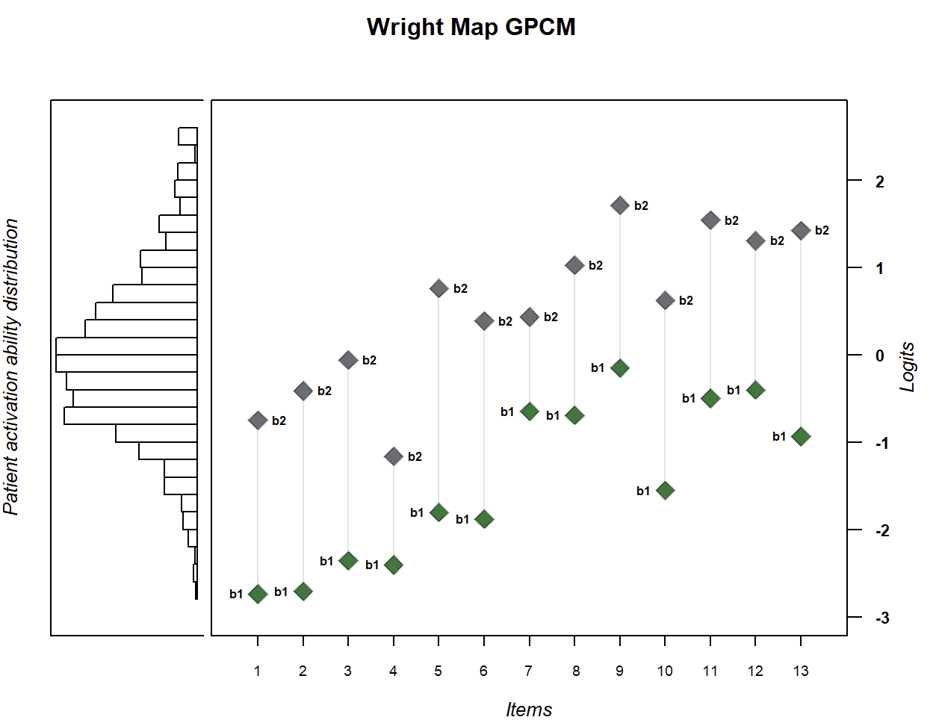

Supplementary Figure 5.2: Test information (green) and standard error (grey)
