Figure 1: PRISMA checklist for scoping reviews part 1. Figure 2: PRISMA checklist for scoping reviews part 2.
Table 1: Search strategy. Table 2: Study characteristics and pre-processing methods used by studies included in the review. Table 3: Model development and evaluation, including study characteristics of papers included in the review

Supplementary Materials
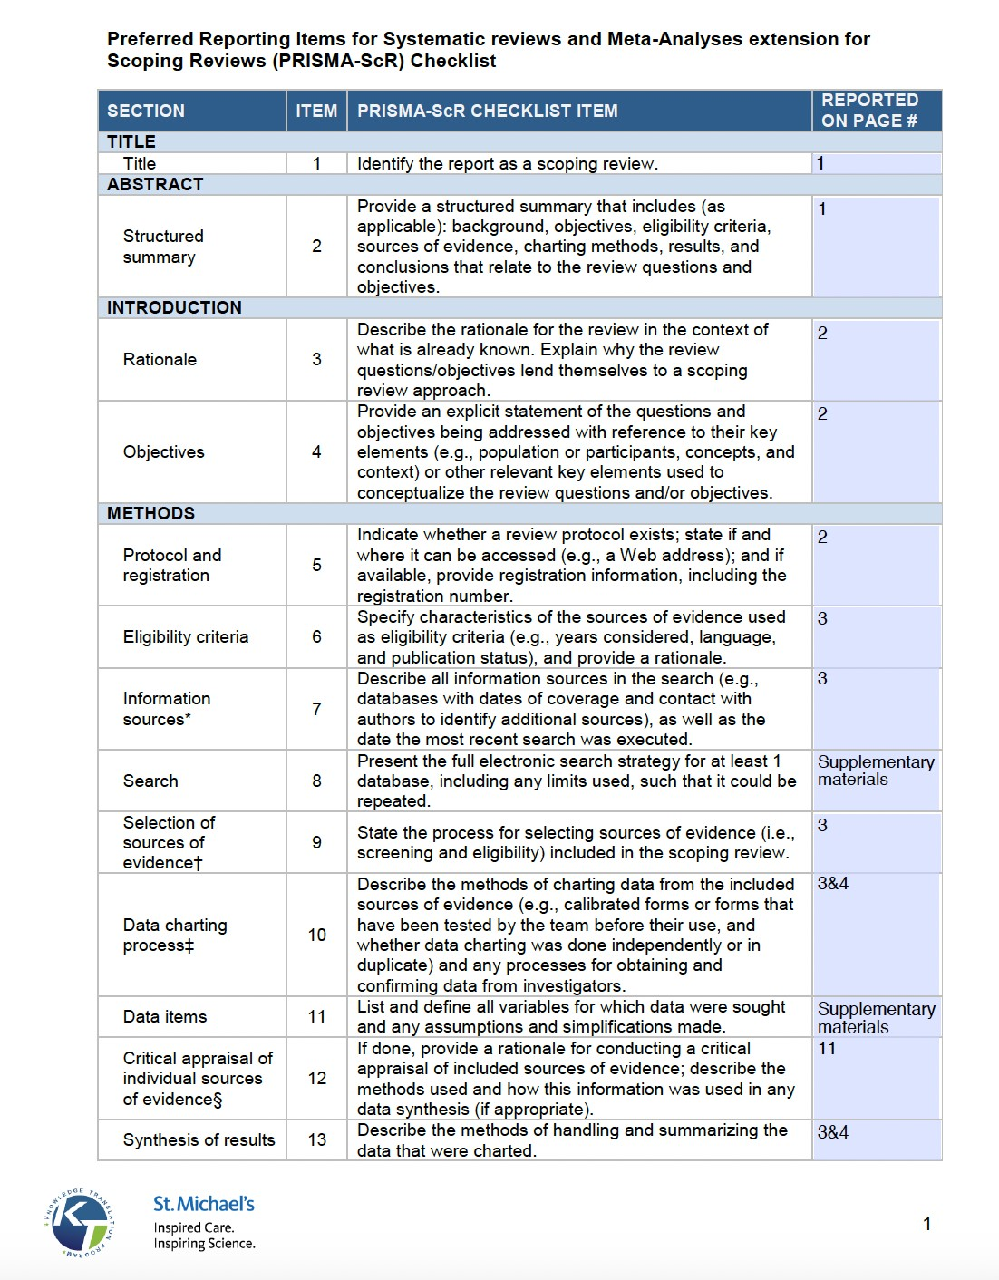
Figure 1: PRISMA checklist for scoping reviews part 1.
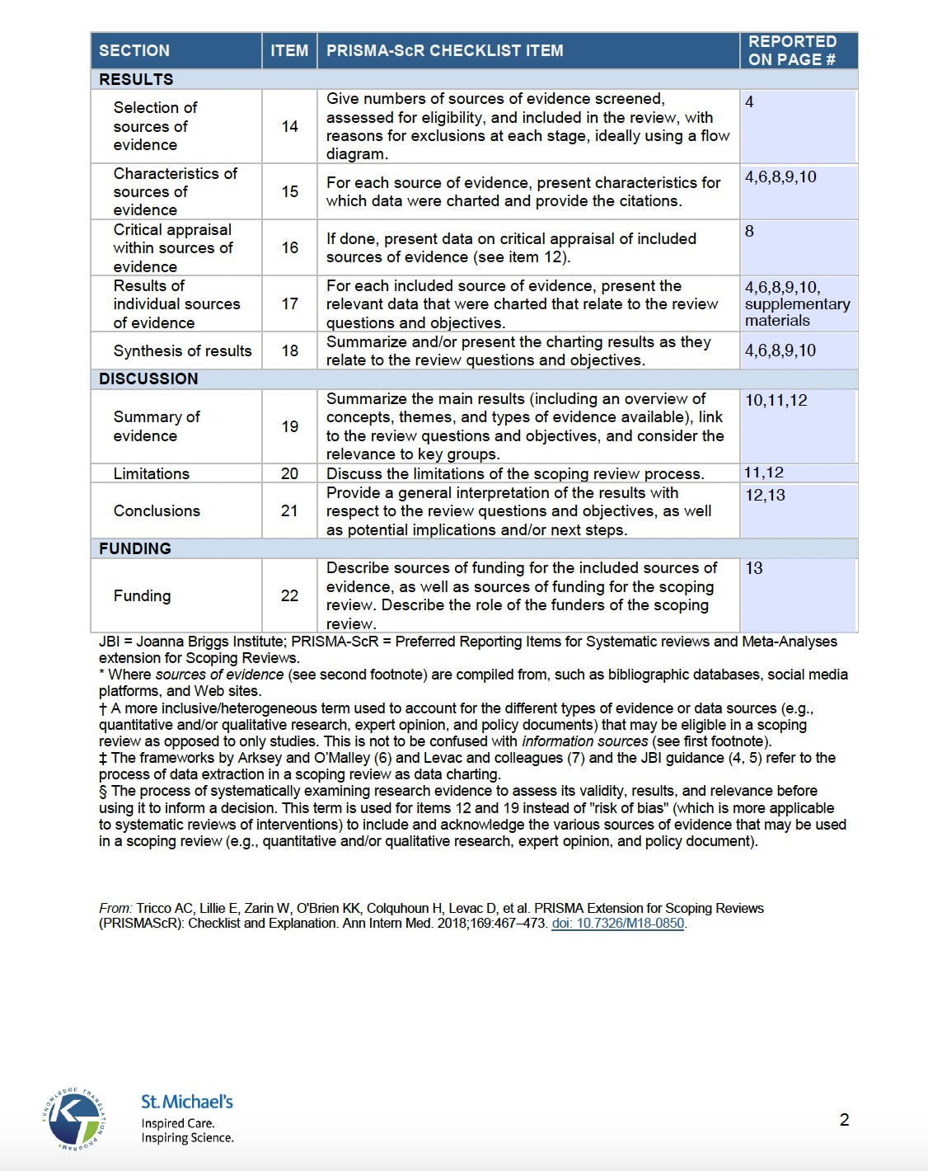
Figure 2: PRISMA checklist for scoping reviews part 2.
Table 1: Search strategy
Database | Search strategy
Web of Science, IEEE Xplore, ACM Digital Library | “artificial intelligence” OR “AI” OR “machine learning” OR “deep learning” OR “neural network” OR “neural networks” OR algorithm* OR “rule-based” OR “rule based” AND “predictive model” OR “predictive models” OR “predictive modelling” OR “predictive modeling” OR predict* OR forecast* OR prognos* OR “predicting outcomes” AND “symptom tracking” OR “symptom-tracking” OR “symptom tracker” OR “symptom trackers” OR “symptom assessment” OR “symptom assessing” OR “symptom-assessing” OR “symptom report” OR “symptom reports” OR “symptom reporting” OR “symptom-reporting” OR “symptom monitoring” OR “symptom-monitoring” OR “patient-reported symptom” OR “patient-reported symptoms” OR “patient reported symptom” OR “patient reported symptoms” OR “self-reported symptom” OR “self-reported symptoms” OR “self reported symptom” OR “self reported symptoms” OR “patient-reported outcome” OR “patientreported outcomes” OR “patient reported outcome” OR “patient reported outcomes” OR “patient-reported outcome measure” OR “patient-reported outcome measures” OR “patient reported outcome measure” OR “patient reported outcome measures” OR “PROMs” OR “self-reported outcome” OR “self-reported outcomes” OR “self reported outcome” OR “self reported outcomes” OR “patient-reported side effect” OR “patient reported side effect” OR “patient reported side effects” OR “patient-reported side effects” OR “self-reported side effect” OR “self reported side effect” OR “self reported side effects” OR “self-reported side effects”
Cochrane Central Register of Controlled Trials | “artificial intelligence” OR “AI” OR “machine learning” OR “deep learning” OR “neural network” OR “neural networks” OR algorithm* OR “rule-based” OR “rule based” AND “predictive model” OR “predictive models” OR “predictive modelling” OR “predictive modeling” OR predict* OR forecast* OR prognos* OR “predicting outcomes” AND “symptom tracking” OR “symptom-tracking” OR “symptom tracker” OR “symptom trackers” OR “symptom assessment” OR “symptom assessing” OR “symptom-assessing” OR “symptom report” OR “symptom reports” OR “symptom reporting” OR “symptom-reporting” OR “symptom monitoring” OR “symptom-monitoring” OR “patient reported symptom” OR “patient reported symptoms” OR “self reported symptom” OR “self reported symptoms” OR “patient reported outcome” OR “patient reported outcomes” OR “patient reported outcome measure” OR “patient reported outcome measures” OR “PROMs” OR “self reported outcome” OR “self reported outcomes” OR “patient reported side effect” OR “patient reported side effects” OR “self reported side effect” OR “self reported side effects”
Medline | exp Artificial Intelligence/ OR AI.mp. OR exp Machine Learning/ OR exp Deep Learning/ OR exp Neural Networks, Computer/ OR exp Algorithms/ OR algorithm*.mp. OR “rule-based”.mp. OR “rule based”.mp AND “predictive model”.mp. OR “predictive models”.mp. OR “predictive modelling”.mp. OR “predictive modeling”.mp. OR predict*.mp. OR forecast*.mp. OR prognos*.mp. OR “predicting outcomes”.mp. AND (symptom adj2 (track* or -track* or assess* or assess* or report* or -report* or monitor* or -monitor*)).mp. OR “patient-reported symptom”.mp. OR “patient-reported symptoms”.mp. OR “self-reported symptom”.mp. OR “self-reported symptoms”.mp. OR exp Patient Reported Outcome Measures/ OR “patient-reported outcome measure”.mp. OR “patient-reported outcome measures”.mp. OR “patient-reported outcome”.mp. OR “patient-reported outcomes”.mp. OR PROMs.mp. OR “self-reported outcome”.mp. OR “selfreported outcomes”.mp. OR “patient-reported side effect”.mp. OR “patientreported side effects”.mp. OR “self-reported side effect”.mp. OR “self-reported side effects”.mp.
Embase | exp artificial intelligence/ OR AI.mp. OR exp machine learning/ OR exp deep learning/ OR exp artificial neural network/ OR “neural networks”.mp. OR exp algorithm/ OR algorithm*.mp. OR “rule-based”.mp. AND exp predictive model/ OR “predictive models”.mp. OR “predictive modelling”.mp. OR “predictive modeling”.mp. OR predict*.mp. OR forecast*.mp. OR prognos*.mp. OR “predicting outcomes”.mp. AND (symptom adj2 (track* or -track* or assess* or -assess* or report* or -report* or monitor* or -monitor*)).mp. OR “patient-reported symptom”.mp. OR “patient-reported symptoms”.mp. OR “self-reported symptom”.mp. OR “self-reported symptoms”.mp. OR exp patient reported outcome/ OR “patientreported outcomes”.mp. OR “self-reported outcome”.mp. OR “self-reported outcomes”.mp. OR “patient-reported side effect”.mp. OR “patient-reported side effects”.mp. OR “patient-reported outcome measure”.mp. OR “patient-reported outcome measures”.mp. OR PROMs.mp. OR “self-reported side effect”.mp. OR  “self-reported side effects”.mp.

Table 2: Study characteristics and pre-processing methods used by studies included in the review.
Authors | Year | Health domain | Sample size | Was outcome self-reported? | Imbalanced data acknowledged? | Need for balancing reported? | Whats the class distribution? | Upsampling type | Missingness reported?
Klemt et al [29] | 2022 | orthopedics | 4526 | yes | no | no | not reported | n/a | no
Sandham et al [107] | 2022 | palliative care | 751 | no | yes | no | n/a | imbalanced | yes
Tennenhouse et al [30] | 2020 | mental health | 637 | no | no | no | imbalanced | n/a | yes
Zhang et al [31] | 2021 | orthopedics | 1508 | yes | yes | yes | n/a | partially balanced | yes
Zhang et al [32] | 2022 | orthopedics | 2840 | yes | yes | yes | n/a | partially balanced | yes
Haeberle et al [103] | 2021 | orthopedics | 3147 | no | yes | yes | n/a | testing data | yes
Verma et al [33] | 2021 | orthopedics | 218 | yes | no | no | no classification | n/a | no
Buus et al [34] | 2022 | orthopedics | 201 | yes | no | no | balanced | n/a | yes
Staartjes et al [35] | 2019 | orthopedics | 422 | MCID | yes | yes | n/a | balanced | yes
Huber et al [36] | 2019 | orthopedics | 34,110 | yes | yes | no | n/a | partially balanced | yes
Wang et al [26] | 2021 | oncology | 823 | yes | no | no | no classification | n/a | yes
Xu et al [37] | 2022 | oncology | 630 | no | no | no | balanced | n/a | yes
Verma et al [88] | 2022 | orthopedics | 1040 | combined | yes | no | n/a | imbalanced | no
Harris et al [38] | 2020 | orthopedics | 587 | MCID | no | no | not reported | n/a | no
Siccoli et al [39] | 2019 | orthopedics | 635 | MCID | yes | yes | n/a | partially balanced | yes
Pfob et al [40] | 2021 | oncology | 1553 | combined | yes | no | n/a | imbalanced | yes
Curtis et al [76] | 2022 | orthopedics | 494 | no | no | no | imbalanced | n/a | yes
Iivanainen et al [77] | 2021 | oncology | 34 | yes | yes | no | n/a | imbalanced | no
Pedersen et al [41] | 2022 | orthopedics | 1968 | MCID | yes | yes | n/a | balanced | yes
Katakam et al [42] | 2022 | orthopedics | 744 | MCID | no | no | imbalanced | n/a | yes
Crowson et al [89] | 2020 | hearing | 1604 | yes | no | no | imbalanced | n/a | yes
Josephson et al [43] | 2021 | neurology | 201 | yes | no | no | imbalanced | n/a | yes
Ramkumar et al [44] | 2021 | orthopedics | 153 | MCID | no | no | imbalanced | n/a | no
Noel et al [78] | 2022 | oncology | 11761 | yes | yes | no | n/a | imbalanced | yes
Munn et al [45] | 2022 | orthopedics | 1432 | yes | no | no | imbalanced | n/a | yes
Kober et al [46] | 2021 | oncology | 1217 | yes | no | no | not reported | n/a | yes
Durand et al [47] | 2020 | orthopedics | 1503 | no | no | no | imbalanced | n/a | yes
Harrison et al [48] | 2022 | orthopedics | 1916 | yes | no | no | balanced | n/a | yes
Kumar et al [49] | 2020 | orthopedics | 2887 | yes | no | no | balanced | n/a | yes
Wshah et al [50] | 2019 | mental health | 90 | yes | no | no | not reported | n/a | yes
Lu et al [51] | 2022 | orthopedics | 381 | yes | no | no | imbalanced | n/a | yes
Kunze et al [64] | 2021 | orthopedics | 818 | MCID | no | no | imbalanced | n/a | yes
Kalweit et al [27] | 2021 | orthopedics | 9500 | yes | no | no | not reported | n/a | yes
Milella et al [90] | 2022 | orthopedics | 6521 | MCID | yes | yes | n/a | partially balanced | yes
Loos et al [53] | 2022 | orthopedics | 2224 | MCID | yes | yes | n/a | balanced | no
Hsu et al [109] | 2022 | neurology | 3495 | no | no | no | imbalanced | n/a | no
Iivanainen et al [101] | 2022 | oncology | 31 | no | yes | no | n/a | imbalanced | no
Polce et al [91] | 2021 | orthopedics | 331 | yes | no | no | imbalanced | n/a | yes
Chmiel et al [79] | 2022 | respiratory | 2374 | yes | no | no | imbalanced | n/a | yes
Sun et al [104] | 2021 | orthopedics | 1,198 | no | yes | yes | n/a | partially balanced | yes
Xuyi et al [132] | 2021 | oncology | 46,104 | yes | no | no | not reported | n/a | yes
Shipston-Sharman et al [54] | 2022 | neurology | 2581 | yes | no | no | imbalanced | n/a | no
Long et al [111] | 2017 | orthopedics | 88 | no | no | no | imbalanced | n/a | no
Luo et al [102] | 2015 | respiratory | 210 | yes | yes | yes | n/a | partially balanced | no
Ziobrowski et al [80] | 2021 | mental health | 1003 | yes | no | no | imbalanced | n/a | yes
Tan et al [55] | 2013 | respiratory | 72 | no | no | no | balanced | n/a | yes
Miranda et al [110] | 2021 | respiratory | 217,580 | no | yes | yes | n/a | partially balanced | no
Annapureddy et al [81] | 2020 | mental health | 83 | yes | yes | yes | n/a | partially balanced | yes
Thanathamathee [92] | 2014 | mental health | 3115 | yes | no | no | imbalanced | n/a | no
Mendoza et al [93] | 2022 | respiratory | 1434868 | no | yes | yes | n/a | balanced | no
Rahman et al [56] | 2022 | mental health | 775 | yes | no | no | not reported | n/a | no
Wang et al [133] | 2010 | sub-health state | 572 | no | yes | no | n/a | imbalanced | yes
Lee [57] | 2017 | mental health | 9,089 | no | no | no | imbalanced | n/a | yes
Xu et al [94] | 2022 | mental health | 25214 | yes | no | no | not reported | n/a | no
Zhong et al [82] | 2022 | mental health | 915 | yes | yes | no | n/a | imbalanced | yes
Pfob et al [134] | 2022 | oncology | 1921 | yes | no | no | imbalanced | n/a | yes
Van der Stap [115] | 2022 | oncology | 532 | yes | no | no | no classification | n/a | yes
Sidey-Gibbons et al [83] | 2022 | oncology | 245 | no | yes | yes | n/a | partially balanced | yes
Nowinka et al [58] | 2022 | orthopedics | 5947 | yes | yes | yes | n/a | imbalanced | yes
Arkin et al [59] | 2020 | oncology | 189 | no | no | no | imbalanced | n/a | no
Fu et al [95] | 2018 | oncology | 355 | no | no | no | balanced | n/a | no
Schultebraucks et al [105] | 2021 | mental health | 473 | yes | yes | yes | n/a | balanced | yes
Hoogendam et al [60] | 2022 | orthopedics | 2119 | MCID | yes | yes | n/a | balanced | yes
Camp et al [61] | 2022 | neurology | 453 | MCID | yes | no | n/a | imbalanced | yes
Canas et al [84] | 2021 | respiratory | 182991 | no | yes | no | n/a | imbalanced | no
Wardenaar [62] | 2021 | mental health | 2,981 | yes | no | no | imbalanced | n/a | yes
Bugajski [114] | 2021 | respiratory | 20 | yes | no | no | not reported | n/a | no
Sim et al [63] | 2020 | oncology | 809 | no | yes | yes | n/a | balanced | yes
Pan et al [96] | 2020 | oncology | 86 | yes | no | no | imbalanced | n/a | yes
Kunze et al [52] | 2020 | orthopedics | 616 | MCID | no | no | imbalanced | n/a | yes
Sutradhar [85] | 2020 | oncology | 212615 | no | no | no | not reported | n/a | no
Verma et al[135] | 2022 | orthopedics | 293 | yes | no | no | no classification | n/a | no
Smith et al [65] | 2022 | mental health | 361 | yes | no | no | no classification | n/a | yes
Agochukwu-Mmonu et al [97] | 2022 | oncology | 2653 | yes | no | no | imbalanced | n/a | yes
Goldstein et al [86] | 2021 | respiratory | 116 | no | yes | yes | n/a | balanced | no
Bone et al [66] | 2021 | mental health | 2317 | yes | no | no | balanced | n/a | yes
O’Driscoll et al [67] | 2021 | mental health | 2858 | yes | no | no | not reported | n/a | yes
Tschuggnall et al [106] | 2021 | orthopedics | 1047 | combined | no | no | not reported | n/a | yes
Rajpurkar et al [2] | 2020 | mental health | 518 | yes | no | no | not reported | n/a | no
Shahzad et al [113] | 2020 | mental health | 600 | yes | no | no | imbalanced | n/a | no
Shi et al [68] | 2012 | oncology | 402 | yes | no | no | imbalanced | n/a | no
Pua et al [69] | 2020 | orthopedics | 4026 | yes | no | no | imbalanced | n/a | yes
Chekroud et al [98] | 2016 | mental health | 4041 | yes | no | no | not reported | n/a | yes
Nijeweme-D’Hollosy et al[99] | 2018 | orthopedics | 1288 | no | no | no | imbalanced | n/a | no
Rahman et al [87] | 2019 | orthopedics | 31,700 | yes | yes | yes | n/a | balanced | no
Langenberger et al [75] | 2022 | orthopedics | 1,843 | MCID | yes | no | n/a | n/a | yes
Pappot et al [108] | 2023 | oncology | 238 | no | no | no | imbalanced | n/a | yes
Hasannejadasl et al [71] | 2023 | oncology | 964 | yes | yes | yes | n/a | partially balanced | yes
Xu et al [72] | 2023 | oncology | 3,058 | yes | yes | no | n/a | n/a | yes
Grant et al [28] | 2023 | oncology | 105,129 | no | no | no | balanced | n/a | yes
Tian et al [73] | 2023 | cardiovascular | 941 | no | yes | yes | n/a | partially balanced | yes
Park et al [74] | 2023 | orthopedics | 1,141 | MCID | no | no | balanced | n/a | yes
Goldstein et al [100] | 2023 | endometriosis | 886 | no | no | no | balanced | n/a | no
Langenberger [70] | 2023 | orthopedics | 5,934 | no | no | no | balanced | n/a | yes

Table 3: Model development and evaluation, including study characteristics of papers included in the review.
Authors | Hyperparameter tuning | Hyperparameters reported? | Variable importance reported? | Best performing model | Clinicians involvement? | Country | Stage of development | Age reported? | Gender reported? | Ethnicity reported?
Klemt et al [29] | nr | no | yes | NN | no | USA | internal validation | yes | yes | no
Sandham et al [107] | experimentally selected | no | yes | NB | no | New Zealand | internal validation | no | yes | yes
Tennenhouse et al [30] | done, no technique | no | yes | regression | yes | Canada | internal validation | yes | yes | yes
Zhang et al [31] | cross-validation | no | yes | regression | no | Singapore | internal validation | yes | yes | no
Zhang et al [32] | cross-validation | no | yes | regression | no | Singapore | internal validation | yes | yes | yes
Haeberle et al [103] | nr | no | yes | n/a | no | USA | internal validation | yes | yes | yes
Verma et al [33] | grid search | no | yes | regression | no | Norway | internal validation | no | no | no
Buus et al [34] | grid search | no | no | RF | no | Denmark | internal validation | yes | yes | no
Staartjes et al [35] | grid search | no | yes | NN | no | Netherlands | internal validation | yes | yes | no
Huber et al [36] | grid search | no | yes | boosting | no | Germany | internal validation | yes | yes | no
Wang et al [26] | nr | no | no | LSTM | no | USA | internal validation | no | no | no
Xu et al [37] | Bayesian Optimisation | yes | yes | boosting | no | USA | internal validation | yes | yes | yes
Verma et al [88] | random search | yes | yes | regression | no | Netherlands | internal validation | no | no | no
Harris et al[38] | nr | no | no | QDA | no | USA | external validation | yes | yes | yes
Siccoli et al [39] | done, no technique | no | yes | nr | no | Netherlands | internal validation | yes | yes | no
Pfob et al [40] | grid search | yes | yes | NN | no | USA and Canada | internal validation | yes | no | yes
Curtis et al [76] | random search | no | yes | RF | no | USA | internal validation | yes | yes | yes
Iivanainen et al[77] | grid search | no | yes | boosting | no | Finland | internal validation | no | no | no
Pedersen et al[41] | done, no technique | no | no | SVM | no | Danemark | internal validation | yes | yes | no
Katakam et al [42] | nr | no | yes | regression | no | USA | internal validation | yes | yes | no
Crowson et al[89] | nr | no | yes | NN | no | Canada | internal validation | yes | yes | no
Josephson et al [43] | nr | no | no | nc | no | Canada and Sweden | internal validation | yes | yes | no
Ramkumar et al [44] | nr | no | yes | NB | no | USA | internal validation | yes | no | no
Noel et al [78] | grid search | no | yes | boosting | no | USA | internal validation | yes | yes | no
Munn et al [45] | nr | no | yes | regression | no | Canada | internal validation | yes | yeas | no
Kober et al [46] | nr | no | yes | RF | no | USA | internal validation | yes | yes | yes
Durand et al [47] | grid search | no | yes | SVM | no | USA | internal validation | yes | yes | no
Harrison et al[48] | nr | no | no | regression | no | Scotland | internal validation | yes | yes | no
Kumar et al [49] | nr | no | yes | Wide and deep | no | USA | internal validation | yes | yes | no
Wshah et al [50] | grid search | yes | yes | SVM | no | UK | internal validation | yes | yes | yes
Lu et al [51] | nr | no | yes | RF | no | USA | internal validation | yes | yes | no
Kunze et al [64] | nr | no | yes | boosting | no | USA | internal validation | yes | yes | yes
Kalweit et al [27] | random search | yes | yes | AdaptiveNet | no | Switzerland | internal validation | yes | no | no
Milella et al [90] | random search | yes | no | boosting | no | Italy | internal validation | yes | yes | no
Loos et al [53] | nr | no | no | boosting | no | Netherlands | internal validation | yes | yes | no
Hsu et al [109] | nr | no | yes | SVM | yes | Taiwan | internal validation | yes | yes | no
Iivanainen et al[101] | nr | no | yes | boosting | no | Finland | internal validation | yes | yes | no
Polce et al [91] | nr | no | yes | SVM | no | USA | internal validation | yes | yes | no
Chmiel et al [79] | Bayesian Optimisation | no | yes | RF | no | UK | internal validation | yes | yes | no
Sun et al [104] | nr | yes | yes | n/a | no | USA | internal validation | yes | yes | yes
Xuyi et al [132] | nr | yes | no | n/a | no | Canada | internal validation | yes | yes | no
Shipston-Sharman et al [54] | experimentally selected | yes | no | regression | no | Scotland | internal validation | yes | yes | no
Long et al [111] | cross-validation | no | yes | nc | no | UK | internal validation | yes | yes | no
Luo et al [102] | done, no technique | no | no | boosting | no | USA | internal validation | yes | yes | yes
Ziobrowski et al [80] | super learner | no | yes | nc | no | USA | internal validation | yes | yes | yes
Tan et al [55] | nr | no | yes | n/a | no | USA | internal validation | no | no | no
Miranda et al [110] | cross-validation | yes | no | NN | no | Brazil | internal validation | yes | yes | yes
Annapureddy et al [81] | Bayesian Optimisation | no | no | voting classifier | no | USA | internal validation | no | yes | no
Thanathamathee [92] | nr | no | yes | boosting | no | Thailand | internal validation | no | no | no
Mendoza et al [93] | nr | no | yes | boosting | no | Philippines | internal validation | no | no | no
Rahman et al[56] | random search | no | yes | regression | no | Jordan | internal validation | no | no | no
Wang et al[133] | nr | no | yes | n/a | no | China | internal validation | no | no | no
Lee [57] | nr | no | yes | regression | no | Korea | internal validation | yes | yes | no
Xu et al[94] | nr | yes | yes | voting classifier | no | China | internal validation | no | no | no
Zhong et al [82] | grid search | yes | yes | boosting | no | Sweden | internal validation | no | no | no
Pfob et al [134] | nr | no | yes | regression | no | USA and Canada | internal validation | yes | yes | yes
Van der Stap [115] | nr | no | no | n/a | no | Netherlands | internal validation | yes | yes | no
Sidey-Gibbons et al [83] | grid search | yes | yes | NN | no | USA | internal validation | yes | yes | yes
Nowinka et al [58] | done, no technique | yes | yes | regression | no | USA | external validation | yes | yes | yes
Arkin et al [59] | nr | no | yes | NN | no | Turkey | internal validation | yes | yes | no
Fu et al [95] | cross-validation | yes | no | NN | no | USA | internal validation | yes | yes | yes
Schultebraucks et al [105] | random search | yes | yes | SVM | no | USA | internal validation | yes? | ? | no
Hoogendam et al [60] | cross-validation | no | yes | regression | no | Netherlands | deployment | yes | yes | no
Camp et al[61] | grid search | no | yes | SVM | no | USA | deployment | yes | yes | yes
Canas et al [84] | nr | no | yes | hierarchical gaussian process | no | UK and USA | internal validation | yes | yes | no
Wardenaar[62] | nr | no | yes | SuperLearner | no | Netherlands | internal validation | yes | yes | no
Bugajski[114] | nr | yes | no | n/a | no | USA | internal validation | yes | yes | yes
Sim et al [63] | done, no technique | no | yes | bagging | no | South Korea | internal validation | yes? | ? | ?
Pan et al [96] | nr | no | no | boosting | no | USA | external validation | no | no | no
Kunze et al[52] | nr | no | yes | RF | no | USA | deployment | yes | no | no
Sutradhar[85] | nr | yes | no | NN | no | Canada | internal validation | yes | yes | no
Verma et al[135] | grid search | no | yes | boosting | no | Norway | external validation | no | no | no
Smith et al [65] | nr | no | no | regression | no | USA | external validation | yes | yes | yes
Agochukwu-Mmonu et al [97] | nr | no | yes | n/a | no | USA | internal validation | yes | yes | no
Goldstein et al [86] | nr | no | yes | RF | no | Israel | internal validation | yes | yes | no
Bone et al [66] | nr | yes | no | boosting | no | UK | external validation | yes | yes | no
O’Driscoll et al[67] | nr | yes | yes | regression | no | UK | internal validation | yes | yes | yes
Tschuggnall et al[106] | cross-validation | no | yes | RF | no | Austria | internal validation | no | no | no
Rajpurkar et al [2] | grid search | no | yes | n/a | no | UK and USA | internal validation | yes | yes | no
Shahzad et al [113] | experimentally selected | no | yes | n/a | no | Pakistan | internal validation | no | yes | no
Shi et al [68] | nr | yes | yes | NN | no | Taiwan | internal validation | yes | no | no
Pua et al [69] | cross-validation | no | yes | regression | no | Singapore | internal validation | yes | yes | yes
Chekroud et al [98] | cross-validation | no | yes | nc | no | USA | external validation | no | no | no
Nijeweme-D’Hollosy et al[99] | nr | no | yes | boosting | yes | Netherlands | internal validation | yes | no | no
Rahman et al[87] | nr | no | yes | regression | no | UK | internal validation | no | no | no
Langenberger et al[75] | cross-validation | yes | yes | RF, regression, boosting | no | Germany | internal validation | yes | yes | no
Pappot et al [108] | nr | yes | yes | random forest | no | Denmark | internal validation | no | yes | no
Hasannejadasl et al [71] | nr | no | yes | LR | no | Netherlands | external validation | yes | yes | no
Xu et al [72] | hypergrid search | yes | yes | LR | no | USA | external validation | no | no | no
Grant et al [28] | Bayesian Optimisation | no | yes | voting classifier | no | Canada | external validation | yes | yes | no
Tian et al [73] | search | yes | yes | XGBoost | no | China | internal validation | yes | yes | no
Park et al [74] | nr | yes | yes | regression | no | USA | internal validation | yes | yes | yes
Goldstein et al [100] | nr | no | yes | AdaBoost | no | Europe, US, Australia, Israel | internal validation | no | no | no
Langenberger [70] | grid search | no | yes | Xboost and regression | no | Germany | internal validation | yes | yes | no

