Appendix Table 1 Checklist of items by Mapping onto Preference-based measures reporting Standards
Section/topic | Reported on page number / line number | whether to report
Title and abstract
Title | 1/1 | √
Abstract | 2/26 | √
Introduction
Study rationale | 4/841 | √
Study objective | 4/101 | √
Methods
Estimation sample | 5/115 | √
External validation sample |  | ×
Source and target measures | 5/138 | √
Exploratory data analysis | 7/175 | √
Missing data | 5/133 | √
Modelling approaches | 8/198 | √
Estimation of predicted scores or utilities | 7/181 | √
Validation methods | 8/218 | √
Measures of model performance | 9/230 | √
Results
Final sample size(s) | 10/255 | √
Descriptive information | 10/256 | √
Model selection | 10/275 | √
Model coefficients | 12/310 | √
Uncertainty | 13/326 | √
Model performance and face validity | 11/280 | √
Discussion
Comparisons with previous studies | 13/345 | √
Study limitations | 15/415 | √
Scope of applications | 16/424 | √
Other
Additional information | 1 | √

Appendix Figure 1 Comparison predicted and observed utility values of EQ-5D-5L at different regression methods
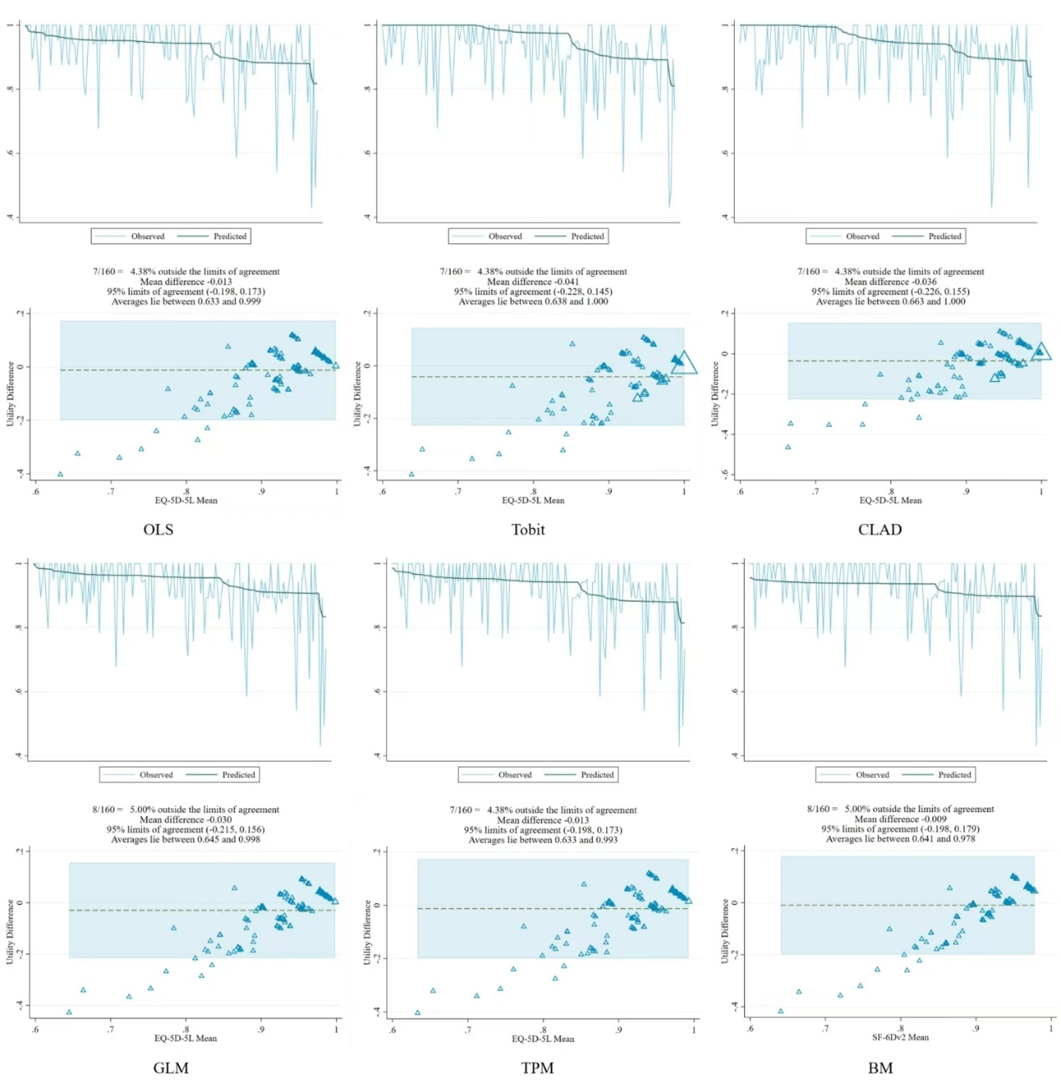

Appendix Figure 2 Comparison of predicted and observed SF-6Dv2 utility values at different regression methods
