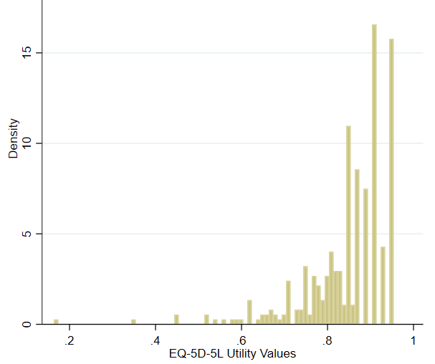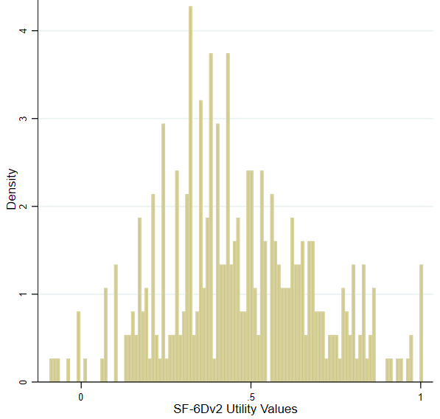
Figure 1. Distribution of observed EQ-5D-5L and SF-6Dv2 utility values in the sample
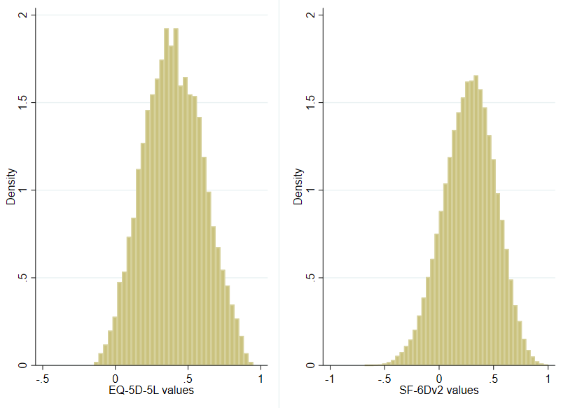
Figure 2. Utility value distributions for EQ-5D-5L and SF-6Dv2 over all possible health states

