Supplementary material

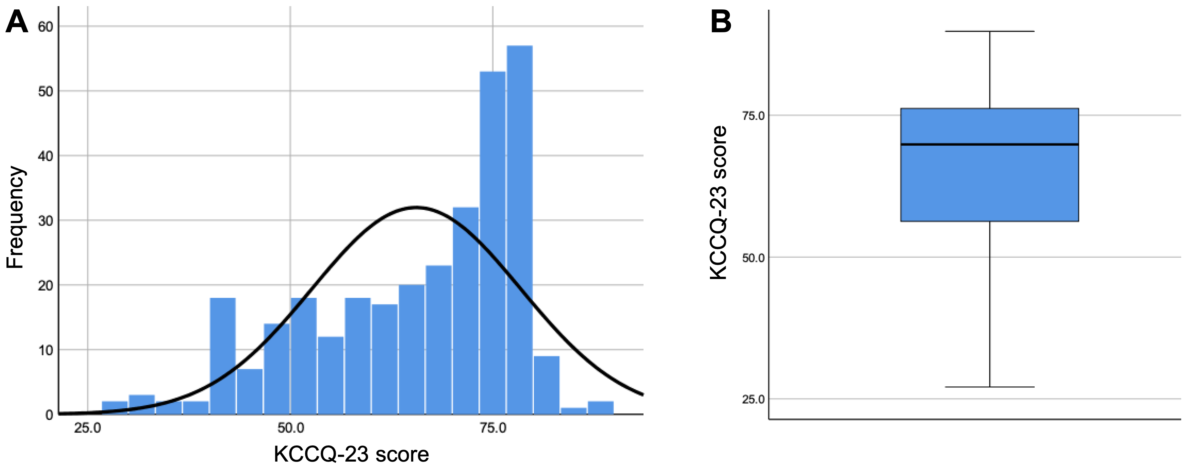
Supplementary Figure S1. Distribution of KCCQ-23 scores. (A) Histogram. (B) Boxplot.

