Supplementary Materials

Index
Study 1 2
Table S1. Selected of the items of the UIQ and dimensions in Italian language 2
Table S2. Demographic characteristics of the sample (n = 408) of Study 1 3
Figure S1. Distribution of responses to the UIQ in Study 1 4
Table S3. Descriptive statistics of the items of the UIQ in Study 1 (N = 408) 5
Figure S2. Heatmap of the Spearman's coefficients among UIQ items (Study1) 6
EGA Structural consistency comment 7
Table S4. PART 1: EGA-based network loadings in Study 1. 8
PART 2: Descriptive statistics of the UIQ dimensions and total score (n = 408) 8
EGA network loadings 9
Figure S3. Spearman correlations among the EGA-based UIQ factors 10
Study 2 11
Table S5. Demographic characteristics of the sample of Study 2 (N = 551). 11
Table S6. Descriptive statistics of the items of the UIQ in the sample of Study 2 (N = 551) 12
Figure S4. Graph of the responses to the items of the UIQ 13
Figure S5. Correlations of the UIQ items in the sample of Study 2 (n 551) 14
Table S7. Descriptive statistics of psychological scales in Study 2 (N = 551) 15
Table S8. Standardized loadings of the CFA in the UIQ with uncorrelated residuals (all p <.001). 16
Table S9. Loadings of the UIQ CFA model with correlated residuals of items R_36 and R_37. 17
Table S10. Descriptive statistics of UIQ-observed dimension scores in Study 2 (n = 551) 18
Figure S6. Correlations among the four UIQ factors and the general total score in Study 2 (n = 551) 19
Figure S7. Correlations among the psychological constructs in Study 2 (n = 551) 20
Description of the Measurement Invariance Procedure 21
Detailed information about the Measurement Invariance (MI) models of the UIQ 22
Study 3 24
Discriminant validity techniques 24
Table S11. Descriptive statistics of sociodemographic and psychological variables in Study 3. 25
Figure S8. Plot of the structural equation models used to assess discriminant validity in Study 3. 26
Table S12. Study 3. Item loadings and R² in the SEM model. 27
Table S13. Assessment of discriminant validity between UIQ and IUS-R. 28

Study 1

Table S1. Selected of the items of the UIQ and dimensions in Italian language
 | UNCERTAINTY ABOUT Symptoms
S_1 | 1. Non saperne abbastanza riguardo alla condizione medica
S_4 | 4. Non sapere se si manifesteranno altri sintomi
S_6 | 6. Non sapere con che intensità si manifesteranno i sintomi
S_7 | 7. Non sapere per quanto tempo dureranno i sintomi
 | UNCERTAINTY ABOUT Change in the future
C_13 | 13. Non sapere se la situazione cambierà
C_14 | 14. Non sapere come sarà la vita d'ora in poi
C_16 | 16. Non sapere come andrà a finire
C_17 | 17. Non sapere se potrò fare piani per il futuro
 | UNCERTAINTY ABOUT Treatments
T_21 | 21. Non sapere se quello che i medici dicono varrà anche in futuro
T_23 | 23. Non sapere se saranno disponibili i servizi di cui si avrà bisogno (es. aiuto infermieristico, medico di base, supporto ospedaliero, etc.)
T_25 | 25. Non conoscere il funzionamento dei trattamenti
T_27 | 27. Non sapere se i trattamenti saranno efficaci
 | UNCERTAINTY ABOUT Relationships
R_36 | 36. Non sapere come reagiranno gli altri (amici, familiari, colleghi...)
R_37 | 37. Non sapere se e come cambieranno le mie relazioni con gli altri
R_38 | 38. Non sapere se gli altri si prenderanno cura di me
R_39 | 39. Non sapere se sarò un peso per gli altri

Table S2. Demographic characteristics of the sample (n = 408) of Study 1
 | Patients (n =243) | Caregivers (n = 165) | Total (N = 408)
Age, mean (SD) | 41.753 (12.398) | 48.321 (14.218) | 44.409 (13.538)
Biological sex
Female, n (%) | 200 (82.3%) | 153 (92.7%) | 353 (86.5%)
Male, n (%) | 43 (17.7%) | 12 (7.3%) | 55 (13.5%)
Civil status
Single, n (%) | 39 (18.6%) | 19 (14.2%) | 58 (16.9%)
Engaged, n (%) | 19 (9.0%) | 13 (9.7%) | 32 (9.3%)
Coliving, n (%) | 38 (18.1%) | 15 (11.2%) | 53 (15.4%)
Married, n (%) | 94 (44.8%) | 78 (58.2%) | 172 (50.0%)
Separated, n (%) | 11 (5.2%) | 2 (1.5%) | 13 (3.8%)
Divorced, n (%) | 8 (3.8%) | 5 (3.7%) | 13 (3.8%)
Widow, n (%) | 1 (0.5%) | 2 (1.5%) | 3 (0.9%)
Education level
Primary school, n (%) | 0 (0%) | 3 (2.2%) | 3 (0.9%)
Middle school, n (%) | 24 (11.4%) | 20 (14.9%) | 44 (12.8%)
High school, n (%) | 119 (56.7%) | 63 (47.0%) | 182 (52.9%)
Bachelor’s degree, n (%) | 25 (11.9%) | 22 (16.4%) | 47 (13.7%)
Master’s degree, n (%) | 26 (12.4%) | 17 (12.7%) | 43 (12.5%)
Post-lauream, n (%) | 16 (7.6%) | 9 (6.7%) | 25 (7.3%)

Figure S1. Distribution of responses to the UIQ in Study 1
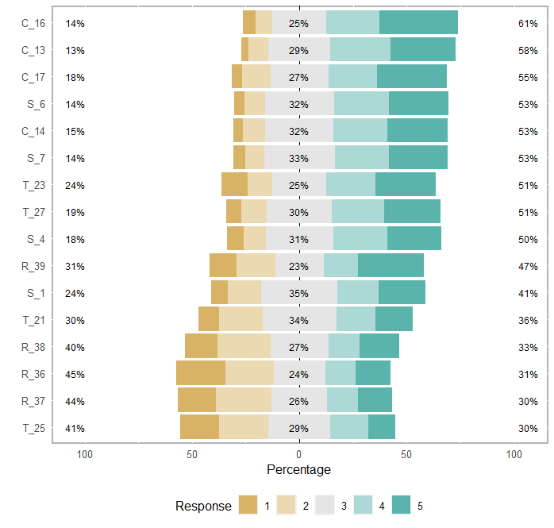

Table S3. Descriptive statistics of the items of the UIQ in Study 1 (N = 408)
item |  | mean | sd | skewness | kurtosis
S_1 | 1. Non saperne abbastanza riguardo alla condizione medica | 3.316 | 1.2 | -0.139 | -0.818
S_4 | 4. Non sapere se si manifesteranno altri sintomi | 3.493 | 1.2 | -0.425 | -0.613
S_6 | 6. Non sapere con che intensità si manifesteranno i sintomi | 3.615 | 1.135 | -0.436 | -0.525
S_7 | 7. Non sapere per quanto tempo dureranno i sintomi | 3.6 | 1.143 | -0.439 | -0.506
C_14 | 13. Non sapere se la situazione cambierà | 3.615 | 1.133 | -0.402 | -0.599
C_17 | 14. Non sapere come sarà la vita d'ora in poi | 3.647 | 1.197 | -0.438 | -0.809
C_16 | 16. Non sapere come andrà a finire | 3.782 | 1.189 | -0.694 | -0.394
C_13 | 17. Non sapere se potrò fare piani per il futuro | 3.723 | 1.095 | -0.492 | -0.5
T_21 | 21. Non sapere se quello che i medici dicono varrà anche in futuro | 3.137 | 1.21 | 0.002 | -0.854
T_23 | 23. Non sapere se saranno disponibili i servizi di cui si avrà bisogno (es. aiuto infermieristico, medico di base, supporto ospedaliero, etc) | 3.436 | 1.336 | -0.422 | -0.947
T_25 | 25. Non conoscere il funzionamento dei trattamenti | 2.836 | 1.268 | 0.143 | -0.971
T_27 | 27. Non sapere se i trattamenti saranno efficaci | 3.507 | 1.202 | -0.386 | -0.717
R_36 | 36. Non sapere come reagiranno gli altri (amici, familiari, colleghi...) | 2.787 | 1.379 | 0.234 | -1.154
R_37 | 37. Non sapere se e come cambieranno le mie relazioni con gli altri | 2.848 | 1.318 | 0.229 | -1.045
R_38 | 38. Non sapere se gli altri si prenderanno cura di me | 2.961 | 1.322 | 0.148 | -1.088
R_39 | 39. Non sapere se sarò un peso per gli altri | 3.343 | 1.404 | -0.229 | -1.253

Figure S2. Heatmap of the Spearman's coefficients among UIQ items (Study1)
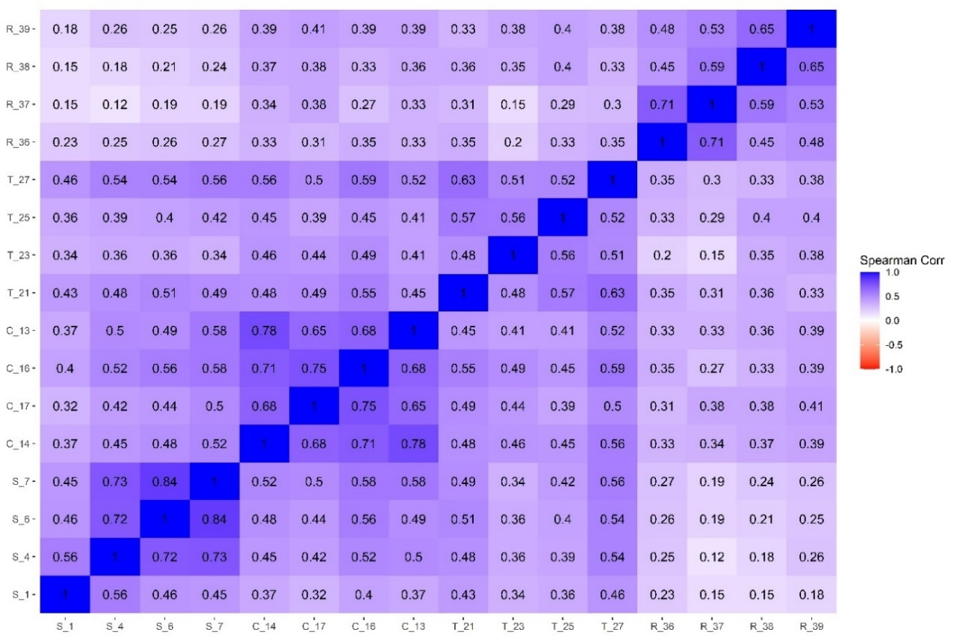

EGA Structural consistency comment

The SC values were: ‘symptoms’ = .896, ‘change’ = 1; ‘treatments’ = 1; and ‘relationships’ = 1. IS analysis revealed that the items remained consistently stable both within and across their assigned dimensions/factors. The average IS for the UIQ dimensions were as follows: ‘symptoms’ = .986; ‘change’ = 1; ‘treatments’ = 1; and ‘relationships’ = 1. The two items with slightly lower—but still optimal—empirical dimension stability were the items S_1 (‘1. not knowing enough about the medical condition’) with a value of .896, and the item T_27 (‘27. not knowing if the treatments will be effective’) with .999.

Table S4. PART 1: EGA-based network loadings in Study 1.
 | Dimensions
Items | Symptoms | Change | Treatments | Relationships
S_6 | .438 | .034 | .059 | 0
S_7 | .43 | .084 | .055 | 0
S_4 | .407 | .027 | .036 | 0
S_1 | .154 | .017 | .139 | 0
C_14 | .002 | .414 | .099 | .016
C_16 | .075 | .358 | .132 | .023
C_13 | .092 | .347 | .006 | .029
C_17 | .004 | .335 | .04 | .068
T_25 | .049 | .024 | .324 | .08
T_21 | .085 | .069 | .302 | .029
T_27 | .139 | .095 | .258 | .033
T_23 | .014 | .073 | .255 | .037
R_37 | 0 | .034 | 0 | .482
R_38 | 0 | .02 | .053 | .382
R_36 | 0 | .025 | .04 | .357
R_39 | 0 | .048 | .084 | .339
Note: S = symptoms; C = change; T = treatments; R = relationships. The role of each node in maintaining the integrity of the dimensions was examined through network loadings, with sizes interpreted as small (λEGA>0.15), moderate (λEGA>0.25), large (λEGA>0.35) (Christensen & Golino, 2021a; Golino et al., 2020).”

PART 2: Descriptive statistics of the UIQ dimensions and total score (n = 408)
 | mean | sd | minimum | maximum | range | skewness | kurtosis
UIQ Total | 53.647 | 13.434 | 16 | 80 | 64 | -0.292 | -0.095
Symptoms | 14.025 | 3.954 | 4 | 20 | 16 | -0.320 | -0.483
Change | 14.767 | 4.080 | 4 | 20 | 16 | -0.480 | -0.551
Treatments | 12.917 | 4.085 | 4 | 20 | 16 | -0.141 | -0.526
Relationships | 11.939 | 4.473 | 4 | 20 | 16 | 0.171 | -0.837
Note:. UIQ: uncertainty in illness; sd: standard deviation.

EGA network loadings

In the ‘symptoms’ dimension/factor, the λEGA ranged from .438 (large) to .154 (small) (M= .357, SD = .136). The ‘change’ dimension had a λEGA ranging from .414 (large) to .335 (large) (M= .364, SD = .0350). The ‘treatments’ dimension had a λEGA from .324 (large) to .255 (large) (M= .284, SD = .034). The ‘relationships’ dimension had a λEGA from .482 (large) to .339 (large) (M= .390, SD = .064).

Figure S3. Spearman correlations among the EGA-based UIQ factors
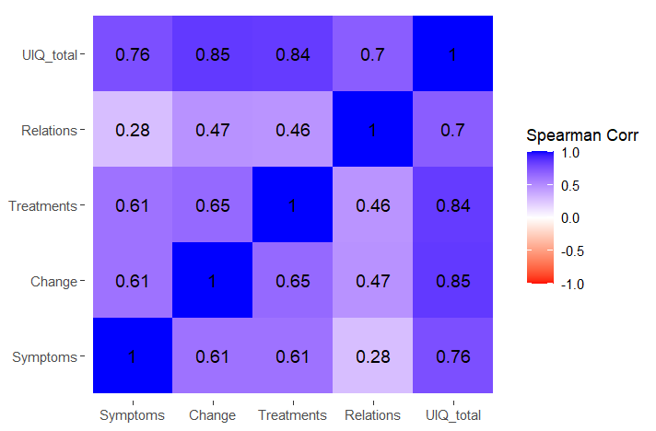

Study 2

Table S5. Demographic characteristics of the sample of Study 2 (N = 551).

 | Patients | Caregivers | Total
 | (n = 328) | (n = 223) | (N = 551)
age - mean (SD) | 42.245 (13.139) | 46.408 (13.309) | 43.933 (13.354)
Biological sex
Female, n (%) | 288 (87.8%) | 196 (87.9%) | 484 (87.8%)
Male, n (%) | 40 (12.2%) | 27 (12.1%) | 67 (12.2%)
Civil status
Single, n (%) | 61 (21.3%) | 24 (13.8%) | 85 (18.4%)
Engaged, n (%) | 24 (8.4%) | 20 (11.5%) | 44 (9.5%)
Coliving, n (%) | 53 (18.5%) | 23 (13.2%) | 76 (16.5%)
Married, n (%) | 113 (39.4%) | 93 (53.4%) | 206 (44.7%)
Separated, n (%) | 10 (3.5%) | 5 (2.9%) | 15 (3.3%)
Divorced, n (%) | 23 (8.0%) | 7 (4.0%) | 30 (6.5%)
Widow, n (%) | 3 (1.0%) | 2 (1.1%) | 5 (1.1%)
Education level
Primary school, n (%) | 2 (0.7%) | 1 (0.6%) | 3 (0.7%)
Middle school, n (%) | 41 (14.3%) | 19 (10.9%) | 60 (13.0%)
High school, n (%) | 139 (48.4%) | 88 (50.6%) | 227 (49.2%)
Bachelor’s degree, n (%) | 29 (10.1%) | 22 (12.6%) | 51 (11.1%)
Master’s degree, n (%) | 43 (15.0%) | 27 (15.5%) | 70 (15.2%)
Postlauream, n (%) | 33 (11.5%) | 17 (9.8%) | 50 (10.8%)
None, n (% | 0 (0.0%) | 0 (0.0%) | 0 (0.0%)

Table S6. Descriptive statistics of the items of the UIQ in the sample of Study 2 (N = 551)
item | Symptoms | mean | sd | skewness | kurtosis
S_1 | 1. Non saperne abbastanza riguardo alla condizione medica | 3.43 | 1.137 | -0.235 | -0.672
S_4 | 4. Non sapere se si manifesteranno altri sintomi | 3.61 | 1.158 | -0.495 | -0.524
S_6 | 6. Non sapere con che intensità si manifesteranno i sintomi | 3.721 | 1.095 | -0.503 | -0.487
S_7 | 7. Non sapere per quanto tempo dureranno i sintomi | 3.78 | 1.094 | -0.564 | -0.443
 | Change in the future | mean | sd | skewness | kurtosis
C_14 | 13. Non sapere se la situazione cambierà | 3.688 | 1.122 | -0.43 | -0.702
C_17 | 14. Non sapere come sarà la vita d'ora in poi | 3.728 | 1.178 | -0.515 | -0.778
C_16 | 16. Non sapere come andrà a finire | 3.855 | 1.168 | -0.68 | -0.547
C_13 | 17. Non sapere se potrò fare piani per il futuro | 3.844 | 1.057 | -0.553 | -0.557
 | Treatments | mean | sd | skewness | kurtosis
T_21 | 21. Non sapere se quello che i medici dicono varrà anche in futuro | 3.299 | 1.203 | -0.057 | -0.951
T_23 | 23. Non sapere se saranno disponibili i servizi di cui si avrà bisogno (es. aiuto infermieristico, medico di base, supporto ospedaliero, etc) | 3.525 | 1.244 | -0.358 | -0.905
T_25 | 25. Non conoscere il funzionamento dei trattamenti | 3.082 | 1.241 | 0.022 | -0.995
T_27 | 27. Non sapere se i trattamenti saranno efficaci | 3.633 | 1.128 | -0.408 | -0.631
 | Relationships | mean | sd | skewness | kurtosis
R_36 | 36. Non sapere come reagiranno gli altri (amici, familiari, colleghi...) | 2.779 | 1.316 | 0.278 | -1.027
R_37 | 37. Non sapere se e come cambieranno le mie relazioni con gli altri | 2.9 | 1.286 | 0.206 | -1.043
R_38 | 38. Non sapere se gli altri si prenderanno cura di me | 3.047 | 1.297 | 0.117 | -1.067
R_39 | 39. Non sapere se sarò un peso per gli altri | 3.485 | 1.311 | -0.358 | -1.02

Figure S4. Graph of the responses to the items of the UIQ
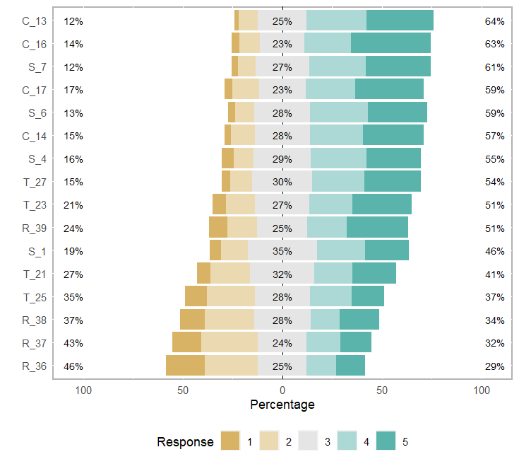

Figure S5. Correlations of the UIQ items in the sample of Study 2 (n 551)
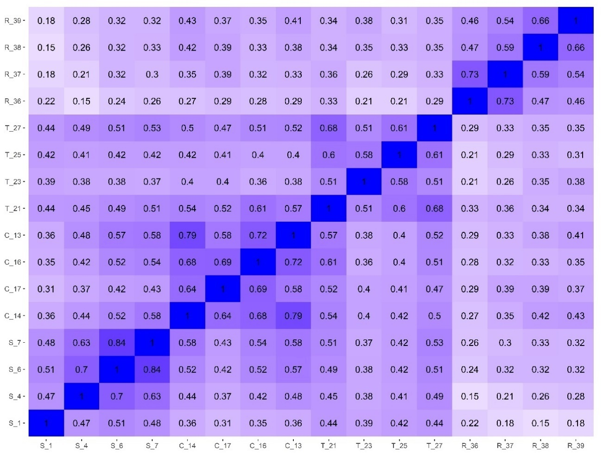

Table S7. Descriptive statistics of psychological scales in Study 2 (N = 551)
 |  | Patients  (n 328) | Caregivers  (n 223) | Total  (N 551)
variable | range | mean (sd) | mean (sd) | mean (sd)
UIQ total | 17 - 80 | 54.933 (12.849) | 56.099 (12.889) | 55.405 (12.866)
UIQ Symptoms | 4 - 20 | 14.174 (3.694) | 15.081 (3.761) | 14.541 (3.745)
UIQ Change | 4 - 20 | 14.832 (3.912) | 15.529 (3.970) | 15.114 (3.947)
UIQ Treatments | 4 - 20 | 13.015 (3.891) | 14.309 (3.999) | 13.539 (3.982)
UIQ Relations | 4 - 20 | 12.912 (4.176) | 11.179 (4.312) | 12.211 (4.312)
GAD-7 | 0 - 21 | 9.865 (5.985) | 9.975 (5.468) | 9.941 (5.622)
AD-R Anxiety | 13 - 38 | 24.908 (5.785) | - | 24.908 (5.785)
HAQ | 22 - 80 | 46.109 (13.276) | 38.782 (12.230) | 42.547 (13.261)
IUS-R | 12 - 60 | 34.063 (11.292) | 31.190 (10.305) | 32.897 (10.983)
PSWQ-16 | 21 - 80 | 53.615 (14.413) | 51.815 (14.247) | 52.815 (14.351)
PSWQ-11 | 11-55 | 33.697 (11.817) | 31.615 (11.920) | 32.772 (11.895)
IUBEL | 14 - 80 | 44.181 (9.490) | 41.270 (10.833) | 42.765 (10.242)
AD-R Depression | 0 - 15 | 7.023 (3.511) | - | 7.023 (3.511)
Resilience (RS-14) | 17 - 98 | 66.026 (18.193) | 66.088 (17.468) | 66.053 (17.857)
RSES | 14 - 33 | 23.758 (8.692) | - | 23.758 (8.692)
Note: UIQ = uncertainty in illness questionnaire; GAD-7 = generalized anxiety disorder scale 7 items; AD-R = scheda ansia depressione ridotta; HAQ = health anxiety questionnaire; IUS-R = intolerance of uncertainty scale revised; PSWQ-16 = Penn state worry questionnaire 16 items; PSWQ-11 = Penn state worry questionnaire 11 items; IUBEL = Intolerance of Uncertainty Behaviors in Everyday Life; RS-14 = resilience scale 14 items.

Table S8. Standardized loadings of the CFA in the UIQ with uncorrelated residuals (all p <.001).
Items | SYMPTOMS |  | FUTURE CHANGE |  | TREATMENTS |  | RELATIONSHIPS |  | UNCERTAINTY |  |  | R²
S_1 |  | 0.558 |  | 0 |  | 0 |  | 0 |  | 0 | 0.311
S_4 |  | 0.722 |  | 0 |  | 0 |  | 0 |  | 0 | 0.522
S_6 |  | 0.932 |  | 0 |  | 0 |  | 0 |  | 0 | 0.868
S_7 |  | 0.901 |  | 0 |  | 0 |  | 0 |  | 0 | 0.812
C_13 |  | 0 |  | 0.876 |  | 0 |  | 0 |  | 0 | 0.767
C_14 |  | 0 |  | 0.865 |  | 0 |  | 0 |  | 0 | 0.748
C_17 |  | 0 |  | 0.739 |  | 0 |  | 0 |  | 0 | 0.546
C_16 |  | 0 |  | 0.823 |  | 0 |  | 0 |  | 0 | 0.677
T_21 |  | 0 |  | 0 |  | 0.830 |  | 0 |  | 0 | 0.689
T_23 |  | 0 |  | 0 |  | 0.641 |  | 0 |  | 0 | 0.411
T_25 |  | 0 |  | 0 |  | 0.741 |  | 0 |  | 0 | 0.549
T_27 |  | 0 |  | 0 |  | 0.816 |  | 0 |  | 0 | 0.666
R_36 |  | 0 |  | 0 |  | 0 |  | 0.760 |  | 0 | 0.577
R_37 |  | 0 |  | 0 |  | 0 |  | 0.852 |  | 0 | 0.725
R_38 |  | 0 |  | 0 |  | 0 |  | 0.741 |  | 0 | 0.549
R_39 |  | 0 |  | 0 |  | 0 |  | 0.701 |  | 0 | 0.491
Dimensions |  | SYMPTOMS |  | FUTURE CHANGE |  | TREATMENTS |  | RELATIONSHIPS |  | UNCERTAINTY | R²
Symptoms |  | 0 |  | 0 |  | 0 |  | 0 |  | 0.781 | 0.610
Change |  | 0 |  | 0 |  | 0 |  | 0 |  | 0.874 | 0.764
Treatments |  | 0 |  | 0 |  | 0 |  | 0 |  | 0.859 | 0.738
Relationships |  | 0 |  | 0 |  | 0 |  | 0 |  | 0.602 | 0.363

Table S9. Loadings of the UIQ CFA model with correlated residuals of items R_36 and R_37.
Items | Symp. | Change | Treat. | Relat. | Uncertainty | R²
S_1 | 0.557 | 0 | 0 | 0 | 0 | 0.310
S_4 | 0.723 | 0 | 0 | 0 | 0 | 0.522
S_6 | 0.932 | 0 | 0 | 0 | 0 | 0.869
S_7 | 0.901 | 0 | 0 | 0 | 0 | 0.812
C_13 | 0 | 0.876 | 0 | 0 | 0 | 0.768
C_14 | 0 | 0.866 | 0 | 0 | 0 | 0.750
C_17 | 0 | 0.738 | 0 | 0 | 0 | 0.545
C_16 | 0 | 0.821 | 0 | 0 | 0 | 0.675
T_21 | 0 | 0 | 0.828 | 0 | 0 | 0.685
T_23 | 0 | 0 | 0.644 | 0 | 0 | 0.415
T_25 | 0 | 0 | 0.743 | 0 | 0 | 0.551
T_27 | 0 | 0 | 0.816 | 0 | 0 | 0.666
R_36 | 0 | 0 | 0 | 0.586 | 0 | 0.344
R_37 | 0 | 0 | 0 | 0.710 | 0 | 0.504
R_38 | 0 | 0 | 0 | 0.838 | 0 | 0.702
R_39 | 0 | 0 | 0 | 0.785 | 0 | 0.617
Dims. | Symp. | Change | Treat. | Relat. | Uncertainty | R²
Symptoms | 0 | 0 | 0 | 0 | 0.779 | 0.607
Change | 0 | 0 | 0 | 0 | 0.878 | 0.771
Treatments | 0 | 0 | 0 | 0 | 0.857 | 0.734
Relationships | 0 | 0 | 0 | 0 | 0.634 | 0.402
Note: R² = R-square. Correlation of R_36 and R_37 = 0.558 All p <.001.

Table S10. Descriptive statistics of UIQ-observed dimension scores in Study 2 (n = 551)
 | mean | Sd | minimum | maximum | range | skewness | kurtosis
Symptoms | 14.541 | 3.745 | 4 | 20 | 16 | -0.380 | -0.379
Change | 15.114 | 3.947 | 4 | 20 | 16 | -0.542 | -0.570
Treatments | 13.539 | 3.982 | 4 | 20 | 16 | -0.150 | -0.723
Relationships | 12.211 | 4.312 | 4 | 20 | 16 | 0.088 | -0.837
UIQ total | 55.404 | 12.866 | 17 | 80 | 63 | -0.329 | -0.347
Note: UIQ = uncertainty in illness questionnaire.

Figure S6. Correlations among the four UIQ factors and the general total score in Study 2 (n = 551)
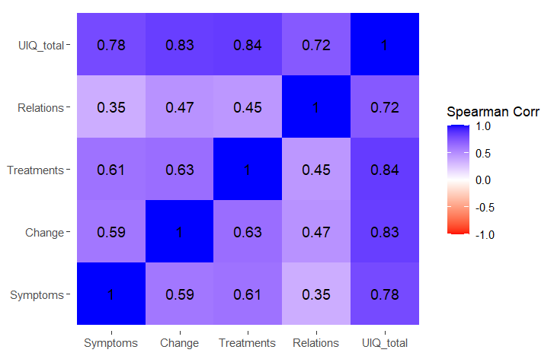

Figure S7. Correlations among the psychological constructs in Study 2 (n = 551)
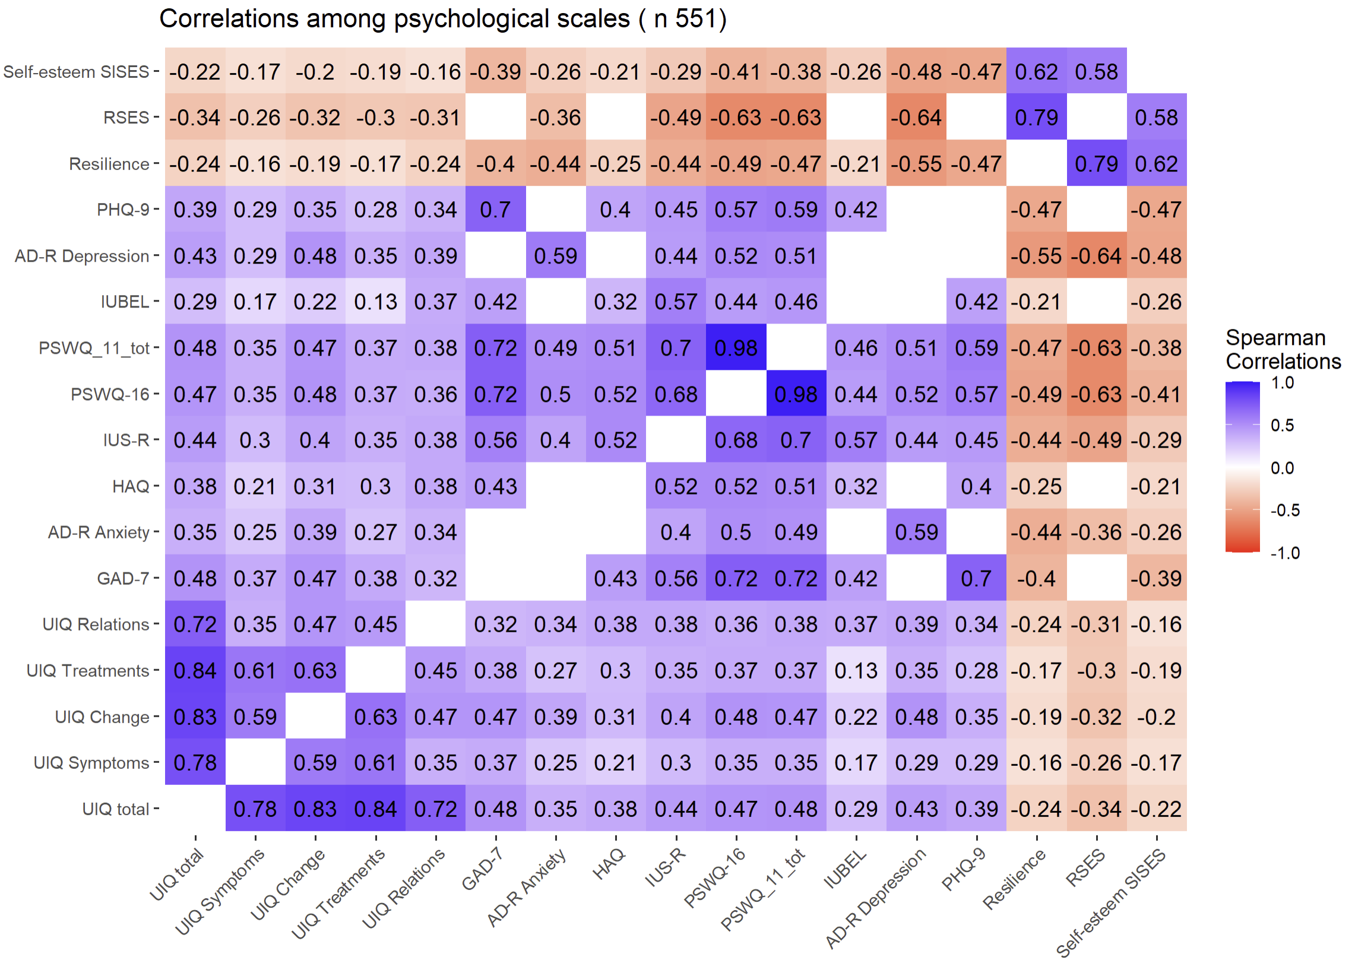

Description of the Measurement Invariance Procedure

Model 1 tests configural invariance separately for patients and caregivers and consists of testing that an equal factorial structure holds for both groups. If both models provide good fit, four nested models were sequentially tested, with constraints to equal increasing sets of parameters (Millsap, 2012). Model 2 tests the metric invariance, in which – beyond the factorial structure – all the factor loadings are constrained to be equal across groups. Model 3 tests scalar invariance, beyond the factorial structure and factor loadings, and intercepts/thresholds are constrained to be equal across groups; Model 4 tests the latent means invariance; in addition to the factorial structure, factor loadings, and intercepts/thresholds, latent means are constrained to be equal. Finally, to assess MI, all these different nested models were compared on the basis of the test differences in three fit indices, considering the following principles for model equivalence (Brown, 2015; Cheung & Rensvold, 2002; Millsap, 2012; van de Schoot et al., 2012): DIFFTEST (equal to Δχ² with p >0.050), CFI difference (ΔCFI) <0.010, and difference in RMSEA (ΔRMSEA) <0.015. Model non-invariance was considered supported when two out of these three fit indices surpassed the cutoff, in combination with poorer fit indices indicating a worsening in model fit.

Detailed information about the Measurement Invariance (MI) models of the UIQ

In the subset of patients (n = 328), the congeneric model (37 model parameters) provided a good fit to the data: χ²: S-B χ²₍₉₉₎ = 204.697; p<.001; robust RMSEA = 0.065; 90% CI [0.052, 0.078], robust CFI = 0.959, robust TLI = .950, SRMR = 0.042. All loadings were sufficiently high (> .577) and statistically significant (p<.001). In the subset of caregivers (n = 223), the congeneric model provided a statistically significant χ²: S-Bχ²₍₉₉₎ =208.258; p<.001. All other fit indices revealed an acceptable fit: robust RMSEA = 0.079; 90% CI [0.064, 0.094], robust CFI = 0.937, robust TLI = .924, SRMR= 0.070. All loadings were high (>.515) and statistically significant (p<.001).
Configural multigroup invariance: The model of configural multigroup invariance showed good model fit indices. Although χ² was statistically significant [S-B χ²₍₁₉₈₎ = 412.897, p <.001], all other fit indices revealed a good fit: robust RMSEA = 0.071, 90% CI of robust RMSEA [0.061, 0.081]; robust CFI = 0.950; robust TLI = .940; and SRMR = 0.050, suggesting that the factor structure was similar between patients and caregivers. In both groups, the loadings were high and statistically significant.
Metric Invariance: The loadings (16+4 = 20) on latent factors were constrained to be equal across groups (111 parameters). The model fit the data well. Although χ² was statistically significant [S-Bχ²₍₂₁₃₎ = 439.593, p <.001], all other fit indices revealed a good fit: robust RMSEA = 0.070, 90% CI of robust RMSEA [0.061, 0.079], robust CFI = 0.949, robust TLI = .942, SRMR = 0.056. The model of metric invariance was compared with the model of multigroup configural invariance. A statistically significant decrease in χ² was found: Δχ²₍₁₅₎ = 25.255; p = .047, but it is probably due to sample size. Nevertheless, nonsignificant decreases in robust RMSEA (|ΔRMSEA|=0.001) and robust CFI (|ΔCFI|=0.002) were found, indicating that the items were equivalently related to the latent factor independently of being a patient or caregiver. Additionally, AIC and BIC indices preferred the metric model (Table 2).
Scalar invariance: Additionally, intercepts were constrained to be equal (equality constraints 36, model parameters 116). This model showed acceptable fit indices. Although χ² was statistically significant [S-Bχ²₍₂₂₄₎ = 492.013, p <.001], all other fit indices revealed an acceptable fit to the data: robust RMSEA = 0.073, 90% CI of robust RMSEA [0.065, 0.082], CFI = 0.940; robust TLI = .936; and SRMR = 0.058. Comparing the scalar and metric models, a statistically significant decrease in χ² was found: Δχ² (11) = 69.836; p <. 001. However, nonsignificant decreases in robust RMSEA (|ΔRMSEA|= 0.004) and robust CFI (|ΔCFI|= 0.008) were found, suggesting that patients and caregivers had the same expected item response at the same trait absolute level. Additionally, the BIC preferred the scalar model.
Latent Means Comparison: Having established scalar invariance, latent means can be compared across groups without bias (equality constraints 36, parameters 111). We therefore interpret group differences at the latent level conditional on scalar invariance. This model fit the data well. Even though the significant χ²[S-Bχ²₍₂₂₉₎ = 542.765, p <.001], all other indices revealed an acceptable fit: robust RMSEA = 0.078, 90% CI of robust RMSEA[0.069, 0.086], robust CFI = 0.932; robust TLI = .928; SRMR = 0.072. Comparing the latent means and the scalar model, a statistically significant difference in the χ² was found: Δχ² (5) = 357.42; p<.001. Furthermore, nonsignificant decreases in robust RMSEA (|ΔRMSEA|= 0.004) and robust CFI(|ΔCFI|= 0.009) were found, suggesting that patients and caregivers had the same expected latent mean of traits in the UIQ factors.

Study 3

Discriminant validity techniques
Among techniques that focus on model fit, we focus on χ²(cut) and CFI(cut) (Panzeri et al., 2024; Rönkkö & Cho, 2022). First, two models have to be fitted and then their fit compared: the unconstrained model with the freely estimated latent factors’ correlation and a second constrained model where the latent correlation is fixed to be equal to a cutoff. Second, the fit of the two models (unconstrained and constrained) is compared and evaluated by using two criteria, χ²(cut) and CFI(cut). Specifically, in terms of χ²(cut), if the unconstrained model with the freely estimated correlation (showing a value < .85) fits better than the model with the fixed correlation (at .85), it means that there are no problems with discriminant validity. Similarly, if the unconstrained model with the freely estimated correlation (reporting a value > .85) fits better than the model with the constrained correlation (at .85), it means that there are problems of discriminant validity. If the difference of χ²(cut) between two models (unconstrained vs. constrained) is not statistically different from zero, it means that there are problems of discriminant validity.
The CFI(cut) consists in comparing the ΔCFI between the constrained and unconstrained model against the .002 cutoff. ΔCFI above the .002 cutoff in favor of the model with the lower latent correlation supports discriminant validity, a ΔCFI below the .002 cutoff indicates the absence of discriminant validity, because the ‘real’ correlation is not lower than .85.

Table S11. Descriptive statistics of sociodemographic and psychological variables in Study 3.
 | Patients  (n = 548) | Caregivers  (n = 377) | Total  (N = 925)
Age, mean (SD) | 42.272 (12.883) | 47.340 (13.698) | 44.340 (13.447)
Range | 18 - 78 | 18 - 93 | 18 - 93
Female, n (%) | 467 (85.2%) | 339 (89.9%) | 806 (87.1%)
Male, n (%) | 81 (14.8%) | 38 (10.1%) | 119 (12.9%)
UIQ total, mean (SD) | 54.124 (13.293) | 55.305 (12.849) | 54.605 (13.120)
UIQ Symptoms, mean (SD) | 14.020 (3.818) | 14.798 (3.824) | 14.337 (3.837)
UIQ Change, mean (SD) | 14.644 (4.002) | 15.377 (3.965) | 14.943 (4.001)
UIQ Treatments, mean (SD) | 12.803 (3.944) | 13.984 (4.024) | 13.284 (4.017)
UIQ Relations, mean (SD) | 12.657 (4.395) | 11.146 (4.182) | 12.041 (4.371)
GAD-7, mean (SD) | 9.849 (5.929) | 9.706 (5.304) | 9.750 (5.500)
AD-R Anxiety, mean (SD) | 24.607 (5.755) | - | 24.607 (5.755)
HAQ, mean (SD) | 46.585 (13.438) | 40.098 (11.602) | 43.564 (13.006)
IUS-R, mean (SD) | 33.597 (11.271) | 30.785 (10.045) | 32.451 (10.871)
PSWQ-16, mean (SD) | 53.399 (14.540) | 51.604 (13.896) | 52.603 (14.277)
PSWQ-11, mean (SD) | 33.461 (11.934) | 31.636 (11.465) | 32.651 (11.756)
IUBEL, mean (SD) | 44.263 (9.251) | 41.804 (9.963) | 43.108 (9.655)
AD-R Depression, mean (SD) | 6.964 (3.561) | - | 6.964 (3.561)
RS-14, mean (SD) | 65.774 (18.623) | 67.213 (16.389) | 66.408 (17.676)
RSES, mean (SD) | 23.741 (8.588) | - | 23.741 (8.588)
Note: UIQ = uncertainty in illness questionnaire; GAD-7 = generalized anxiety disorder 7 items; AD-R = Scheda ansia-depressione ridotta; HAQ = health anxiety questionnaire; IUS-R = intolerance of uncertainty scale revised; PSWQ-16 = Penn State Worry Questionnaire 16 items; PSWQ-11 = Penn State Worry Questionnaire 11 items; IUBEL = intolerance of uncertainty behavior in everyday life; RS-14 = resilience scale 14 items; RSES = Rosenberg self-esteem scale.

Figure S8. Plot of the structural equation models used to assess discriminant validity in Study 3.
Latent factors are shown as circles, with arrows between them representing the latent correlations. Items are displayed as rectangles, and arrows from the latent factors to the items indicate the factor loadings. Each path is labeled with its standardized estimate, and the thickness of the arrows reflects the magnitude of these loadings.
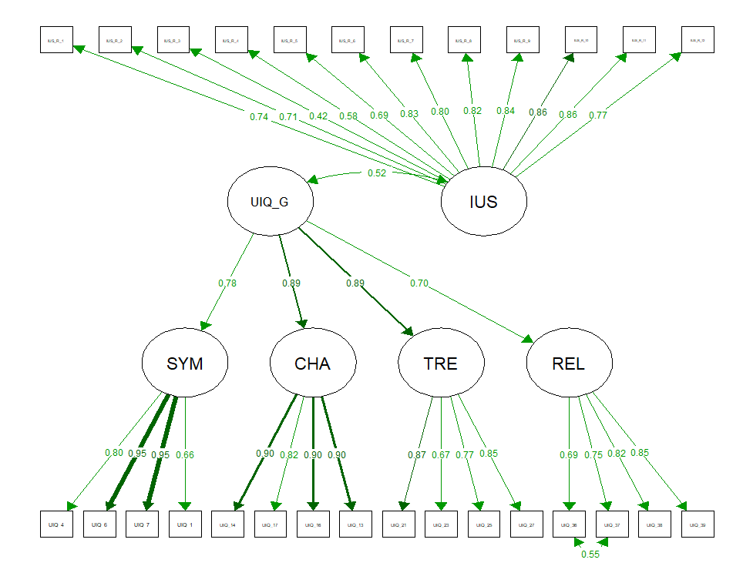

Table S12. Study 3. Item loadings and R² in the SEM model.
lambda | SYMP | CHANGE | TREAT | REL | UIQ G | IUS-R |  | R²
UIQ_4 | 0.804 | 0 | 0 | 0 | 0 | 0 |  | 0.647
UIQ_6 | 0.951 | 0 | 0 | 0 | 0 | 0 |  | 0.904
UIQ_7 | 0.951 | 0 | 0 | 0 | 0 | 0 |  | 0.905
UIQ_1 | 0.656 | 0 | 0 | 0 | 0 | 0 |  | 0.430
UIQ_14 | 0 | 0.902 | 0 | 0 | 0 | 0 |  | 0.814
UIQ_17 | 0 | 0.821 | 0 | 0 | 0 | 0 |  | 0.674
UIQ_16 | 0 | 0.896 | 0 | 0 | 0 | 0 |  | 0.802
UIQ_13 | 0 | 0.904 | 0 | 0 | 0 | 0 |  | 0.817
UIQ_21 | 0 | 0 | 0.866 | 0 | 0 | 0 |  | 0.751
UIQ_23 | 0 | 0 | 0.673 | 0 | 0 | 0 |  | 0.453
UIQ_25 | 0 | 0 | 0.768 | 0 | 0 | 0 |  | 0.590
UIQ_27 | 0 | 0 | 0.855 | 0 | 0 | 0 |  | 0.731
UIQ_36 | 0 | 0 | 0 | 0.692 | 0 | 0 |  | 0.479
UIQ_37 | 0 | 0 | 0 | 0.750 | 0 | 0 |  | 0.563
UIQ_38 | 0 | 0 | 0 | 0.824 | 0 | 0 |  | 0.679
UIQ_39 | 0 | 0 | 0 | 0.849 | 0 | 0 |  | 0.721
IUS_R_1 | 0 | 0 | 0 | 0 | 0 | 0.737 |  | 0.543
IUS_R_2 | 0 | 0 | 0 | 0 | 0 | 0.705 |  | 0.498
IUS_R_3 | 0 | 0 | 0 | 0 | 0 | 0.416 |  | 0.173
IUS_R_4 | 0 | 0 | 0 | 0 | 0 | 0.577 |  | 0.333
IUS_R_5 | 0 | 0 | 0 | 0 | 0 | 0.693 |  | 0.481
IUS_R_6 | 0 | 0 | 0 | 0 | 0 | 0.828 |  | 0.686
IUS_R_7 | 0 | 0 | 0 | 0 | 0 | 0.800 |  | 0.640
IUS_R_8 | 0 | 0 | 0 | 0 | 0 | 0.816 |  | 0.666
IUS_R_9 | 0 | 0 | 0 | 0 | 0 | 0.835 |  | 0.697
IUS_R_10 | 0 | 0 | 0 | 0 | 0 | 0.865 |  | 0.748
IUS_R_11 | 0 | 0 | 0 | 0 | 0 | 0.857 |  | 0.735
IUS_R_12 | 0 | 0 | 0 | 0 | 0 | 0.775 |  | 0.600
beta | SYMP | CHANGE | TREAT | REL | UIQ G | IUS-R |  | R2
SYMP | 0 | 0 | 0 | 0 | 0.777 | 0 |  | 0.603
CHANGE | 0 | 0 | 0 | 0 | 0.886 | 0 |  | 0.786
TREAT | 0 | 0 | 0 | 0 | 0.887 | 0 |  | 0.787
REL | 0 | 0 | 0 | 0 | 0.702 | 0 |  | 0.493
UIQ GEN | 0 | 0 | 0 | 0 | 0 | 0 |  | -
IUS-R | 0 | 0 | 0 | 0 | 0 | 0 |  | -
Note: UIQ GEN = general factor of the uncertainty in illness questionnaire, IUS-R = intolerance of uncertainty scale revised, SYMP = symptoms, TREAT = treatments, RELAT = relationships, R² = R squared.

Table S13. Assessment of discriminant validity between UIQ and IUS-R.
 |  | Model fit
 | latent correlation of UIQ and IUS-R | X² | df | p | CFI | RMSEA | SRMR
Model unconstr. | est. .523, 95%CI[0.513, 0.533], se = 0.005, p < .001 | 1906.924 | 345 | <.001 | .990 | .070 | .059
Model constr. | est. .850, 95%CI[.850, .850] | 5368.566 | 346 | <.001 | .969 | .125 | .105
Model comparison |  | ΔX² | Δdf | p |  | ΔCFI | ΔRMSEA
 |  | 3461.6 | 1 | <.001 |  | .021 | .055
Note. UIQ = uncertainty in illness questionnaire, IUS-R = intolerance of uncertainty scale revised.
est. = point estimate of the correlation; 95% CI = confidence interval at 95%. X2 = chi-square statistic; df = degrees of freedom; p = p value; CFI = comparative fit index; RMSEA = root means square error of approximation; Δ = difference; DV = discriminant validity.

