SUPPLEMENTARY FILES

Supplementary File 1: Search strategies

BVS: Search made on 10/2022, 415 references found.

#37 #4 AND #28 AND #36
#36 (("quality of life") OR ("health related quality of life") OR ("health-related quality of life") OR ("value of life") OR (hqol) OR (hrqol) OR (qol) OR (camphor) OR ("cambridge pulmonary hypertension outcome review") OR (sf36) OR (sf12) OR (mlhfq) OR ("minnesota living with heart failure questionnaire") OR (prom) OR ("patient reported outcomes") OR ("patient reported outcome measures") OR (eq5d) OR (euroqol) OR (wellbeing) OR ("well being") OR ("pah sympact") OR ("emphasis 10")) AND (("pulmonary arterial hypertension") OR ("pulmonary hypertension") OR (PAH)) AND (("descriptive study") OR ("observational study") OR ("observational design") OR ("cross sectional study") OR ("longitudinal study") OR ("cohort study") OR ("prevalence")) 415
#35 (("descriptive study") OR ("observational study") OR ("observational design") OR ("cross sectional study") OR ("longitudinal study") OR ("cohort study") OR ("prevalence")) 3.391.574
#34 "prevalence" Title/abstract/subject 2.793.145
#33 "cohort study" Title/abstract/subject 486.851
#32 "longitudinal study" Title/abstract/subject 191.080
#31 "cross sectional study" Title/abstract/subject 557.856
#30 "observational design" Title/abstract/subject 1.484
#29 "observational study"Title/abstract/subject 217.342
#28= #4 AND #27 "descriptive study"Title/abstract/subject 52.903
#27= #5 OR #6 OR #7 OR #8 OR #9 OR #10 OR #11 OR #12 OR #13 OR #14 OR #15 OR #16 OR #17 OR #18 OR #19 OR #20 OR #21 OR #22 OR #23 OR #24 OR #25 OR #26 (("quality of life") OR ("health related quality of life") OR ("health-related quality of life") OR ("value of life") OR (hqol) OR (hrqol) OR (qol) OR (camphor) OR ("cambridge pulmonary hypertension outcome review") OR (sf36) OR (sf12) OR (mlhfq) OR ("minnesota living with heart failure questionnaire") OR (prom) OR ("patient reported outcomes") OR ("patient reported outcome measures") OR (eq5d) OR (euroqol) OR (wellbeing) OR ("well being") OR ("pah sympact") OR ("emphasis 10")) AND (("pulmonary arterial hypertension") OR ("pulmonary hypertension") OR (PAH)) 1.850
#26 ("quality of life") OR ("health related quality of life") OR ("health-related quality of life") OR ("value of life") OR (hqol) OR (hrqol) OR (qol) OR (camphor) OR ("cambridge pulmonary hypertension outcome review") OR (sf36) OR (sf12) OR (mlhfq) OR ("minnesota living with heart failure questionnaire") OR (prom) OR ("patient reported outcomes") OR ("patient reported outcome measures") OR (eq5d) OR (euroqol) OR (wellbeing) OR ("well being") OR ("pah sympact") OR ("emphasis 10") 632.269
#25 "emphasis 10"Title/abstract/subject 30
#24 "pah sympact"Title/abstract/subject 10
#23 "well being"Title/abstract/subject 125.405
#22 wellbeing Title/abstract/subject 165.069
#21 euroqol Title/abstract/subject 7.767
#20 eq5d Title/abstract/subject 4.178
#19 "patient reported outcome measures" Title/abstract/subject 17.709
#18 "patient reported outcomes" Title/abstract/subjectÇ 26.834
#17 prom Title/abstract/subject 9.547
#16 "minnesota living with heart failure questionnaire" Title/abstract/subject 852
#15 mlhfq Title/abstract/subject 327
#14 sf12 Title/abstract/subject 20.719
#13 sf36 Title/abstract/subject 28.130
#12 "cambdrigde pulmonary hypertension outcome review" Title/abstract/subject 50
#11 camphor Title/abstract/subject 4.233
#10 hrqol Title/abstract/subject 274.949
#9 qol Title/abstract/subject 50.415
#8 hqol Title/abstract/subject 132
#7 "value of life" Title/abstract/subject 32.753
#6 "health-related quality of life" Title/abstract/subject 6
#5 "health related quality of life" Title/abstract/subject 284.855
#4= #1 OR #2 OR #3 "quality of life"Title/abstract/subject 439.525
#3 ("pulmonary arterial hypertension"Title/abstract/subject) OR ("pulmonary hypertension"Title/abstract/subject) OR (PAH Title/abstract/subject) 84.282
#2 PAH Title/abstract/subject 32.753
#1 "pulmonary hypertension"Title/abstract/subject 56.103

PUBMED: Search made on 10/2022, 326 references found.

42 #34 AND #41 326
41 #35 OR #36 OR #37 OR #38 OR #39 OR #40 " 1,511,328
40 """descriptive study""[Title/Abstract]",,,"""descriptive study""[Title/Abstract]" 33,092
39 """observational study""[Title/Abstract]",,,"""observational study""[Title/Abstract]"," " 109,748
38 """cross-sectional""[Title/Abstract]",,,"""cross-sectional""[Title/Abstract]"," 472,275
37 ,"""longitudinal study""[Title/Abstract]",,,"""longitudinal study""[Title/Abstract]" 70,892
36 """cohort study""[Title/Abstract]",,,"""cohort study""[Title/Abstract]"," 260,702
35 prevalence[Title/Abstract],,,"""prevalence""[Title/Abstract]"," 747,846
34 #5 AND #33 2,712
33 #6 OR #7 OR #8 OR #9 OR #10 OR #11 OR #12 OR #13 OR #14 OR #15 OR #16 OR #17 OR #18 OR #19 OR #20 OR #21 OR #22 OR #23 OR #24 OR #25 OR #26 OR #27 OR #28 OR #29 OR #30 OR #31 OR #32 776,929
32 sf36[Title/Abstract],,,"""sf36""[Title/Abstract]"," ", 24
31 sf12[Title/Abstract],,,"""sf12""[Title/Abstract] 5,617
30 """minnesota living with heart failure questionnaire""[Title/Abstract]",,,"""minnesota living with heart failure questionnaire""[Title/Abstract]", 795
29 mlhfq[Title/Abstract],,,"""mlhfq""[Title/Abstract]" 299
28 pah sympact[Title/Abstract],,,"""pah sympact""[Title/Abstract]" 10
27 emphasis 10[Title/Abstract],,,"""emphasis 10""[Title/Abstract]" 31
26 euroqol[Title/Abstract],,,"""euroqol""[Title/Abstract]” 7,544
25 eq5d[Title/Abstract],,,"""eq5d""[Title/Abstract]" 8,723
24 """wellbeing""[Title/Abstract]",,,"""wellbeing""[Title/Abstract]" 120,837
23 """well Being""[Title/Abstract]",,,"""well being""[Title/Abstract]" 102,99
22 """quality of well being""[Title/Abstract]",,,"""quality of well being""[Title/Abstract]" 352
21 """cambridge pulmonary hypertension outcome review""[Title/Abstract]",,,"""cambridge pulmonary hypertension outcome review""[Title/Abstract]", 48
20 camphor[Title/Abstract],,,"""camphor""[Title/Abstract]" 3,291
19 qwb[Title/Abstract],,,"""qwb""[Title/Abstract]" 212
18 prom[Title/Abstract],,,"""prom""[Title/Abstract]" 4,455
17 pro[Title/Abstract],,,"""pro""[Title/Abstract]" 236,725
16 """patient reported outcome measure*""[Title/Abstract]",,,"""patient reported outcome measure*""[Title/Abstract]"," " 10,588
15 """patient reported outcome*""[Title/Abstract]",,,"""patient reported outcome*""[Title/Abstract]" 31,971
14 """self perceived health""[Title/Abstract]",,,"""self perceived health""[Title/Abstract]"," ", 1,82
13 """quality adjusted life year""[Title/Abstract]",,,"""quality adjusted life year""[Title/Abstract]" 6,429
12 """value of life""[Title/Abstract]",,,"""value of life""[Title/Abstract]" 439
11 hrqol[Title/Abstract],,,"""hrqol""[Title/Abstract]" 22,105
10 hqol[Title/Abstract],,,"""hqol""[Title/Abstract]", 131
9 qol[Title/Abstract],,,"""qol""[Title/Abstract]" 48,958
8 """quality of life""[Title/Abstract]",,,"""quality of life""[Title/Abstract]"," 8340,648
7 """health related quality of life""[Title/Abstract]",,,"""health related quality of life""[Title/Abstract]"," 55,537
6 quality of life[MeSH Terms],,,"""quality of life""[MeSH Terms]"," " 250,616
5 #1 OR #2 OR #3 OR #4 77,898
4 PAH[Title/Abstract],,,"""PAH""[Title/Abstract]"," " 26,274
3 ,"""pulmonary hypertension""[Title/Abstract]",,,"""pulmonary hypertension""[Title/Abstract]"," 42,057
2 """pulmonary arterial hypertension""[Title/Abstract]",,,"""pulmonary arterial hypertension""[Title/Abstract]"," 14,649
1 pulmonary hypertension[MeSH Terms],,,"""hypertension, pulmonary""[MeSH Terms]" 40,749
Web Of Science: Search made on 10/2022, 59763 references found.

1 (TI=(“Pulmonary hypertension”)) OR AB=(“Pulmonary hypertension”) 59763
2 (TI=(“Pulmonary arterial hipertension”)) OR AB=(“Pulmonary arterial hypertension”) 14390
3 #1 OR #2 68912
4 (TI=(“Health related quality of life”)) OR AB=(“Health related quality of life”) 68580
5 (TI=(“Quality of life”)) OR AB=(“Quality of life”) 466883
6 (TI=(Hrqol)) OR AB=(Hrqol) 24408
7 (TI=(Qol )) OR AB=(Qol) 60275
8 (TI=(“Patient reported outcome*”)) OR AB=(“Patient reported outcome*”) 35385
9 (TI=(“Patient reported outcome* measure*”)) OR AB=(“Patient reported outcome* measure*”) 12594
10 (TI=(“Cambridge pulmonary hypertension outcome review”)) OR AB=(“ Cambridge pulmonary hypertension outcome review”) 58
11 (TI=(“Self perceived health”)) OR AB=(“Self perceived health”) 2288
12 (TI=(Eq5d)) OR AB=(Eq5d) 1065
13 (TI=(“Pah sympact”)) OR AB=(“Pah sympact”) 18
14 (TI=(Sf36)) OR AB=(Sf36) 1916
15 (TI=(Sf-36)) OR AB=(Sf-36) 27679
16 (TI=(Euroqol )) OR AB=(Euroqol) 8098
17 (TI=(“minnesota living with heart failure questionnaire“)) OR AB=(“minnesota living with heart failure questionnaire“) 935
18 (TI=(“Value of life”)) OR AB=(“Value of life”) 1373
19 (TI=(Wellbeing)) OR AB=(Wellbeing) 55507
20 (TI=(Well-being)) OR AB=(Well-being) 196334
21 #20 OR #19 OR #18 OR #17 OR #16 OR #15 OR #14 OR #13 OR #12 OR #11 OR #10 OR #9 OR #8 OR #7 OR #6 OR #5 OR #4 724152
22 #21 AND #3 1629
23 TI=(Cross-sectional) OR AB=(Cross-sectional) 1097766
24 TI=("Cohort study") OR AB=("Cohort study") 294368
25 TI=("Longitudinal study") OR AB=("Longitudinal study") 101224
26 TI=("Observational study") OR AB=("Observational study") 133750
27 TI=("Descriptive study") OR AB=("Descriptive study") 55799
28 TI=("prevalence") OR AB=("prevalence") 980659
29 #27 OR #26 OR #25 OR #24 OR #23 OR #28 2447821
30 #22 AND #29 206

SCOPUS: Search made on 10/2022, 1.025 references found.

41 ( ( ( TITLE-ABS-KEY ( pulmonary AND hypertension ) ) OR ( TITLE-ABS-KEY ( pulmonary AND arterial AND hypertension ) ) ) AND ( ( TITLE-ABS-KEY ( "quality of life" ) ) OR ( TITLE-ABS-KEY ( "health related quality of life" ) ) OR ( TITLE-ABS-KEY ( hrqol ) ) OR ( TITLE-ABS-KEY ( qol ) ) OR ( TITLE-ABS-KEY ( hqol ) ) OR ( TITLE-ABS-KEY ( "value of life" ) ) OR ( TITLE-ABS-KEY ( "quality adjusted life year" ) ) OR ( TITLE-ABS-KEY ( "self perceived health" ) ) OR ( TITLE-ABS-KEY ( "patient reported outcome*" ) ) OR ( TITLE-ABS-KEY ( "patient reported outcome measure*" ) ) OR ( TITLE-ABS-KEY ( prom ) ) OR ( TITLE-ABS-KEY ( qwb ) ) OR ( TITLE-ABS-KEY ( camphor ) ) OR ( TITLE-ABS-KEY ( "Cambridge pulmonary hypertension outcome review" ) ) OR ( TITLE-ABS-KEY ( "quality of wellbeing" ) ) OR ( TITLE-ABS-KEY ( "quality of well being" ) ) OR ( TITLE-ABS-KEY ( eq5d ) ) OR ( TITLE-ABS-KEY ( euroqol ) ) OR ( TITLE-ABS-KEY ( "emphasis 10" ) ) OR ( TITLE-ABS-KEY ( "pah sympact" ) ) OR ( TITLE-ABS-KEY ( mlhfq ) ) OR ( TITLE-ABS-KEY ( "minnesota living with heart failure questionnaire" ) ) OR ( TITLE-ABS-KEY ( sf12 ) ) OR ( TITLE-ABS-KEY ( "sf-12" ) ) OR ( TITLE-ABS-KEY ( "short form 12" ) ) OR ( TITLE-ABS-KEY ( sf36 ) ) OR ( TITLE-ABS-KEY ( sf-36 ) ) ) ) AND ( ( TITLE-ABS-KEY ( cross-sectional AND study ) ) OR ( TITLE-ABS-KEY ( longitudinal AND study ) ) OR ( TITLE-ABS-KEY ( cohort AND study ) ) OR ( TITLE-ABS-KEY ( prevalence ) ) OR ( TITLE-ABS-KEY ( "descriptive study" ) ) ) ... 1.025
40 ( ( TITLE-ABS-KEY ( pulmonary AND hypertension ) ) OR ( TITLE-ABS-KEY ( pulmonary AND arterial AND hypertension ) ) ) AND ( ( TITLE-ABS-KEY ( "quality of life" ) ) OR ( TITLE-ABS-KEY ( "health related quality of life" ) ) OR ( TITLE-ABS-KEY ( hrqol ) ) OR ( TITLE-ABS-KEY ( qol ) ) OR ( TITLE-ABS-KEY ( hqol ) ) OR ( TITLE-ABS-KEY ( "value of life" ) ) OR ( TITLE-ABS-KEY ( "quality adjusted life year" ) ) OR ( TITLE-ABS-KEY ( "self perceived health" ) ) OR ( TITLE-ABS-KEY ( "patient reported outcome*" ) ) OR ( TITLE-ABS-KEY ( "patient reported outcome measure*" ) ) OR ( TITLE-ABS-KEY ( prom ) ) OR ( TITLE-ABS-KEY ( qwb ) ) OR ( TITLE-ABS-KEY ( camphor ) ) OR ( TITLE-ABS-KEY ( "Cambridge pulmonary hypertension outcome review" ) ) OR ( TITLE-ABS-KEY ( "quality of wellbeing" ) ) OR ( TITLE-ABS-KEY ( "quality of well being" ) ) OR ( TITLE-ABS-KEY ( eq5d ) ) OR ( TITLE-ABS-KEY ( euroqol ) ) OR ( TITLE-ABS-KEY ( "emphasis 10" ) ) OR ( TITLE-ABS-KEY ( "pah sympact" ) ) OR ( TITLE-ABS-KEY ( mlhfq ) ) OR ( TITLE-ABS-KEY ( "minnesota living with heart failure questionnaire" ) ) OR ( TITLE-ABS-KEY ( sf12 ) ) OR ( TITLE-ABS-KEY ( "sf-12" ) ) OR ( TITLE-ABS-KEY ( "short form 12" ) ) OR ( TITLE-ABS-KEY ( sf36 ) ) OR ( TITLE-ABS-KEY ( sf-36 ) ) ) 4.261
39 ( TITLE-ABS-KEY ( cross-sectional AND study ) ) OR ( TITLE-ABS-KEY ( longitudinal AND study ) ) OR ( TITLE-ABS-KEY ( cohort AND study ) ) OR ( TITLE-ABS-KEY ( prevalence ) ) OR ( TITLE-ABS-KEY ( "descriptive study" ) ) 2.954.451
38 ( TITLE-ABS-KEY ( "quality of life" ) ) OR ( TITLE-ABS-KEY ( "health related quality of life" ) ) OR ( TITLE-ABS-KEY ( hrqol ) ) OR ( TITLE-ABS-KEY ( qol ) ) OR ( TITLE-ABS-KEY ( hqol ) ) OR ( TITLE-ABS-KEY ( "value of life" ) ) OR ( TITLE-ABS-KEY ( "quality adjusted life year" ) ) OR ( TITLE-ABS-KEY ( "self perceived health" ) ) OR ( TITLE-ABS-KEY ( "patient reported outcome*" ) ) OR ( TITLE-ABS-KEY ( "patient reported outcome measure*" ) ) OR ( TITLE-ABS-KEY ( prom ) ) OR ( TITLE-ABS-KEY ( qwb ) ) OR ( TITLE-ABS-KEY ( camphor ) ) OR ( TITLE-ABS-KEY ( "Cambridge pulmonary hypertension outcome review" ) ) OR ( TITLE-ABS-KEY ( "quality of wellbeing" ) ) OR ( TITLE-ABS-KEY ( "quality of well being" ) ) OR ( TITLE-ABS-KEY ( eq5d ) ) OR ( TITLE-ABS-KEY ( euroqol ) ) OR ( TITLE-ABS-KEY ( "emphasis 10" ) ) OR ( TITLE-ABS-KEY ( "pah sympact" ) ) OR ( TITLE-ABS-KEY ( mlhfq ) ) OR ( TITLE-ABS-KEY ( "minnesota living with heart failure questionnaire" ) ) OR ( TITLE-ABS-KEY ( sf12 ) ) OR ( TITLE-ABS-KEY ( "sf-12" ) ) OR ( TITLE-ABS-KEY ( "short form 12" ) ) OR ( TITLE-ABS-KEY ( sf36 ) ) OR ( TITLE-ABS-KEY ( sf-36 ) ) ... 710.941
37 TITLE-ABS-KEY ( "descriptive study" ) 52.223
36 TITLE-ABS-KEY ( prevalence ) 1.179.416
35 TITLE-ABS-KEY ( cohort AND study ) 1.020.011
34 TITLE-ABS-KEY ( longitudinal AND study ) 4801
33 TITLE-ABS-KEY ( cross-sectional AND study ) 726.093
32 TITLE-ABS-KEY ( sf-36 ) 26.839
31 TITLE-ABS-KEY ( sf36 ) 1.688
30 TITLE-ABS-KEY ( "short form 12" ) 7.031
29 TITLE-ABS-KEY ( "sf-12" ) 5.854
27 TITLE-ABS-KEY ( sf12 ) 583
26 TITLE-ABS-KEY ( "minnesota living with heart failure questionnaire" ) 966
24 TITLE-ABS-KEY ( mlhfq ) 339
23 TITLE-ABS-KEY ( "pah sympact" ) 10
22 TITLE-ABS-KEY ( "emphasis 10" ) 29
21 TITLE-ABS-KEY ( euroqol ) 7.972
20 TITLE-ABS-KEY ( eq5d ) 854
19 TITLE-ABS-KEY ( "quality of well being" ) 425
18 TITLE-ABS-KEY ( "quality of wellbeing" ) 24
17 TITLE-ABS-KEY ( "Cambridge pulmonary hypertension outcome review" ) 51
16 TITLE-ABS-KEY ( camphor ) 13.314
15 TITLE-ABS-KEY ( qwb ) 254
14 TITLE-ABS-KEY ( prom ) 11070
13 TITLE-ABS-KEY ( "patient reported outcome measure*" ) 20.469
12 TITLE-ABS-KEY ( "patient reported outcome*" ) 45.177
11 TITLE-ABS-KEY ( "self perceived health" ) 2.143
10 TITLE-ABS-KEY ( "quality adjusted life year" ) 29.553
9 TITLE-ABS-KEY ( "value of life" ) 6.566
8 TITLE-ABS-KEY ( hqol ) 155
7 TITLE-ABS-KEY ( qol ) 56.466
6 TITLE-ABS-KEY ( hrqol ) 22.476
5 TITLE-ABS-KEY ( "health related quality of life" ) 60.513
4 TITLE-ABS-KEY ( "quality of life" ) 628.605
3 ( TITLE-ABS-KEY ( pulmonary AND hypertension ) ) OR ( TITLE-ABS-KEY ( pulmonary AND arterial AND hypertension ) ) 110.999
2 TITLE-ABS-KEY ( pulmonary AND arterial AND hypertension ) 32.594
1 TITLE-ABS-KEY ( pulmonary AND hypertension ) 110.999

EMBASE: Search made on 10/2022, 456 references found.

#38 #31 AND #37 456
#37 #32 OR #33 OR #34 OR #35 OR #36 1
#36 "'descriptive study'/exp OR 'descriptive study'" 50671
#35 "'prevalence':ti,ab" 1058634
#34 "'cohort analysis'/exp OR 'cohort analysis'" 901493
#33 "'longitudinal study'/exp OR 'longitudinal study'" 201934
#32 "'cross-sectional study'/exp OR 'cross-sectional study'" 548330
#31 (#4 OR #5 OR #6 OR #7 OR #8 OR #9 OR #10 OR #11 OR #12 OR #13 OR #14 OR #15 OR #16 OR #17 OR #18 OR #19 OR #20 OR #21 OR #22 OR #23 OR # 24 OR #25 OR #26 OR #27 OR #28 OR #29) AND (#3) 715221
#29 "'minnesota living with heart failure questionnaire':ab,ti" 1461
#28 "'camphor':ab,ti" 4244
#27 "'mlhfq':ab,ti" 733
#26 "'cambridge pulmonary hypertension outcome review':ab,ti" 83
#25 "'short form 12':ab,ti" 3336
#24 "'sf12':ab,ti" 9387
#23 "'sf-12':ab,ti" 8913
#22 "'sf36':ab,ti" 40240
#21 "'sf-36':ab,ti" 38616
#20 “'eq5d':ab,ti" 17451
#19 "'euro qol 5d':ab,ti" 170
#18 "'emphasis 10':ab,ti" 87
#17 "'pah sympact':ab,ti" 28
#16 "'quality adjusted life year':ab,ti" 8467
#15 "'well-being':ab,ti" 122497
#14 "'well being':ab,ti" 122463
#13 "'wellbeing':ab,ti" 148761
#12 "'self perceived health':ab,ti" 2043
#11 "'value of life':ab,ti" 442
#10 "'patient reported outcome* measure':ab,ti" 2597
#9 "'patient reported outcome*':ab,ti" 47448
#8 "'patient -reported outcome':ab,ti" 19794
#7 "'hrqol':ab,ti" 3509

Supplementary File 2.
JBI Critical Appraisal Checklist for
analytical cross sectional studies

Reviewer ______________________________________ Date_______________________________

Author_______________________________________ Year_________ Record Number_________

 | Yes | No | Unclear | Not applicable
- Were the criteria for inclusion in the sample clearly defined? | □ | □ | □ | □
- Were the study subjects and the setting described in detail? | □ | □ | □ | □
- Was the exposure measured in a valid and reliable way? | □ | □ | □ | □
- Were objective, standard criteria used for measurement of the condition? | □ | □ | □ | □
- Were confounding factors identified? | □ | □ | □ | □
- Were strategies to deal with confounding factors stated? | □ | □ | □ | □
- Were the outcomes measured in a valid and reliable way? | □ | □ | □ | □
- Was appropriate statistical analysis used? | □ | □ | □ | □

Overall appraisal: Include □ Exclude □ Seek further info □
Comments (Including reason for exclusion)

Supplementary File 3.

Instrument_n = SF36, Dim_n = PCS
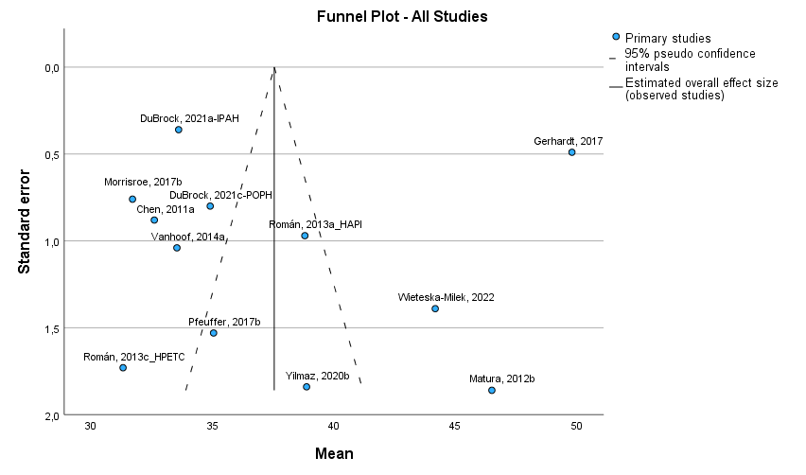
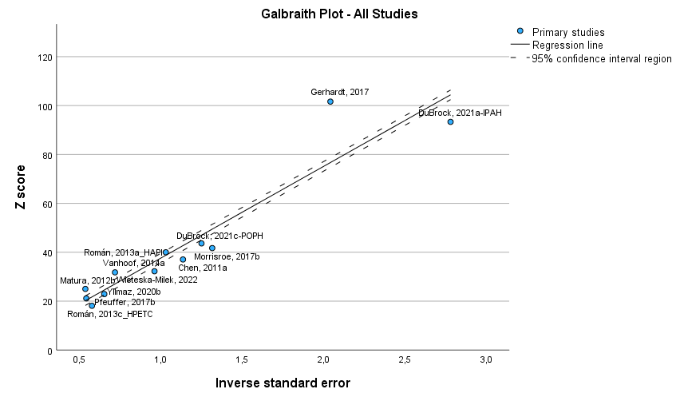

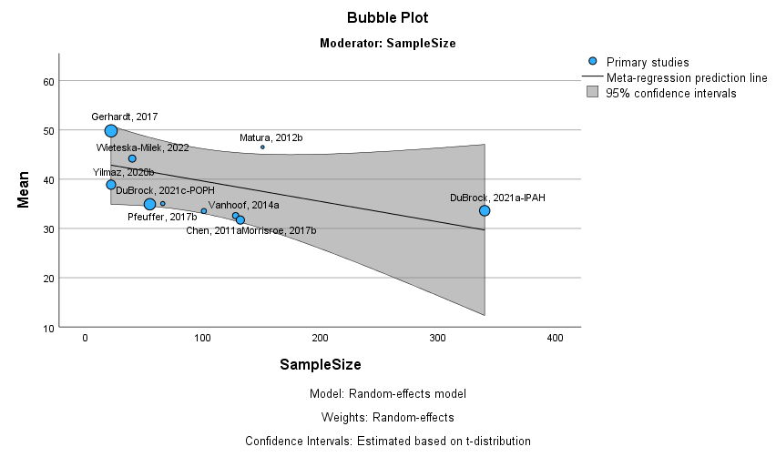
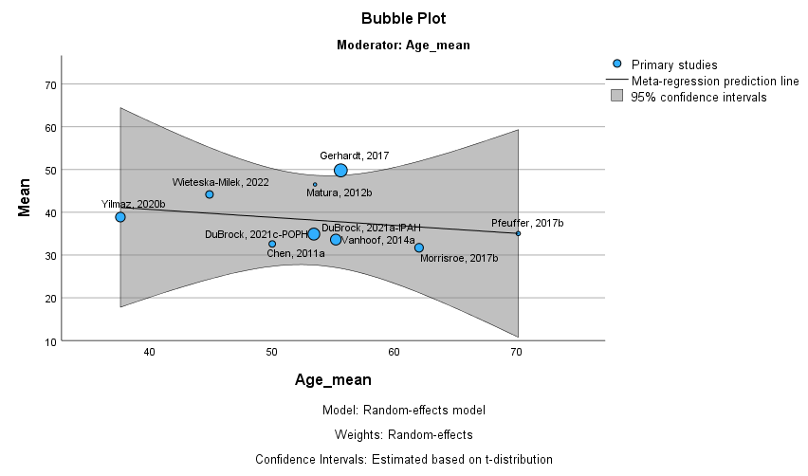

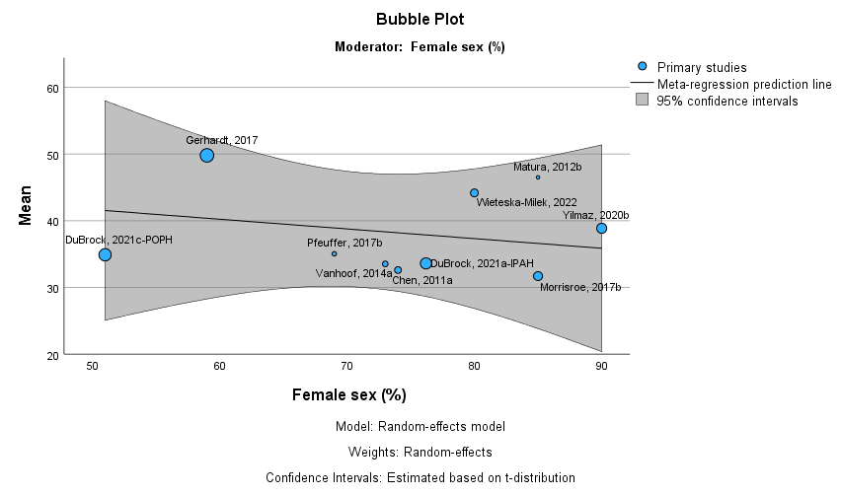
Instrument_n = SF36, Dim_n = MCS

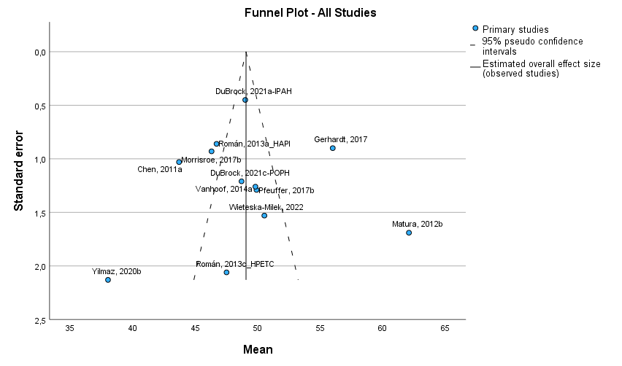

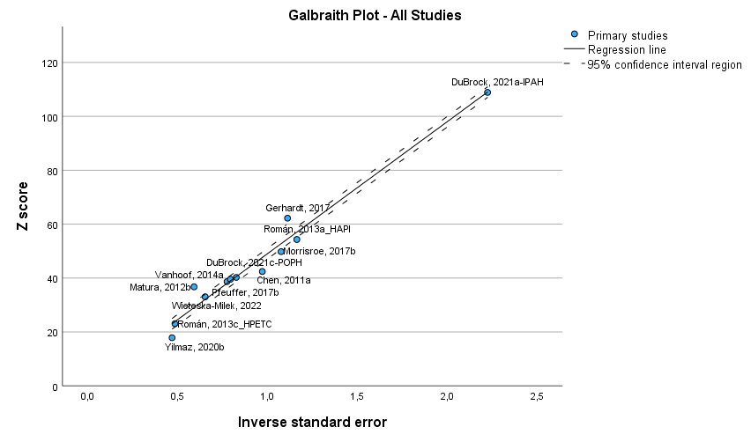
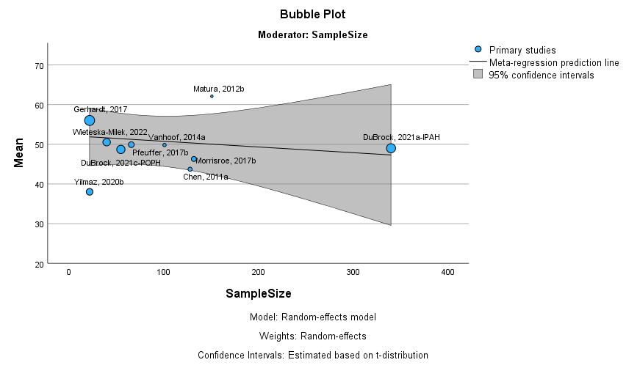
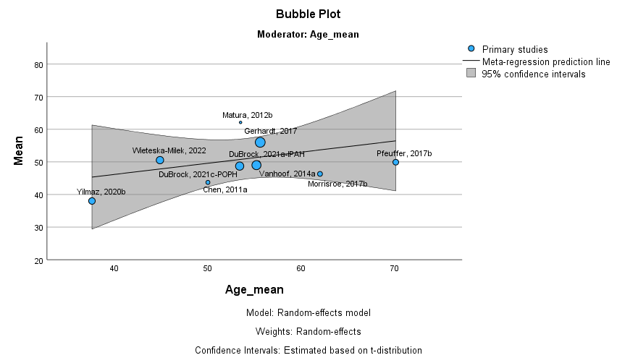
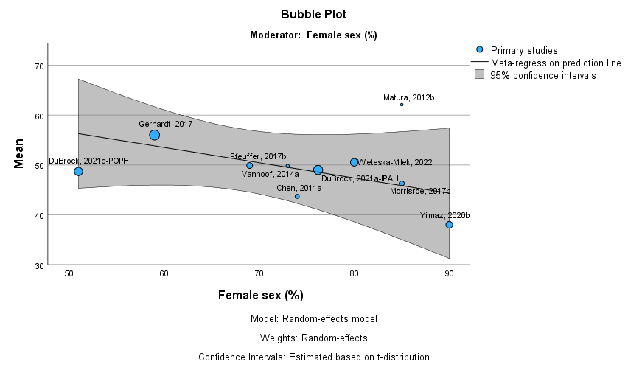

Instrument_n = SF12, Dim_n = PCS
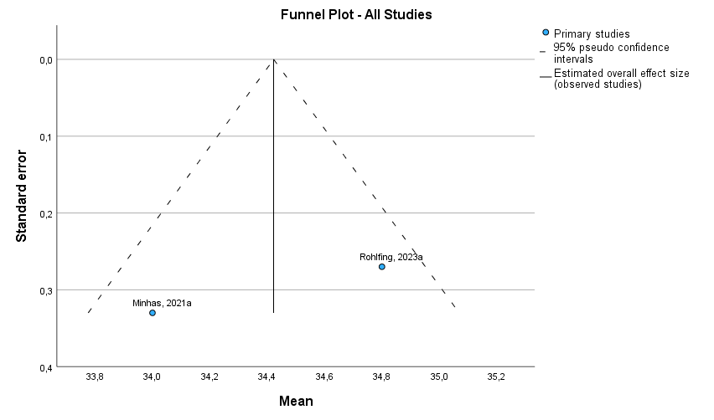
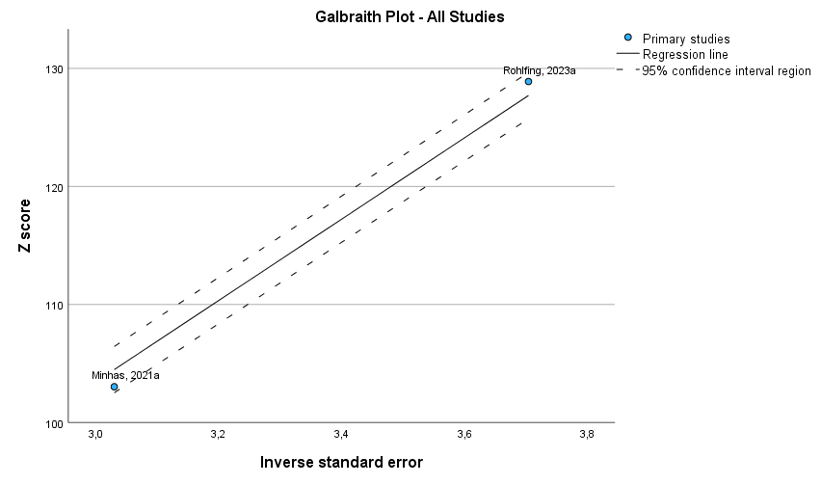

Instrument_n = SF12, Dim_n = MCS
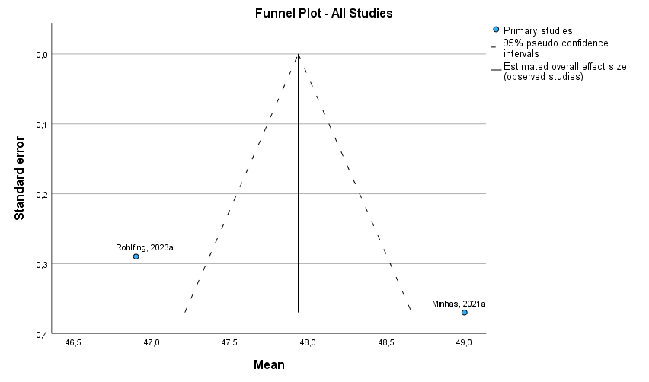
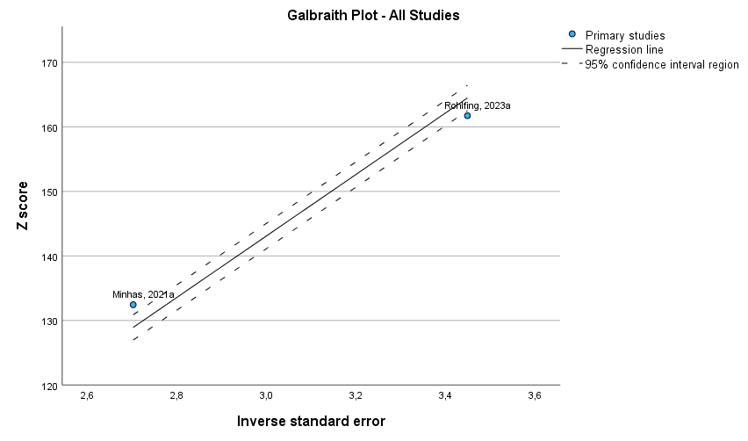

Instrument_n = EMPHASIS-10
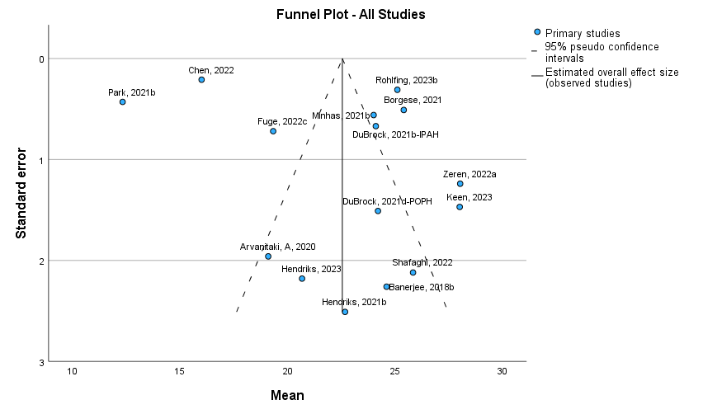

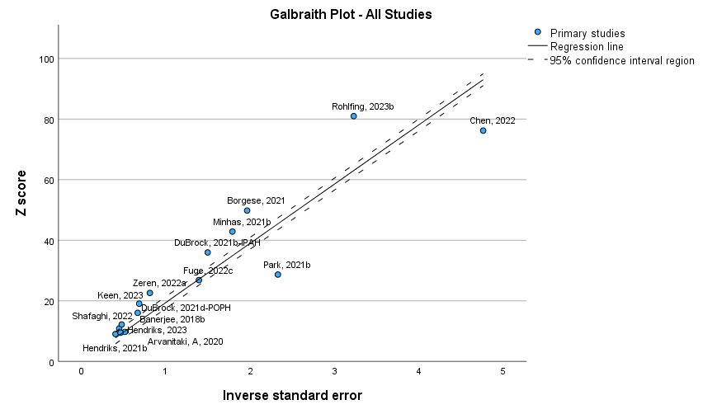

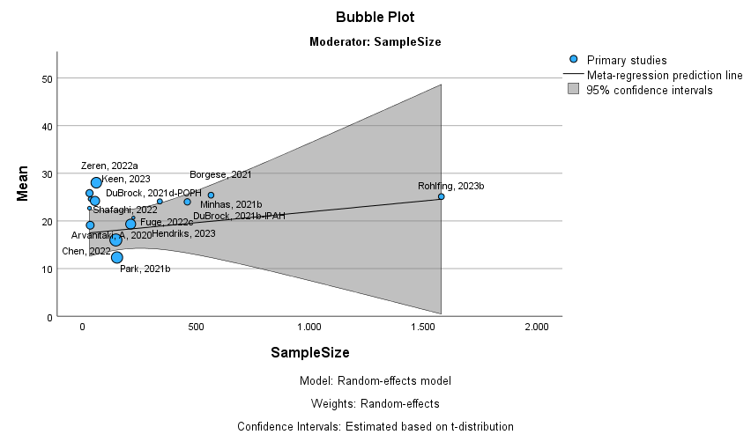
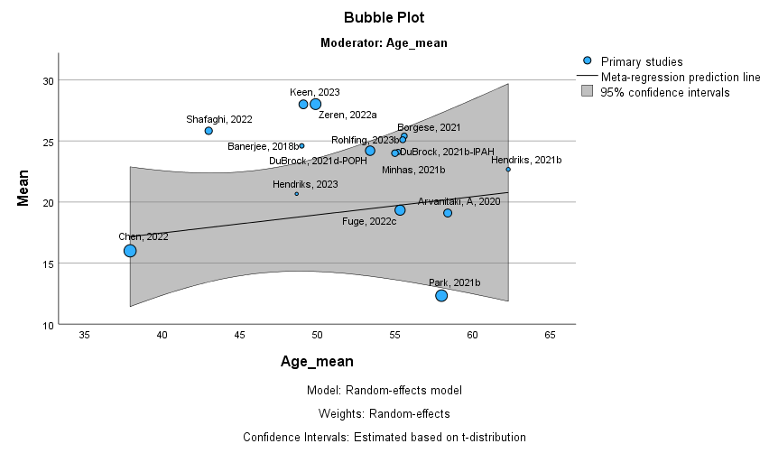
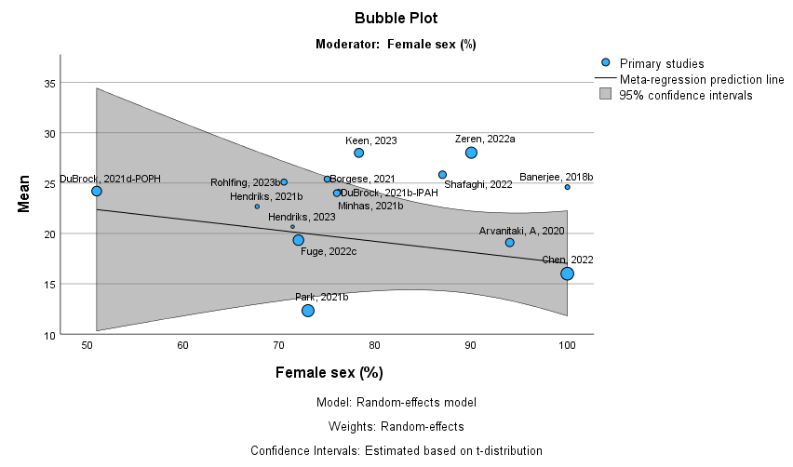
Instrument_n = EQ5D
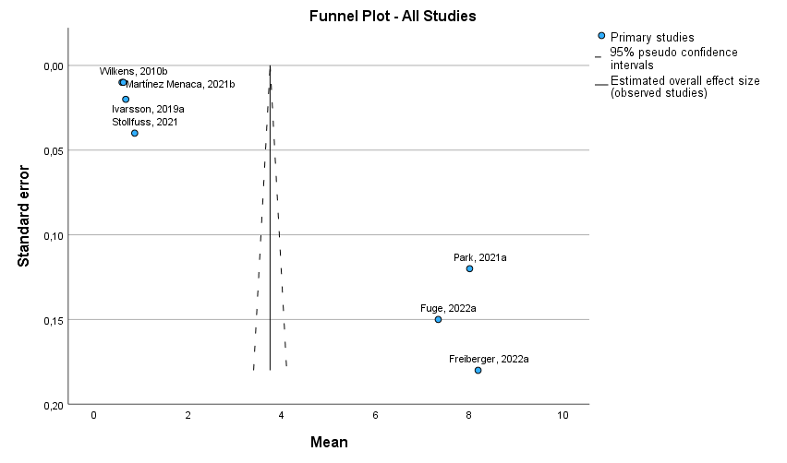

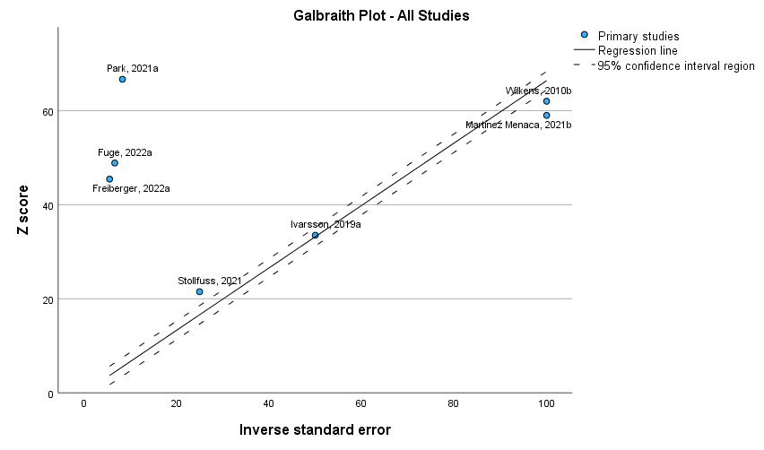
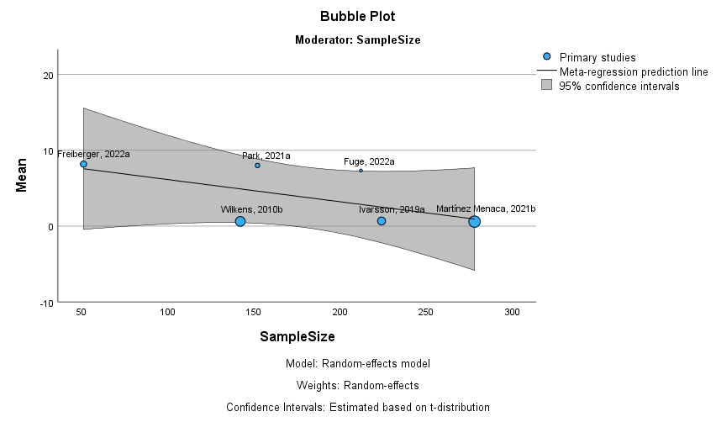
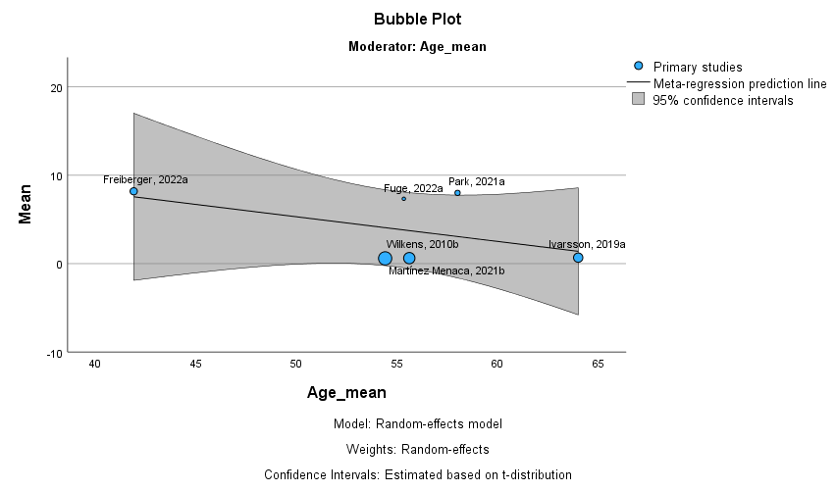
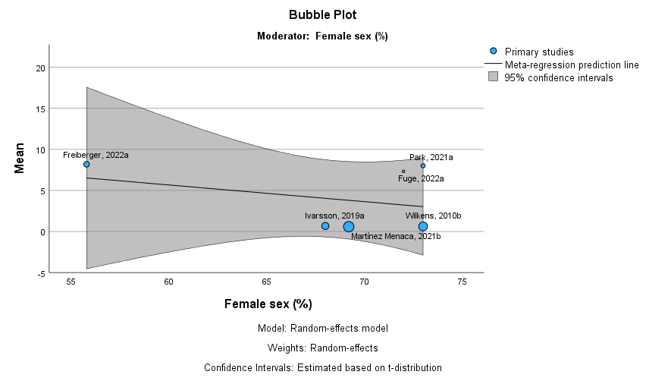

Instrument_n = EQ5D VAS

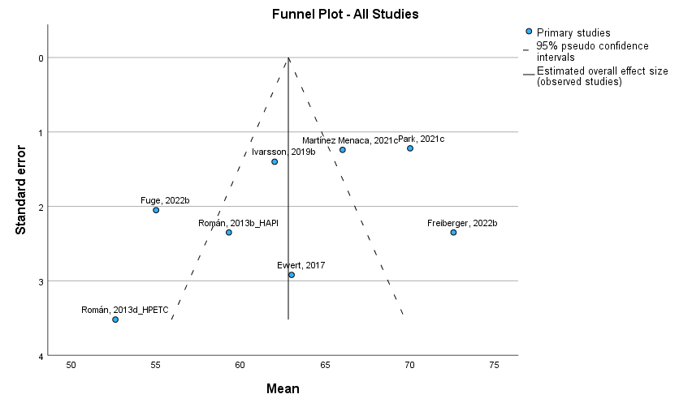

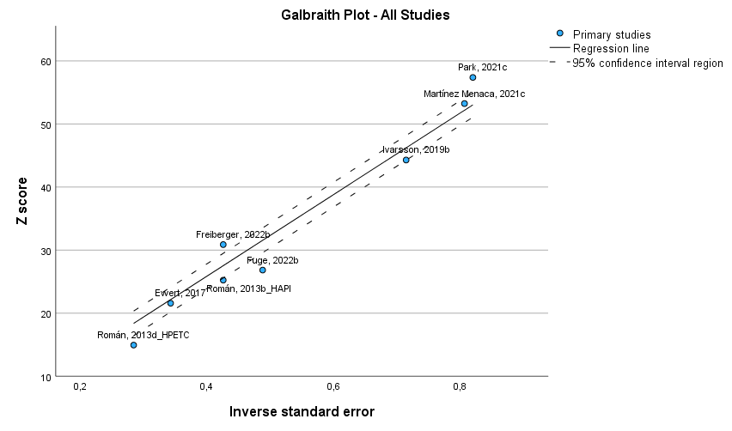
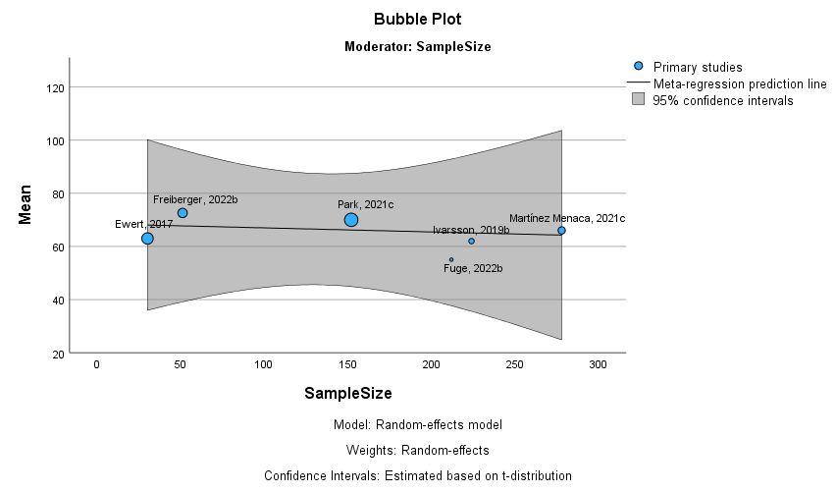
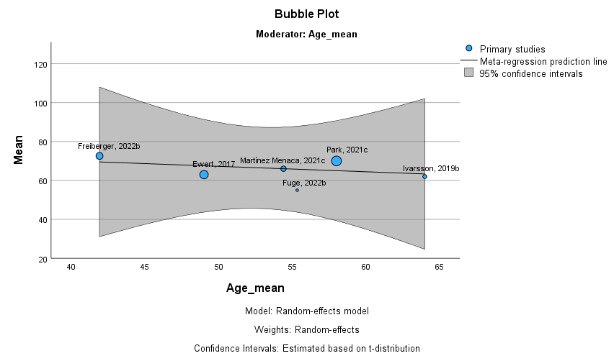
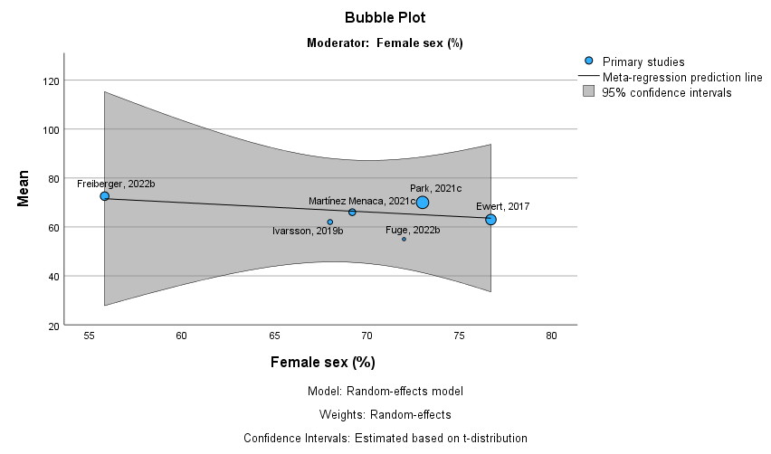

Supplementary File 4: Geographical distribution of included studies

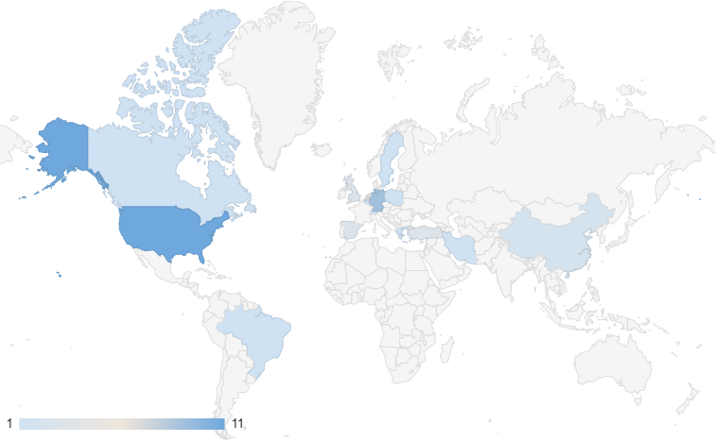

Supplementary File 5: Patients’ clinical characteristics
 | Idiopathic n(%) | Congenital heart disease n(%) | Heritable n(%) | Connective tissue disease n(%) | Drug and toxin induced n(%) | Portal hypertension n(%) | HIV infection n(%) | PVOD n(%) | FC_I n(%) | FC_II n(%) | FC_III n(%) | FC_IV n(%) | TREATMENT n(%) | OXYGEN n(%)
Aguirre-Camacho,A., 2018 | 31(48) | 9(14) | 6(9) | 5(8) | 4(6) | 1(1,5) | 1(1,5) |  |  |  |  |  |  | 21(32)
Arvanitaki, A, 2020 | 5(15) | 12(35) | 1(3) | 13(38) |  | 3(9) |  |  | 3(9) | 24(70) | 5(15) | 2(6) | Monotherapy: 22(65)  Double combination: 6(18)  Triple combination: 6(18)
Banerjee, 2018 | 21(60) | 2(6) | 1(2,8) | 4(11) | 0 | 0 | 0 |  | 5(15) | 22(67) | 6(18) | 0(0) | Calcium channel blockers: 2(7)  Phosphodiesterase type 5 inhibitors: 27(93)  Endothelin receptor antagonists: 19(66)  Riociguat: 0(0)  Oral prostacyclin analogues: 3(10)  Intravenous or subcutaneous prostacyclin analogues: 14(48)  Inhaled prostacyclin analogues: 0(0) | 3(8,6)
Batt, 2014 | 12(100) |  |  |  |  |  |  |  | 0 | 10(83) | 2(16) | 0 | Sildenafil: 8 (67)  Tadalafil: 2 (16)  Bosentan: 3 (25)  Ambrisentan: 2 (16)  Sitaxsentan: 1 (8)  Epoprostenol: 1 (8)
Borgese, 2021 | 224(39,6) | 30(5,3) | 19(3,4) | 181(32) | 66(11,7) | 36(6,4) | 9(1,6) |  | 43(8,2) | 172(32,6) | 276(52,4) | 36(6,8)
Chen, 2011 | 50(39) | 3(2) |  | 36(28) | 11(9) | 16(13) | 6(5) |  | 8(6) | 45(35) | 66(52) | 9(7) | Intravenous or subcutaneous prostacyclin infusion: 49 (38)  Inhaled prostacyclin: 4 (3)  Oral endothelin receptor antagonist: 82 (64)Oral phosphodiesterase-5 inhibitor: 41 (32)
Chen, 2022 |  |  |  |  |  |  |  |  | 12(8) | 67(45) | 68(46) | 0
DuBrock, 2021
DuBrock, 2022 | 43(39) | 13(12) | 6(5) | 42(38) | 3(3) | 1(1) | 1(1) |  | 15(14) | 46(43) | 39(36) | 7(7) | Calcium channel blocker: 11 (10)  Phosphodiesterase 5 inhibitor: 77 (70)  Soluble guanylate cyclase stimulator: 7 (6)  Endothelin receptor antagonist: 67 (61)  Oral or inhaled prostacyclin pathway agent: 31 (28)  Parenteral prostacyclin: 16 (15)
Ewert, 2017 | 30(100) |  |  |  |  |  |  |  | 0(0) | 5(16,7) | 23(76,7) | 2(6,7) | ERA: 28 (93.3)  PDE5I: 28 (93.3)  Riociguat: 1 (3.3)  Inhaled prostanoids: 4 (13.3)  Subcutaneous prostanoids: 25 (83.3)  Intravenous prostanoids: 5 (16.7)
Freiberger, 2022 |  | 51(100) |  |  |  |  |  |  | 33(66) |  | 15(30) | 2(4)
Fuge, 2022 | 12(6) | 0 | 21(10) | 21(10) | 4(2) | 0 | 0 | 3(1) | 0 | 78(37) | 17(8) | 10(5)
Gerhardt, 2017 | 14(64) |  |  | 6(27) |  |  |  |  |  | 13(59) | 9(41) |  | PDE5i monotherapy: 7 (32)  ERA+PDE5i: 7 (32)  ERA+sGC-S: 3 (14)  ERA+PDE5i+PCA: 3 (14)  PDE5i+TKI: 1 (4)  ERA+PDE5i+TKI: 1 (4)
Hendriks, 2021 |  |  |  |  |  |  |  |  | 0 | 6(19,4) | 21(67,7) | 4(12,9)
Hendriks, 2023 | 17(34,7) | 7(14,3) | 9(18,4) | 7(14,3) |  | 4(8,2) |  |  | 8(16,3) | 25(51,0) | 9(18,4) | 7(9) | PDE5-inhibitor: 47 (95.9)  ET-1 antagonist: 44 (89.8)  Riociguat: 0 (–)  Selexipag: 12 (24.5)  Pump therapy: 16 (22.7)  Intravenous: 8 (50.0)  Subcutaneous: 4 (25.0)  Lenus Pro: 4 (25.0) | 5(10,2)
Ivarsson, 2019 | 112(50) |  |  | 67(30)
Keen, 2023 |  |  |  |  |  |  |  |  |  | 4(6,7) | 49(81,7) | 7(11,7)
Koudstaal, 2019
Kwant, 2022 | x |  | x |  | x |  |  |  | 37(100) |  |  |  | Endothelin antagonists: 27 (75.0)  Phosphodiesterase inhibitors: 33 (91.7)  Postacyclin p.o: 7 (19.4)  Postacyclin i.v.: 5 (13.9)  Calcium antagonists: 3 (8.3)  Diuretics: 19 (52.8)  Vitamin K antagonists: 19 (52.8)
Martínez Menaca, 2021 |  |  |  |  |  |  |  |  | 117(63.6) |  | 67(36.4)
Matura, 2012 |  |  |  |  |  |  |  |  | 21(14) | 24(16) | 39(26) | 67(44) | Calcium channel blockers: 36 (27)  ERA: 67(50)  PDE-5: 81(60)  Prostanoids: 58(43)  Diuretics: 87(65)  Digoxin 21(169)
McCabe, 2013 | 87(100) |  |  |  |  |  |  |  |  | 8(9) | 61(71) | 17(20)
Minhas, 2021 | 461(100) |  |  |  |  |  |  |  | 50(11.7) | 144(33.8) | 206(48.4) | 26(6.1) | PDE5 inhibitors: 200(43.4)  ERA: 160(34.7)  Parenteral prostacyclin: 78(16.9)  Inhaled prostacyclin: 5(1.1)  Selexipag: 11(2.4)  Riociguat: 12(2.6)  Any combination: 176(38.2) | 140(30.4)
Morrisroe, 2017 |  |  |  | 132(100) |  |  |  |  | 3(2.3) | 23(17.4) | 79(59.9) | 12(9.1) | Monotherapy: 91 (68.9)  Combination therapy: 41(31.1) | 28 (21.5)
Nakazato, 2021 | 16(80) | 4(20) |  |  |  |  |  |  | 7(35) | 10(50) | 3(15) |  | Monotherapy (sildenafil): 8 (40)  Combination therapy (sildenafil + bosentan/ambrisentan): 10 (50)  No therapy (only calcium channel blocker): 2 (10)
Park, 2021 | 80(53) |  | 17(11) |  |  |  |  | 2(1) | 16(11) | 72(48) | 63(41) |  | PDE5i: 126 (83)  - ERA: 121 (80)  - PCA (Selexipag and Treprostinil): 42 (28)  - TKI: 5 (3)  - sGCs: 15 (10)  - CCB: 21 (14)
Park, 2022 | 122(56) |  | 25(12) |  |  |  |  |  | 20(9) | 92(43) | 93(43) | 10(5) | -Monotherapy: 44 (20)  -Double combination therapy: 102 (47)  -Triple combination therapy: 71 (33)
Pellino, 2018 |  |  |  |  |  |  |  |  | 48(17) |  | 229(83) |  | Combination therapy: 121(43)  IV epoprostenol: 42(15)
Pfeuffer, 2017
Rohlfing, 2023 | 548(34.7) |  |  | 418(26.5) |  |  |  |  | 122(7.7) | 531(33.7) | 719(45.6) | 95(6.0) | Parenteral prostanoid use: 289(18.3) | 653(41.4)
Román, 2013 | 76(48.7) | 9(5.7) | 5(3.2) | 8(5.1) | 2(1.2) |  |  | 23(14.7)
Saglam, 2015 | 8(25.8) | 7(22.6) |  | 16(41.7) |  |  |  |  |  | 16(51.6) | 15(48.4) |  | Bosentan 10(32.3), ilioprost 7(22.6), Sildenafil 3 (9.7)
Shafaghi, 2022 | 31(100) |  |  |  |  |  |  |  |  |  |  |  | Macitentan 31(100)
Shafazand, 2004 |  |  |  |  |  |  |  |  | 15(28) |  | 26(49) | 12(23) | Epoprostenol 28 (52) | 27(51)
Stollfuss, 2021 |  |  |  |  |  |  |  |  |  |  |  |  | Inhaled iloprost 18(100)
Tonelli, 2015 |  | 2(6) |  |  |  | 6(18) | 1(3) |  |  |  |  |  | PH specific 24(71): oral 15(63), parenteral or inhaled 9(37)
Ulrich, 2010 | 16(100) |  |  |  |  |  |  |  | 1(6) | 8(50) | 7(46)
Vanhoof, 2014 | 33(32.7) | 17(16.8) |  | 18(17.8) | 13(12.9) | 12(11.9) |  |  | 19(18.8) | 43(42.6) | 32(31.7) | 7(6.9) | Prostacyclin analogs  Intravenous: 8 (7.9)  Subcutaneous: 8 (7.9)  Inhalation: 1 (1.0)  Endothelin receptor antagonists: 70 (69.3)  PDE5: 57 (56.4)
Von Visger, 2018 |  |  |  |  |  |  |  |  | 4(3.8) | 52(48.1) | 47(43.5) | 5(4.6)
White, 2006 |  |  |  |  |  |  |  |  | 2(4.3) | 9(19.6) | 34(67.4) | 1(2.2) | Vasodilators: 25 (54.3)  Calcium Channel Blockers: 16 (34.8)  Endothelial Receptor Antagonists: 15 (32.6)  Epoprostenol: 12 (25.5)  Treprostinil: 16 (34.8) | 30(65.2)
Wieteska-Milek, 2022 | 22(55) | 5(12.5) | 3(7.5) | 9(22.5) |  | 1(2.5) |  |  | 2(5) | 33(82.5) | 5(12.5) |  | PDE5i/sCG: 35 (87.5)  ERA: 30 (75)  Prostacyclin/IP receptor agonist: 20 (50)  Monotherapy: 11 (27.5)  Double combination therapy: 13 (32.5)  Triple combination therapy: 16 (40)
Wilkens, 2010 | 88(62) | 15(30) |  | 19(38) |  | 10(20) |  |  | 2(1) | 46(32) | 68(48) | 9(6)
Yilmaz, 2020
Zeren, 2022 | 35(57) | 26(43) |  |  |  |  |  |  | 23(38) | 22(36) | 16(26) |  | ERA: 15 (25)  PDE5i: 7 (11)  ERA + PDE5i: 11 (18)  ERA + PDE5+PCA: 8 (13)

*Note: (CCB) Calcium Channel Blocker, (ERA) Endothelin Receptor Antagonist, (PDE5i) Phosphodiesterase Type 5 Inhibitor (PCA) Prostacyclin Analog, , (sGCs) Soluble Guanylate Cyclases, (TKI)Tyrosine Kinase Inhibito

Supplementary File 6 Forest plot for PCS dimension Assessment of QoL by SF12.
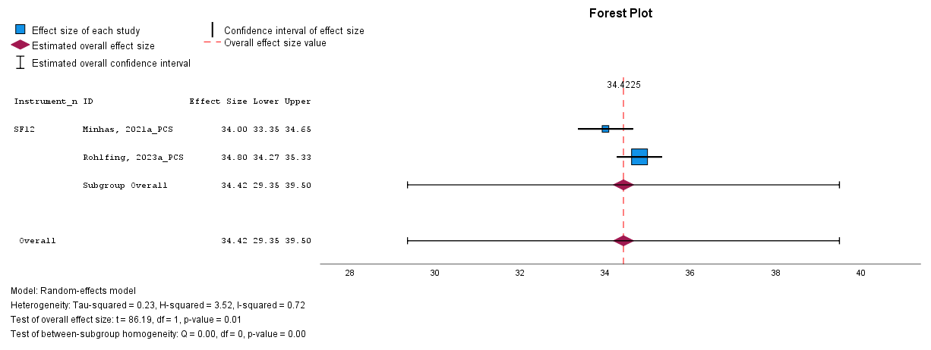

Supplementary File 7: Forest plot for MCS dimension Assessment of QoL by SF12.

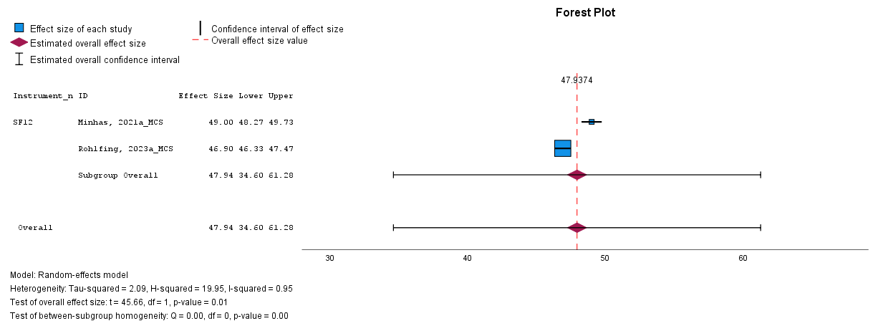

Supplementary File 8: Forest plot for Assessment of QoL by EQ5D.

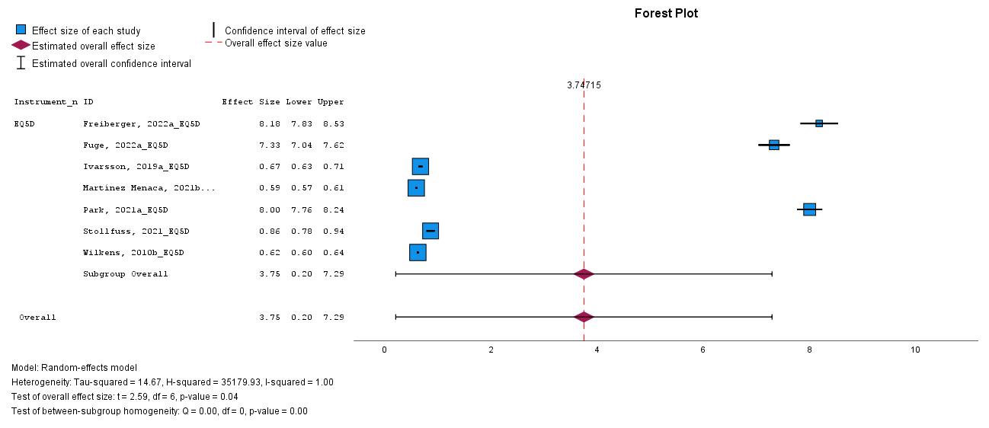

Supplementary File 9: Forest plot for Assessment of QoL by EQ5D VAS.

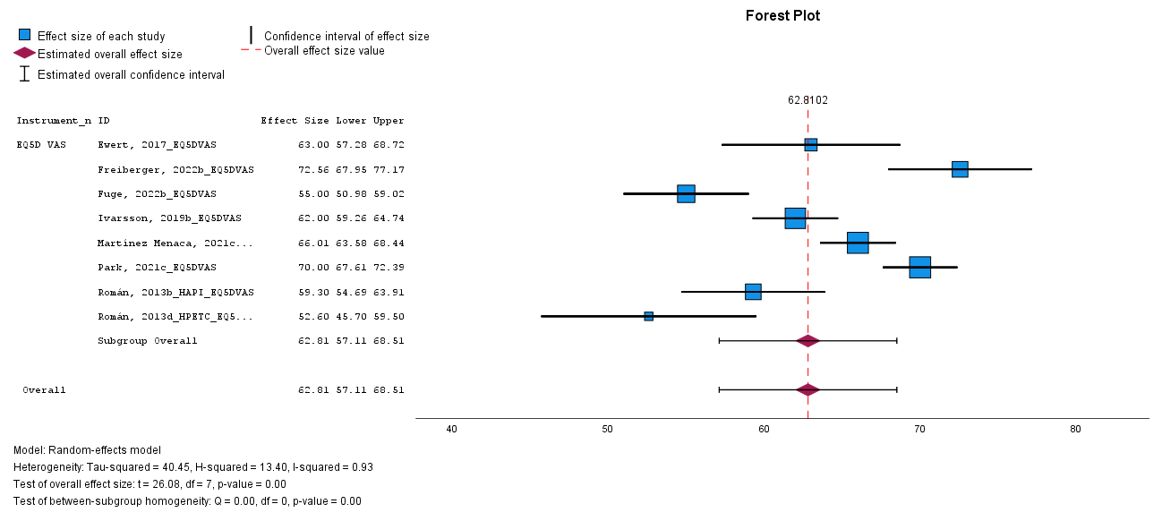

Supplementary File 10: Forest plot for Assessment of QoL by EMPHASIS-10.
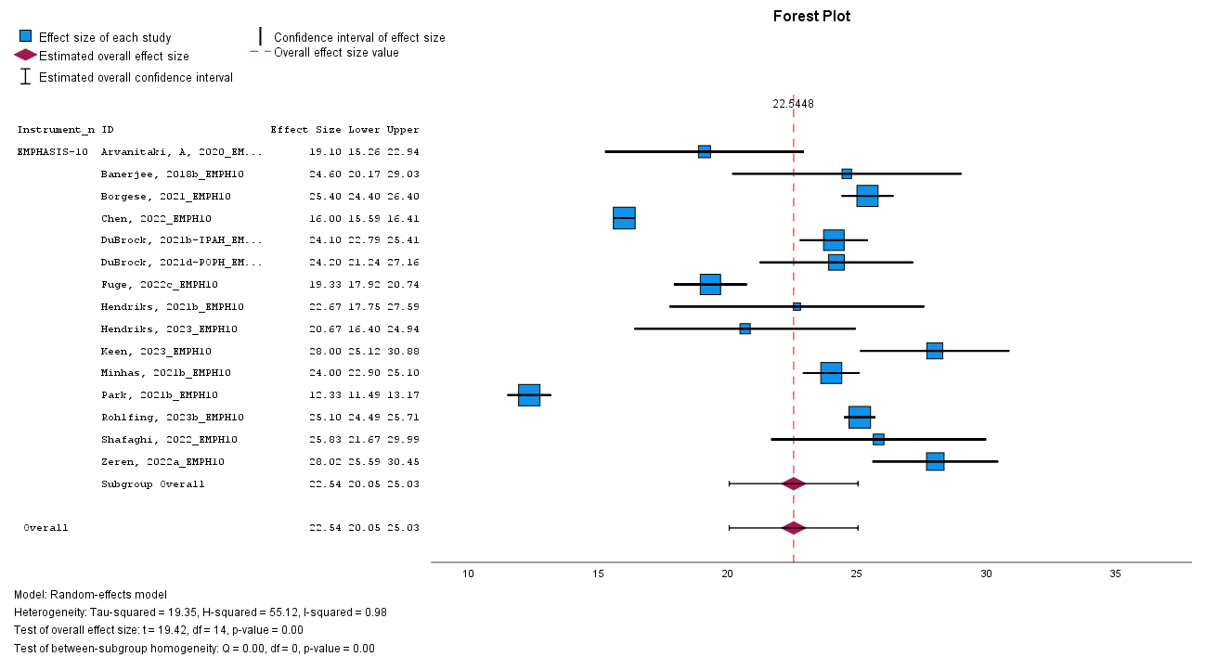

Supplementary File 11: Forest plot for Assessment of QoL by CAMPHOR.
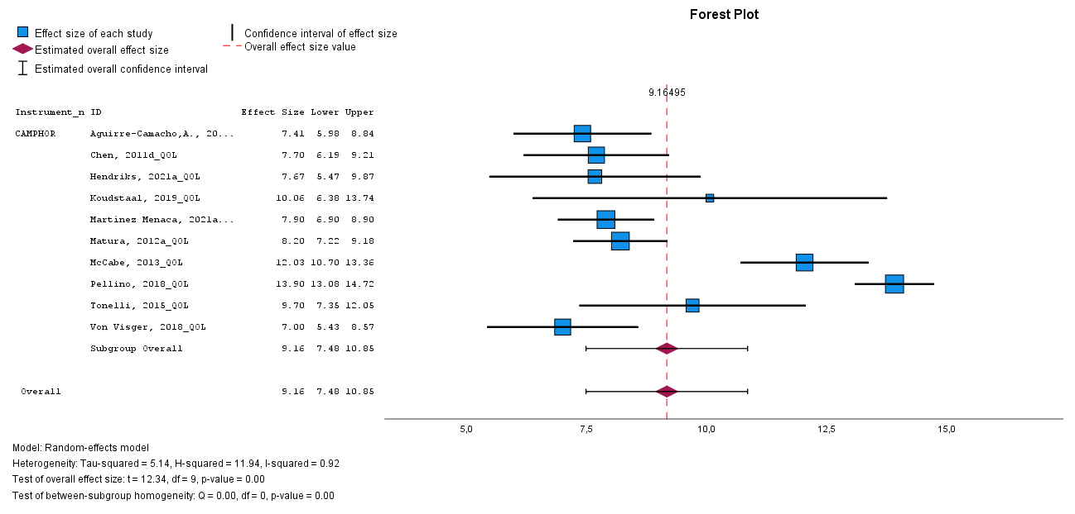

Supplementary File 12: Forest plot for Assessment of QoL by MLHFQ.
