Supplementary material
Title: Health-Related Quality of Life Inequity and Influencing Factors among Urban and Rural Elderly Hypertensive Populations: Baseline Survey of the Northern China Lifestyle Medicine Cohort.
Supplementary Methods
Fig.S1: Common support domain of PSM for urban and rural areas.
Fig.S2-5: Standardized contribution rates for urban and rural areas among different genders (male and female).
Table S1: The Composition of C-MMAS-8 and adapted item
Table S2: Imputation Variable Types and Models
Table S3: Basic characteristics of the respondents-all variables
Table S4: Factors associated with HRQoL scores among urban and rural participants-Tobit regression model results (all variables)
Table S5: Basic characteristics of urban populations.
Table S6: Basic characteristics of rural populations.
Table S7: PSM balance test for the urban and rural samples.
Table S8: The mean of HUV/VAS for the urban and rural samples.
Table S9: Results of the Stratified analysis (HUV and VAS).
Table S10: Sensitivity Results -Tobit regression model results
Table S11: Sensitivity Results -Logistic regression model results
Table S12: Factors associated with 5L issues among urban and rural participants-Logistic regression model results (unadjusted OR).
Supplementary References
1 Supplementary Methods
1.1 Medication Adherence Assessment
Medication adherence was measured using an adapted version of the Chinese 8-item Morisky Medication Adherence Scale (C-MMAS-8) in this study, with established reliability and validity in Chinese chronic disease populations[1-3]. In this study, we only revised the wording of questions to enhance local comprehensibility, without altering the 8-item content or scoring rules, higher scores still indicate better medication adherence. In this study, the scale showed good internal consistency (Cronbach’s $α$ = 0.745) and acceptable validity (validity coefficient = 0.834), consistent with previous validation findings.
1.1.1 Development History
C-MMAS-8 is a mature self-assessment scale derived from the 8-item Morisky Medication Adherence Scale (MMAS-4), with the complete development process as follows:
The original MMAS-4 laid the foundation for assessing adherence in patients with hypertension. It primarily captures whether patients forget to take their medication, are sometimes careless or negligent with their medication, stop taking medication when they feel better, or stop taking it when symptoms worsen after taking medication—four types of non-adherence scenarios. It is an early exploration of multi-item adherence questionnaires, laying the groundwork for future expansion[4]. In 2014, the C-MMAS-8 was validated in a group of myocardial infarction patients(Cronbach's $α$ coefficient is 0.77, pre- and post-test correlation coefficient of 0.88), which consists of 8 questions that require a dichotomous reply from the patients for the first 7 questions, the last is answered using a 5-point Likert scale, the total score is 8 points, with a score of ≥6 defined as good medication adherence, otherwise it is considered poor. [2]. The C-MMAS-8 scale was applied to the population with hypertension in 2019 [3]. In this study, Cronbach's $α$ coefficient was 0.745, which is at an acceptable level.
1.1.2 Composition
Based on the content of the Northern China Lifestyle Medicine Cohort (NCLM-Cohort) study, some items of the C-MMAS-8 were appropriately adjusted to facilitate data collection. The specific composition and scoring method are as follows:
Table S1 The Composition of C-MMAS-8 and adapted item
C-MMAS-8 item | Adapted item | Scoring Method
1.Do you sometimes forget to take your medicine? | 1.Do you sometimes forget to take your diabetes/hypertension medication? | Answering yes scores 0 points, no scores 1 point
2.People sometimes miss taking their medications for reasons other than forgetting. Thinking over the past 2 weeks, were there any days when you did not take your medicine? | 2.In the past two weeks, have you ever forgotten to take your diabetes/hypertension medication? | Answering yes scores 0 points, no scores 1 point
3.Have you ever cut back or stopped taking your medication without telling your doctor, because you felt worse when you took it? | 3.During medication, when you felt your symptoms worsening or experienced other symptoms, did you reduce the dosage or stop taking the medication on 4your own without informing your doctor? | Answering yes scores 0 points, no scores 1 point
4.When you travel or leave home, do you sometimes forget to bring along your medication? | 4.When you go out or are not at home, do you sometimes forget to carry your medication with you? | Answering yes scores 0 points, no scores 1 point
5.Did you take your medicine yesterday? | 5.Did you take your medication yesterday? | Answering yes scores 1 point, no scores 0 points
6.When you feel like your illness is under control, do you sometimes stop taking your medicine? | 6.When you feel that your diabetes/hypertension is under control, do you sometimes stop taking your medication? | Answering yes scores 0 points, no scores 1 point
7.Taking medication everyday is a real inconvenience for some people. Do you ever fell hassled about sticking to your treatment plan? | 7.For some people, it is indeed inconvenient to take diabetes/hypertension medication every day. Do you find it difficult to adhere to a lifelong medication regimen? | Answering yes scores 0 points, no scores 1 point
8.How often do you have difficulty remembering to take all your medications? | 8.How often do you forget to take your medication? | For answers Never, Rarely, Sometimes, Often, Always, assign 1, 0.75, 0.5, 0.25, 0 points respectively
Note：C-MMAS-8 indicates Chinese 8-item Morisky Medication Adherence Scale.
1.2 Statistical analysis
1.2.1 Propensity score matching (PSM) [5, 6]
The propensity score is the probability of treatment assignment conditional on observed baseline characteristics. The classic theory of propensity score was proposed by Rosenbaum & Rubin (1983, 1985)，and in 2011, Austin published a standardized methodological framework for PSM. The 1:2 nearest neighbor PSM in this study is an extended application of the classic nearest neighbor matching framework, where one treated unit is matched with two control units that have the closest propensity scores (within the common support region). The specific implementation procedures and core diagnostic criteria are as follows.
Step 1: Definition and screening of core variables
- Treatment assignment variable: Define binary treatment indicator $z_{i}$ (1 = treatment group, 0 = control group) for each study unit $i$, adhering to the binary treatment framework of PSM foundational theory. In this study, the treatment group consisted of urban subjects and the control of rural subjects.
- Select baseline covariates${ x}_{i}$ (all measured prior to treatment assignment) based on the principle that affect treatment variable and are related to the outcome. In this study, age, educational attainment, living status, duration of hypertension, and sleep duration were ultimately selected as covariates.
Step 2: Estimation of the propensity score
- Propensity score definition: Calculate the propensity score $e\left(x_{i}\right)=Pr\left(z_{i}=1|x_{i}\right)$ for each unit—the conditional probability of receiving the treatment given the observed baseline covariates;
- Model fitting for propensity score estimation: Adopt the logistic regression model with treatment assignment $z_{i}$ as the dependent variable and pretreatment covariates $x_{i}$​ as independent variables.
- Sample propensity score calculation: Derive the estimated propensity score $\hat{e}\left(x_{i}\right)$ for each unit as the predicted probability from the fitted logistic regression.
Step 3: 1:2 Nearest neighbor matching implementation
- 1:2 matching rule: For each treated unit $\left(z=1\right)$within the common support region, select two control units $\left(z=0\right)$with the smallest absolute differences in estimated propensity scores $\hat{e}\left(x_{i}\right)$ from the control reservoir.
- Matched sample construction: Form the final 1:2 matched sample consisting of treated units and their corresponding two matched control units.
Step 4: Estimation of causal treatment effects
- Unit-level effect calculation: For each treated unit and its two matched control units, calculate the mean outcome of the two control units, and then compute the individual treatment effect as the difference between the treated unit’s outcome and the mean outcome of its matched controls.
- Average treatment effect (ATE) estimation: The average treatment effect for the treated (ATT) is the mean of all individual treatment effects in the matched sample.
- Statistical inference: For continuous outcomes in this study (Health utility value (HUV) and visual analogue scale (VAS) scores), use paired t-tests (adapted for 1:2 matched data) to assess the statistical significance of the ATT.
Core Diagnostic Criterion 1: Covariate balance conditional on the propensity score (Balance Test)
After matching, an independent-samples t-test revealed no significant differences for the same variables between the experimental group and the control group (P > 0.05), indicating a satisfactory matching outcome. If the P-value for any variable between the two groups was less than 0.05 post-matching, covariates would need to be replaced or added. Through repeated trials, the final matching in this study was performed based on the treatment variable (residential address) and the covariates (age, educational attainment, living status, duration of hypertension, and sleep duration).
Core Diagnostic Criterion 2: Validity of the common support region
All units in the final matched sample fall within the common support region, the propensity score distribution of the matched control group is highly consistent with that of the treated group, with no obvious separation or skewness.
1.2.2 The Shapley value decomposition[7]
In this study, Shapley value decomposition was used to quantify the relative contributions of multiple groups of variables—including demographic, lifestyle, clinical and health factors—to the variance in difficulty in reporting 5L issues. The implementation strictly follows the logic of variable preparation to model specification to contribution calculation. The detailed reproducible steps are as follows.
Step 1: Variable Definition
- Outcome variables: Define binary outcome variables: For mobility (MO), self-care (SC), usual activities (UA), pain/discomfort (PD), and anxiety/depression (AD) issues, they were coded as “1 = reported the issue, 0 = did not report the issue” respectively.
- Explanatory variables: Categorize 18 factors into 3 mutually exclusive and collectively exhaustive domains (consistent with 2.2.2 Covariates assessment of the study), ensuring no overlap between domains to avoid double-counting of contributions
• Demographics: Age, gender, marital status, educational attainment, employment status, annual per capita income, and living alone.
• Lifestyle factors: Sleep, physical activity intensity, smoking status, and alcohol consumption status.
• Clinical and health factors: Body Mass Index, family history of hypertension, duration of hypertension diagnosis, medicine adherence, coexisting diseases, anxiety, and depression.
Step 2：Construction and Validation of Logistic Regression Models
For the outcome variables (K = 1~5, corresponding to MO, SC, UA, PD, and AD), the model form is:
$$logit\left[P\left(Y_{k}=1\right)\right]=β_{0k}+\sum_{g=1}^{3}{\sum_{j=1}^{m_{g}}{β_{kgj}X_{gj}}}$$
Among them, $β_{0k}$​ is the intercept, $g$ =1,2,3 corresponds to three groups of independent variables, $X_{gj}$ is the j-th variable in the g-th group, $β_{kgj}$​ is its regression coefficient.
The Hosmer-Lemeshow test was used (P>0.05, indicating good model fit); the pseudo $R^{2}$ was calculated as an indicator of the total explanatory power of outcome variation.
Step 3：Shapley value decomposition calculation
The Shapley value decomposition distributes the total explainable variance ($R^{2}$) among the 3 domains based on the marginal contribution of each domain in all possible subsets of explanatory variables. The specific calculation steps are as follows:
- Generate all possible variable subsets. For a total of $M$ variables (the total number of variables in three groups), there are $2^{M}-1$ non-empty subsets.
- Calculate the pseudo $R^{2}$ for each subset. For each subset $S$, fit a logistic regression model to obtain the pseudo $R^{2}$（$R_{S}^{2}$​).
- Calculate the marginal contribution. For the $j$-th variable $X_{gj}$ in group $g$, its marginal contribution in subset $S$ is:
$$∆R^{2}\left(S, X_{gj}\right)=R_{S}^{2}-R_{S\backslash \left\{X_{gj}\right\}}^{2}$$
Here, $R_{S\backslash \left\{X_{gj}\right\}}^{2}$​ is the pseudo $R^{2}$ of the subset after excluding $X_{gj}$​​.
- Calculate Shapley values (contribution proportion):
• Individual variable Shapley value:
$$∅_{kgj}=\sum_{S:X_{gj}∈S}{\frac{\left(\left|S\right|-1\right)!×\left(M-|S|\right)!}{M!}×∆R^{2}\left(S, X_{gj}\right)}$$
The weight $\frac{\left(\left|S\right|-1\right)!×\left(M-|S|\right)!}{M!}$ reflects the probability of the subset $S$ occurring.
• Group Contribution: The contribution of group $g$ to outcome $Y_{k}$is:
$C_{kg}={\sum_{j=1}^{m_{g}}{∅}}_{kgj}$, with a proportion of $\frac{C_{kg}}{\sum_{g=1}^{3}{C_{kg}}}×100\%$. And the Shapley value of a group equals the sum of the Shapley values of the individual variables.
• Total contribution: The total contribution of the three groups of variables to $Y_{k}$ is (the pseudo R2 of the full model): $Total{C​}_{k}=\sum_{g=1}^{3}{C_{kg}}​​$ .
1.2.3 Sensitivity analysis: Handling Missing Data with Multiple Imputation (MI)
All analysis procedures were carried out using the $mi impute chained$ package in Stata 17. 0. Among the 11,406 cases, the data missing rate ranged from 0.2% to 23.79%. For convenient multiple imputation and post-imputation analysis, dummy variables were set for both binary and ordinal categorical variables. For example, residence (0 for rural, 1 for urban), gender (0 for male, 1 for female), and educational attainment (0 for no schooling, 1 for primary school, 2 for junior high, 3 for high school and above).We considered 3 missing-data models, with a progressive increase in both the number of variables with missing data and the number of incomplete observations[8]:
- Model 1: Missing data on HUV and VAS.
- Model 2: As for model 1, with missing data on binary variables.
- Model 3: As for model 2, with missing data also on ordinal variables.
For detailed variables classification and imputation method, see the table below.

Table S2 Imputation Variable Types and Models
Variable | Example Variables | Imputation Method
continuous | HUV and VAS scores. | linear regression (REG)[9]
binary | Residential address, sex, marital status, employment status, annual per capita income, living alone, Body Mass Index (BMI), family history of hypertension, compliance, combine, sleep, smoke status, alcohol consumption status, anxiety, depression, MO, SC, UA, PD, and AD issues. | logistic regression (Logit)[9]
ordinal | Age, educational attainment, duration of hypertension diagnosis, physical activity intensity (MET). | predictive mean matching (PMM)[10]
Note：HUV indicates health utility value; EQ VAS, visual analog scale; MO, mobility; SC, self-care; UA, usual activities; PD, pain/discomfort; AD, anxiety/depression.
After three imputations, 15 new datasets were generated. In the newly generated 15 datasets, the urban variable size varies between 1,346 and 2,287, the rural variable size varies between 4,130 and 7,280. $Mi estimate$ and $cmdok$ packages in Stata version 17.0 were used to perform pooled logistic regression and Tobit regression. The $esampvaryok$ option allows for variation in the independent variable samples.
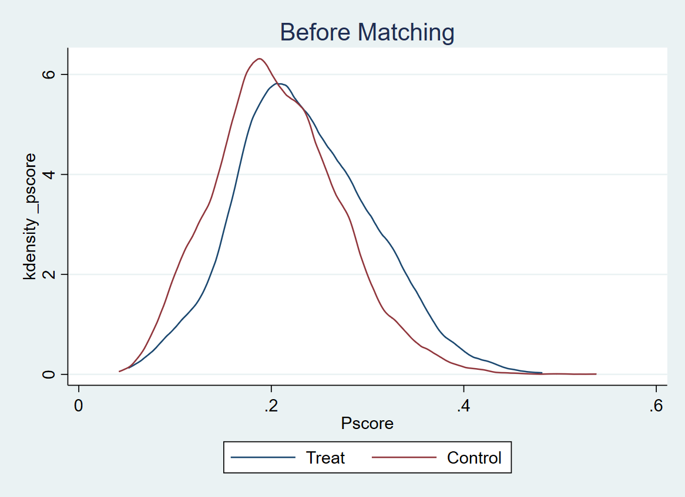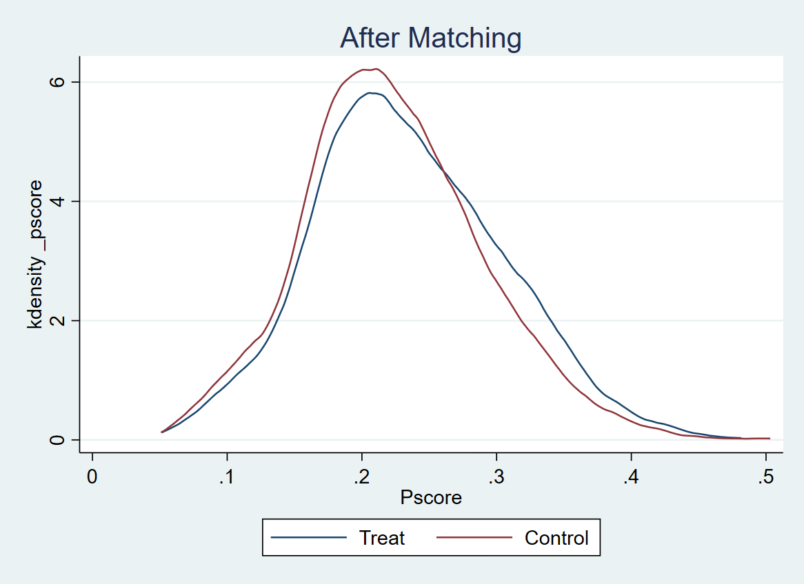
Fig.S1 Common support domain of PSM for urban and rural areas.
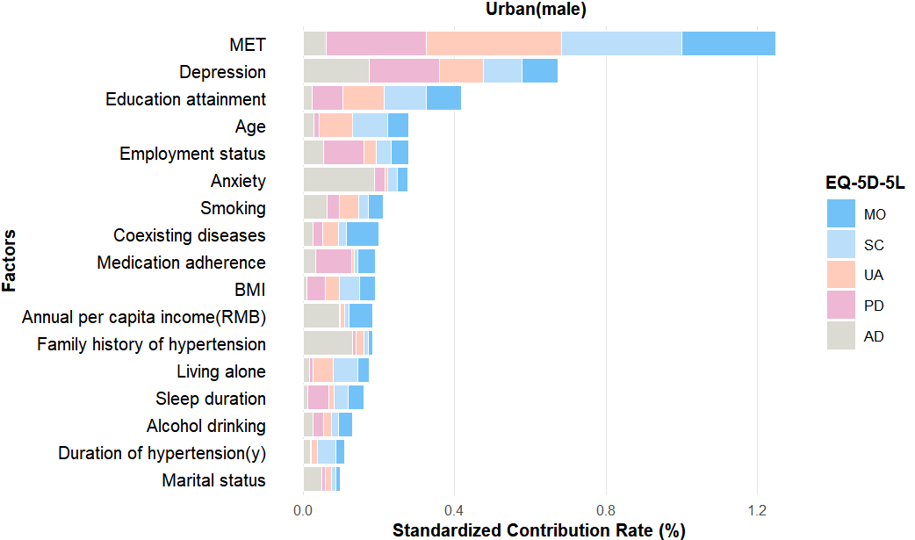
Fig.S2 Standardized contribution rates for urban areas among male.
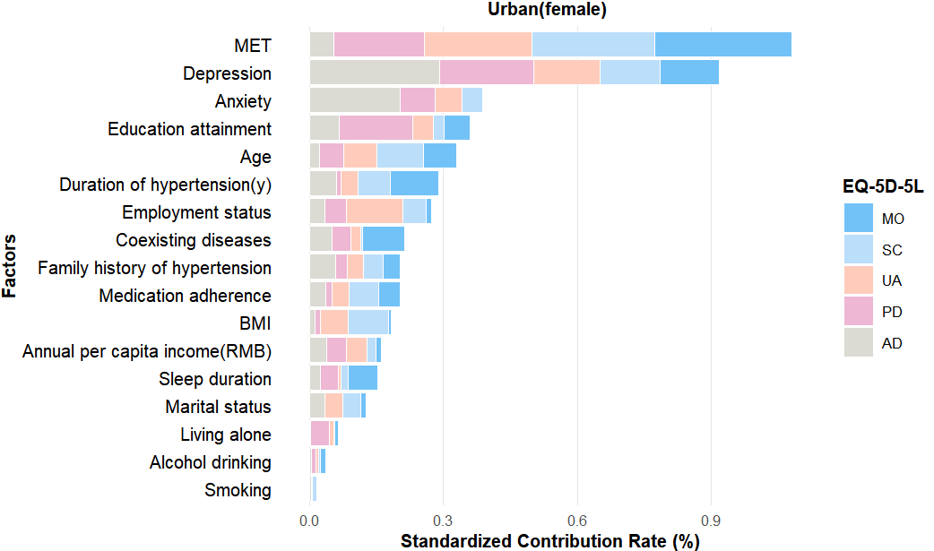
Fig.S3 Standardized contribution rates for urban areas among female.

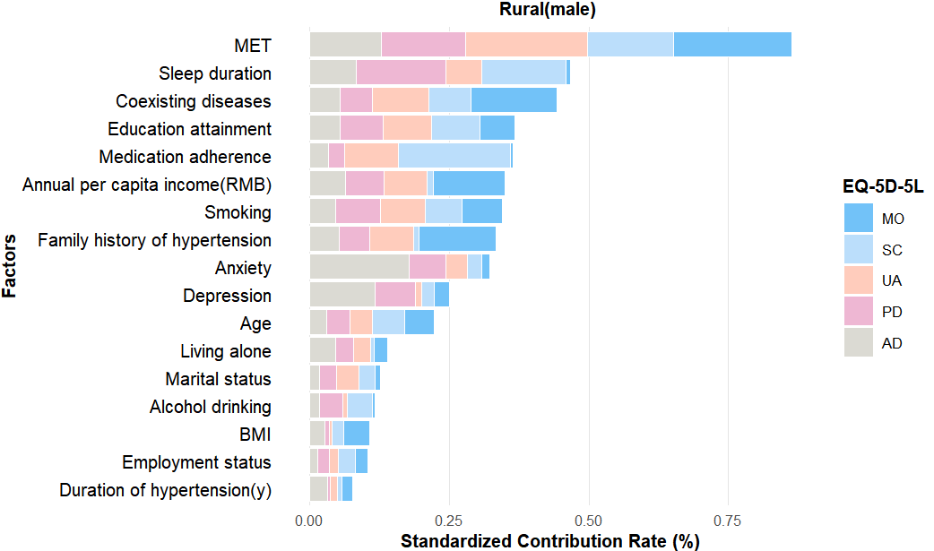
Fig.S4 Standardized contribution rates for rural areas among male.
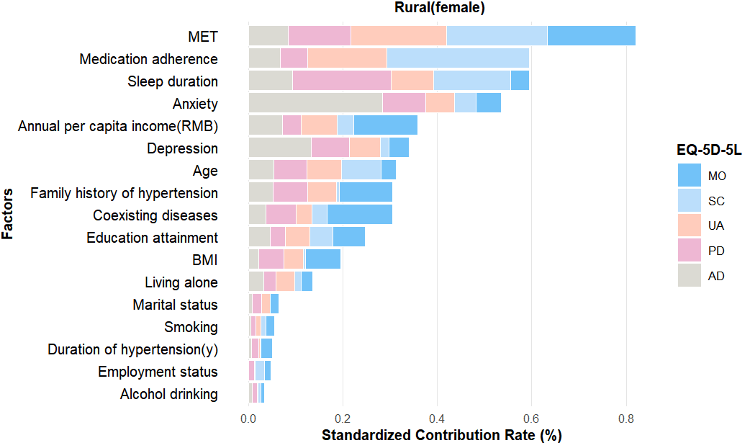
Fig.S5 Standardized contribution rates for rural areas among female.
MET indicates metabolic equivalent of task; MO, mobility; SC, self-care; UA, usual activities; PD, pain/discomfort; AD, anxiety/depression.

Table S3 Basic characteristics of the respondents-all variables
Variable |  | N（%） |  | Number of cases with difficulties in the EQ-5D-5L dimensions（%） |  |  |  |  |  |  |  |  |  |  |  | HUV  [Median (IQR)] | P | VAS  [Median (IQR)] | P
 |  |  |  | MO | P |  | SC | P | UA | P |  | PD | P | AD | P
All participants |  |  |  | 2215(31.37) |  |  | 1536(21.75) |  | 1512(21.41) |  |  | 2694(38.15) |  | 1184(16.77) |  | 0.951(0.876,1.000) |  | 80(70,82)
Residential address |  |  |  | 0.085 |  |  | <0.001 |  | <0.001 |  |  | <0.001 |  | <0.001 |  | <0.001 |  | 0.165
urban |  | 1500(21.24) |  | 443(29.53) |  |  | 202(13.47) |  | 243(16.20) |  |  | 371(24.73) |  | 201(13.40) |  | 1.000(0.893,1.000) |  | 80(70,80)
rural |  | 5562(78.76) |  | 1772(31.86) |  |  | 1334(23.98) |  | 1269(22.82) |  |  | 2323(41.77) |  | 983(17.67) |  | 0.942(0.862,1.000) |  | 80(70,82)
Gender |  |  |  | <0.001 |  |  | 0.037 |  | <0.001 |  |  | <0.001 |  | 0.003 |  | <0.001 |  | <0.001
Male |  | 2955(41.84) |  | 814(27.55) |  |  | 607(20.54) |  | 567(19.19) |  |  | 1011(34.21) |  | 430(14.55) |  | 1.000(0.889,1.000) |  | 80(70,83)
Female |  | 4107(58.16) |  | 1401(34.11) |  |  | 929(22.62) |  | 945(23.01) |  |  | 1683(40.98) |  | 754(18.36) |  | 0.942(0.848,1.000) |  | 80(70,80)
Age group (y) |  |  |  | <0.001 |  |  | <0.001 |  | <0.001 |  |  | <0.001 |  | 0.060 |  | <0.001 |  | <0.001
65-69 |  | 2140(30.30) |  | 563(26.31) |  |  | 363(16.96) |  | 357(16.68) |  |  | 723(33.79) |  | 328(15.33) |  | 1.000(0.893,1.000) |  | 80(70,84)
70-79 |  | 4179(59.18) |  | 1352(32.35) |  |  | 909(21.75) |  | 910(21.78) |  |  | 1615(38.65) |  | 717(17.16) |  | 0.942(0.876,1.000) |  | 80(70,80)
≥80 |  | 743(10.52) |  | 300(40.38) |  |  | 264(35.53) |  | 245(32.97) |  |  | 356(47.91) |  | 139(18.71) |  | 0.897(0.769,1.000) |  | 75(68,80)
Marital status |  |  |  | <0.001 |  |  | 0.066 |  | <0.001 |  |  | 0.003 |  | 0.262 |  | <0.001 |  | <0.001
Married |  | 5380(76.18) |  | 1577(29.31) |  |  | 1143(21.25) |  | 1090(20.26) |  |  | 2000(37.17) |  | 887(16.49) |  | 0.951(0.876,1.000) |  | 80(70,82)
Others |  | 1682(23.82) |  | 638(37.93) |  |  | 393(23.37) |  | 422(25.09) |  |  | 694(41.26) |  | 297(17.66) |  | 0.942(0.828,1.000) |  | 79(70,80)
Educational attainment |  |  |  | <0.001 |  |  | <0.001 |  | <0.001 |  |  | <0.001 |  | <0.001 |  | <0.001 |  | <0.001
No schooling |  | 2179(30.86) |  | 884(40.57) |  |  | 544(24.97) |  | 606(27.81) |  |  | 955(43.83) |  | 447(20.51) |  | 0.942(0.783,1.000) |  | 75(68,80)
Primary school |  | 3030(42.91) |  | 871(28.75) |  |  | 728(24.03) |  | 623(20.56) |  |  | 1209(39.90) |  | 501(16.53) |  | 0.942(0.876,1.000) |  | 80(70,82)
Junior school |  | 1410(19.97) |  | 358(25.39) |  |  | 216(15.32) |  | 228(16.17) |  |  | 425(30.14) |  | 187(13.26) |  | 1.000(0.893,1.000) |  | 80(70,85)
High school and above |  | 443(6.27) |  | 102(23.02) |  |  | 48(10.84) |  | 55(12.42) |  |  | 105(23.70) |  | 49(11.06) |  | 1.000(0.934,1.000) |  | 80(70,85)
Employment status |  |  |  | 0.058 |  |  | <0.001 |  | 0.227 |  |  | <0.001 |  | 0.191 |  | 0.001 |  | 0.061
Unemployed |  | 1685(23.86) |  | 560(33.23) |  |  | 315(18.69) |  | 343(20.36) |  |  | 537(31.87) |  | 265(15.73) |  | 1.000(0.862,1.000) |  | 80(70,80)
Employed |  | 5377(76.14) |  | 1655(30.78) |  |  | 1221(22.71) |  | 1169(21.74) |  |  | 2157(40.12) |  | 919(17.09) |  | 0.942(0.876,1.000) |  | 80(70,82)
Annual per capita income (RMB) |  |  |  | <0.001 |  |  | 0.677 |  | <0.001 |  |  | 0.859 |  | 0.742 |  | <0.001 |  | 0.001
<2400 |  |  | 3532(50.01) | 1341(37.97) |  |  | 761(21.55) |  | 855(24.21) |  |  | 1351(38.25) |  | 587(16.62) |  | 0.951(0.827,1.000) |  | 80(70,81)
≥2400 |  |  | 3530(49.99) | 874(24.76) |  |  | 775(21.95) |  | 657(18.61) |  |  | 1343(38.05) |  | 597(16.91) |  | 0.951(0.893,1.000) |  | 80(70,82)
Living alone |  |  |  | <0.001 |  |  | 0.044 |  | <0.001 |  |  | <0.001 |  | 0.720 |  | <0.001 |  | <0.001
No |  |  | 5894(83.46) | 1778(30.17) |  |  | 1256(21.31) |  | 1205(20.44) |  |  | 2194(37.22) |  | 984(16.69) |  | 0.951(0.876,1.000) |  | 80(70,82)
Yes |  |  | 1168(16.54) | 437(37.41) |  |  | 280(23.97) |  | 307(26.28) |  |  | 500(42.81) |  | 200(17.12) |  | 0.942(0.827,1.000) |  | 78(70,81)
BMI |  |  |  | <0.001 |  |  | <0.001 |  | 0.159 |  |  | 0.895 |  | 0.202 |  | 0.515 |  | 0.480
Abnormal |  |  | 4481(63.45) | 1481(33.05) |  |  | 900(20.08) |  | 936(20.89) |  |  | 1712(38.21) |  | 732(16.34) |  | 0.951(0.876,1.000) |  | 80(70,81)
Normal |  |  | 2581(36.55) | 734(28.44) |  |  | 636(24.64) |  | 576(22.32) |  |  | 982(38.05) |  | 452(17.51) |  | 0.951(0.876,1.000) |  | 80(70,82)
Family history of hypertension |  |  |  | <0.001 |  |  | 0.001 |  | 0.019 |  |  | 0.003 |  | <0.001 |  | 0.001 |  | <0.001
No |  |  | 4557(64.53) | 1250(27.43) |  |  | 1048(23.00) |  | 937(20.56) |  |  | 1680(36.87) |  | 832(18.26) |  | 0.951(0.882,1.000) |  | 80(70,82)
Yes |  |  | 2505(35.47) | 965(38.52) |  |  | 488(19.48) |  | 575(22.95) |  |  | 1014(40.48) |  | 352(14.05) |  | 0.942(0.831,1.000) |  | 80(70,80)
Duration of hypertension(y) |  |  |  | <0.001 |  |  | 0.407 |  | 0.024 |  |  | 0.346 |  | 0.002 |  | <0.001 |  | 0.001
1-5 |  |  | 1152(16.31) | 305(26.48) |  |  | 267(23.18) |  | 234(20.31) |  |  | 422(36.63) |  | 172(14.93) |  | 0.942(0.893,1.000) |  | 80(70,80)
6-15 |  |  | 3730(52.82) | 1087(29.14) |  |  | 795(21.31) |  | 768(20.59) |  |  | 1418(38.02) |  | 596(15.98) |  | 0.952(0.876,1.000) |  | 80(70,82)
＞15 |  |  | 2180(30.87) | 823(37.75) |  |  | 474(21.74) |  | 510(23.39) |  |  | 854(39.17) |  | 416(19.08) |  | 0.942(0.827,1.000) |  | 80(70,80)
Medication adherence |  |  |  | <0.001 |  |  | <0.001 |  | <0.001 |  |  | 0.689 |  | 0.761 |  | 0.052 |  | <0.001
Poor |  |  | 2585(36.60) | 704(27.23) |  |  | 765(29.59) |  | 619(23.95) |  |  | 994(38.45) |  | 438(16.94) |  | 0.942(0.876,1.000) |  | 80(70,83)
Good |  |  | 4477(63.40) | 1511(33.75) |  |  | 771(17.22) |  | 893(19.95) |  |  | 1700(37.97) |  | 746(16.66) |  | 0.952(0.876,1.000) |  | 80(70,80)
Coexisting diseases |  |  |  | <0.001 |  |  | 0.093 |  | <0.001 |  |  | <0.001 |  | <0.001 |  | <0.001 |  | <0.001
No |  |  | 3052(43.22) | 702(23.00) |  |  | 635(20.81) |  | 572(18.74) |  |  | 1083(35.48) |  | 439(14.38) |  | 1.000(0.893,1.000) |  | 80(70,83)
Yes |  |  | 4010(56.78) | 1513(37.73) |  |  | 901(22.47) |  | 940(23.44) |  |  | 1611(40.17) |  | 745(18.58) |  | 0.942(0.831,1.000) |  | 80(70.80)
Sleep duration |  |  |  | 0.001 |  |  | <0.001 |  | <0.001 |  |  | <0.001 |  | <0.001 |  | <0.001 |  | <0.001
Unhealthy | 3776(53.47) |  |  | 1252(33.16) |  |  | 983(26.03) |  | 914(24.21) |  |  | 1716(45.44) |  | 784(20.76) |  | 0.942(0.845,1.000) |  | 79(70,80)
Healthy | 3286(46.53) |  |  | 963(29.31) |  |  | 553(16.83) |  | 598(18.20) |  |  | 978(29.76) |  | 400(12.17) |  | 1.000(0.885,1.000) |  | 80(70,84)
MET |  |  |  | <0.001 |  |  | <0.001 |  | <0.001 |  |  | <0.001 |  | <0.001 |  | <0.001 |  | <0.001
Low | 1076(15.24) |  |  | 549(51.02) |  |  | 443(41.17) |  | 455(42.29) |  |  | 643(59.76) |  | 349(32.43) |  | 0.893(0.508,0.952) |  | 70(60,75)
Medium | 2222(31.46) |  |  | 866(38.97) |  |  | 463(20.84) |  | 530(23.85) |  |  | 854(38.43) |  | 354(15.93) |  | 0.951(0.827,1.000) |  | 80(70,81)
High | 3764(53.30) |  |  | 800(21.25) |  |  | 630(16.74) |  | 527(14.00) |  |  | 1197(31.80) |  | 481(12.78) |  | 1.000(0.894,1.000) |  | 80(70,84)
Smoking |  |  |  | 0.054 |  |  | 0.693 |  | 0.696 |  |  | 0.525 |  | 0.024 |  | 0.197 |  | 0.004
No | 5255(74.41) |  |  | 1681(31.99) |  |  | 1137(21.64) |  | 1131(21.52) |  |  | 2016(38.36) |  | 912(17.35) |  | 0.951(0.876,1.000) |  | 80(70,81)
Yes | 1807(25.59) |  |  | 534(29.55) |  |  | 399(22.08) |  | 381(21.08) |  |  | 678(37.52) |  | 272(15.05) |  | 0.951(0.876,1.000) |  | 80(70,84)
Alcohol drinking |  |  |  | 0.004 |  |  | 0.003 |  | 0.035 |  |  | 0.001 |  | <0.001 |  | <0.001 |  | <0.001
No | 5958(84.37) |  |  | 1910(32.06) |  |  | 1333(22.37) |  | 1302(21.85) |  |  | 2324(39.01) |  | 1050(17.62) |  | 0.942(0.876,1.000) |  | 80(70,81)
Yes | 1104(15.63) |  |  | 305(27.63) |  |  | 203(18.39) |  | 210(19.02) |  |  | 370(33.51) |  | 134(12.14) |  | 1.000(0.878,1.000) |  | 80(70,85)
Anxiety |  |  |  | <0.001 |  |  | <0.001 |  | <0.001 |  |  | <0.001 |  | <0.001 |  | <0.001 |  | <0.001
No | 6080(86.09) |  |  | 1755(28.87) |  |  | 1231(20.25) |  | 1158(19.05) |  |  | 2078(34.18) |  | 636(10.46) |  | 1.000(0.876,1.000) |  | 80(70,83)
Yes | 982(13.91) |  |  | 460(46.84) |  |  | 305(31.06) |  | 354(36.05) |  |  | 616(62.73) |  | 548(55.80) |  | 0.893(0.599,0.951) |  | 70(60,78)
Depression |  |  |  | <0.001 |  |  | <0.001 |  | <0.001 |  |  | <0.001 |  | <0.001 |  | <0.001 |  | <0.001
No | 5912(83.72) |  |  | 1666(28.18) |  |  | 1182(19.99) |  | 1092(18.47) |  |  | 1976(33.62) |  | 620(10.49) |  | 1.000(0.886,1.000) |  | 80(70,83)
Yes | 1150(16.28) |  |  | 549(47.74) |  |  | 354(30.78) |  | 420(36.52) |  |  | 718(62.43) |  | 564(49.04) |  | 0.893(0.665,0.951) |  | 70(60,80)
Note：HUV indicates health utility value; VAS, visual analogue scale; MET, metabolic equivalent of task; RMB, renminbi; MO, mobility; SC, self-care; UA, usual activities; PD, pain/discomfort; AD anxiety/depression; IQR, interquartile range.
Table S4: Factors associated with HRQoL scores among urban and rural participants-Tobit regression model results (all variables)
Variable |  | Urban β(95%CI) |  |  | Rural β(95%CI)
 |  | HUV | VAS |  | HUV | VAS
Gender | Ref: Male
 | Female | -0.027*(-0.048, -0.006) | -0.254(-1.675,1.167) |  | -0.012(-0.025,0.004) | 0.092(-0.665,0.849)
Age group(y) | Ref: 65-69
 | 70-79 | -0.011(-0.029,0.006) | 0.478(-0.764,1.720) |  | -0.020***(-0.030, -0.009) | -1.170**(-1.845, -0.495)
 | ≥80 | -0.053**(-0.088, -0.019) | 1.672(-0.432,3.776) |  | -0.055***(-0.075, -0.036) | -2.070***(-3.163, -1.978)
Marital status | Ref: Others
 | Married | 0.002(-0.023,0.019) | 0.429(-1.047,1.906) |  | -0.005(-0.010,0.021) | 0.354(-0.588,1.295)
Educational attainment | Ref: No schooling
Educational attainment | Primary school | 0.018(-0.004,0.039) | 0.201(-1.196,1.599) |  | 0.023***(0.010,0.035) | 1.971***(1.250,2.693)
 | Junior school | 0.045***(0.021,0.068) | 2.252*(0.636,3.867) |  | 0.047***(0.032,0.062) | 2.901***(1.990,3.811)
 | High school and above | 0.044**(0.016,0.072) | 2.348*(0.401,4.294) |  | 0.059***(0.035,0.083) | 3.253***(1.703,4.802)
Employment status | Ref: Unemployed
Employment status | Employed | -0.002(-0.020,0.016) | 1.043(-0.219,2.305) |  | 0.016*(0.002, 0.029) | 2.236***(1.379, 3.093)
Annual per capita income (RMB) | Ref: <2400
Annual per capita income (RMB) | ≥2400 | 0.008(-0.010,0.026) | -1.103(-2.339,0.133) |  | 0.017**(0.007,0.028) | 0.707*(0.081,1.334)
Living alone | Ref: No
 | Yes | -0.016(-0.048,0.016) | -2.059(-4.195,0.078) |  | 0.001(-0.016,0.017) | -0.803(-1.809,0.202)
BMI | Ref: Abnormal
 | Normal | -0.006(-0.024,0.012) | -1.583*(-2.801, -0.365) |  | 0.015**(0.005,0.025) | 0.478(-0.134,1.090)
Family history of hypertension | Ref: No
Family history of hypertension | Yes | 0.003(-0.015,0.020) | 0.070(-1.116,1.256) |  | -0.018**(-0.029, -0.007) | -1.162***(-1.804, -0.520)
Duration of hypertension(y) | Ref:1-5
Duration of hypertension(y) | 6-15 | 0.002(-0.021,0.024) | -1.718*(-3.291, -0.145) |  | 0.014*(0.001,0.028) | 2.067*** (1.235,2.899)
 | >15 | -0.026*(-0.051, -0.002) | -2.492**(-4.143, -0.841) |  | -0.011(-0.027,0.004) | 1.266**(0.334,2.197)
Medication adherence | Ref: Poor
Medication adherence | Good | -0.021*(-0.038, -0.004) | -0.097(-1.331,1.136) | 0.026***(0.015,0.037) |  | 0.320(-0.316,0.956)
Coexisting diseases | Ref: No
Coexisting diseases | Yes | -0.026**(-0.043, -0.009) | -0.524(-1.728,0.680) | -0.039***(-0.049, -0.029) |  | -1.937***(-2.539, -1.334)
Sleep duration | Ref: Unhealthy
 | Healthy | 0.002(-0.014,0.018) | 0.879(-0.222,1.980) | 0.048***(0.038,0.058) |  | 1.793***(1.197,2.390)
MET | Ref: Low
 | Medium | 0.191***(0.150,0.232) | 8.838***(6.968,10.709) | 0.080***(0.062,0.099) |  | 6.600***(5.663,7.538)
 | High | 0.230***(0.190,0.271) | 10.297***(8.460,12.135) | 0.123***(0.106,0.141) |  | 8.800***(7.921,9.679)
Smoking | Ref: No
 | Yes | -0.023(-0.052,0.006) | -0.278(-2.076,1.520) | -0.015*(-0.028, -0.001) |  | -0.306(-1.105,0.494)
Alcohol drinking | Ref: No
 | Yes | 0.013(-0.015,0.041) | 0.859(-1.099,2.817) | 0.003(-0.012,0.019) |  | 0.712(-0.200,1.624)
Anxiety | Ref: No
 | Yes | -0.062***(-0.093, -0.031) | -3.340***(-5.181, -1.498) | -0.080***(-0.100, -0.059) |  | -5.319***(-6.398, -4.240)
Depression | Ref: No
 | Yes | -0.093***(-0.122, -0.064) | -5.030***(-6.664, -3.395) | -0.045***(-0.063, -0.027) |  | -1.544***(-2.565, -0.524)
Note：HUV indicates health utility value; VAS, visual analogue scale; MET, metabolic equivalent of task; RMB, renminbi; β, standardized beta coefficient in the regression models; Ref, reference.
*P<0.05, **P<0.01, ***P<0.001.
Table S5 Basic characteristics of urban populations.
Variables | N (%) | Number of cases with difficulties in the EQ-5D-5L dimensions（%） |  |  |  |  |  | HUV  [Median (IQR)] | VAS  [Median (IQR)]
Variables | N (%) | MO | SC |  | UA | PD | AD | HUV  [Median (IQR)] | VAS  [Median (IQR)]
Gender
Male | 605(40.33) | 156(25.79) | 84(13.88) |  | 93(15.37) | 124(20.50) | 64(10.58) | 1.000(0.934,1.000) | 80(70,80)
Female | 895(59.67) | 287(32.07) | 118(13.18) |  | 150(16.76) | 247(27.60) | 137(15.31) | 1.000(0.876,1.000) | 80(70,80)
Age(y)
65-69 | 493(32.87) | 114(23.12) | 33(6.69) |  | 45(9.13) | 105(21.30) | 62(12.58) | 1.000(0.934,1.000) | 80(70,80)
70-79 | 859(57.27) | 256(29.80) | 117(13.62) |  | 142(16.53) | 202(23.52) | 109(12.69) | 1.000(0.893,1.000) | 80(70,80)
≥80 | 148(9.87) | 73(49.32) | 52(35.14) |  | 56(37.84) | 64(43.24) | 30(20.27) | 0.893(0.568,1.000) | 75(69,80)
Marital status
Married | 1096(73.07) | 302(27.55) | 123(11.22) |  | 150(13.69) | 251(22.90) | 133(12.14) | 1.000(0.934,1.000) | 80(70,80)
Others | 404(26.93) | 141(34.90) | 79(19.55) |  | 93(23.02) | 120(29.70) | 68(16.83) | 1.000(0.865,1.000) | 80(70,80)
Education attainment
No schooling | 449(29.93) | 165(36.75) | 84(18.71) |  | 110(24.50) | 164(36.53) | 75(16.70) | 0.951(0.831,1.000) | 75(66,80)
Primary school | 519(34.60) | 163(31.41) | 76(14.64) |  | 80(15.41) | 123(23.70) | 69(13.29) | 1.000(0.893,1.000) | 80(70,80)
Junior school | 328(21.87) | 72(21.95) | 25(7.62) |  | 33(10.06) | 53(16.16) | 34(10.37) | 1.000(0.934,1.000) | 80(70,85)
High school and above | 204(13.60) | 43(21.08) | 17(8.33) |  | 20(9.80) | 31(15.20) | 23(11.27) | 1.000(0.942,1.000) | 80(75,85)
Employment status
Unemployed | 868(57.87) | 256(29.69) | 122(14.06) |  | 135(15.55) | 202(23.27) | 129(14.86) | 1.000(0.885,1.000) | 80(70,80)
Employed | 632(42.13) | 187(29.59) | 80(12.66) |  | 108(17.09) | 169(26.74) | 72(11.39) | 0.906(0.897,1.000) | 80(70,80)
Annual per capita income (RMB)
<2400 | 652(43.47) | 1341(37.97) | 761(21.55) |  | 855(24.21) | 1351(38.25) | 587(16.62) | 1.000(0.876,1.000) | 80(70,80)
≥2400 | 848(56.53) | 874(24.76) | 775(21.95) |  | 657(18.61) | 1343(38.05) | 597(16.91) | 1.000(0.934,1.000) | 80(70,80)
Living alone
No | 1347(89.80) | 385(28.58) | 168(12.47) |  | 203(15.07) | 318(23.61) | 170(12.62) | 0.942(0.840,1.000) | 75(67,80)
Yes | 153(10.20) | 58(37.91) | 34(22.22) |  | 40(26.14) | 53(34.64) | 31(20.26) | 1.000(0.897,1.000) | 80(70,80)
BMI
Abnormal | 1036(69.07) | 292(28.19) | 110(10.62) |  | 139(13.42) | 241(23.26) | 133(12.84) | 1.000(0.906,1.000) | 80(70,80)
Normal | 464(30.93) | 151(32.54) | 92(19.83) |  | 104(22.41) | 130(28.02) | 68(14.66) | 1.000(0.876,1.000) | 79(67,80)
Family history of hypertension
No | 949(63.27) | 271(28.56) | 137(14.44) |  | 164(17.28) | 240(25.29) | 142(14.96) | 1.000(0.891,1.000) | 80(70,80)
Yes | 551(36.73) | 172(31.22) | 65(11.80) |  | 79(14.34) | 131(23.77) | 59(10.71) | 1.000(0.893,1.000) | 80(70,80)
Duration of hypertension(y)
1-5 | 252(16.80) | 53(21.03) | 20(7.94) |  | 27(10.71) | 48(19.05) | 27(10.71) | 1.000(0.936,1.000) | 80(70,84)
6-15 | 674(44.93) | 192(28.49) | 95(14.09) |  | 119(17.66) | 181(26.85) | 84(12.46) | 1.000(0.893,1.000) | 80(70,80)
＞15 | 574(38.27) | 198(34.49) | 87(15.16) |  | 97(16.90) | 142(24.74) | 90(15.68) | 1.000(0.876,1.000) | 80(70,80)
Medication adherence |  | <0.001 | <0.001 |  | <0.001 | 0.029 | 0.008 | 0.631 | 0.195
Poor | 451(30.07) | 125(27.72) | 57(12.64) |  | 73(16.19) | 109(24.17) | 51(11.31) | 1.000(0.897,1.000) | 80(69,80)
Good | 1049(69.93) | 318(30.31) | 145(13.82) |  | 170(16.21) | 262(24.98) | 150(14.30) | 1.000(0.889,1.000) | 80(70,80)
Sleep duration
Unhealthy | 735(49.00) | 225(30.61) | 111(15.10) |  | 135(18.37) | 195(26.53) | 109(14.83) | 1.000(0.876,1.000) | 80(70,80)
Healthy | 765(51.00) | 218(28.50) | 91(11.90) |  | 108(14.12) | 176(23.01) | 92(12.03) | 1.000(0.934,1.000) | 80(70,80)
MET
Low | 183(12.20) | 123(67.21) | 85(46.45) |  | 96(52.46) | 98(53.55) | 40(21.86) | 0.796(0.303,0.942) | 65(60,75)
Medium | 533(35.53) | 164(30.77) | 76(14.26) |  | 95(17.82) | 144(27.02) | 81(15.20) | 1.000(0.885,1.000) | 80(70,80)
High | 784(52.27) | 156(19.90) | 41(5.23) |  | 52(6.63) | 129(16.45) | 80(10.20) | 1.000(0.942,1.000) | 80(70,82)
Smoking
No | 1242(82.80) | 374(30.11) | 169(13.61) |  | 206(16.59) | 317(25.52) | 177(14.25) | 1.000(0.888,1.000) | 80(70,80)
Yes | 258(17.20) | 69(26.74) | 33(12.79) |  | 37(14.34) | 54(20.39) | 24(9.30) | 1.000(0.934,1.000) | 80(70,82)
Alcohol drinking
No | 1315(87.67) | 397(30.19) | 184(13.99) |  | 223(16.96) | 338(25.70) | 188(14.30) | 1.000(0.886,1.000) | 80(70,80)
Yes | 185(12.33) | 46(24.86) | 18(9.73) |  | 20(10.81) | 33(17.84) | 13(7.03) | 1.000(0.934,1.000) | 80(70,85)
Anxiety
No | 1318(87.87) | 374(28.38) | 160(12.14) |  | 191(14.49) | 290(22.00) | 114(8.65) | 1.000(0.934,1.000) | 80(70,80)
Yes | 182(12.13) | 69(37.69) | 42(23.08) |  | 52(28.57) | 81(44.51) | 87(47.80) | 0.934(0.779,1.000) | 70(60,80)
Depression
No | 1241(82.73) | 316(25.46) | 125(10.07) |  | 148(11.93) | 234(18.86) | 85(6.85) | 1.000(0.934,1.000) | 80(70,80)
Yes | 259(17.27) | 127(49.03) | 77(29.73) |  | 95(36.68) | 137(52.90) | 116(44.79) | 0.889(0.734,0.901) | 70(60,80)
Note：HUV indicates health utility value; EQ VAS, visual analog scale; RMB, renminbi; MET indicates metabolic equivalent of task; MO, mobility; SC, self-care; UA, usual activities; PD, pain/discomfort; AD, anxiety/depression.
Table S6 Basic characteristics of rural populations
Variables | N (%) | Number of cases with difficulties in the EQ-5D-5L dimensions（%） |  |  |  |  | HUV  [Median (IQR)] | VAS  [Median (IQR)]
Variables | N (%) | MO | SC | UA | PD | AD | HUV  [Median (IQR)] | VAS  [Median (IQR)]
Gender
Male | 1647(29.61) | 449(27.26) | 330(20.04) | 312(18.94) | 618(37.52) | 266(16.15) | 0.955(0.885,1.000) | 80(70,84)
Female | 3320(59.69) | 1096(33.01) | 792(23.86) | 768(23.13) | 1413(42.56) | 608(18.31) | 0.942(0.858,1.000) | 80(70,82)
Age(y) | 595(10.70) | 227(38.15) | 212(35.63) | 189(31.76) | 292(49.08) | 109(18.32) | 0.903(0.783,1.000) | 75(65,81)
65-69
70-79 | 2350(42.25) | 658(28.00) | 523(22.26) | 474(20.17) | 887(37.74) | 366(15.57) | 0.955(0.876,1.000) | 80(70,84)
≥80 | 3212(57.75) | 1114(34.68) | 811(25.25) | 795(24.75) | 1436(44.71) | 617(19.21) | 0.942(0.840,1.000) | 80(70,82)
Marital status
Married | 4284(77.02) | 1275(29.76) | 1020(23.81) | 940(21.94) | 1749(40.83) | 754(17.60) | 0.942(0.876,1.000) | 80(70,81)
Others | 1278(22.98) | 497(38.89) | 3140(24.57) | 329(25.74) | 574(44.91) | 229(17.92) | 0.942(0.824,1.000) | 76(70,80)
Education attainment
No schooling | 1730(31.10) | 719(41.56) | 460(26.59) | 496(28.67) | 791(45.72) | 372(21.50) | 0.942(0.783,1.000) | 75(70,80)
Primary school | 2511(45.15) | 708(28.20) | 652(25.97) | 543(21.62) | 1086(43.25) | 432(17.20) | 0.942(0.876,1.000) | 80(70,82)
Junior school | 1082(19.45) | 286(26.43) | 191(17.65) | 195(18.02) | 372(34.38) | 153(14.14) | 1.000(0.893,1.000) | 80(70,85)
High school and above | 239(4.30) | 59(24.69) | 31(12.97) | 35(14.64) | 74(30.96) | 26(10.88) | 1.000(0.889,1.000) | 80(70,86)
Employment status
Unemployed | 817(14.69) | 304(37.21) | 193(23.62) | 208(25.46) | 335(41.00) | 136(16.65) | 0.942(0.876,1.000) | 80(70,82)
Employed | 4745(85.31) | 1468(30.94) | 1141(24.05) | 1061(22.36) | 1988(41.90) | 847(17.85) | 0.942(0.817,1.000) | 80(70,85)
Annual per capita income (RMB)
<2400 | 2880(51.78) | 1096(39.95) | 655(23.52) | 734(26.36) | 1140(40.93) | 473(16.98) | 0.942(0.783,1.000) | 80(70,82)
≥2400 | 2682(48.22) | 676(24.34) | 679(24.45) | 535(19.27) | 1183(42.60) | 510(18.37) | 0.942(0.893,1.000) | 80(70,82)
Living alone
No | 4547(81.75) | 1393(30.64) | 1088(23.93) | 1002(22.04) | 1876(41.26) | 814(17.90) | 0.942(0.827,1.000) | 80(70,82)
Yes | 1015(18.25) | 379(37.34) | 246(24.24) | 267(26.31) | 441(44.04) | 169(16.65) | 0.942(0.876,1.000) | 80(70,82)
BMI
Abnormal | 3445(61.94) | 1189(34.51) | 790(22.93) | 797(23.13) | 1471(42.70) | 599(17.39) | 0.942(0.841,1.000) | 80(70,82)
Normal | 2117(38.06) | 583(27.54) | 544(25.70) | 472(22.30) | 852(40.25) | 384(18.14) | 0.942(0.876,1.000) | 80(70,82)
Family history of hypertension
No | 3608(64.87) | 979(27.13) | 911(25.25) | 773(21.42) | 1440(39.91) | 690(19.12) | 0.942(0.876,1.000) | 80(70,82)
Yes | 1954(35.13) | 793(40.58) | 423(21.65) | 496(25.38) | 883(45.19) | 293(14.99) | 0.942(0.816,1.000) | 80(70,80)
Duration of hypertension(y)
1-5 | 900(16.18) | 252(28.00) | 247(27.44) | 207(23.00) | 374(41.56) | 145(16.11) | 0.942(0.876,1.000) | 80(70,80)
6-15 | 3056(54.94) | 895(29.29) | 700(22.91) | 649(21.24) | 1237(40.48) | 512(16.75) | 0.942(0.876,1.000) | 80(70,84)
＞15 | 1606(28.87) | 625(38.92) | 387(24.10) | 413(25.72) | 712(44.33) | 326(20.30) | 0.942(0.796,1.000) | 80(70,82)
Medication adherence
Poor | 2134(38.37) | 579(27.13) | 708(33.18) | 546(25.59) | 885(41.47) | 387(18.13) | 0.934(0.876,1.000) | 80(70,83)
Good | 3428(61.63) | 1193(34.80) | 626(18.26) | 723(21.09) | 1438(41.95) | 596(17.39) | 0.942(0.841,1.000) | 80(70,80)
Coexisting diseases
No | 2564(46.10) | 594(23.17) | 576(22.46) | 499(19.46) | 977(38.10) | 392(15.29) | 0.952(0.893,1.000) | 80(70,84)
Yes | 2998(53.90) | 1178(39.29) | 758(25.28) | 770(25.68) | 1346(44.90) | 591(19.71) | 0.942(0.827,1.000) | 80(70,80)
Sleep duration
Unhealthy | 3041(54.67) | 1027(33.77) | 872(28.67) | 779(25.62) | 1521(50.02) | 675(22.20) | 0.907(0.841,1.000) | 75(70,80)
Healthy | 2521(45.33) | 745(29.55) | 462(18.33) | 490(19.44) | 802(31.81) | 308(12.22) | 1.000(0.876,1.000) | 80(70,84)
MET
Low | 893(16.06) | 426(47.70) | 358(40.09) | 359(40.20) | 545(61.03) | 309(34.60) | 0.893(0.686,0.952) | 70(60,75)
Medium | 1689(30.37) | 702(41.56) | 387(22.91) | 435(25.76) | 710(42.04) | 273(16.16) | 0.942(0.783,1.000) | 80(70,82)
High | 2980(53.58) | 644(21.61) | 589(19.77) | 475(15.94) | 1068(35.84) | 401(13.46) | 1.000(0.894,1.000) | 80(70,85)
Smoking
No | 4013(72.15) | 1307(32.57) | 968(24.12) | 925(23.05) | 1699(42.34) | 735(18.32) | 0.942(0.858,1.000) | 80(70,82)
Yes | 1549(27.85) | 465(30.02) | 366(23.63) | 344(22.21) | 624(40.28) | 248(16.01) | 0.942(0.876,1.000) | 80(70,84)
Alcohol drinking
No | 4643(83.48) | 1513(32.59) | 1149(24.75) | 1079(23.24) | 1986(42.77) | 862(18.57) | 0.942(0.858,1.000) | 80(70,82)
Yes | 919(16.52) | 259(28.18) | 185(20.13) | 190(20.67) | 337(36.67) | 121(13.17) | 0.955(0.876,1.000) | 80(70,85)
Anxiety
No | 4762(85.62) | 1381(29.00) | 1071(22.49) | 967(20.31) | 1788(37.55) | 522(10.96) | 0.952(0.876,1.000) | 80(70,84)
Yes | 800(14.38) | 391(48.88) | 263(32.88) | 302(37.75) | 535(66.88) | 461(57.63) | 0.886(0.539,0.942) | 70(60,75)
Depression
No | 4671(83.98) | 1350(28.90) | 1057(22.63) | 944(20.21) | 1742(37.29) | 535(11.45) | 0.952(0.876,1.000) | 80(70,84)
Yes | 891(16.02) | 422(47.36) | 277(31.09) | 325(36.48) | 581(65.21) | 448(50.28) | 0.853(0.654,0.951) | 70(60,80)
Note：HUV indicates health utility value; EQ VAS, visual analog scale; RMB, renminbi; MET indicates metabolic equivalent of task; MO, mobility; SC, self-care; UA, usual activities; PD, pain/discomfort; AD, anxiety/depression.
Table S7 PSM balance test for the urban and rural samples.
Variable | Pre-PSM |  |  | Post-PSM
Variable | urban | rural | P | urban | rural | P
Age | 72.563 | 72.926 | 0.019 | 72.563 | 72.418 | 0.440
Educational attainment | 2.191 | 2.191 | <0.001 | 1.969 | 2.176 | 0.666
Living alone | 0.102 | 0.182 | <0.001 | 0.106 | 0.106 | 0.720
Duration of hypertension | 14.041 | 12.908 | <0.001 | 14.041 | 13.862 | 0.585
Sleep duration | 7.410 | 7.080 | <0.001 | 7.410 | 7.472 | 0.284
Note：HUV indicates health utility value; VAS, visual analog scale; ATT, The average treatment effect for the treated.
Table S8 The mean of HUV/VAS for the urban and rural samples.
Variable | Sample | Urban | Rural | Difference | T-test | P
HUV | Unmatched | 0.890 | 0.860 | 0.030 | 4.42 | <0.001
HUV | ATT | 0.890 | 0.881 | 0.009 | 1.03 | <0.001
VAS | Unmatched | 75.08 | 75.20 | -0.121 | -0.34 | 0.165
VAS | ATT | 75.08 | 75.83 | -0.747 | -1.68 | 0.034
Note：HUV indicates health utility value; VAS, visual analog scale; ATT, The average treatment effect for the treated.

Table S9 Results of the Stratified analysis (HUV and VAS).
Variable |  | Urban β(95%CI) |  | Rural β(95%CI)
 |  | HUV | VAS | HUV | VAS
Male
Age group(y) | Ref: 65-69
 | 70-79 | -0.007(-0.033,0.019) | 0.113(-1.914,2.140) | -0.012 (-0.029, 0.005) | -0.901(-1.968, 0.167)
 | ≥80 | -0.051*(-0.100, -0.002) | -0.104(-3.401,3.193) | -0.060***(-0.090, -0.030) | -1.659(-3.327, 0.008)
Marital status | Ref: Others
 | Married | 0.017(-0.025,0.060) | 0.591(-2.470,3.651) | -0.002(-0.027,0.023) | 0.452(-2.026,1.123)
Educational attainment | Ref: No schooling
Educational attainment | Primary school | 0.044*(0.004,0.084) | 6.698(-1.886,3.282) | 0.038**(0.013,0.062) | 1.494* (0.159,2.829)
 | Junior school | 0.083***(0.042,0.124) | 4.218**(1.398,7.037) | 0.065***(0.040,0.091) | 2.287**(0.838,3.736)
 | High school and above | 0.067**(0.022,0.112) | 3.108(-0.015,6.232) | 0.083***(0.050,0.116) | 2.397*(0.259,4.535)
Employment status | Ref: Unemployed
Employment status | Employed | -0.018(-0.009,0.046) | -1.795(-3.913,0.322) | -0.026*(-0.047, -0.005) | -3.042***(-4.523, -1.632)
Annual per capita income (RMB) | Ref: <2400
Annual per capita income (RMB) | ≥2400 | 0.028(-0.001,0.056) | -1.119(-3.184,0.945) | 0.012(-0.004,0.027) | 1.196*(0.237,2.154)
Living alone | Ref: No
 | Yes | -0.005(-0.057,0.047) | 0.381(-3.680,4.441) | 0.015(-0.010,0.040) | -1.067(-2.698,0.563)
BMI | Ref: Abnormal
 | Normal | -0.005(-0.031,0.021) | -1.398(-3.358, 0.562) | -0.006(-0.009, 0.021) | -0.041(-0.981,0.899)
Family history of hypertension | Ref: No
Family history of hypertension | Yes | -0.001(-0.027,0.025) | 0.964(-0.978,2.907) | -0.025(-0.042,0.008) | -1.371**(-2.384, -0.358)
Duration of hypertension(y) | Ref:1-5
Duration of hypertension(y) | 6-15 | 0.010(-0.025,0.044) | -2.109(-4.635, 0.418) | 0.001(-0.019,0.021) | 2.527*** (1.262,3.392)
Duration of hypertension(y) | >15 | -0.006(-0.043, 0.030) | -2.519(-5.134, 0.095) | -0.013(-0.036,0.011) | 2.028**(0.577,3.479)
Medication adherence | Ref: Poor
Medication adherence | Good | -0.031*(-0.056, -0.007) | -1.447(-3.479,0.586) | 0.023**(0.006,0.039) | 0.516(-0.486,1.519)
Coexisting diseases | Ref: No
Coexisting diseases | Yes | -0.022(-0.046, 0.002) | 0.499(-1.378,2.376) | -0.048***(-0.063, -0.033) | -1.708***(-2.642, -0.775)
Sleep duration | Ref: Unhealthy
 | Healthy | 0.015(-0.008,0.039) | 1.843*(0.058,3.628) | 0.044***(0.030,0.059) | 1.421**(0.504,2.339)
MET | Ref: Low
 | Medium | 0.197***(0.139,0.255) | 8.578***(5.795,11.361) | 0.082***(0.053,0.120) | 7.232***(5.796,8.668)
 | High | 0.242***(0.185,0.299) | 8.571***(5.789,11.353) | 0.129***(0.103,0.155) | 8.912***(7.576,10.248)
Smoking | Ref: No
 | Yes | -0.022(-0.047,0.004) | -0.448(-2.363,1.476) | -0.031*** (-0.046, -0.015) | -0.599(-1.560,0.362)
Alcohol drinking | Ref: No
 | Yes | -0.003(-0.031,0.025) | 0.549(-1.525,2.624) | 0.008(-0.008,0.024) | 0.540(-0.466,1.546)
Anxiety | Ref: No
 | Yes | -0.040(-0.088, 0.009) | -3.178(-6.603, 0.278) | -0.064***(-0.097, -0.030) | -5.212***(-7.053, -3.371)
Depression | Ref: No
 | Yes | -0.135***(-0.193, -0.076) | -5.445**(-8.602, -2.288) | -0.030*(-0.060, -0.001) | -0.618(-2.349, 1.113)
Female
Age group(y) | Ref: 65-69
 | 70-79 | -0.017(-0.039,0.008) | 0.693(-0.866,2.252) | -0.024**(-0.038, -0.010) | -0.024**(-0.038, -0.010)
 | ≥80 | -0.057*(-0.104, -0.009) | 3.086*(0.368,5.804) | -0.051***(-0.077, -0.026) | -0.051***(-0.077, -0.026)
Marital status | Ref: Others
 | Married | -0.001(-0.027,0.025) | -0.592(-2.278,1.093) | -0.004(-0.023,0.016) | 0.004(-0.023,0.016)
Educational attainment | Ref: No schooling
Educational attainment | Primary school | 0.017(-0.009,0.044) | 0.162(-1.507,1.829) | 0.019*(0.004,0.033) | 0.019* (0.004,0.033)
 | Junior school | 0.028(-0.002,0.059) | 0.797(-1.214,2.809) | 0.035**(0.015,0.056) | 0.035**(0.015,0.056)
 | High school and above | 0.044*(0.006,0.081) | 2.058(-0.555,4.672) | 0.037(-0.003,0.078) | 0.037(-0.003,0.078)
Employment status | Ref: Unemployed
Employment status | Employed | -0.008(-0.032,0.016) | -0.437(-2.000,1.125) | -0.011(-0.029, 0.006) | -0.011(-0.029, 0.006)
Annual per capita income (RMB) | Ref: <2400
Annual per capita income (RMB) | ≥2400 | 0.005(-0.029,0.018) | -0.990(-2.526,0.546) | 0.020**(0.006,0.034) | 0.020**(0.006,0.034)
Living alone | Ref: No
 | Yes | -0.012(-0.051,0.027) | -2.814(-5.328,0.299) | -0.007(-0.029,0.015) | -0.007(-0.029,0.015)
BMI | Ref: Abnormal
 | Normal | -0.001(-0.024,0.024) | -1.446(-3.007, 0.114) | 0.023**(0.010, 0.036) | 0.023**(0.010,0.036)
Family history of hypertension | Ref: No
Family history of hypertension | Yes | -0.001(-0.024,0.022) | -0.418(-1.914,1.078) | -0.013(-0.027,0.001) | -0.013(-0.027, 0.001)
Duration of hypertension(y) | Ref:1-5
Duration of hypertension(y) | 6-15 | -0.001(-0.031,0.029) | -1.552(-3.550, 0.445) | 0.023*(0.004,0.041) | 0.023*(0.004,0.041)
Duration of hypertension(y) | >15 | -0.034*(-0.067, -0.001) | -2.333(-4.450, 0.216) | -0.009(-0.031,0.012) | -0.009(-0.031,0.012)
Medication adherence | Ref: Poor
Medication adherence | Good | -0.020(-0.043, 0.003) | 0.629(-0.922,2.180) | 0.028***(0.014,0.042) | 0.028***(0.014,0.042)
Coexisting diseases | Ref: No
Coexisting diseases | Yes | -0.025*(-0.048, 0.002) | -1.232(-2.798,0.334) | -0.032***(-0.045, -0.017) | -0.032***(-0.045, -0.019)
Sleep duration | Ref: Unhealthy
 | Healthy | -0.009(-0.031,0.012) | 1.190(-1.204,1.585) | 0.050***(0.037,0.063) | 0.050***(0.037,0.063)
MET | Ref: Low
 | Medium | 0.167***(0.111,0.223) | 8.707***(6.176,11.237) | 0.080***(0.056,0.104) | 0.080***(0.056,0.104)
 | High | 0.204***(0.149,0.259) | 11.486***(9.036,13.936) | 0.122***(0.099,0.145) | 0.122***(0.099,0.145)
Smoking | Ref: No
 | Yes | -0.075(-0.222,0.072) | 3.529(-3.380,10.437) | 0.025* (0.002, 0.048) | 0.025*(0.002,0.048)
Alcohol drinking | Ref: No
 | Yes | 0.125***(0.113,0.136) | 0.759(-8.627,10.145) | 0.001(-0.039,0.041) | 0.001(-0.039,0.041)
Anxiety | Ref: No
 | Yes | -0.065**(-0.104, -0.027) | -3.511**(-5.688, 1.333) | -0.087***(-0.112, -0.061) | -0.087***(-0.112, -0.061)
Depression | Ref: No
 | Yes | -0.082***(-0.116, -0.048) | -4.907***(-6.797, -3.018) | -0.058***(-0.081, -0.035) | -0.058***(-0.081, -0.035)
Note：HUV indicates health utility value; EQ VAS, visual analog scale; MET indicates metabolic equivalent of task; MO, mobility; SC, self-care; UA, usual activities; PD, pain/discomfort; AD, anxiety/depression.
Table S10 Sensitivity Results -Tobit regression model results
Variable |  | Urban β(95%CI) |  | Rural β(95%CI)
 |  | HUV | VAS | HUV | VAS
Gender | Ref: Male
 | Female | -0.106**(-0.169, -0.043) | 0.188(-1.248,1.624) | -0.019(-0.051,0.013) | 0.088(-0.768,0.945)
Age group(y) | Ref: 65-69
 | 70-79 | -0.065**(-0.112, -0.018) | 0.287(-1.113,1.686) | -0.043**(-0.068, -0.017) | -1.269*(-2.327, -0.212)
 | ≥80 | -0.143***(-0.218, -0.067) | 0.736(-1.429,3.901) | -0.123***(-1.172, -0.074) | -2.197**(-3.770, -0.624)
Marital status | Ref: Others
 | Married | -0.018(-0.074,0.037) | -0.830(-2.430,0.769) | 0.003(-0.041,0.048) | -0.266(-1.717,1.186)
Educational attainment | Ref: No schooling
Educational attainment | Primary school | -0.001(-0.065,0.064) | 0.679(-0.789,2.147) | 0.046**(0.014,0.079) | 1.994***(1.025,2.963)
 | Junior school | 0.052 (-0.009,0.113) | 2.105*(0.139,4.070) | 0.095***(0.056,0.135) | 2.962***(1.627,4.297)
 | High school and above | 0.064(-0.012,0.139) | 2.724*(0.455,4.993) | 0.098**(0.038,0.158) | 2.732**(0.994,4.469)
Employment status | Ref: Unemployed
Employment status | Employed | -0.022(-0.090,0.046) | -1.064(-2.359,0.231) | -0.040(-0.091, 0.012) | -2.640**(-4.056, -1.225)
Annual per capita income (RMB) | Ref: <2400
Annual per capita income (RMB) | ≥2400 | -0.004(-0.069,0.062) | -0.329(-1.791,1.132) | 0.061*(0.009,0.113) | 1.005*(0.096,1.914)
Living alone | Ref: No
 | Yes | -0.065(-0.136,0.005) | -0.908(-3.099,1.284) | 0.011(-0.038,0.060) | -0.889(-2.827,1.050)
BMI | Ref: Abnormal
 | Normal | 0.001(-0.043,0.046) | -1.118(-2.715, 0.339) | 0.037**(0.014,0.060) | 0.455(-0.303,1.213)
Family history of hypertension | Ref: No
Family history of hypertension | Yes | -0.020(-0.072,0.032) | -0.092(-1.342,1.158) | -0.039*(-0.075, -0.003) | -0.855 (-2.006, 0.296)
Duration of hypertension(y) | Ref:1-5
Duration of hypertension(y) | 6-15 | -0.019(-0.066,0.029) | -0.988(-2.423, 0.447) | -0.011 (-0.049,0.028) | 0.970 (-0.116,2.056)
 | >15 | -0.039(-0.097, 0.019) | -1.990*(-3.541, -0.440) | -0.071**(-0.116, -0.025) | 0.160 (-0.956,1.275)
Medication adherence | Ref: Poor
Medication adherence | Good | -0.009(-0.085, 0.067) | 1.108(-1.145,2.361) | 0.023 (-0.013,0.059) | -0.177(-1.791,1.437)
Coexisting diseases | Ref: No
Coexisting diseases | Yes | 0.026(-0.043, 0.009) | 0.871(-0.375,2.117) | -0.018(-0.046, 0.011) | -0.388 (-1.189, 0.413)
Sleep duration | Ref: Unhealthy
 | Healthy | 0.021(-0.028,0.070) | 1.111(-0.017,2.239) | 0.041 (-0.018,0.100) | 1.317**(0.503,2.132)
MET | Ref: Low
 | Medium | 0.262***(0.139,0.385) | 7.838***(4.323,10.236) | 0.127***(0.062,0.191) | 5.700***(4.112,7.288)
 | High | 0.352***(0.205,0.499) | 8.297***(5.099,11.389) | 0.253***(0.190,0.315) | 8.307***(6.183,10.431)
Smoking | Ref: No
 | Yes | -0.095** (-0.159, -0.030) | -0.282(-2.113,1.549) | -0.009 (-0.046, 0.028) | 0.015(-0.981,0.011)
Alcohol drinking | Ref: No
 | Yes | 0.062(-0.056,0.180) | 2.116(-0.289,4.520) | 0.038(-0.003,0.079) | 1.267(-0.054,2.588)
Anxiety | Ref: No
 | Yes | -0.141***(-0.205, -0.076) | -2.537*(-4.549, -0.524) | -0.155**(-0.192, -0.117) | -6.306***(-7.558, -5.055)
Depression | Ref: No
 | Yes | -0.211***(-0.266, -0.155) | -6.760***(-8.706, -4.814) | -0.128***(-0.164, -0.093) | -2.472***(-3.659, -1.286)
Note：HUV indicates health utility value; EQ VAS, visual analog scale; MET indicates metabolic equivalent of task; MO, mobility; SC, self-care; UA, usual activities; PD, pain/discomfort; AD, anxiety/depression.
Table S11 Sensitivity Results -Logistic regression model results
Variable |  | Mobility | Self-care | Usual activities | Pain/discomfort | Anxiety/depression
 |  | OR (95%CI) | OR (95%CI) | OR (95%CI) | OR (95%CI) | OR (95%CI)
Urban
Age group(y) | Ref: 65-69
 | 70-79 | 1.454*(1.081,1.955) | 1.590*(1.026,2.462) | 1.601*(1.020,2.511) | 1.219(1.081,1.955) | 0.896(0.595,1.351)
 | ≥80 | 2.123**(1.243,3.627) | 3.028***(1.552,5.909) | 2.573***(1.489,4.448) | 1.627(0.982,2.696) | 1.167(0.579,2.349)
Marital status | Ref: Others
 | Married | 0.944(0.674,1.321) | 1.069(0.629,1.816) | 0.967(0.644,1.453) | 1.127(0.749,1.696) | 0.960(0.550,1.677)
Educational attainment | Ref: No schooling
Educational attainment | Primary school | 0.993(0.728,1.354) | 1.187(0.571,2.468) | 0.739(0.500,1.094) | 0.852(0.503,1.443) | 1.074(0.600,1.922)
Educational attainment | Junior school | 0.750(0.488,1.153) | 0.615(0.351,1.077) | 0.640(0.398,1.031) | 0.602**(0.409,0.887) | 0.866(0.503,1.489)
Educational attainment | High school and above | 0.790(0.499,1.253) | 0.821(0.434,1.551) | 0.613(0.338,1.115) | 0.499*(0.265,0.938) | 1.016(0.538,1.918)
Employment status | Ref: Unemployed
 | Employed | 1.011(0.690,1.483) | 1.581(0.701,3.566) | 1.525(0.979,2.374) | 1.722*(1.096,2.707) | 0.851(0.453,1.599)
Annual per capita income (RMB) | Ref: <2400
Annual per capita income (RMB) | ≥2400 | 0.849(0.634,1.136) | 1.370(0.674,2.786) | 1.434(0.948,2.169) | 1.438(0.960,2.153) | 0.836(0.430,1.623)
Living alone | Ref: No
 | Yes | 1.015(0.627,1.642) | 1.151(0.630,2.100) | 1.165(0.636,2.133) | 1.591(0.985,2.570) | 1.371(0.760,2.475)
BMI | Ref: Abnormal
 | Normal | 0.936(0.709,1.235) | 1.445*(1.018,2.051) | 1.286(0.913,1.812) | 1.034(0.748,1.429) | 1.216(0.839,1.761)
Family history of hypertension | Ref: No
Family history of hypertension | Yes | 1.381*(1.050,1.816) | 0.868(0.483,1.561) | 0.929(0.645,1.339) | 0.930(0.645,1.341) | 0.570*(0.360,0.901)
Duration of hypertension(y) | Ref: 1-5
Duration of hypertension(y) | 6-15 | 1.251(0.923,1.695) | 1.020(0.686,1.517) | 1.148(0.727,1.814) | 1.232(0.893,1.700) | 0.882(0.545,1.426)
 | >15 | 1.463*(1.049,2.040) | 1.278(0.779,2.097) | 1.079(0.600,1.940) | 1.167(0.812,1.679) | 1.461(0.818,2.608)
Medication adherence | Ref: Poor
Medication adherence | Good | 1.197(0.891,1.609) | 0.735(0.289,1.869) | 0.794(0.535,1.179) | 0.911(0.502,1.654) | 0.923(0.520,1.639)
Coexisting diseases | Ref: No
Coexisting diseases | Yes | 0.929(0.715,1.208) | 0.942(0.661,1.341) | 0.719*(0.521,0.993) | 0.749*(0.579,0.969) | 0.834(0.519,1.340)
Sleep duration | Ref: Unhealthy
 | Healthy | 1.053(0.775,1.430) | 0.783(0.486,1.261) | 0.835(0.591,1.180) | 0.929(0.676,1.277) | 0.723(0.469,1.115)
MET | Ref: Low
 | Medium | 0.272***(0.170,0.436) | 0.298***(0.158,0.561) | 0.289***(0.166,0.505) | 0.470**(0.292,0.758) | 0.578*(0.335,0.995)
 | High | 0.195***(0.117,0.327) | 0.130***(0.045,0.374) | 0.125***(0.056,0.279) | 0.287***(0.159,0.519) | 0.418**(0.242,0.720)
Smoking | Ref: No
 | Yes | 1.392(0.949,2.042) | 1.325(0.807,2.176) | 1.348(0.833,2.180) | 1.491(0.971,2.289) | 1.626(0.957,2.763)
Alcohol drinking | Ref: No
 | Yes | 0.573(0.304,1.081) | 0.786(0.375,1.647) | 0.950(0.437,2.065) | 1.156(0.607,2.203) | 0.621(0.160,2.409)
Anxiety | Ref: No
 | Yes | 1.034(0.680,1.572) | 1.453(0.826,2.558) | 1.294(0.807,2.076) | 1.742**(1.186,2.559) | 6.559***(4.206,10.230)
Depression | Ref: No
 | Yes | 2.869***(1.970,4.180) | 2.857***(1.846,4.420) | 3.460***(2.128,5.626) | 3.540***(2.506,5.001) | 4.897***(3.242,7.396)
Rural
Age group(y) | Ref: 65-69
 | 70-79 | 1.238**(1.072,1.430) | 1.236*(1.025,1.490) | 1.251*(1.054,1.485) | 1.147(0.999,1.317) | 1.187(0.932,1.512)
 | ≥80 | 1.573*(1.122,2.205) | 1.795***(1.368,2.356) | 1.777***(1.297,2.435) | 1.535**(1.192,1.978) | 1.153(0.819,1.623)
Gender | Ref: Male
 | Female | 1.223*(1.008,1.484) | 1.062(0.875,1.288) | 1.179(0.947,1.468) | 1.332**(1.129,1.572) | 1.117(0.867,1.440)
Marital status | Ref: Others
 | Married | 0.950(0.763,1.183) | 1.008(0.775,1.310) | 1.176(0.880,1.572) | 1.022(0.833,1.252) | 1.019(0.739,1.404)
Educational attainment | Ref: No schooling
Educational attainment | Primary school | 0.787*(0.644,0.963) | 0.790**(0.663,0.941) | 0.788*(0.657,0.945) | 0.917(0.757,1.109) | 0.824(0.664,1.022)
 | Junior school | 0.652**(0.513,0.829) | 0.711*(0.544,0.929) | 0.686**(0.534,0.879) | 0.685**(0.554,0.847) | 0.645**(0.489,0.851)
 | High school and above | 0.673(0.452,1.004) | 0.610*(0.395,0.944) | 0.688(0.455,1.040) | 0.687*(0.493,0.958) | 0.682(0.397,1.173)
Employment status | Ref: Unemployed
Employment status | Employed | 1.297(0.981,1.716) | 1.005(0.785,1.287) | 1.142(0.895,1.456) | 1.217(0.862,1.719) | 1.005(0.711,1.419)
Annual per capita income (RMB) | Ref: <2400
Annual per capita income (RMB) | ≥2400 | 0.650***(0.524,0.808) | 0.729(0.470,1.132) | 0.634**(0.463,0.868) | 1.023(0.839,1.249) | 1.058(0.866,1.294)
Living alone | Ref: No
 | Yes | 0.996(0.783,1.268) | 1.094(0.835,1.433) | 1.264(0.957,1.669) | 1.119(0.850,1.475) | 0.952(0.653,1.388)
BMI | Ref: Abnormal
 | Normal | 0.785**(0.684,0.900) | 0.954(0.820,1.110) | 0.878(0.756,1.019) | 0.895(0.778,1.029) | 0.961(0.801,1.154)
Family history of hypertension | Ref: No
Family history of hypertension | Yes | 1.461**(1.122,1.904) | 1.116(0.944,1.320) | 1.299**(1.080,1.561) | 1.353*(1.031,1.775) | 0.828(0.630,1.088)
Duration of hypertension(y) | Ref: 1-5
Duration of hypertension(y) | 6-15 | 1.047(0.860,1.276) | 0.985(0.813,1.193) | 1.005(0.815,1.239) | 1.105(0.894,1.364) | 0.893(0.691,1.155)
 | >15 | 1.287(0.981,1.688) | 1.210(0.955,1.533) | 1.235(0.943,1.618) | 1.332*(1.025,1.730) | 1.146(0.873,1.505)
Medication adherence | Ref: Poor
Medication adherence | Good | 0.865(0.566,1.323) | 0.609***(0.496,0.748) | 0.709***(0.589,0.854) | 0.913(0.747,1.116) | 1.009(0.815,1.250)
Coexisting diseases | Ref: No
Coexisting diseases | Yes | 1.103(0.923,1.318) | 1.121(0.960,1.309) | 1.207*(1.030,1.413) | 0.983(0.820,1.178) | 1.061(0.827,1.359)
Sleep duration | Ref: Unhealthy
 | Healthy | 0.903(0.757,1.076) | 0.863(0.547,1.362) | 0.956(0.708,1.290) | 0.691*(0.510,0.936) | 0.971(0.674,1.398)
MET | Ref: Low
 | Medium | 0.712***(0.589,0.861) | 0.436***(0.336,0.565) | 0.485***(0.390,0.603) | 0.698**(0.558,0.874) | 0.746(0.535,1.040)
 | High | 0.323***(0.252,0.415) | 0.190***(0.132,0.274) | 0.218***(0.163,0.293) | 0.431***(0.339,0.548) | 0.435***(0.284,0.667)
Smoking | Ref: No
 | Yes | 1.088(0.921,1.286) | 1.005(0.801,1.262) | 1.097(0.848,1.419) | 1.116(0.943,1.322) | 1.047(0.798,1.374)
Alcohol drinking | Ref: No
 | Yes | 0.812(0.622,1.061) | 0.943(0.680,1.309) | 0.912(0.686,1.212) | 0.933(0.742,1.174) | 0.799(0.530,1.205)
Anxiety | Ref: No
 | Yes | 1.504**(1.196,1.890) | 1.544***(1.214,1.965) | 1.580**(1.223,2.042) | 1.977***(1.580,2.474) | 5.937***(4.706,7.489)
Depression | Ref: No
 | Yes | 1.577***(1.291,1.925) | 1.529**(1.176,1.987) | 1.840***(1.482,2.284) | 1.987***(1.609,2.453) | 3.314***(2.606,4.214)
Note：MET indicates metabolic equivalent of task; RMB, renminbi; OR, odds ratio; CI, confidence interval.
*P<0.05, **P<0.01, ***P<0.001.
Table S12 Factors associated with 5L issues among urban and rural participants-Logistic regression model results (unadjusted OR).
Variable |  | Mobility |  | Self-care |  | Usual activities |  | Pain/discomfort |  | Anxiety/depression
 |  | OR | 95%CI | OR | 95%CI | OR | 95%CI | OR | 95%CI | OR | 95%CI
Urban
Age group(y) | Ref: 65-69
Age group(y) | 70-79 | 1.411** | 1.093,1.822 | 2.198*** | 1.468,3.290 | 1.972*** | 1.133,2.541 | 1.136 | 0.870,1.484 | 1.010 | 0.724,1.410
Age group(y) | ≥80 | 3.236*** | 2.203,4.752 | 7.551*** | 4.633,12.307 | 6.060*** | 1.650,4.915 | 2.815*** | 1.906,4.159 | 1.767* | 1.092,2.859
gender | Ref: Male
gender | Female | 1.359** | 1.080,1.710 | 0.942 | 0.697,1.273 | 1.108 | 0.836,1.470 | 1.479** | 1.156,1.891 | 1.528** | 1.113,2.097
Marital status | Ref: Others
Marital status | Married | 0.709** | 0.556,0.905 | 0.520*** | 0.382,0.709 | 0.530*** | 0.397,0.708 | 0.703** | 0.544,0.908 | 0.682* | 0.497,0.937
Educational attainment | Ref: No schooling
Educational attainment | Primary school | 0.788 | 0.604,1.029 | 0.745 | 0.531,1.047 | 0.562*** | 0.407,0.774 | 0.540*** | 0.408,0.713 | 0.765 | 0.536,1.090
Educational attainment | Junior school | 0.484*** | 0.350,0.670 | 0.359*** | 0.224,0.575 | 0.345*** | 0.227,0.524 | 0.335*** | 0.236,0.476 | 0.577* | 0.374,0.889
Educational attainment | High school and above | 0.460*** | 0.312,0.677 | 0.395** | 0.228,0.685 | 0.335*** | 0.201,0.557 | 0.311*** | 0.203,0.478 | 0.634 | 0.384,1.044
Employment status | Ref: Unemployed
Employment status | Employed | 1.005 | 0.802,1.258 | 0.886 | 0.655,1.199 | 1.119 | 0.849,1.476 | 1.203 | 0.950,1.524 | 0.737 | 0.541,1.003
Annual per capita income (RMB) | Ref: <2400
Annual per capita income (RMB) | ≥2400 | 0.757* | 0.606,0.946 | 0.827 | 0.615,1.114 | 0.881 | 0.669,1.161 | 0.796 | 0.629,1.007 | 0.681* | 0.505,0.917
Living alone | Ref: No
Living alone | Yes | 1.526* | 1.078,2.159 | 2.005* | 1.325,3.033 | 1.995* | 1.350,2.947 | 1.715** | 1.201,2.448 | 1.759** | 1.149,2.693
BMI | Ref: Abnormal
BMI | Normal | 1.229 | 0.970,1.557 | 2.082*** | 1.539,2.816 | 1.864*** | 1.406,2.472 | 1.284* | 1.001,1.646 | 1.166 | 0.851,1.598
Family history of hypertension | Ref: No
Family history of hypertension | Yes | 1.135 | 0.903,1.427 | 0.793 | 0.578,1.087 | 0.801 | 0.598,1.072 | 0.921 | 0.721,1.177 | 0.682* | 0.493,0.942
Duration of hypertension(y) | Ref:1-5
Duration of hypertension(y) | 6-15 | 1.496* | 1.058,2.114 | 1.903* | 1.148,3.156 | 1.787* | 1.144,2.790 | 1.560* | 1.091,2.231 | 1.186 | 0.749,1.879
Duration of hypertension(y) | ≥16 | 1.977*** | 1.396,2.801 | 2.072** | 1.244,3.453 | 1.695* | 1.075,2.671 | 1.397 | 0.968,2.017 | 1.550 | 0.980,2.450
Medication adherence | Ref: Poor
Medication adherence | Good | 1.315 | 0.888,1.449 | 1.109 | 0.798,1.540 | 1.001 | 0.742,1.351 | 1.045 | 0.808,1.351 | 1.309 | 0.933,1.836
Coexisting diseases | Ref: No
Coexisting diseases | Yes | 1.741*** | 1.355,2.237 | 1.197 | 0.865,1.655 | 1.148 | 0.852,1.547 | 1.278 | 0.989,1.653 | 1.684** | 1.191,2.381
Sleep duration | Ref: Unhealthy
Sleep duration | Healthy | 0.903 | 0.724,1,128 | 0.759 | 0.564,1.022 | 0.731* | 0.554,0.963 | 0.827 | 0.654,1.047 | 0.785 | 0.583,1.058
MET | Ref: Low
MET | Medium | 0.217*** | 0.151,0.311 | 0.192*** | 0.131,0.280 | 0.197*** | 0.136,0.283 | 0.321*** | 0.227,0.455 | 0.641* | 0.420,0.978
MET | High | 0.121*** | 0.085,0.173 | 0.064*** | 0.041,0.098 | 0.064*** | 0.043,0.096 | 0.171*** | 0.121,0.242 | 0.406*** | 0.267,0.618
Smoking | Ref: No
Smoking | Yes | 0.847 | 0.627,1.145 | 0.931 | 0.624,1.389 | 0.842 | 0.576,1.230 | 0.772 | 0.558,1.070 | 0.617* | 0.394,0.967
Drinking | Ref: No
Drinking | Yes | 0.765 | 0.537,1.090 | 0.663 | 0.398,1.104 | 0.594* | 0.365,0.965 | 0.628* | 0.422,0.933 | 0.453** | 0.253,0.813
Anxiety | Ref: No
Anxiety | Yes | 1.541** | 1.116,2.128 | 2.171*** | 1.481,3.183 | 2,360*** | 1.653,3.370 | 2.843*** | 2.064,3.915 | 9.672*** | 6.826,13.705
Depression | Ref: No
Depression | Yes | 2.816*** | 2.139,3.708 | 3.777*** | 2.731,5.224 | 4.278*** | 3.152,5.807 | 4.833*** | 3.644,6.410 | 11.032*** | 7.936,15.336
Rural
Age group(y) | Ref: 65-69
Age group(y) | 70-79 | 1.315*** | 1.154,1.498 | 1.250** | 1.082,1.445 | 1.288** | 1.111,1.492 | 1.234** | 1.093,1.393 | 1.164 | 0.994,1.363
Age group(y) | ≥80 | 1.646*** | 1.350,2.006 | 2.209*** | 1.797,2.716 | 1.992*** | 1.611,2.462 | 1.605*** | 1.328,1.939 | 1.164 | 0.911,1.489
gender | Ref: Male
gender | Female | 1.365** | 1.216,1.533 | 1.180* | 1.041,1.338 | 1.302*** | 1.145,1.481 | 1.334** | 1.196,1.487 | 1.289** | 1.118,1.485
Marital status | Ref: Others
Marital status | Married | 0.666** | 0.585,0.758 | 0.959 | 0.830,1.110 | 0.811** | 0.702,0.937 | 0.846** | 0.746,0.960 | 0.978 | 0.831,1.152
Educational attainment | Ref: No schooling
Educational attainment | Primary school | 0.552*** | 0.485,0.628 | 0.968 | 0.843,1.113 | 0.686*** | 0.596,0.790 | 0.905 | 0.800,1.023 | 0.759*** | 0.650,0.885
Educational attainment | Junior school | 0.505*** | 0.428,0.596 | 0.592*** | 0.490,0.715 | 0.547*** | 0.454,0.609 | 0.622*** | 0.532,0.728 | 0.601*** | 0.489,0.739
Educational attainment | High school and above | 0.461*** | 0.338,0.628 | 0.411*** | 0.278,0.609 | 0.427*** | 0.294,0.620 | 0.532*** | 0.398,0.712 | 0.446*** | 0.292,0.680
Employment status | Ref: Unemployed
Employment status | Employed | 0.756*** | 0.648,0.882 | 1.024 | 0.860,1.219 | 0.843 | 0.710,1.001 | 1.037 | 0.892,1.206 | 1.088 | 0.892,1.327
Annual per capita income (RMB) | Ref: <2400
Annual per capita income (RMB) | ≥2400 | 0.493*** | 0.439,0.553 | 1.107 | 0.979,1.252 | 0.702*** | 0.618,1.796 | 1.089 | 0.979,1.212 | 1.137 | 0.991,1.305
Living alone | Ref: No
Living alone | Yes | 1.349*** | 1.171,1.555 | 1.017 | 0.868,1.192 | 1.263** | 1.080,1.477 | 1.120 | 0.977,1.285 | 0.916 | 0.764,1.099
BMI | Ref: Abnormal
BMI | Normal | 0.721*** | 0.641,0.812 | 1.162* | 1.025,1.318 | 0.953 | 0.838,1.085 | 0.904 | 0.810,1.009 | 1.053 | 0.914,1.213
Family history of hypertension | Ref: No
Family history of hypertension | Yes | 1.834*** | 1.633,2.061 | 0.818** | 0.717,0.933 | 1.248** | 1.096,1.420 | 1.241*** | 1.111,1.387 | 0.746*** | 0.642,0.866
Duration of hypertension(y) | Ref:1-5
Duration of hypertension(y) | 6-15 | 1.065 | 0.903,1.256 | 0.785** | 0.663,0.930 | 0.903 | 0.756,1.078 | 0.956 | 0.822,1.112 | 1.048 | 0.857,1.282
Duration of hypertension(y) | ≥16 | 1.638*** | 1.373,1.955 | 0.839 | 0.697,1.011 | 1.159 | 0.957,1.403 | 1.120 | 0.950,1.321 | 1.326* | 1.069,1.645
Medication adherence | Ref: Poor
Medication adherence | Good | 1.434*** | 1.273,1.614 | 0.450*** | 0.397,0.510 | 0.777*** | 0.684,0.883 | 1.020 | 0.914,1.138 | 0.950 | 0.825,1.094
Coexisting diseases | Ref: No
Coexisting diseases | Yes | 2.147*** | 1.909,2.414 | 1.168* | 1.032,1.322 | 1.430*** | 1.259,1.625 | 1.323*** | 1.189,1.474 | 1.360*** | 1.182,1.565
Sleep duration | Ref: Unhealthy
Sleep duration | Healthy | 0.823** | 0.734,0,922 | 0.558*** | 0.491,0.634 | 0.701*** | 0.616,0.796 | 0.466*** | 0.418,0.520 | 0.488*** | 0.421,0.565
MET | Ref: Low
MET | Medium | 0.780** | 0.662,0.918 | 0.444*** | 0.373,0.529 | 0.516*** | 0.434,0.613 | 0.463*** | 0.392,0.546 | 0.364* | 0.302,0.440
MET | High | 0.302*** | 0.258,0.354 | 0.368*** | 0.313,0.433 | 0.282*** | 0.239,0.333 | 0.357*** | 0.306,0.416 | 0.294*** | 0.247,0.350
Smoking | Ref: No
Smoking | Yes | 0.888 | 0.782,1.009 | 0.973 | 0.848,1.117 | 0.953 | 0.828,1.097 | 0.919 | 0.815,1.035 | 0.850* | 0.726,0.995
Drinking | Ref: No
Drinking | Yes | 0.812** | 0.694,0.949 | 0.766** | 0.644,0.913 | 0.861 | 0.724,1.024 | 0.775** | 0.669,0.897 | 0.665** | 0.542,0.816
Anxiety | Ref: No
Anxiety | Yes | 2.340** | 2.010,2.725 | 1.688*** | 1.435,1.986 | 2,380*** | 2.029,2.791 | 3.358*** | 2.866,3.935 | 11.046*** | 9.346,13.055
Depression | Ref: No
Depression | Yes | 2.213*** | 1.913,2.561 | 1.542*** | 1.318,1.806 | 2.267*** | 1.944,2.644 | 3.151*** | 2.712,3.662 | 7.818*** | 6.667,9.168
Note：MET indicates metabolic equivalent of task; RMB, renminbi; OR, odds ratio,; CI, confidence interval.
*P<0.05, **P<0.01, ***P<0.001

Supplementary References
1. Xu M, Markström U, Lyu J, Xu L: Detection of Low Adherence in Rural Tuberculosis Patients in China: Application of Morisky Medication Adherence Scale. Int J Environ Res Public Health 2017, 14.
2. Yan J, You LM, Yang Q, Liu B, Jin S, Zhou J, Lin C, Morisky DE: Translation and validation of a Chinese version of the 8-item Morisky medication adherence scale in myocardial infarction patients. J Eval Clin Pract 2014, 20:311-317.
3. Shi S, Shen Z, Duan Y, Ding S, Zhong Z: Association Between Medication Literacy and Medication Adherence Among Patients With Hypertension. Front Pharmacol 2019, 10:822.
4. Morisky DE, Green LW, Levine DM: Concurrent and predictive validity of a self-reported measure of medication adherence. Med Care 1986, 24:67-74.
5. Rosenbaum PR, Rubin DB: THE CENTRAL ROLE OF THE PROPENSITY SCORE IN OBSERVATIONAL STUDIES FOR CAUSAL EFFECTS. Biometrika 1983, 70:41-55.
6. Austin PC: An Introduction to Propensity Score Methods for Reducing the Effects of Confounding in Observational Studies. Multivariate Behav Res 2011, 46:399-424.
7. Cao X, Ma C, Zheng Z, He L, Hao M, Chen X, Crimmins EM, Gill TM, Levine ME, Liu Z: Contribution of life course circumstances to the acceleration of phenotypic and functional aging: A retrospective study. EClinicalMedicine 2022, 51:101548.
8. Lee KJ, Carlin JB: Multiple imputation for missing data: fully conditional specification versus multivariate normal imputation. Am J Epidemiol 2010, 171:624-632.
9. Austin PC, White IR, Lee DS, van Buuren S: Missing Data in Clinical Research: A Tutorial on Multiple Imputation. Can J Cardiol 2021, 37:1322-1331.
10. Austin PC, van Buuren S: Imputation of incomplete ordinal and nominal data by predictive mean matching. Stat Methods Med Res 2025, 34:9622802251362642.

