Contents of the Supplementary Materials

Table S1. Descriptive statistics and network indices for individual depressive, anxiety, and sleep symptoms in the CHD and non-CHD groups (n = 3,075)

Table S2. Edge weights and edge-invariance tests for associations between the EQ-5D-5L index and symptom nodes in the CHD and non-CHD groups

Table S3. Edge-weight invariance tests for the depressive–anxiety–sleep symptom networks in the CHD and non-CHD groups

Table S4. Node-centrality invariance tests for the depressive–anxiety–sleep symptom networks in the CHD and non-CHD groups

Figure S1. Flowchart of sample selection

Figure S2. Distribution of propensity scores before and after matching

Figure S3. Weighted adjacency matrices of the depressive–anxiety–sleep symptom networks in the CHD and non-CHD groups

Figure S4. Case-dropping bootstrap analysis of centrality stability in the depressive–anxiety–sleep symptom networks. The correlation stability coefficients for expected influence and bridge expected influence were 0.75 in both the CHD and non-CHD groups

Figure S5. Bootstrapped confidence intervals for edge weights in the depressive–anxiety–sleep symptom networks in the CHD and non-CHD groups

Figure S6. Case-dropping bootstrap analysis of centrality stability in the HRQoL–symptom networks. The correlation stability coefficient for expected influence was 0.75 in both the CHD and non-CHD groups.

Figure S7. Bootstrapped confidence intervals for edge weights in the HRQoL–symptom networks in the CHD and non-CHD groups

Table S1. Descriptive statistics and network indices for individual depressive, anxiety, and sleep symptoms in the CHD and non-CHD groups (n = 3,075)

Items | Names | CHD |  |  |  |  | Non-CHD
Items | Names | Mean | SD | EI | BEI | Predictability | Mean | SD | EI | BEI | Predictability
PHQ1 | Anhedonia | 1.01 | 0.86 | 0.747 | 0.277 | 50.8% | 0.79 | 0.82 | 0.820 | 0.228 | 60.4%
PHQ2 | Sad mood | 0.86 | 0.82 | 0.921 | 0.232 | 55.4% | 0.63 | 0.79 | 1.012 | 0.329 | 66.1%
PHQ5 | Appetite | 1.00 | 0.86 | 0.952 | 0.427 | 56.0% | 0.73 | 0.79 | 0.851 | 0.202 | 58.3%
PHQ6 | Guilty | 0.85 | 0.87 | 0.996 | 0.331 | 59.6% | 0.59 | 0.80 | 0.915 | 0.148 | 64.8%
PHQ7 | Concentration | 0.91 | 0.87 | 0.956 | 0.161 | 58.2% | 0.68 | 0.81 | 0.957 | 0.268 | 64.6%
PHQ8 | Motor disturbance | 0.85 | 0.86 | 0.990 | 0.311 | 57.1% | 0.59 | 0.78 | 1.050 | 0.210 | 68.3%
PHQ9 | Suicidal ideation | 0.67 | 0.85 | 0.857 | 0.503 | 53.8% | 0.41 | 0.76 | 1.023 | 0.322 | 59.6%
GAD1 | Nervousness | 0.92 | 0.82 | 1.024 | 0.439 | 63.3% | 0.70 | 0.76 | 1.048 | 0.326 | 69.6%
GAD2 | Uncontrollable worrying | 0.91 | 0.84 | 0.991 | 0.267 | 61.7% | 0.62 | 0.78 | 1.057 | 0.282 | 69.9%
GAD3 | Worry too much | 0.94 | 0.83 | 0.952 | 0.088 | 62.7% | 0.70 | 0.79 | 0.916 | 0.063 | 67.7%
GAD4 | Trouble relaxing | 0.89 | 0.84 | 1.031 | 0.299 | 63.0% | 0.65 | 0.78 | 1.060 | 0.170 | 70.6%
GAD5 | Restlessness | 0.86 | 0.83 | 1.054 | 0.293 | 65.4% | 0.61 | 0.78 | 1.048 | 0.360 | 69.6%
GAD6 | Irritability | 0.88 | 0.80 | 1.023 | 0.294 | 63.9% | 0.65 | 0.77 | 0.931 | 0.202 | 66.9%
GAD7 | Feeling afraid | 0.79 | 0.84 | 1.094 | 0.464 | 65.1% | 0.53 | 0.77 | 1.092 | 0.303 | 70.8%
PSQI1 | Sleep quality | 1.23 | 0.79 | 0.736 | 0.100 | 32.6% | 1.05 | 0.76 | 0.897 | 0.086 | 39.6%
PSQI2 | Night awakenings | 1.31 | 1.04 | 0.874 | 0.102 | 34.8% | 0.99 | 1.00 | 0.861 | 0.069 | 38.7%
PSQI3 | Sleep efficiency | 0.78 | 1.13 | 1.063 | 0.177 | 55.1% | 0.58 | 0.99 | 0.957 | 0.140 | 43.5%
PSQI4 | Hours of sleep | 0.77 | 0.92 | 0.719 | -0.129 | 54.6% | 0.66 | 0.78 | 0.691 | -0.084 | 41.2%
PSQI5 | Sleep latency | 1.20 | 1.00 | 0.433 | 0.003 | 15.8% | 0.98 | 0.94 | 0.530 | 0.031 | 22.0%
Notes: PHQ-9: Patient Health Questionnaire-9; GAD-7: Generalized Anxiety Disorder-7; B-PSQI: Brief Pittsburgh Sleep Quality Index; SD: standard deviation; EI: expected influence; BEI: bridge expected influence. Predictability is reported as explained variance (R²).

Table S2. Edge weights and edge-invariance tests for associations between the EQ-5D-5L index and symptom nodes in the CHD and non-CHD groups

 | Edge weights between symptom nodes and EQ-5D-5L index |  | Edge weight invariance tests
Edge | CHD edge weight | Non-CHD edge weight | E | Holm–Bonferroni-adjusted P value
PHQ1-QoL | -0.037 | -0.032 | 0.002 | 1.000
PHQ2-QoL | 0.000 | 0.000 | 0.000 | 1.000
PHQ5-QoL | -0.017 | -0.052 | 0.054 | 1.000
PHQ6-QoL | 0.000 | 0.000 | 0.000 | 1.000
PHQ7-QoL | 0.000 | 0.000 | 0.004 | 1.000
PHQ8-QoL | 0.000 | 0.000 | 0.006 | 1.000
PHQ9-QoL | 0.000 | 0.000 | 0.048 | 1.000
GAD1-QoL | 0.000 | 0.000 | 0.000 | 1.000
GAD2-QoL | -0.024 | -0.025 | 0.002 | 1.000
GAD3-QoL | -0.012 | -0.050 | 0.012 | 1.000
GAD4-QoL | -0.039 | -0.004 | 0.037 | 1.000
GAD5-QoL | -0.008 | -0.003 | 0.012 | 1.000
GAD6-QoL | 0.000 | 0.000 | 0.015 | 1.000
GAD7-QoL | -0.024 | 0.000 | 0.041 | 1.000
PSQI1-QoL | -0.082 | -0.113 | 0.004 | 1.000
PSQI2-QoL | -0.160 | -0.095 | 0.052 | 1.000
PSQI3-QoL | -0.063 | -0.001 | 0.050 | 1.000
PSQI4-QoL | -0.073 | 0.000 | 0.047 | 1.000
PSQI5-QoL | 0.000 | -0.067 | 0.047 | 1.000
Notes: PHQ-9: Patient Health Questionnaire-9; GAD-7: Generalized Anxiety Disorder-7; B-PSQI: Brief Pittsburgh Sleep Quality Index; EQ-5D-5L: European Quality of Life Five Dimension Five Level; QoL: quality of life. Edge weights represent regularized partial correlations between each symptom node and the EQ-5D-5L index node. Bold values indicate the strongest negative edge involving the EQ-5D-5L index in each group. E denotes the edge-invariance test statistic from the Network Comparison Test. P values were adjusted using the Holm–Bonferroni method.
Table S3. Edge-weight invariance tests for the depressive–anxiety–sleep symptom networks in the CHD and non-CHD groups

Edge weight invariance tests
Node1 | Node2 | E | Holm–Bonferroni-adjusted P value
PHQ1 | PHQ2 | 0.052 | 1.000
PHQ1 | PHQ5 | 0.042 | 1.000
PHQ2 | PHQ5 | 0.020 | 1.000
PHQ1 | PHQ6 | 0.048 | 1.000
PHQ2 | PHQ6 | 0.001 | 1.000
PHQ5 | PHQ6 | 0.020 | 1.000
PHQ1 | PHQ7 | 0.004 | 1.000
PHQ2 | PHQ7 | 0.040 | 1.000
PHQ5 | PHQ7 | 0.011 | 1.000
PHQ6 | PHQ7 | 0.023 | 1.000
PHQ1 | PHQ8 | 0.020 | 1.000
PHQ2 | PHQ8 | 0.002 | 1.000
PHQ5 | PHQ8 | 0.010 | 1.000
PHQ6 | PHQ8 | 0.048 | 1.000
PHQ7 | PHQ8 | 0.016 | 1.000
PHQ1 | PHQ9 | 0.021 | 1.000
PHQ2 | PHQ9 | 0.021 | 1.000
PHQ5 | PHQ9 | 0.086 | 1.000
PHQ6 | PHQ9 | 0.101 | 1.000
PHQ7 | PHQ9 | 0.037 | 1.000
PHQ8 | PHQ9 | 0.030 | 1.000
PHQ1 | GAD1 | 0.072 | 1.000
PHQ2 | GAD1 | 0.009 | 1.000
PHQ5 | GAD1 | 0.079 | 1.000
PHQ6 | GAD1 | 0.037 | 1.000
PHQ7 | GAD1 | 0.008 | 1.000
PHQ8 | GAD1 | 0.079 | 1.000
PHQ9 | GAD1 | 0.041 | 1.000
PHQ1 | GAD2 | 0.014 | 1.000
PHQ2 | GAD2 | 0.046 | 1.000
PHQ5 | GAD2 | 0.034 | 1.000
PHQ6 | GAD2 | 0.028 | 1.000
PHQ7 | GAD2 | 0.015 | 1.000
PHQ8 | GAD2 | 0.001 | 1.000
PHQ9 | GAD2 | 0.058 | 1.000
GAD1 | GAD2 | 0.003 | 1.000
PHQ1 | GAD3 | 0.022 | 1.000
PHQ2 | GAD3 | 0.035 | 1.000
PHQ5 | GAD3 | 0.030 | 1.000
PHQ6 | GAD3 | 0.068 | 1.000
PHQ7 | GAD3 | 0.082 | 1.000
PHQ8 | GAD3 | 0.003 | 1.000
PHQ9 | GAD3 | 0.003 | 1.000
GAD1 | GAD3 | 0.022 | 1.000
GAD2 | GAD3 | 0.035 | 1.000
PHQ1 | GAD4 | 0.046 | 1.000
PHQ2 | GAD4 | 0.051 | 1.000
PHQ5 | GAD4 | 0.001 | 1.000
PHQ6 | GAD4 | 0.093 | 1.000
PHQ7 | GAD4 | 0.039 | 1.000
PHQ8 | GAD4 | 0.005 | 1.000
PHQ9 | GAD4 | 0.049 | 1.000
GAD1 | GAD4 | 0.048 | 1.000
GAD2 | GAD4 | 0.057 | 1.000
GAD3 | GAD4 | 0.015 | 1.000
PHQ1 | GAD5 | 0.005 | 1.000
PHQ2 | GAD5 | 0.014 | 1.000
PHQ5 | GAD5 | 0.037 | 1.000
PHQ6 | GAD5 | 0.013 | 1.000
PHQ7 | GAD5 | 0.028 | 1.000
PHQ8 | GAD5 | 0.094 | 1.000
PHQ9 | GAD5 | 0.031 | 1.000
GAD1 | GAD5 | 0.015 | 1.000
GAD2 | GAD5 | 0.028 | 1.000
GAD3 | GAD5 | 0.126 | 1.000
GAD4 | GAD5 | 0.039 | 1.000
PHQ1 | GAD6 | 0.029 | 1.000
PHQ2 | GAD6 | 0.050 | 1.000
PHQ5 | GAD6 | 0.014 | 1.000
PHQ6 | GAD6 | 0.064 | 1.000
PHQ7 | GAD6 | 0.083 | 1.000
PHQ8 | GAD6 | 0.003 | 1.000
PHQ9 | GAD6 | 0.000 | 1.000
GAD1 | GAD6 | 0.056 | 1.000
GAD2 | GAD6 | 0.097 | 1.000
GAD3 | GAD6 | 0.045 | 1.000
GAD4 | GAD6 | 0.000 | 1.000
GAD5 | GAD6 | 0.047 | 1.000
PHQ1 | GAD7 | 0.043 | 1.000
PHQ2 | GAD7 | 0.055 | 1.000
PHQ5 | GAD7 | 0.012 | 1.000
PHQ6 | GAD7 | 0.052 | 1.000
PHQ7 | GAD7 | 0.088 | 1.000
PHQ8 | GAD7 | 0.012 | 1.000
PHQ9 | GAD7 | 0.043 | 1.000
GAD1 | GAD7 | 0.060 | 1.000
GAD2 | GAD7 | 0.000 | 1.000
GAD3 | GAD7 | 0.042 | 1.000
GAD4 | GAD7 | 0.015 | 1.000
GAD5 | GAD7 | 0.042 | 1.000
GAD6 | GAD7 | 0.052 | 1.000
PHQ1 | PSQI1 | 0.000 | 1.000
PHQ2 | PSQI1 | 0.000 | 1.000
PHQ5 | PSQI1 | 0.012 | 1.000
PHQ6 | PSQI1 | 0.000 | 1.000
PHQ7 | PSQI1 | 0.000 | 1.000
PHQ8 | PSQI1 | 0.000 | 1.000
PHQ9 | PSQI1 | 0.011 | 1.000
GAD1 | PSQI1 | 0.022 | 1.000
GAD2 | PSQI1 | 0.018 | 1.000
GAD3 | PSQI1 | 0.000 | 1.000
GAD4 | PSQI1 | 0.000 | 1.000
GAD5 | PSQI1 | 0.017 | 1.000
GAD6 | PSQI1 | 0.000 | 1.000
GAD7 | PSQI1 | 0.020 | 1.000
PHQ1 | PSQI2 | 0.005 | 1.000
PHQ2 | PSQI2 | 0.000 | 1.000
PHQ5 | PSQI2 | 0.000 | 1.000
PHQ6 | PSQI2 | 0.004 | 1.000
PHQ7 | PSQI2 | 0.000 | 1.000
PHQ8 | PSQI2 | 0.028 | 1.000
PHQ9 | PSQI2 | 0.043 | 1.000
GAD1 | PSQI2 | 0.000 | 1.000
GAD2 | PSQI2 | 0.028 | 1.000
GAD3 | PSQI2 | 0.000 | 1.000
GAD4 | PSQI2 | 0.000 | 1.000
GAD5 | PSQI2 | 0.009 | 1.000
GAD6 | PSQI2 | 0.000 | 1.000
GAD7 | PSQI2 | 0.000 | 1.000
PSQI1 | PSQI2 | 0.099 | 0.342
PHQ1 | PSQI3 | 0.013 | 1.000
PHQ2 | PSQI3 | 0.005 | 1.000
PHQ5 | PSQI3 | 0.000 | 1.000
PHQ6 | PSQI3 | 0.000 | 1.000
PHQ7 | PSQI3 | 0.000 | 1.000
PHQ8 | PSQI3 | 0.000 | 1.000
PHQ9 | PSQI3 | 0.000 | 1.000
GAD1 | PSQI3 | 0.000 | 1.000
GAD2 | PSQI3 | 0.000 | 1.000
GAD3 | PSQI3 | 0.000 | 1.000
GAD4 | PSQI3 | 0.028 | 1.000
GAD5 | PSQI3 | 0.000 | 1.000
GAD6 | PSQI3 | 0.014 | 1.000
GAD7 | PSQI3 | 0.021 | 1.000
PSQI1 | PSQI3 | 0.003 | 1.000
PSQI2 | PSQI3 | 0.009 | 1.000
PHQ1 | PSQI4 | 0.000 | 1.000
PHQ2 | PSQI4 | 0.000 | 1.000
PHQ5 | PSQI4 | 0.021 | 1.000
PHQ6 | PSQI4 | 0.000 | 1.000
PHQ7 | PSQI4 | 0.006 | 1.000
PHQ8 | PSQI4 | 0.000 | 1.000
PHQ9 | PSQI4 | 0.015 | 1.000
GAD1 | PSQI4 | 0.000 | 1.000
GAD2 | PSQI4 | 0.013 | 1.000
GAD3 | PSQI4 | 0.009 | 1.000
GAD4 | PSQI4 | 0.002 | 1.000
GAD5 | PSQI4 | 0.000 | 1.000
GAD6 | PSQI4 | 0.000 | 1.000
GAD7 | PSQI4 | 0.000 | 1.000
PSQI1 | PSQI4 | 0.039 | 1.000
PSQI2 | PSQI4 | 0.033 | 1.000
PSQI3 | PSQI4 | 0.014 | 1.000
PHQ1 | PSQI5 | 0.000 | 1.000
PHQ2 | PSQI5 | 0.008 | 1.000
PHQ5 | PSQI5 | 0.024 | 1.000
PHQ6 | PSQI5 | 0.000 | 1.000
PHQ7 | PSQI5 | 0.029 | 1.000
PHQ8 | PSQI5 | 0.000 | 1.000
PHQ9 | PSQI5 | 0.000 | 1.000
GAD1 | PSQI5 | 0.000 | 1.000
GAD2 | PSQI5 | 0.012 | 1.000
GAD3 | PSQI5 | 0.000 | 1.000
GAD4 | PSQI5 | 0.032 | 1.000
GAD5 | PSQI5 | 0.037 | 1.000
GAD6 | PSQI5 | 0.027 | 1.000
GAD7 | PSQI5 | 0.000 | 1.000
PSQI1 | PSQI5 | 0.038 | 1.000
PSQI2 | PSQI5 | 0.013 | 1.000
PSQI3 | PSQI5 | 0.054 | 1.000
PSQI4 | PSQI5 | 0.036 | 1.000
Notes: PHQ-9: Patient Health Questionnaire-9; GAD-7: Generalized Anxiety Disorder-7; B-PSQI: Brief Pittsburgh Sleep Quality Index. E denotes the edge-invariance test statistic from the Network Comparison Test. P values were adjusted using the Holm–Bonferroni method.
Table S4. Node-centrality invariance tests for the depressive–anxiety–sleep symptom networks in the CHD and non-CHD groups
Node | Strength adjusted P-value | Expected influence adjusted P-value
PHQ1 | 1.000 | 1.000
PHQ2 | 1.000 | 1.000
PHQ5 | 1.000 | 1.000
PHQ6 | 1.000 | 1.000
PHQ7 | 1.000 | 1.000
PHQ8 | 1.000 | 1.000
PHQ9 | 1.000 | 1.000
GAD1 | 1.000 | 1.000
GAD2 | 1.000 | 1.000
GAD3 | 1.000 | 1.000
GAD4 | 1.000 | 1.000
GAD5 | 1.000 | 1.000
GAD6 | 1.000 | 1.000
GAD7 | 1.000 | 1.000
PSQI1 | 1.000 | 1.000
PSQI2 | 1.000 | 1.000
PSQI3 | 1.000 | 1.000
PSQI4 | 1.000 | 1.000
PSQI5 | 1.000 | 1.000

Notes: PHQ-9: Patient Health Questionnaire-9; GAD-7: Generalized Anxiety Disorder-7; B-PSQI: Brief Pittsburgh Sleep Quality Index. Values are Holm–Bonferroni-adjusted P values from the node-centrality invariance tests. Strength and expected influence were examined as centrality indices.

Figure S1. Flowchart of sample selection
Adults invited to participate in PBICR-2023 (N = 48,485)
Adults who met the eligibility criteria and had complete data on CHD status, PHQ-9, GAD-7, B-PSQI, EQ-5D-5L, and key sociodemographic variables (N=45,830)
Propensity score matching by age, sex, marital status, and education level at a 1:2 ratio between the CHD and non-CHD groups (n = 3,075)
Non-CHD group (n = 2,048)
CHD group (n = 1,027)

Figure S2. Distribution of propensity scores before and after matching
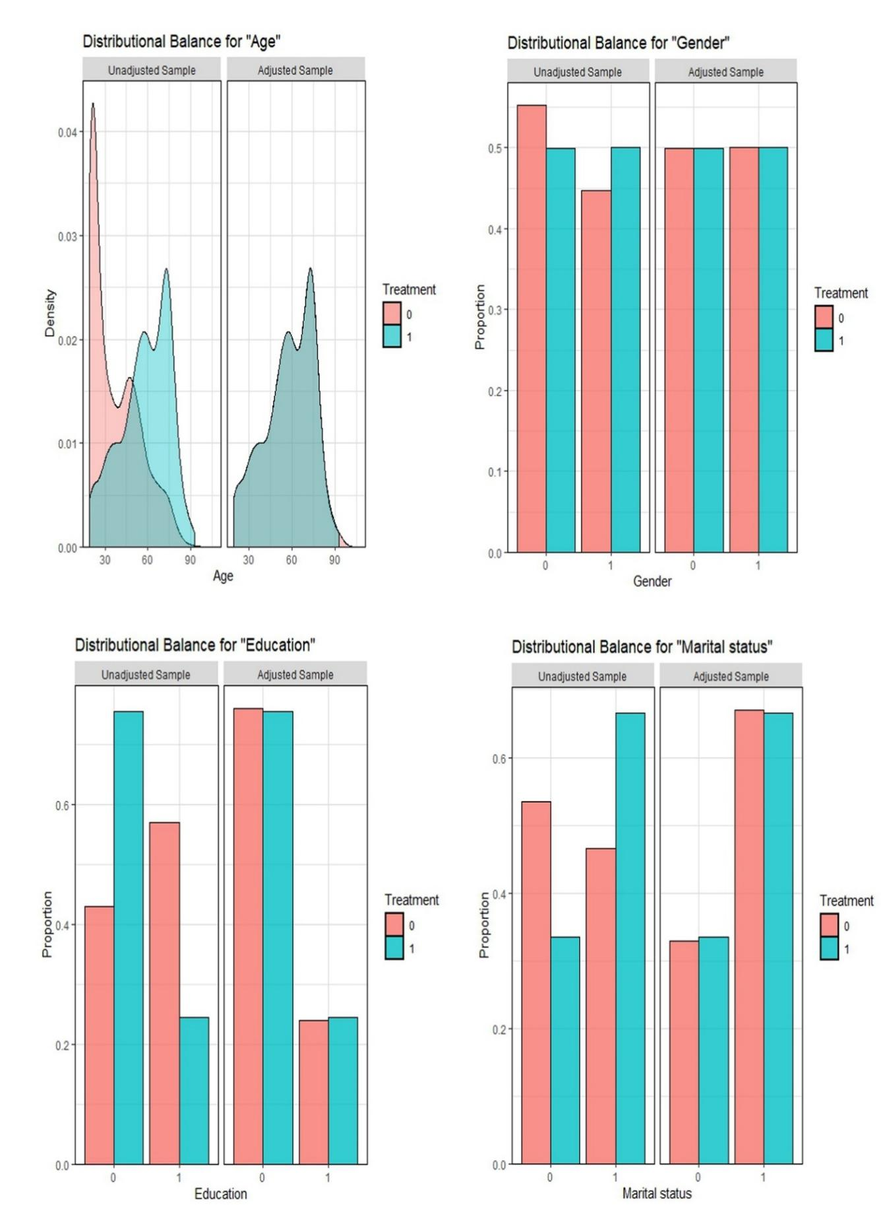
Figure S3. Weighted adjacency matrices of the depressive–anxiety–sleep symptom networks in the CHD and non-CHD groups.
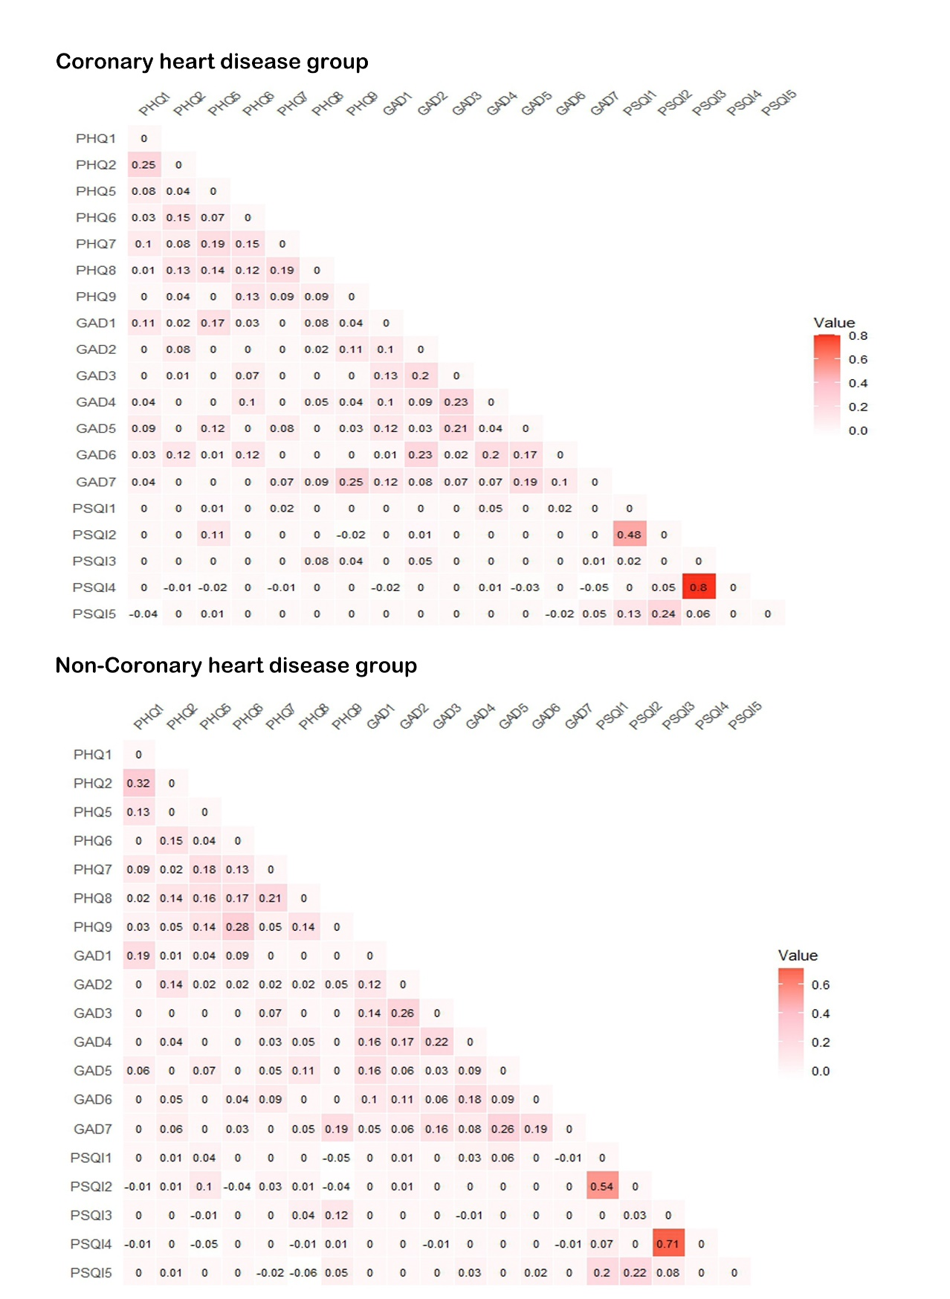
Figure S4. Case-dropping bootstrap analysis of centrality stability in the depressive–anxiety–sleep symptom networks. The correlation stability coefficients for expected influence and bridge expected influence were 0.75 in both the CHD and non-CHD groups.
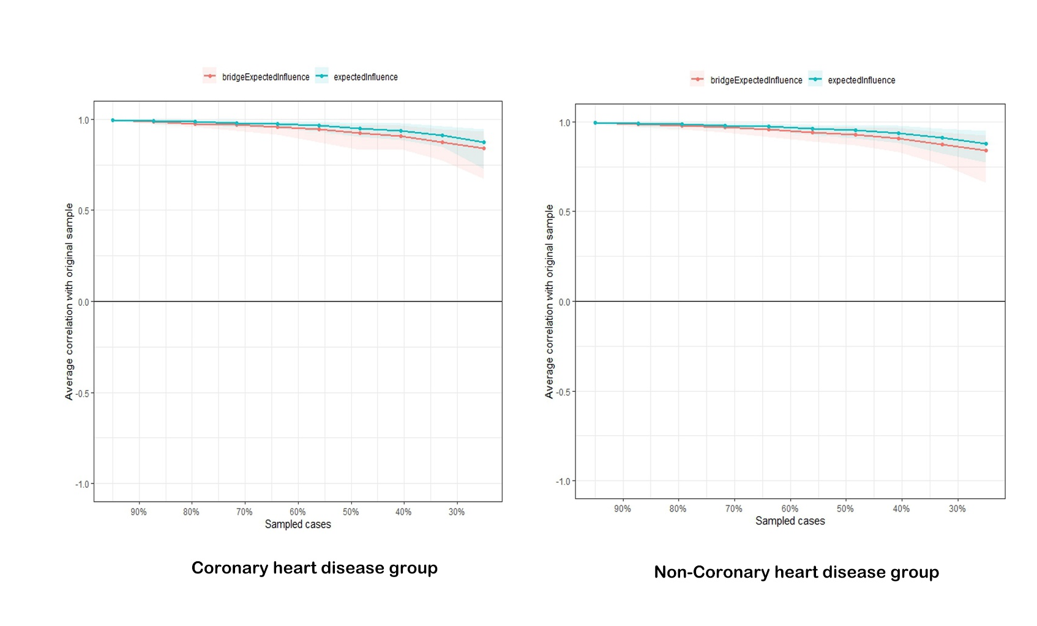

Figure S5. Bootstrapped confidence intervals for edge weights in the depressive–anxiety–sleep symptom networks in the CHD and non-CHD groups.
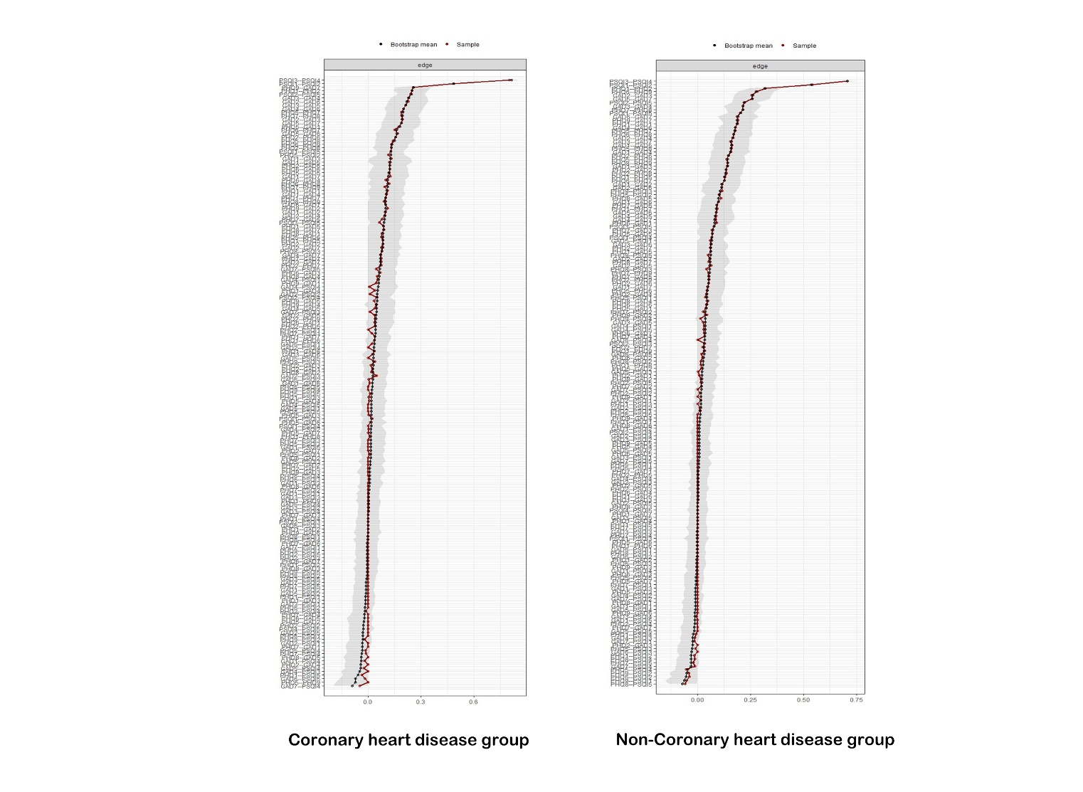
Note: Red dots represent the estimated edge weights, ordered from largest to smallest, and gray bars represent the 95% confidence intervals obtained using nonparametric bootstrapping. Wider intervals indicate lower precision, whereas narrower intervals indicate greater precision of the edge-weight estimates.

Figure S6. Case-dropping bootstrap analysis of centrality stability in the HRQoL–symptom networks. The correlation stability coefficient for expected influence was 0.75 in both the CHD and non-CHD groups.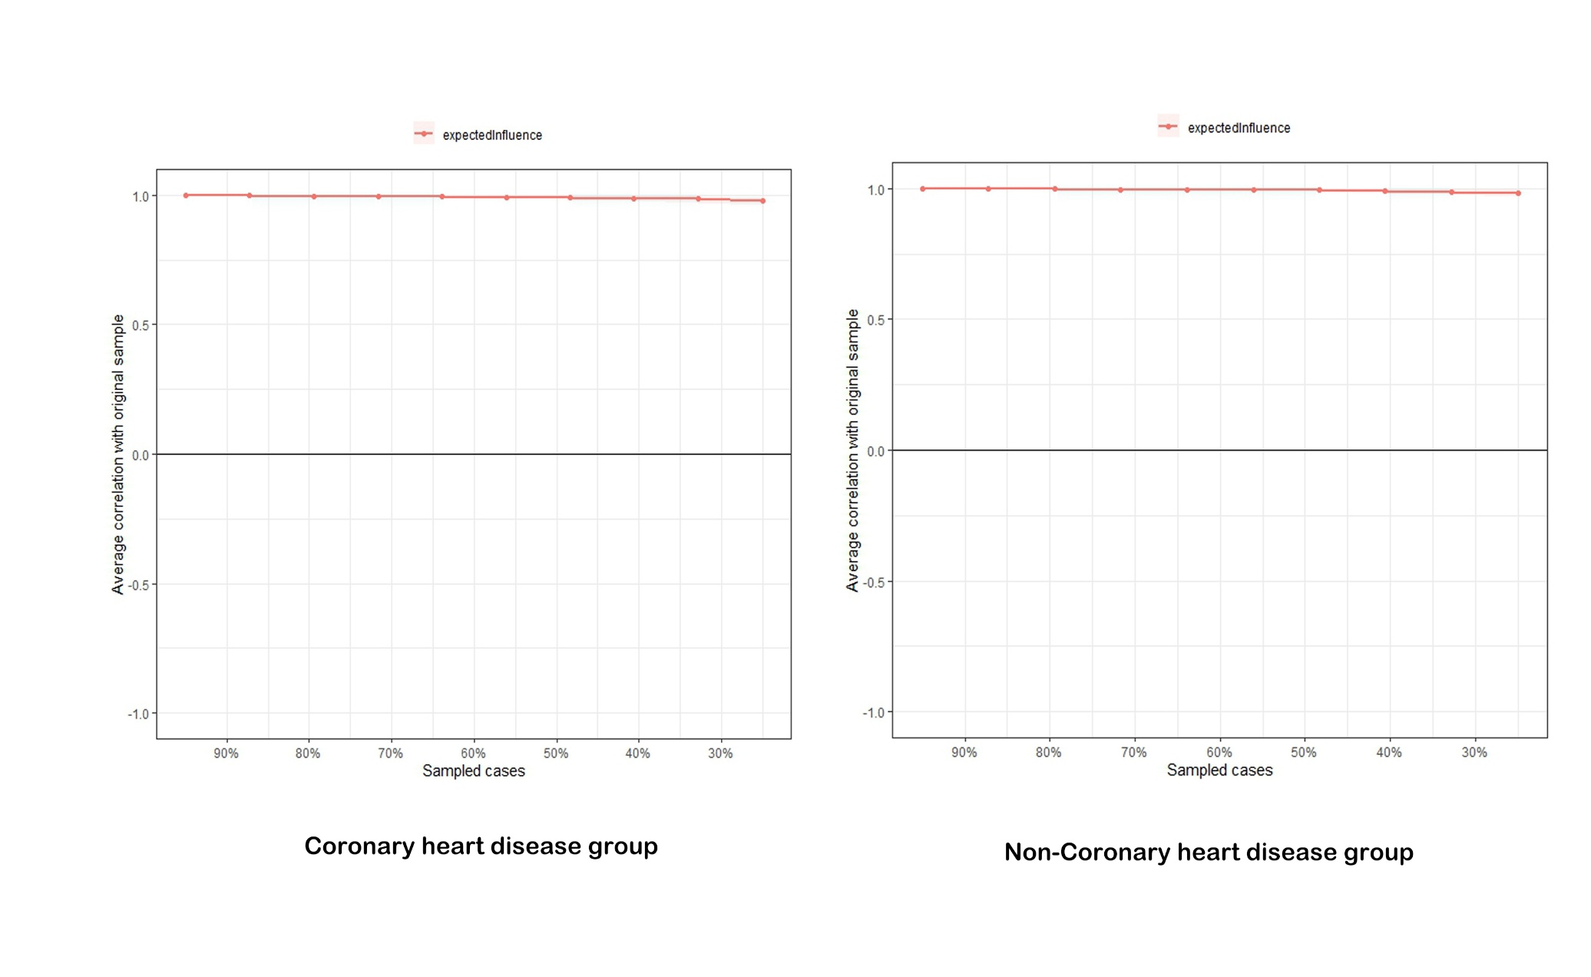

Figure S7. Bootstrapped confidence intervals for edge weights in the HRQoL–symptom networks in the CHD and non-CHD groups. 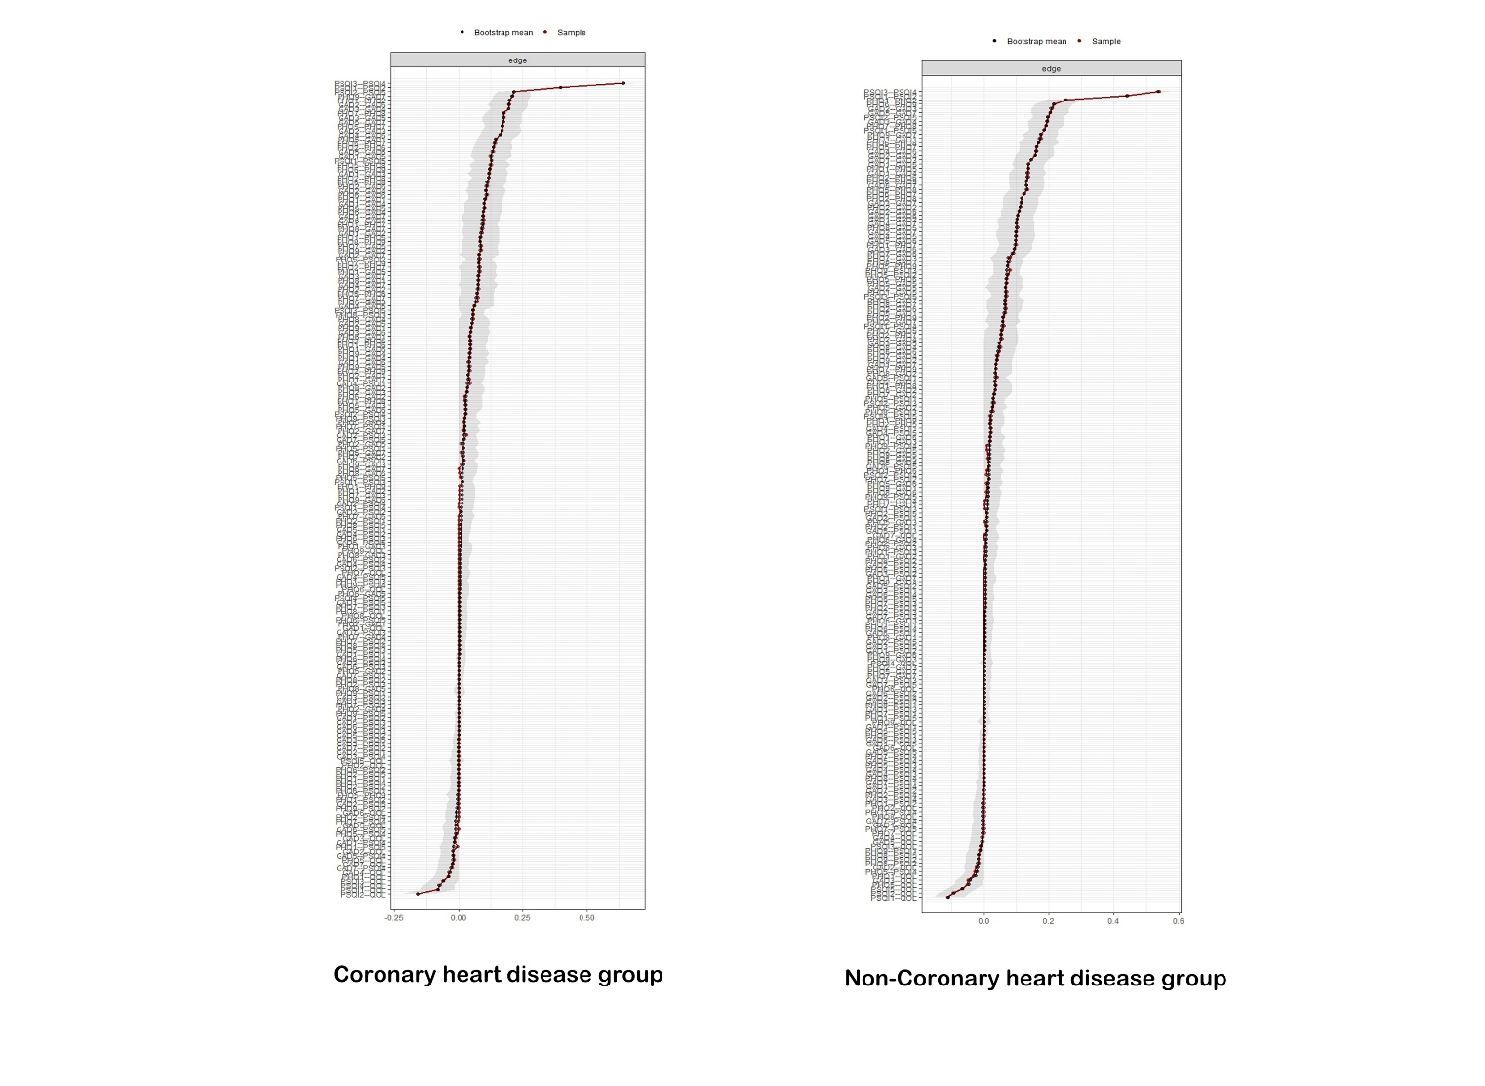
Note: Red dots represent the estimated edge weights, ordered from largest to smallest, and gray bars represent the 95% confidence intervals obtained using nonparametric bootstrapping. Wider intervals indicate lower precision, whereas narrower intervals indicate greater precision of the edge-weight estimates.

