Additional File 1

Additional Figure Legends
Figure S1. Postbaseline time point assessments for tumor response by study for patients with ≥1 evaluable time point assessment. Per protocol, the sites were instructed to perform CT or MRI scans of the lesion at baseline and quarterly during the treatment period. ¹⁸FDG-PET scans were performed at the discretion of the investigator. Because this was a retrospective, independent image review, no specific acquisition parameters were provided. Sites were instructed to use their standard acquisition parameters for CT, MRI, and ¹⁸FDG-PET. Consistent use of the imaging modalities, parameters, and contrast was recommended for reproducibility. CT computed tomography, ¹⁸FDG-PET 2-deoxy-2-[18F] fluoro-D-glucose positron emission tomography, MRI magnetic resonance imaging.
Figure S2. (a) Best percentage change in SLD for target lesions in the ICDS evaluation and (b) best percentage change in density for target lesions in the ICDS evaluation. ICDS Inverse Choi Density/Size; LD longest diameter; SLD sum of longest diameter.

Figure S1.
Study 1 (N=27) Study 2 (N=163)
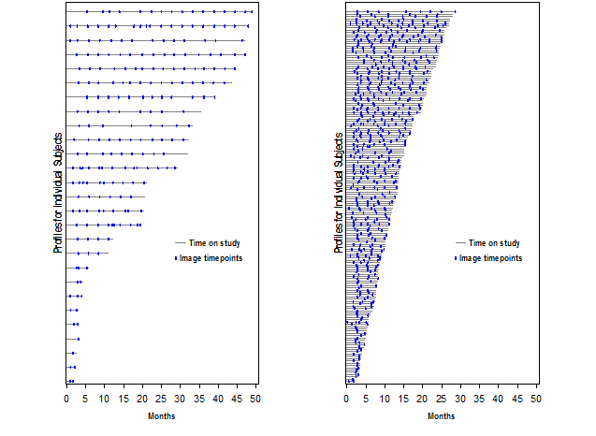

Figure S2.
a

b

