Supplementary material

Supplemental text S1

Exclusion criteria and primary selection
The definition for the primary selection at WIdO was as follows: Continuously insured (>350 days/year) with the AOK with german postal code (0< plz < 99999) in the years 2006-2017 or until death (totalling ca. 15,56 mio). Incident diagnosis of colon (C18,C19) or rectal cancer with first inpatient diagnosis with hospital admission date within the years 2009-2017 with primary or secondary diagnosis C18/19 or C20, respectively.
The following sequential exclusion criteria (with rationales) were used for this pre-selected data set:
- Not insured for the whole period (Relevant diagnoses, treatments, and events (incl. death) may not be observed), except for breaks up to 14 days or death. It is assumed that this exclusion does not introduce a sort of bias as changing the type of health insurance may have economic reasons, but is most likely independent of the type of treatment offered healthcare, i.e. we treated the scenario of “having more than one insurance throughout the observation period” as equal with the scenario “not insured by AOK at all”, the latter is the case for roughly 2/3 of the german population [https://www.bundesgesundheitsministerium.de/themen/krankenversicherung/zahlen-und-fakten-zur-krankenversicherung/kennzahlen-daten-bekanntmachungen.html].
- No primary inpatient diagnosis (The primary inpatient diagnosis indicates entity-specific treatment in a hospital; the focus of the analysis was on survival differences between patients with center and non-center treatments. To compare a complex intervention in a meaningful way we require patients to have at least one hospital stay in order to actually compare hospitals with or without certification. In addition, we expect the outpatient cohort to exhibit very different patterns of treatment.)
- Age < 18 years at diagnosis (Analysis was restricted to the adult population to exclude rare, special cases of colorectal cancer)
- Washout: Inpatient or outpatient diagnosis of colon or rectal cancer in the period 2006-2008 (Used for identification of incident cases of colorectal cancer)
- Treatment in a hospital which became a certified center within 1 year before index treatment (Hospitals are likely to have already established structures required for certification before the certificate is issued; patients treated in this 1-year period before certification therefore are likely to have effectively received center treatment)
- Primary resection more than 6 months after index treatment (Primary tumor resection was used for definition of index treatment only if it occurs within a reasonable time frame after the first relevant inpatient diagnosis of colorectal cancer; other cases may have low plausibility)
- Survival time of zero (patients dying at the date of index treatment may not benefit from treatment in certified center
- Missing hospital characteristics (The full regression model adjusts for hospital characteristics that represent potential confounders of center treatment. Patients treated in hospitals for which those characteristics were unknown were excluded to ensure comparability of results between different model specifications, i.e. complete case analysis). The number of patients with the sole exclusion reason being “missing hospital characteristics” for both colon and rectal cancer, split by category (multiple missings per patient are possible) is summarized in the following table (missings are due to incomplete information in data provided by the SQR.):

missings, category | Colon, n | Rectum, n
"university hospital" | 1936 | 751
"teaching hospital" | 606 | 238
"hospital type" | 822 | 316
"number of beds" | 606 | 238
total | 2152 | 829

Table S1: OPS-codes for definition of resection (in German):
OPS:5-455 | Inzision, Exzision, Resektion und Anastomose an Dünn- und Dickdarm- Partielle Resektion des Dickdarmes
OPS:5-456 | Inzision, Exzision, Resektion und Anastomose an Dünn- und Dickdarm- (Totale) Kolektomie und Proktokolektomie
OPS:5-459 | Inzision, Exzision, Resektion und Anastomose an Dünn- und Dickdarm- Bypass-Anastomose des Darmes
OPS:5-482 | Operationen am Rektum- Peranale lokale Exzision und Destruktion von erkranktem Gewebe des Rektums
OPS:5-484 | Operationen am Rektum- Rektumresektion unter Sphinktererhaltung
OPS:5-485 | Operationen am Rektum- Rektumresektion ohne Sphinktererhaltung
OPS:5-541.2 | Andere Operationen in der Bauchregion- Laparotomie und Eröffnung des Retroperitoneums- Relaparotomie-NA
OPS:5-471 | Operationen an der Appendix- Simultane Appendektomie

Figure S1: relative survival stratified by hospital size
- Colon, 1-299 beds B) Colon, 300-499 beds
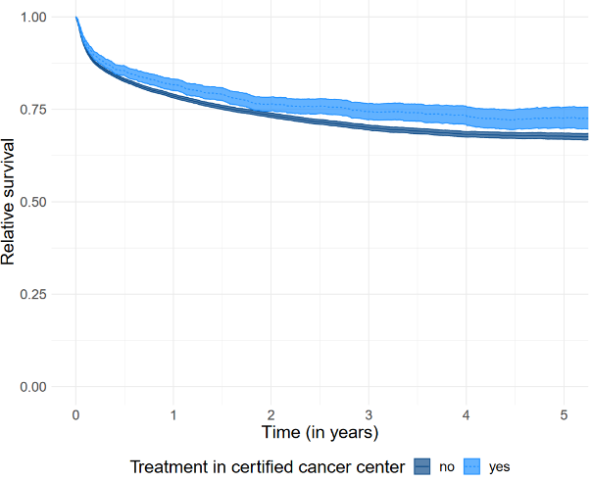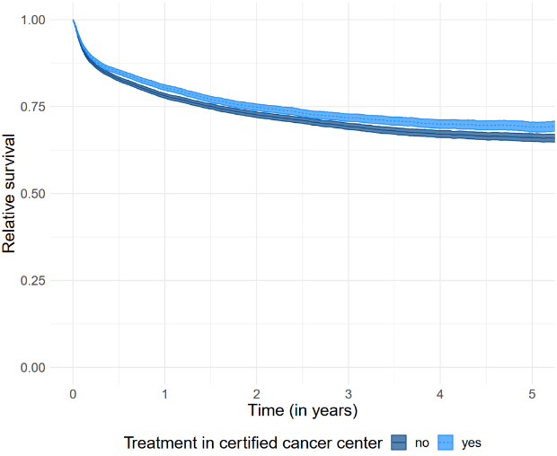

C) Colon, 500-999 beds D) Colon, 1000+ beds
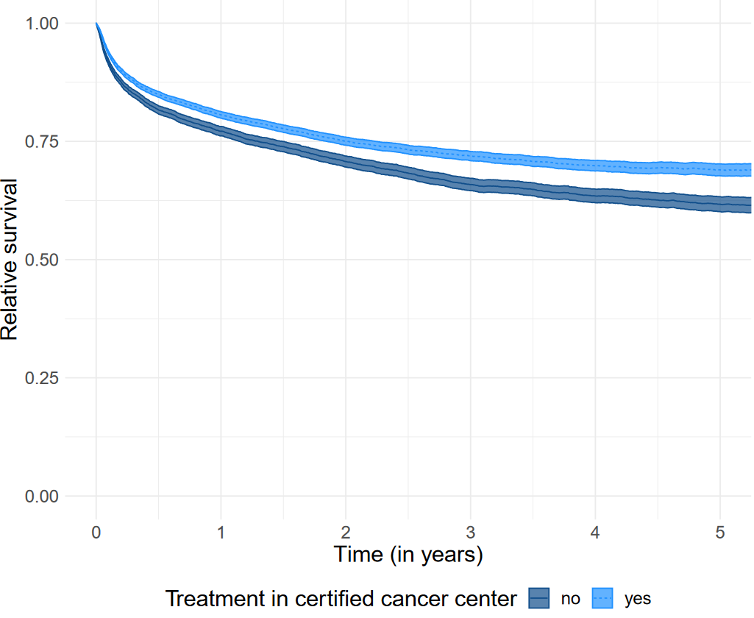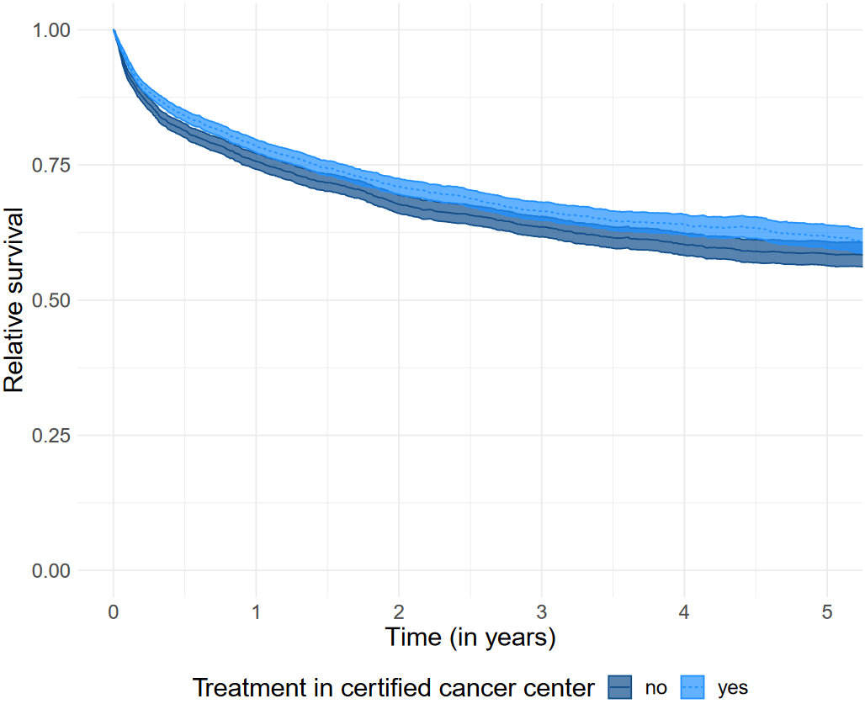
- Rectum, 1-299 beds F) Rectum, 300-499 beds
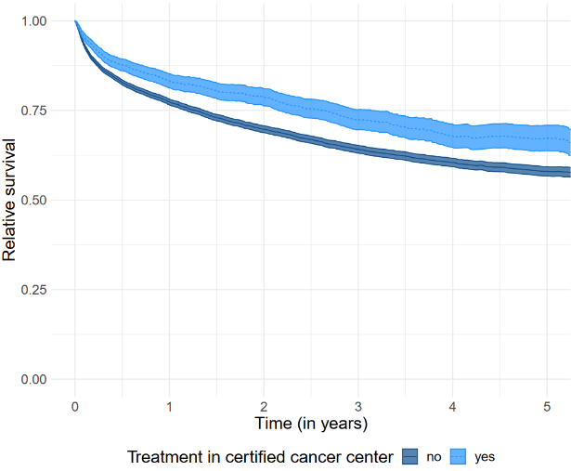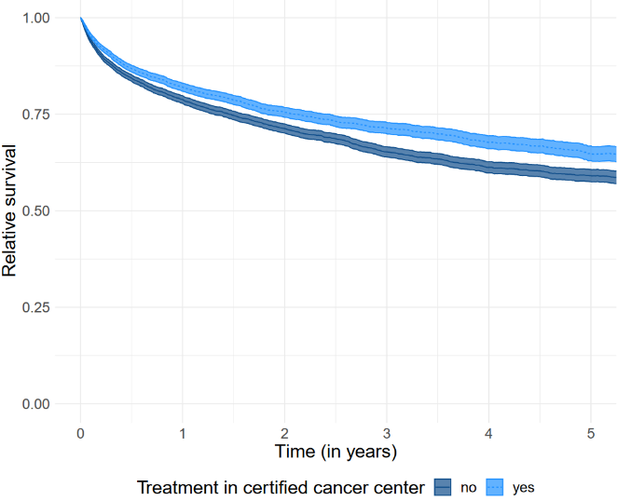
G) Rectum, 500-999 beds H) Rectum, 1000+ beds
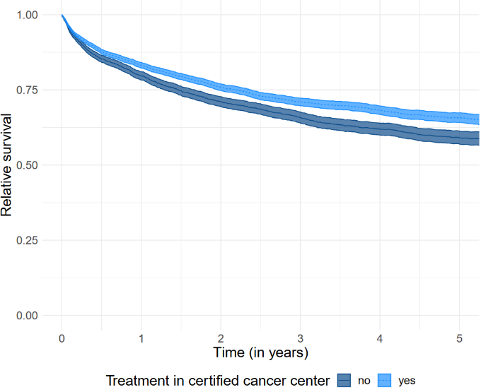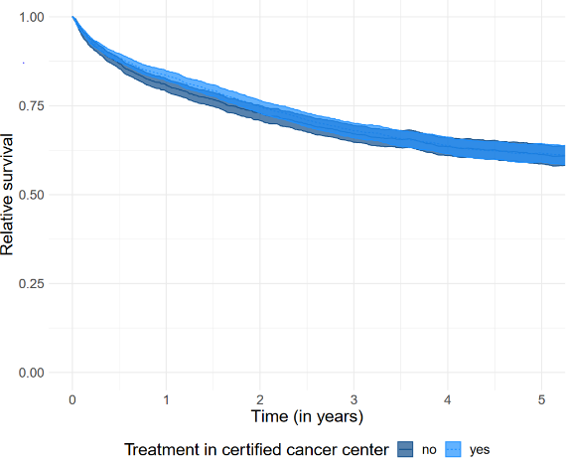

Table S2a: Clopper-Pearson Intervals of baseline table for patients with colon cancer by certification status with interval overlap
Variable | cert., % | cert., lower CI, % | cert., upper CI, % | non-cert., % | non-cert., lower CI % | cert., upper CI, % | CI overlap
Age 18-59 | 12.7% | 12.5 | 13.0 | 11.6% | 11.4 | 11.7 | no
Age 60-79 | 56.7% | 56.4 | 57.1 | 0.55 | 54.8 | 55.3 | no
Age 80+ | 30.5% | 30.2 | 30.8 | 33.4% | 33.2 | 33.6 | no
Sex female | 48.9% | 48.6 | 49.3 | 50.5% | 50.2 | 50.7 | no
Sex male | 51.1% | 50.7 | 51.4 | 49.5% | 49.3 | 49.8 | no
Distant metastasis yes | 28.8% | 28.5 | 29.1 | 26.4% | 26.2 | 26.7 | no
Other oncological disease | 37.4% | 37.1 | 37.7 | 35.8% | 35.6 | 36.1 | no
Congestive heart failure | 35.4% | 35.1 | 35.7 | 38.3% | 38.1 | 38.6 | no
Cardiac arrhythmias | 38.7% | 38.4 | 39.0 | 38.1% | 37.8 | 38.3 | no
Valvular disease | 20.5% | 20.2 | 20.7 | 19.7% | 19.5 | 19.9 | no
Pulmonary circulation disorders | 8.6% | 8.4 | 8.7 | 8.1% | 7.9 | 8.2 | no
Periph. vascular disorders | 31.2% | 30.9 | 31.5 | 30.5% | 30.3 | 30.7 | no
Hypertension (uncomplicated) | 81.7% | 81.4 | 81.9 | 82.7% | 82.5 | 82.9 | no
Hypertension (complicated) | 27.6% | 27.3 | 27.9 | 28.2% | 28.0 | 28.5 | no
Other neurological disorders | 11.4% | 11.2 | 11.6 | 11.3% | 11.2 | 11.5 | yes
Chronic pulmonary disease | 44.8% | 44.5 | 45.1 | 42.5% | 42.3 | 42.8 | no
Diabetes (uncomplicated) | 38.8% | 38.5 | 39.1 | 39.2% | 39.0 | 39.5 | yes
Diabetes (complicated) | 21.9% | 21.6 | 22.2 | 21.4% | 21.2 | 21.6 | no
Renal failure | 25.4% | 25.2 | 25.7 | 24.9% | 24.7 | 25.2 | no
Liver disease | 29.7% | 29.4 | 29.9 | 26.8% | 26.5 | 27.0 | no
Blood loss anemia | 9.1% | 8.9 | 9.3 | 9.5% | 9.3 | 9.6 | no
Deficiency anemia | 27.9% | 27.6 | 28.1 | 26.7% | 26.5 | 27.0 | no
Alcohol abuse | 7.2% | 7.0 | 7.4 | 0.07 | 6.9 | 7.1 | yes
Drug abuse | 2.3% | 2.2 | 2.4 | 2.5% | 0.2 | 0.3 | no

Table S2b: Clopper-Pearson Intervals of baseline table for patients with rectal cancer by certification status with interval overlap
Variable | cert., % | cert., lower CI, % | cert., upper CI, % | non-cert., % | non-cert., lower CI % | cert., upper CI, % | CI overlap
Age 18-59 | 18.8% | 18.5 | 19.1 | 15% | 14.7 | 15.3 | no
Age 60-79 | 59.4% | 59.0 | 59.8 | 58.1% | 57.7 | 58.4 | no
Age 80+ | 21.8% | 21.5 | 22.2 | 26.9% | 26.6 | 27.2 | no
Sex female | 39.1% | 38.7 | 39.5 | 40.8% | 40.5 | 41.2 | no
Sex male | 60.9% | 60.5 | 61.3 | 59.2% | 58.8 | 59.5 | no
Distant metastasis yes | 25.5% | 25.2 | 25.9 | 25.6% | 25.3 | 25.9 | yes
Other oncological disease | 50% | 49.6 | 50.4 | 49.7% | 49.3 | 50.0 | yes
Congestive heart failure | 27.6% | 27.3 | 28.0 | 32.6% | 32.2 | 32.9 | no
Cardiac arrhythmias | 32.4% | 32.0 | 32.8 | 33.1% | 32.8 | 33.5 | yes
Valvular disease | 16.1% | 15.8 | 16.4 | 16.6% | 16.3 | 16.9 | yes
Pulmonary circulation disorders | 5.9% | 5.7 | 6.1 | 6.2% | 6.1 | 6.4 | yes
Periph. vascular disorders | 30.3% | 29.9 | 30.7 | 30.2% | 29.9 | 30.5 | yes
Hypertension (uncomplicated) | 75.8% | 75.4 | 76.2 | 78.5% | 78.2 | 78.8 | no
Hypertension (complicated) | 22.7% | 22.3 | 23.1 | 24.7% | 24.4 | 25.0 | no
Other neurological disorders | 9.4% | 9.2 | 9.7 | 10.2% | 9.9 | 10.4 | no
Chronic pulmonary disease | 40.9% | 40.5 | 41.3 | 38.9% | 38.5 | 39.2 | no
Diabetes (uncomplicated) | 34.4% | 34.0 | 34.8 | 36.3% | 35.9 | 36.6 | no
Diabetes (complicated) | 18.7% | 18.4 | 19.1 | 19% | 18.7 | 19.3 | yes
Renal failure | 19.9% | 19.5 | 20.2 | 20.7% | 20.4 | 21.1 | no
Liver disease | 27.8% | 27.4 | 28.2 | 24.9% | 24.6 | 25.2 | no
Blood loss anemia | 4.7% | 4.5 | 4.9 | 5.6% | 5.4 | 5.8 | no
Deficiency anemia | 15.1% | 14.8 | 15.5 | 15.8% | 15.5 | 16.0 | no
Alcohol abuse | 8.9% | 8.6 | 9.1 | 8.8% | 8.5 | 9.0 | yes
Drug abuse | 2% | 1.9 | 2.1 | 2.2% | 2.1 | 2.3 | yes

Table S3: Baseline table for hospital characteristics for patients with rectal cancer by certification status
Variable | All | (n=1,051) | Certified: no | (n=741) | Certified: yes | (n=310)
Hospital beds, n (%)
1-299 | 580 | (55.2%) | 540 | (72.9%) | 40 | (12.9%)
300-499 | 261 | (24.8%) | 142 | (19.2%) | 119 | (38.4%)
500-999 | 160 | (15.2%) | 50 | (6.7%) | 110 | (35.5%)
1000+ | 50 | (4.8%) | 9 | (1.2%) | 41 | (13.2%)
Teaching hospital, n (%)
no | 449 | (42.7%) | 399 | (53.8%) | 50 | (16.1%)
yes | 602 | (57.3%) | 342 | (46.2%) | 260 | (83.9%)
University hospital, n (%)
no | 1,023 | (97.3%) | 734 | (99.1%) | 289 | (93.2%)
yes | 28 | (2.7%) | 7 | (0.9%) | 21 | (6.8%)
Hospital ownership, n (%)
public | 382 | (36.3%) | 239 | (32.3%) | 143 | (46.1%)
non-profit | 459 | (43.7%) | 336 | (45.3%) | 123 | (39.7%)
private | 210 | (20%) | 166 | (22.4%) | 44 | (14.2%)
Certified center, n (%)
no | 741 | (70.5%)
yes | 310 | (29.5%)

Table S4: Overall survival rates for 30days, 1, 2, 3, 4, 5 years with 95% CI-intervals (lower, upper)
Entity | certified | 30d | 1year | 2year | 3year | 4year | 5year
colon | yes | 0.940 (0.937,0.942) | 0.756 (0.751,0.760) | 0.657 (0.652,0.662) | 0.587 (0.582,0.593) | 0.532 (0.527,0.538) | 0.487 (0.481,0.493)
 | no | 0.923 (0.921,0.925) | 0.732 (0.729,0.736) | 0.636 (0.632,0.640) | 0.564 (0.560,0.568) | 0.509 (0.505,0.513) | 0.467 (0.463,0.471)
Rectum | yes | 0.959 (0.956,0.962) | 0.786 (0.781,0.792) | 0.682 (0.676,0.689) | 0.602 (0.595,0.610) | 0.541 (0.534,0.549) | 0.492 (0.484,0.500)
 | no | 0.943 (0.941,0.946) | 0.739 (0.734,0.744) | 0.628 (0.623,0.634) | 0.544 (0.538,0.550) | 0.481 (0.474,0.487) | 0.433 (0.427,0.440)

Supplemental Table S5: Full results of Cox regression with shared frailty for colon cancer

Colon cancer, C18/C19
 | certification only |  | + age, sex |  | + metastasis, secondary malignoma, Elixhauser comorbidities |  | + hospital characteristics |  | + calendar year dummies
Variable | HR | CI | HR | CI | HR | CI | HR | CI | HR | CI
Certified center (ref: no) | - | - | - | - | - | - | - | - | - | -
yes | 0.93*** | (0.90,0.96) | 0.94*** | (0.91,0.96) | 0.89*** | (0.87,0.92) | 0.88*** | (0.86,0.91) | 0.92*** | (0.89,0.95)
Age (ref: 18-59) | - | - | - | - | - | - | - | - | - | -
60-79 |  |  | 1.73*** | (1.67,1.79) | 1.62*** | (1.56,1.68) | 1.62*** | (1.56,1.68) | 1.61*** | (1.55,1.67)
80+ |  |  | 3.58*** | (3.45,3.70) | 3.23*** | (3.11,3.36) | 3.23*** | (3.11,3.36) | 3.22*** | (3.10,3.35)
Sex (ref: female) | - | - | - | - | - | - | - | - | - | -
male |  |  | 1.17*** | (1.15,1.19) | 1.10*** | (1.08,1.12) | 1.10*** | (1.08,1.12) | 1.10*** | (1.08,1.12)
Distant metastasis (ref: no) | - | - | - | - | - | - | - | - | - | -
yes |  |  |  |  | 4.19*** | (4.11,4.26) | 4.19*** | (4.11,4.26) | 4.20*** | (4.13,4.28)
Other oncological disease (ref: no) | - | - | - | - | - | - | - | - | - | -
yes |  |  |  |  | 0.98* | (0.96,1.00) | 0.98* | (0.96,1.00) | 0.98* | (0.96,1.00)
Congestive heart failure (ref: no) | - | - | - | - | - | - | - | - | - | -
yes |  |  |  |  | 1.41*** | (1.38,1.44) | 1.41*** | (1.38,1.44) | 1.40*** | (1.37,1.43)
Cardiac arrhythmias (ref: no) | - | - | - | - | - | - | - | - | - | -
yes |  |  |  |  | 1.04*** | (1.02,1.06) | 1.04*** | (1.02,1.06) | 1.05*** | (1.03,1.07)
Valvular disease (ref: no) | - | - | - | - | - | - | - | - | - | -
yes |  |  |  |  | 0.95*** | (0.93,0.97) | 0.95*** | (0.93,0.97) | 0.95*** | (0.93,0.97)
Pulmonary circulation disorders (ref: no) | - | - | - | - | - | - | - | - | - | -
yes |  |  |  |  | 1.27*** | (1.23,1.31) | 1.27*** | (1.23,1.31) | 1.27*** | (1.23,1.31)
Periph. vascular disorders (ref: no) | - | - | - | - | - | - | - | - | - | -
yes |  |  |  |  | 1.07*** | (1.05,1.09) | 1.07*** | (1.05,1.09) | 1.08*** | (1.06,1.10)
Hypertension, (uc) (ref: no) | - | - | - | - | - | - | - | - | - | -
yes |  |  |  |  | 0.92*** | (0.90,0.94) | 0.92*** | (0.90,0.94) | 0.92*** | (0.90,0.95)
Hypertension, (c) (ref: no) | - | - | - | - | - | - | - | - | - | -
yes |  |  |  |  | 0.91*** | (0.89,0.93) | 0.91*** | (0.89,0.93) | 0.92*** | (0.90,0.94)
Other neurological disorders (ref: no) | - | - | - | - | - | - | - | - | - | -
yes |  |  |  |  | 1.37*** | (1.33,1.40) | 1.37*** | (1.33,1.40) | 1.37*** | (1.33,1.40)
Chronic pulmonary disease (ref: no) | - | - | - | - | - | - | - | - | - | -
yes |  |  |  |  | 1.00 | (0.98,1.02) | 1.00 | (0.98,1.02) | 1.01 | (0.99,1.02)
Diabetes (uc) (ref: no) | - | - | - | - | - | - | - | - | - | -
yes |  |  |  |  | 1.10*** | (1.07,1.12) | 1.10*** | (1.07,1.12) | 1.09*** | (1.07,1.12)
Diabetes (c) (ref: no) | - | - | - | - | - | - | - | - | - | -
yes |  |  |  |  | 1.03* | (1.00,1.05) | 1.03* | (1.00,1.05) | 1.03** | (1.01,1.06)
Renal failure (ref: no) | - | - | - | - | - | - | - | - | - | -
yes |  |  |  |  | 1.29*** | (1.26,1.32) | 1.29*** | (1.26,1.32) | 1.30*** | (1.28,1.33)
Liver disease (ref: no) | - | - | - | - | - | - | - | - | - | -
yes |  |  |  |  | 0.97*** | (0.95,0.99) | 0.97*** | (0.95,0.99) | 0.97** | (0.95,0.99)
Blood loss anemia (ref: no) | - | - | - | - | - | - | - | - | - | -
yes |  |  |  |  | 1.01 | (0.99,1.04) | 1.01 | (0.99,1.04) | 1.01 | (0.98,1.04)
Deficiency anemia (ref: no) | - | - | - | - | - | - | - | - | - | -
yes |  |  |  |  | 1.01 | (0.99,1.03) | 1.01 | (0.99,1.03) | 1.02 | (1.00,1.04)
Alcohol abuse (ref: no) | - | - | - | - | - | - | - | - | - | -
yes |  |  |  |  | 1.39*** | (1.34,1.44) | 1.39*** | (1.34,1.44) | 1.40*** | (1.35,1.44)
Drug abuse (ref: no) | - | - | - | - | - | - | - | - | - | -
yes |  |  |  |  | 1.16*** | (1.11,1.23) | 1.16*** | (1.11,1.22) | 1.16*** | (1.10,1.22)
Hospital beds (ref: 1-299) | - | - | - | - | - | - | - | - | - | -
300-499 |  |  |  |  |  |  | 1.04 | (1.00,1.07) | 1.02 | (0.98,1.05)
500-999 |  |  |  |  |  |  | 1.05* | (1.01,1.10) | 1.03 | (0.98,1.07)
1000+ |  |  |  |  |  |  | 1.08* | (1.01,1.16) | 1.05 | (0.98,1.12)
Teaching hospital (ref: no) | - | - | - | - | - | - | - | - | - | -
yes |  |  |  |  |  |  | 0.97 | (0.94,1.00) | 0.98 | (0.95,1.01)
University hospital (ref: no) | - | - | - | - | - | - | - | - | - | -
yes |  |  |  |  |  |  | 0.99 | (0.90,1.08) | 1.00 | (0.91,1.10)
Hospital ownership (ref: public) | - | - | - | - | - | - | - | - | - | -
non-profit |  |  |  |  |  |  | 1.01 | (0.98,1.04) | 1.01 | (0.98,1.04)
private |  |  |  |  |  |  | 1.03 | (0.99,1.07) | 1.03 | (0.99,1.07)
Year of index treatment (ref: 2009) | - | - | - | - | - | - | - | - | - | -
2010 |  |  |  |  |  |  |  |  | 0.95** | (0.92,0.98)
2011 |  |  |  |  |  |  |  |  | 0.97 | (0.94,1.01)
2012 |  |  |  |  |  |  |  |  | 0.95** | (0.92,0.98)
2013 |  |  |  |  |  |  |  |  | 0.93*** | (0.90,0.97)
2014 |  |  |  |  |  |  |  |  | 0.90*** | (0.87,0.93)
2015 |  |  |  |  |  |  |  |  | 0.87*** | (0.84,0.90)
2016 |  |  |  |  |  |  |  |  | 0.86*** | (0.82,0.89)
2017 |  |  |  |  |  |  |  |  | 0.82*** | (0.77,0.86)
Number of patients | 109,687 |  | 109,687 |  | 109,687 |  | 109,687 |  | 109,687
Number of hospitals | 1,087 |  | 1,087 |  | 1,087 |  | 1,087 |  | 1,087
SD(RE) | 0.23 |  | 0.2 |  | 0.18 |  | 0.17 |  | 0.18
Model | me |  | me |  | me |  | me |  | me

HR=Hazard ratio, CI=95%-confidence interval, significance levels: *1%, **5%, ***0.1%

Supplemental Table S6: Full results of Cox regression with shared frailty for rectal cancer

Rectal cancer, C20
 | certification only |  | + age, sex |  | + metastasis, secondary malignoma, Elixhauser comorbidities |  | + hospital characteristics |  | + calendar year dummies
Variable | HR | CI | HR | CI | HR | CI | HR | CI | HR | CI
Certified center (ref: no) | - | - | - | - | - | - | - | - | - | -
yes | 0.86*** | (0.83,0.89) | 0.88*** | (0.86,0.91) | 0.88*** | (0.85,0.90) | 0.88*** | (0.85,0.92) | 0.90*** | (0.87,0.94)
Age (ref: 18-59) | - | - | - | - | - | - | - | - | - | -
60-79 |  |  | 1.76*** | (1.68,1.83) | 1.72*** | (1.65,1.80) | 1.72*** | (1.65,1.80) | 1.71*** | (1.64,1.79)
80+ |  |  | 3.79*** | (3.62,3.97) | 3.59*** | (3.42,3.78) | 3.59*** | (3.41,3.77) | 3.58*** | (3.40,3.76)
Sex (ref: female) | - | - | - | - | - | - | - | - | - | -
male |  |  | 1.11*** | (1.08,1.14) | 1.05*** | (1.03,1.08) | 1.06*** | (1.03,1.08) | 1.06*** | (1.03,1.08)
Distant metastasis (ref: no) | - | - | - | - | - | - | - | - | - | -
yes |  |  |  |  | 3.59*** | (3.50,3.69) | 3.60*** | (3.50,3.69) | 3.61*** | (3.51,3.70)
Other oncological disease (ref: no) | - | - | - | - | - | - | - | - | - | -
yes |  |  |  |  | 0.91*** | (0.88,0.93) | 0.91*** | (0.88,0.93) | 0.91*** | (0.88,0.93)
Congestive heart failure (ref: no) | - | - | - | - | - | - | - | - | - | -
yes |  |  |  |  | 1.34*** | (1.30,1.38) | 1.34*** | (1.30,1.38) | 1.33*** | (1.29,1.38)
Cardiac arrhythmias (ref: no) | - | - | - | - | - | - | - | - | - | -
yes |  |  |  |  | 1.03 | (1.00,1.06) | 1.03 | (1.00,1.06) | 1.04* | (1.01,1.07)
Valvular disease (ref: no) | - | - | - | - | - | - | - | - | - | -
yes |  |  |  |  | 0.95** | (0.92,0.99) | 0.95** | (0.92,0.99) | 0.95** | (0.92,0.99)
Pulmonary circulation disorders (ref: no) | - | - | - | - | - | - | - | - | - | -
yes |  |  |  |  | 1.28*** | (1.22,1.34) | 1.28*** | (1.22,1.34) | 1.28*** | (1.22,1.35)
Periph. vascular disorders (ref: no) | - | - | - | - | - | - | - | - | - | -
yes |  |  |  |  | 1.05*** | (1.03,1.08) | 1.05*** | (1.03,1.08) | 1.06*** | (1.03,1.09)
Hypertension, (uc) (ref: no) | - | - | - | - | - | - | - | - | - | -
yes |  |  |  |  | 0.91*** | (0.88,0.95) | 0.91*** | (0.88,0.95) | 0.91*** | (0.88,0.95)
Hypertension, (c) (ref: no) | - | - | - | - | - | - | - | - | - | -
yes |  |  |  |  | 0.91*** | (0.88,0.94) | 0.91*** | (0.88,0.94) | 0.91*** | (0.88,0.94)
Other neurological disorders (ref: no) | - | - | - | - | - | - | - | - | - | -
yes |  |  |  |  | 1.44*** | (1.38,1.49) | 1.44*** | (1.38,1.49) | 1.44*** | (1.39,1.50)
Chronic pulmonary disease (ref: no) | - | - | - | - | - | - | - | - | - | -
yes |  |  |  |  | 0.97* | (0.95,1.00) | 0.97 | (0.95,1.00) | 0.98 | (0.95,1.01)
Diabetes (uc) (ref: no) | - | - | - | - | - | - | - | - | - | -
yes |  |  |  |  | 1.09*** | (1.06,1.13) | 1.09*** | (1.06,1.13) | 1.09*** | (1.05,1.12)
Diabetes (c) (ref: no) | - | - | - | - | - | - | - | - | - | -
yes |  |  |  |  | 1.02 | (0.98,1.06) | 1.02 | (0.98,1.06) | 1.03 | (0.99,1.07)
Renal failure (ref: no) | - | - | - | - | - | - | - | - | - | -
yes |  |  |  |  | 1.26*** | (1.22,1.30) | 1.26*** | (1.22,1.30) | 1.27*** | (1.23,1.31)
Liver disease (ref: no) | - | - | - | - | - | - | - | - | - | -
yes |  |  |  |  | 0.95*** | (0.92,0.98) | 0.95*** | (0.92,0.98) | 0.95** | (0.93,0.98)
Blood loss anemia (ref: no) | - | - | - | - | - | - | - | - | - | -
yes |  |  |  |  | 1.19*** | (1.13,1.25) | 1.19*** | (1.13,1.25) | 1.19*** | (1.13,1.25)
Deficiency anemia (ref: no) | - | - | - | - | - | - | - | - | - | -
yes |  |  |  |  | 1.19*** | (1.15,1.23) | 1.19*** | (1.15,1.23) | 1.20*** | (1.16,1.24)
Alcohol abuse (ref: no) | - | - | - | - | - | - | - | - | - | -
yes |  |  |  |  | 1.52*** | (1.45,1.58) | 1.52*** | (1.45,1.58) | 1.53*** | (1.46,1.60)
Drug abuse (ref: no) | - | - | - | - | - | - | - | - | - | -
yes |  |  |  |  | 1.21*** | (1.12,1.31) | 1.21*** | (1.12,1.31) | 1.21*** | (1.12,1.30)
Hospital beds (ref: 1-299) | - | - | - | - | - | - | - | - | - | -
300-499 |  |  |  |  |  |  | 1.00 | (0.96,1.04) | 0.98 | (0.94,1.03)
500-999 |  |  |  |  |  |  | 0.99 | (0.94,1.04) | 0.97 | (0.92,1.02)
1000+ |  |  |  |  |  |  | 1.00 | (0.93,1.07) | 0.98 | (0.91,1.05)
Teaching hospital (ref: no) | - | - | - | - | - | - | - | - | - | -
yes |  |  |  |  |  |  | 0.99 | (0.95,1.03) | 1.00 | (0.96,1.04)
University hospital (ref: no) | - | - | - | - | - | - | - | - | - | -
yes |  |  |  |  |  |  | 0.95 | (0.86,1.04) | 0.95 | (0.86,1.04)
Hospital ownership (ref: public) | - | - | - | - | - | - | - | - | - | -
non-profit |  |  |  |  |  |  | 1.01 | (0.97,1.05) | 1.01 | (0.97,1.04)
private |  |  |  |  |  |  | 1.02 | (0.97,1.07) | 1.02 | (0.98,1.07)
Year of index treatment (ref: 2009) | - | - | - | - | - | - | - | - | - | -
2010 |  |  |  |  |  |  |  |  | 1.02 | (0.97,1.06)
2011 |  |  |  |  |  |  |  |  | 1.00 | (0.95,1.04)
2012 |  |  |  |  |  |  |  |  | 0.97 | (0.92,1.01)
2013 |  |  |  |  |  |  |  |  | 0.99 | (0.94,1.04)
2014 |  |  |  |  |  |  |  |  | 0.94* | (0.89,0.99)
2015 |  |  |  |  |  |  |  |  | 0.87*** | (0.82,0.92)
2016 |  |  |  |  |  |  |  |  | 0.88*** | (0.83,0.94)
2017 |  |  |  |  |  |  |  |  | 0.83*** | (0.76,0.89)
Number of patients | 51,456 |  | 51,456 |  | 51,456 |  | 51,456 |  | 51,456
Number of hospitals | 1,050 |  | 1,050 |  | 1,050 |  | 1,050 |  | 1,050
SD(RE) | 0.24 |  | 0.14 |  | 0.14 |  | 0.14 |  | 0.14
Model | me |  | me |  | me |  | me |  | me
HR=Hazard ratio, CI=95%-confidence interval, significance levels: *1%, **5%, ***0.1%
Table S7: Hazard ratios (HR) with 95%-confidence intervals (CI) from Cox regressions with shared frailty for certification effect and each hospital characteristic separately (1a-d), and a full model with standard Cox regression (1f).
 |  | Colon |  | Rectum
Model nr. | Variable | HR | CI | HR | CI
1a | Certified center yes (ref: no) | 0.92*** | (0.89,0.95) | 0.92*** | (0.89,0.95)
 | Hospital beds (ref: 1-299) | - | - | - | -
 | 300-499 | 1.00 | (0.96,1.04) | 1.00 | (0.96,1.04)
 | 500-999 | 1.01 | (0.97,1.06) | 1.01 | (0.97,1.06)
 | 1000+ | 1.07 | (1.00,1.14) | 1.07 | (1.00,1.14)
1b | Certified center yes (ref: no) | 0.92*** | (0.89,0.95) | 0.92*** | (0.89,0.95)
 | Teaching hospital yes (ref:no) | 1.01 | (0.98,1.05) | 1.01 | (0.98,1.05)
1c | Certified center yes (ref: no) | 0.92*** | (0.90,0.95) | 0.92*** | (0.90,0.95)
 | University hospital yes (ref:no) | 1.03 | (0.93,1.14) | 1.03 | (0.93,1.14)
1d | Certified center yes (ref: no) | 0.93*** | (0.90,0.95) | 0.93*** | (0.90,0.95)
 | Type (ref:public): non-profit | 0.98 | (0.95,1.02) | 0.98 | (0.95,1.02)
 | Type: private | 1.03 | (0.98,1.08) | 1.03 | (0.98,1.08)

Tables S8: Colon cancer: Hazard ratios (HR) with 95%-confidence intervals (CI) from Cox regressions with shared frailty for different subgroups of patients and hospitals
Colon, C18/C19 | Sex |  |  |  | Secondary malignoma |  |  |  | Distant metastasis |  |  |  | Hospital number
Colon, C18/C19 | male |  | female |  | no |  | yes |  | no |  | yes |  | single |  | association
Variable | HR | CI | HR | CI | HR | CI | HR | CI | HR | CI | HR | CI | HR | CI | HR | CI
Certified center (ref: no) | - | - | - | - | - | - | - | - | - | - | - | - | - | - | - | -
yes | 0.90*** | (0.87,0.94) | 0.92*** | (0.88,0.95) | 0.92*** | (0.88,0.95) | 0.91*** | (0.86,0.95) | 0.90*** | (0.86,0.93) | 0.93*** | (0.89,0.96) | 0.91*** | (0.88,0.95) | 0.92* | (0.86,0.99)
Age (ref: 18-59) | - | - | - | - | - | - | - | - | - | - | - | - | - | - | - | -
60-79 | 1.59*** | (1.52,1.66) | 1.66*** | (1.56,1.75) | 1.67*** | (1.61,1.74) | 1.32*** | (1.21,1.44) | 2.33*** | (2.19,2.48) | 1.30*** | (1.24,1.36) | 1.62*** | (1.55,1.68) | 1.59*** | (1.46,1.73)
80+ | 3.05*** | (2.89,3.21) | 3.46*** | (3.26,3.67) | 3.44*** | (3.29,3.59) | 2.44*** | (2.23,2.67) | 5.30*** | (4.98,5.65) | 2.17*** | (2.07,2.29) | 3.24*** | (3.10,3.38) | 3.16*** | (2.90,3.45)
Sex (ref: female) | - | - | - | - | - | - | - | - | - | - | - | - | - | - | - | -
male | - | - | - | - | 1.10*** | (1.07,1.12) | 1.10*** | (1.06,1.14) | 1.16*** | (1.13,1.18) | 1.02 | (0.99,1.05) | 1.10*** | (1.08,1.13) | 1.07** | (1.02,1.11)
Distant metastasis (ref: no) | - | - | - | - | - | - | - | - | - | - | - | - | - | - | - | -
yes | 4.17*** | (4.07,4.28) | 4.27*** | (4.16,4.38) | 4.52*** | (4.43,4.62) | 3.35*** | (3.23,3.48) | - | - | - | - | 4.21*** | (4.13,4.30) | 4.18*** | (4.02,4.35)
Other oncological disease (ref: no) | - | - | - | - | - | - | - | - | - | - | - | - | - | - | - | -
yes | 0.98 | (0.95,1.01) | 0.98 | (0.95,1.01) | - | - | - | - | 1.08*** | (1.05,1.11) | 0.89*** | (0.86,0.92) | 0.97* | (0.95,0.99) | 0.99 | (0.95,1.04)
Year of index treatment (ref: 2009) | - | - | - | - | - | - | - | - | - | - | - | - | - | - | - | -
2010 | 0.95* | (0.91,0.99) | 0.96 | (0.92,1.01) | 0.96* | (0.92,0.99) | 0.94 | (0.88,1.00) | 0.97 | (0.93,1.00) | 0.92*** | (0.87,0.96) | 0.96** | (0.93,0.99) | 0.92* | (0.85,1.00)
2011 | 0.96 | (0.92,1.01) | 0.99 | (0.95,1.04) | 0.99 | (0.95,1.03) | 0.94 | (0.88,1.00) | 0.98 | (0.94,1.02) | 0.94* | (0.89,0.99) | 0.97 | (0.94,1.00) | 0.97 | (0.89,1.05)
2012 | 0.97 | (0.92,1.01) | 0.94* | (0.90,0.99) | 0.96* | (0.92,0.99) | 0.94 | (0.88,1.01) | 0.92*** | (0.88,0.96) | 0.95 | (0.90,1.00) | 0.95** | (0.92,0.99) | 0.90* | (0.83,0.98)
2013 | 0.94** | (0.89,0.98) | 0.94* | (0.90,0.99) | 0.94** | (0.91,0.98) | 0.92* | (0.86,0.99) | 0.92*** | (0.88,0.96) | 0.92** | (0.87,0.97) | 0.95** | (0.91,0.99) | 0.85*** | (0.78,0.93)
2014 | 0.87*** | (0.83,0.92) | 0.94* | (0.89,0.98) | 0.90*** | (0.86,0.94) | 0.89** | (0.83,0.96) | 0.88*** | (0.83,0.92) | 0.89*** | (0.85,0.94) | 0.92*** | (0.88,0.95) | 0.81*** | (0.75,0.88)
2015 | 0.87*** | (0.82,0.92) | 0.88*** | (0.84,0.93) | 0.88*** | (0.84,0.92) | 0.86*** | (0.79,0.93) | 0.87*** | (0.82,0.91) | 0.86*** | (0.81,0.90) | 0.88*** | (0.84,0.92) | 0.81*** | (0.74,0.88)
2016 | 0.84*** | (0.79,0.89) | 0.89*** | (0.84,0.94) | 0.86*** | (0.82,0.91) | 0.85*** | (0.78,0.93) | 0.80*** | (0.76,0.85) | 0.88*** | (0.83,0.93) | 0.86*** | (0.82,0.90) | 0.80*** | (0.73,0.88)
2017 | 0.84*** | (0.78,0.90) | 0.80*** | (0.75,0.87) | 0.82*** | (0.78,0.88) | 0.80*** | (0.72,0.89) | 0.76*** | (0.70,0.82) | 0.86*** | (0.80,0.93) | 0.83*** | (0.78,0.88) | 0.75*** | (0.67,0.84)
Number of patients | 54,934 |  | 54,753 |  | 86,474 |  | 23,213 |  | 79,730 |  | 29,957 |  | 85,007 |  | 24,680
Number of hospitals | 1,051 |  | 1,062 |  | 1,070 |  | 1,036 |  | 1,059 |  | 1,039 |  | 1,020 |  | 220
Note: The full set of covariates is included in the model but not shown in the table; HR=Hazard ratio, CI=95%-confidence interval, significance levels: *1%, **5%, ***0.1%
Table S9: Rectal cancer: Hazard ratios (HR) with 95%-confidence intervals (CI) from Cox regressions with shared frailty for different subgroups of patients and hospitals

Rectum, C20 | Sex |  |  |  | Secondary malignoma |  |  |  | Distant metastasis |  |  |  | Hospital number
 | male |  | female |  | no |  | yes |  | no |  | yes |  | single |  | association
Variable | HR | CI | HR | CI | HR | CI | HR | CI | HR | CI | HR | CI | HR | CI | HR | CI
Certified center (ref: no) | - | - | - | - | - | - | - | - | - | - | - | - | - | - | - | -
yes | 0.90*** | (0.86,0.94) | 0.91*** | (0.87,0.96) | 0.89*** | (0.85,0.93) | 0.94* | (0.88,0.99) | 0.91*** | (0.87,0.96) | 0.89*** | (0.84,0.94) | 0.91*** | (0.87,0.94) | 0.88** | (0.81,0.96)
Age (ref: 18-59) | - | - | - | - | - | - | - | - | - | - | - | - | - | - | - | -
60-79 | 1.69*** | (1.60,1.78) | 1.77*** | (1.63,1.91) | 1.74*** | (1.65,1.83) | 1.63*** | (1.48,1.79) | 2.10*** | (1.97,2.25) | 1.44*** | (1.35,1.53) | 1.72*** | (1.63,1.80) | 1.69*** | (1.53,1.87)
80+ | 3.43*** | (3.22,3.66) | 3.81*** | (3.51,4.15) | 3.68*** | (3.47,3.89) | 3.35*** | (3.02,3.71) | 4.96*** | (4.62,5.32) | 2.41*** | (2.23,2.59) | 3.59*** | (3.40,3.80) | 3.54*** | (3.17,3.96)
Sex (ref: female) | - | - | - | - | - | - | - | - | - | - | - | - | - | - | - | -
male | - | - | - | - | 1.06*** | (1.02,1.09) | 1.06* | (1.00,1.11) | 1.08*** | (1.05,1.12) | 1.01 | (0.96,1.05) | 1.07*** | (1.03,1.10) | 1.02 | (0.96,1.08)
Distant metastasis (ref: no) | - | - | - | - | - | - | - | - | - | - | - | - | - | - | - | -
yes | 3.68*** | (3.56,3.81) | 3.52*** | (3.37,3.67) | 3.79*** | (3.67,3.91) | 3.21*** | (3.06,3.38) | - | - | - | - | 3.61*** | (3.50,3.72) | 3.61*** | (3.40,3.82)
Other oncological disease (ref: no) | - | - | - | - | - | - | - | - | - | - | - | - | - | - | - | -
yes | 0.91*** | (0.87,0.94) | 0.91*** | (0.87,0.95) | - | - | - | - | 0.95** | (0.91,0.98) | 0.89*** | (0.85,0.93) | 0.91*** | (0.88,0.94) | 0.90** | (0.85,0.96)
Year of index treatment (ref: 2009) | - | - | - | - | - | - | - | - | - | - | - | - | - | - | - | -
2010 | 0.99 | (0.93,1.05) | 1.06 | (0.99,1.14) | 1.02 | (0.96,1.07) | 01. Jan | (0.93,1.11) | 1.00 | (0.95,1.06) | 1.03 | (0.95,1.11) | 1.01 | (0.96,1.06) | 1.06 | (0.93,1.20)
2011 | 0.98 | (0.92,1.04) | 1.02 | (0.95,1.10) | 0.99 | (0.94,1.04) | 01. Feb | (0.93,1.11) | 0.99 | (0.94,1.05) | 1.00 | (0.92,1.08) | 1.00 | (0.95,1.05) | 0.99 | (0.88,1.12)
2012 | 0.97 | (0.91,1.03) | 0.97 | (0.90,1.04) | 0.95 | (0.90,1.01) | 0.99 | (0.91,1.09) | 0.97 | (0.91,1.03) | 0.95 | (0.87,1.02) | 0.97 | (0.92,1.02) | 0.97 | (0.86,1.10)
2013 | 0.98 | (0.91,1.04) | 1.01 | (0.94,1.09) | 1.01 | (0.96,1.07) | 0.94 | (0.85,1.03) | 0.99 | (0.93,1.05) | 0.97 | (0.90,1.06) | 0.98 | (0.93,1.03) | 1.04 | (0.92,1.18)
2014 | 0.94 | (0.88,1.00) | 0.94 | (0.87,1.02) | 0.94 | (0.89,1.00) | 0.92 | (0.83,1.01) | 0.91** | (0.85,0.98) | 0.96 | (0.88,1.04) | 0.94* | (0.88,0.99) | 0.95 | (0.84,1.08)
2015 | 0.88*** | (0.82,0.94) | 0.87** | (0.80,0.95) | 0.89*** | (0.83,0.95) | 0.83*** | (0.75,0.93) | 0.87*** | (0.80,0.93) | 0.89** | (0.82,0.97) | 0.88*** | (0.82,0.93) | 0.88 | (0.77,1.01)
2016 | 0.84*** | (0.77,0.91) | 0.94 | (0.86,1.03) | 0.88*** | (0.82,0.95) | 0.86* | (0.77,0.97) | 0.89** | (0.82,0.97) | 0.87** | (0.79,0.96) | 0.86*** | (0.80,0.92) | 0.95 | (0.82,1.09)
2017 | 0.83*** | (0.75,0.92) | 0.83** | (0.73,0.94) | 0.82*** | (0.75,0.90) | 0.82** | (0.71,0.95) | 0.81*** | (0.73,0.90) | 0.85** | (0.76,0.95) | 0.80*** | (0.73,0.88) | 0.90 | (0.76,1.06)
Number of patients | 30,835 |  | 20,621 |  | 37,949 |  | 13,507 |  | 38,294 |  | 13,162 |  | 40,144 |  | 11,312
Number of hospitals | 1,019 |  | 1,015 |  | 1,038 |  | 975 |  | 1,022 |  | 991 |  | 984 |  | 219

Note: The full set of covariates is included in the model but not shown in the table; HR=Hazard ratio, CI=95%-confidence interval, significance levels: *5%, **1%, ***0.1%
Table S10: Descriptive statistics of subgroups of patients with resection date/date of first diagnosis within a given time span from date of index treatment
Colon | all, n | all, % | cert., n | cert., % | non-cert. , n | non-cert., %
Index date vs. resection date
all patients | 109687 | 100.0 | 40861 | 100.0 | 68826 | 100.0
patients with surgery | 89726 | 81.8 | 34422 | 84.2 | 55304 | 80.4
surgery within 4 weeks of index treatment | 86983 | 79.3 | 33017 | 80.8 | 53966 | 78.4
surgery date = date of index treatment | 79536 | 72.5 | 29677 | 72.6 | 49859 | 72.4
Index date vs. date of diagnosis
diagnosed within 4 weeks of ind. treatment | 98137 | 89.5 | 35868 | 87.8 | 62269 | 90.5
diagnosis date = date of index treatment | 73200 | 66.7 | 25028 | 61.3 | 48172 | 70.0
Rectum
Index date vs. resection date
all patients | 51456 | 100.0 | 22086 | 100.0 | 29370 | 100.0
patients with surgery | 38678 | 75.2 | 17408 | 78.8 | 21270 | 72.4
surgery within 4 weeks of index treatment | 26357 | 51.2 | 11054 | 50.0 | 15303 | 52.1
surgery date = date of index treatment | 22604 | 43.9 | 9257 | 41.9 | 13347 | 45.4
Index date vs. date of diagnosis
diagnosed within 4 weeks of ind. treatment | 43306 | 84.2 | 17876 | 80.9 | 25430 | 86.6
diagnosis date = date of index treatment | 29880 | 58.1 | 11425 | 51.7 | 18455 | 62.8
Table S11: Hazard ratios (HR) with 95%-confidence intervals (CI) from Cox regressions with shared frailty for resection/no resection and analysis with “date of first diagnosis” instead of “date of index treatment”
 | Colon cancer, C18/C19 |  |  | Rectal cancer, C20
Variable | number of patients | HR | CI | number of patients | HR | CI
Resection only | 89726 | 0.92*** | (0.89,0.95) | 38678 | 0.90*** | (0.86,0.94)
no resection | 19961 | 0.96 | (0.90,1.03) | 12778 | 1.04 | (0.99,1.10)
date of first diagnosis | 109687 | 0.91*** | (0.88,0.94) | 51456 | 0.90*** | (0.87,0.94)
Note: The full set of covariates is included in the model but not shown in the table; HR=Hazard ratio, CI=95%-confidence interval, significance levels: *5%, **1%, ***0.1%

Table S12: Hazard ratios (HR) with 95%-confidence intervals (CI) from Cox regressions with shared frailty including continuity of certification
 | Colon cancer, C18/C19 |  | Rectal cancer, C20
Variable | HR | CI | HR | CI
Continuity of certification (ref: not certified) | - | - | - | -
<1 year | 0.96 | (0.92,1.01) | 0.93* | (0.88,0.99)
1-<2 years | 0.91*** | (0.88,0.96) | 0.93** | (0.88,0.98)
2-<5 years | 0.89*** | (0.86,0.93) | 0.89*** | (0.86,0.93)
5 or more years | 0.90*** | (0.86,0.94) | 0.86*** | (0.82,0.91)
Note: The full set of covariates is included in the model but not shown in the table; HR=Hazard ratio, CI=95%-confidence interval, significance levels: *5%, **1%, ***0.1%

