Efficacy and safety of laparoscopic liver resection versus radiofrequency ablation in patients with early and small hepatocellular carcinoma: an updated meta-analysis and meta-regression of observational studies
Mahmoud Shaban Abdelgalil¹*, Basma Ehab Amer², Noha Yasen^{3,9}, Mohamed El-Samahy ⁴, Ahmed K. Awad ⁵, Bahaa Elfakharany ⁶, Omar Saeed ⁷, Mohamed Abd-ElGawad⁸
- Faculty of Medicine, Ain-shams University, Cairo, Egypt.
29908068800596@med.asu.edu.eg
ORCID: 0000-0002-7325-0129
- Faculty of Medicine, Benha University, Benha, Egypt.
basma.ehab15@gmail.com
ORCID: 0000-0001-7787-5508
- Faculty of Applied Medical Sciences, Misr university for science and technology, Cairo, Egypt.
nohayasen1724@gmail.com
- Faculty of Medicine, Zagazig University, Zagazig, Egypt.
sama7y1@gmail.com
ORCID: 0000-0002-3517-0822
- Faculty of Medicine, Ain-shams University, Cairo, Egypt.
ahmedkawad@gmail.com
- Faculty of Applied Medical Sciences, Jerash University, Jerash, Jordan.
bahaaelfkharany@gmail.com
ORCID: 0009-0004-3046-847X
- Faculty of Medicine, Ain-shams University, Cairo, Egypt.
30007312101431@med.asu.edu.eg
ORCID: 0000-0001-8333-1742
- Faculty of Medicine, Fayoum University, Fayoum, Egypt.
mm2953@fayoum.edu.eg

- Medical Research Group of Egypt, Negida Academy, Arlington, MA, United States.

Corresponding author*:
Faculty of Medicine, Ain-shams University, Cairo, Egypt.
Postal address; 359 Abd Allah Nadim Street, Cairo, Egypt.
Email: 29908068800596@med.asu.edu.eg
ORCID: 0000-0002-7325-0129
Phone: :(+20)1154257518
Search strategy: -
PubMed;
1-(Liver neoplasm* OR Hepatic Neoplasm* OR Hepatocellular Cancer* OR Liver Cancer* OR Hepatic Cancer* OR Hepatocellular Carcinoma* OR HCC OR Liver Cancer OR Liver cell Carcinoma* OR Hepatoma* OR hepatic malignanc*)
2- (Laparoscopic OR Laparoscop* OR Celioscop* OR Peritoneoscop* OR Laparoscopic Surgery)
3- (Hepatectomy AND Hepatectomies)
4- (Radiofrequency OR Radiofrequency Ablation OR Radio Frequency Ablation OR Radio-frequency Ablation)
5- #1 AND #2 AND #3 AND #4
No limitations were applied.
Filed of search: All fields’
From inception to July 31, 2023
Results: 206
Cochrane:
1-(Liver neoplasm* OR Hepatic Neoplasm* OR Hepatocellular Cancer* OR Liver Cancer* OR Hepatic Cancer* OR Hepatocellular Carcinoma* OR HCC OR Liver Cancer OR Liver cell Carcinoma* OR Hepatoma* OR hepatic malignanc*)
2- (Laparoscopic OR Laparoscop* OR Celioscop* OR Peritoneoscop* OR Laparoscopic Surgery)
3- (Hepatectomy AND Hepatectomies)
4- (Radiofrequency OR Radiofrequency Ablation OR Radio Frequency Ablation OR Radio-frequency Ablation)
5- #1 AND #2 AND #3 AND #4
No limitations were applied.
From inception to July 31, 2023
Filed of search: All fields
Results: 17
Web of Science:
1- ALL=(Liver neoplasm* OR Hepatic Neoplasm* OR Hepatocellular Cancer* OR Liver Cancer* OR Hepatic Cancer* OR Hepatocellular Carcinoma* OR HCC OR Liver Cancer OR Liver cell Carcinoma* OR Hepatoma* OR hepatic malignanc*)
2- ALL= (Laparoscopic OR Laparoscop* OR Celioscop* OR Peritoneoscop* OR Laparoscopic Surgery)
3- ALL=(Hepatectomy AND Hepatectomies)
4- ALL=(Radiofrequency OR Radiofrequency Ablation OR Radio Frequency Ablation OR Radio-frequency Ablation)
5- ALL= (#1 AND #2 AND #3 AND #4)
No limitations were applied.
From inception to July 31, 2023
Results: 12

Scopus:

1-TITLE-ABS-KEY (“Liver neoplasm* “OR” Hepatic Neoplasm*” OR “Hepatocellular Cancer*” OR “Liver Cancer*” OR” Hepatic Cancer*” OR” Hepatocellular Carcinoma*” OR HCC OR” Liver Cancer “OR “Liver cell Carcinoma*” OR Hepatoma* OR “hepatic malignanc*”)
2-TITLE-ABS-KEY (Laparoscopic OR Laparoscop* OR Celioscop* OR Peritoneoscop* OR Laparoscopic Surgery)
3- TITLE-ABS-KEY(Hepatectomy AND Hepatectomies)
4- TITLE-ABS-KEY(Radiofrequency OR” Radiofrequency Ablation” OR” Radio Frequency Ablation “OR “Radio-frequency Ablation”)
5-TITLE-ABS-KEY (#1 AND #2 AND #3 AND #4)
No limitations were applied.
From inception to July 31, 2023
Results: 292

Supplementary figures:

Supplementary figure S1: Sensitivity analysis of overall survival at 3 years
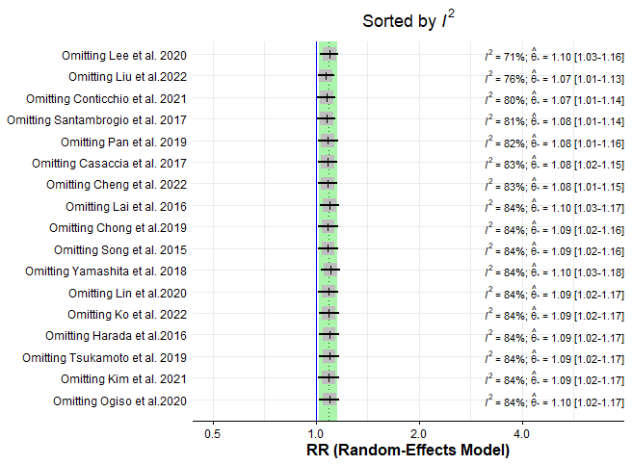

Supplementary figure S2: Sensitivity analysis of overall survival at 5 years
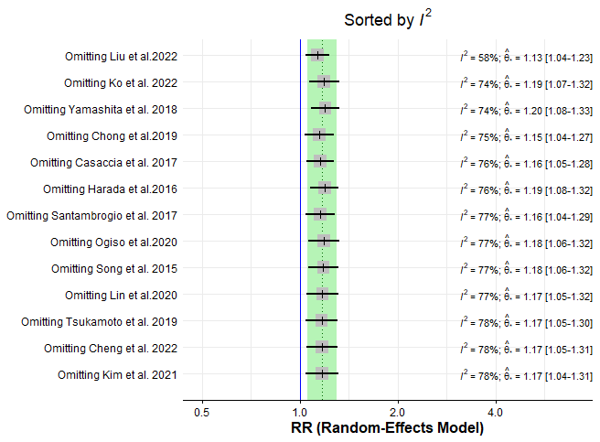

Supplementary file figure S3: Forrest plot illustrating subgroup analysis for 1-year overall survival based on RFA type
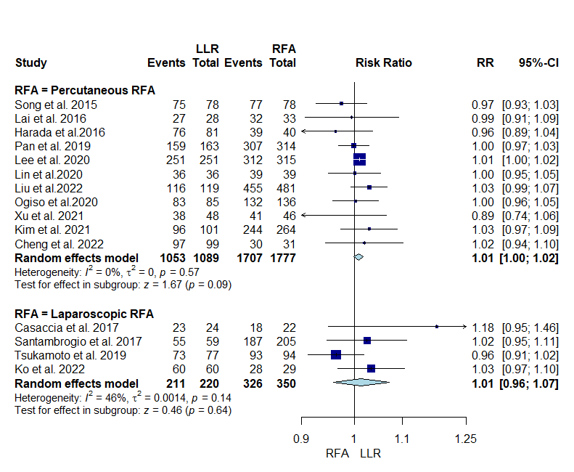

Supplementary file figure S4: Forrest plot illustrating Subgroup analysis for 3-years overall survival based on RFA type
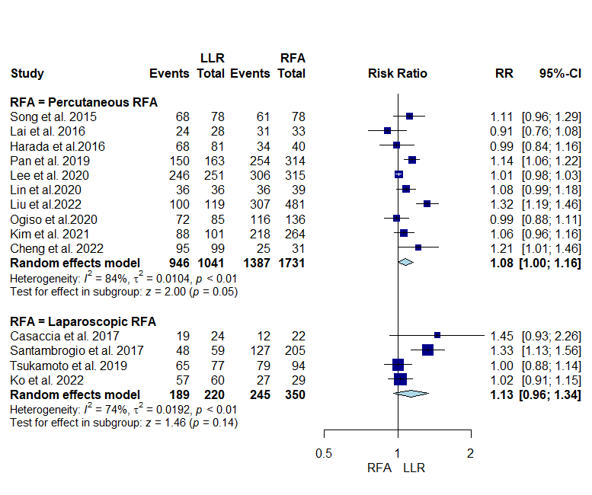

Supplementary file figure S5: Sensitivity analysis of laparoscopic subgroup overall survival at 3 years
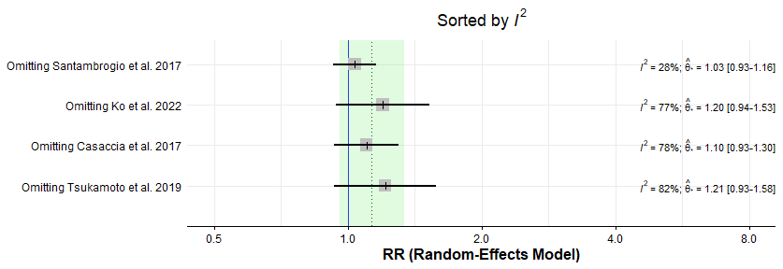

Supplementary file figure S6: Sensitivity analysis of percutaneous subgroup overall survival at 3 years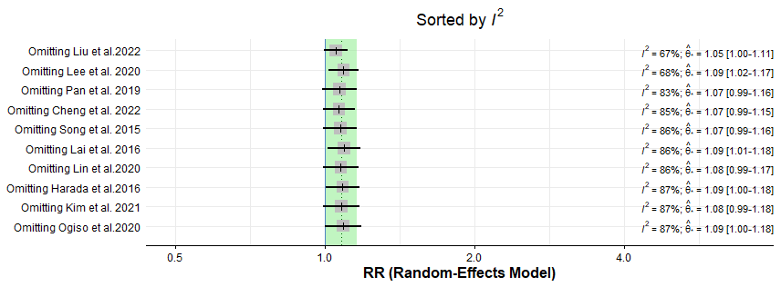

Supplementary file figure S7:Forrest plot illustrating Subgroup analysis for 5-years overall survival based on RFA type
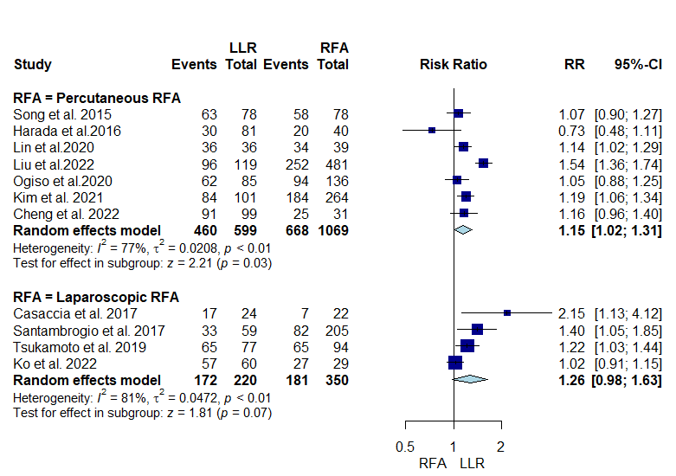

Supplementary file figure S8 :Sensitivity analysis of percutaneous subgroup overall survival at 5 years
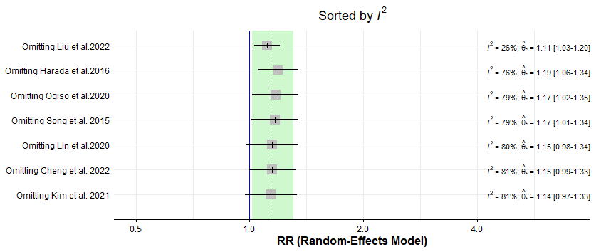

Supplementary file figure S9:Sensitivity analysis of laparoscopic subgroup overall survival at 5 years
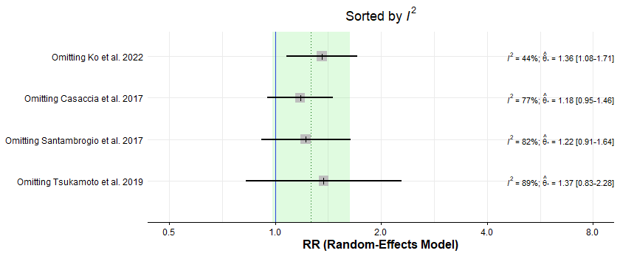

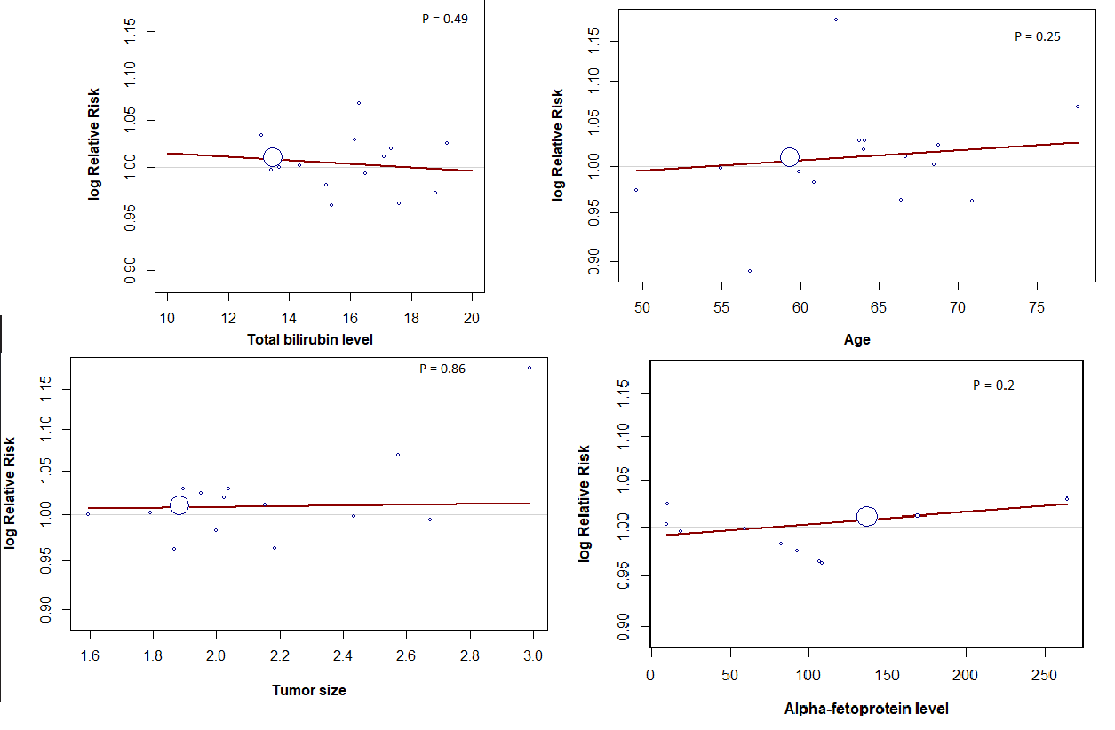
Supplementary file figure S10: Meta-Regression Analysis of Covariates and 1-Year overall Survival

Supplementary file figure S11:Forrest plot illustrating overall survival PSM
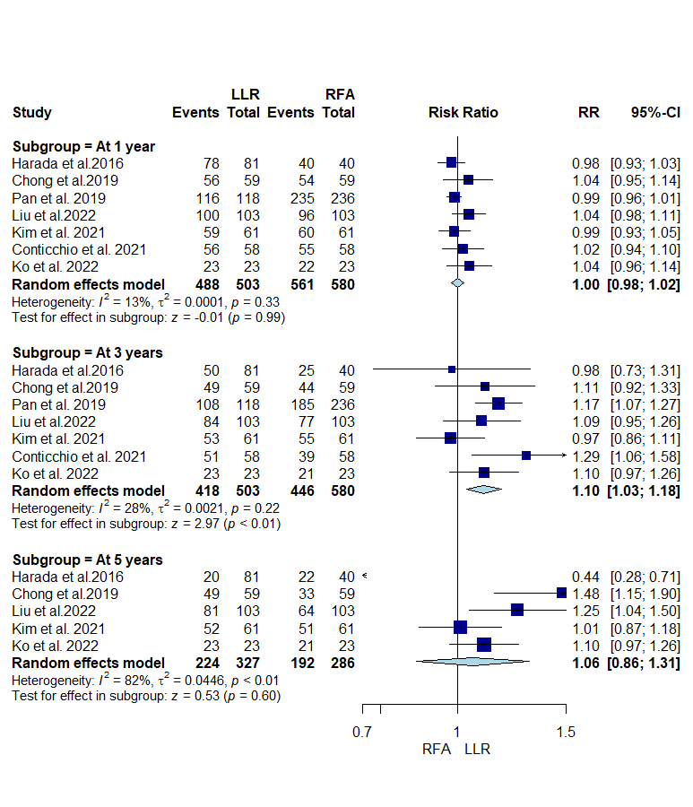

Supplementary file figure S12: Sensitivity analysis of overall survival PSM at 5 years
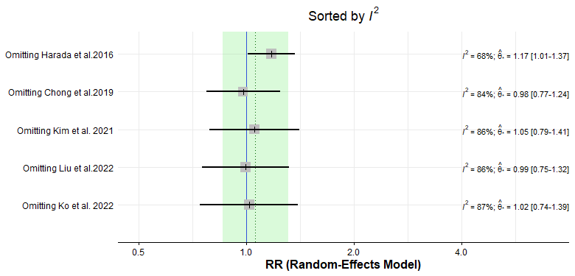

Supplementary file Figure S13:Sensitivity analysis of disease-free survival at 3 years
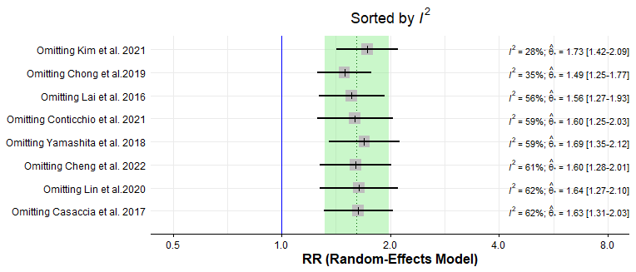

Supplementary file Figure S14:Sensitivity analysis of disease-free survival at 1 year
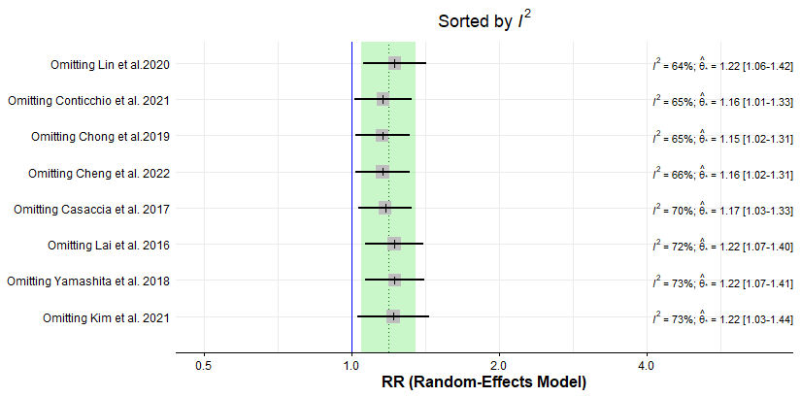

Supplementary file Figure S15:Sensitivity analysis of Disease-free survival at 5 years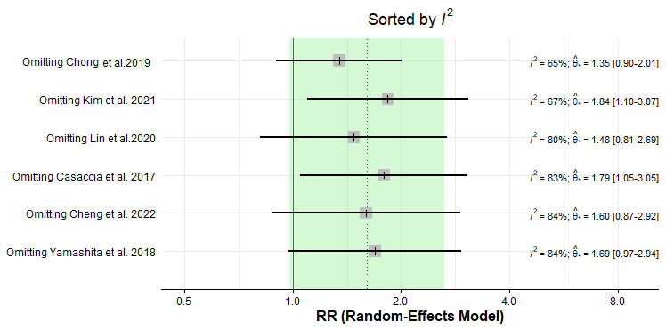

Supplementary file Figure S16: Forrest plot illustrating disease-free survival PSM
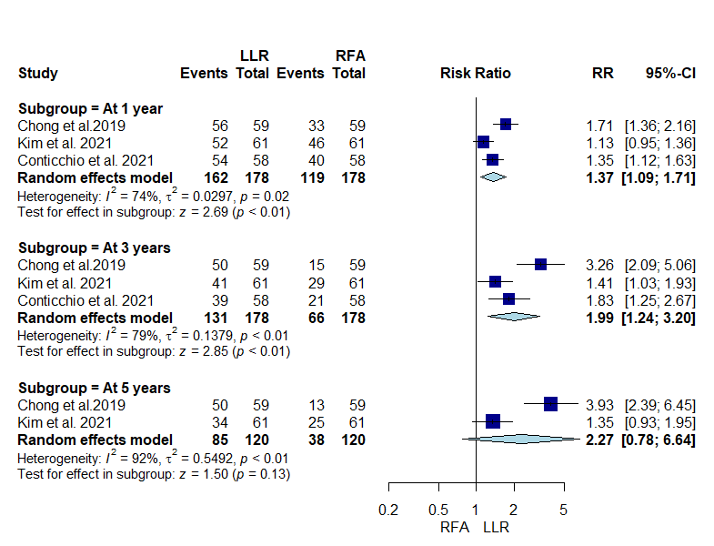

Supplementary file Figure S17:Sensitivity analysis of disease-free survival PSM at 1 year
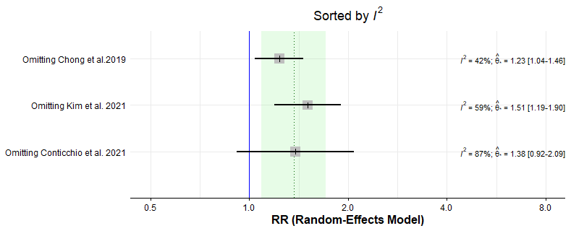

Supplementary file Figure S18: Sensitivity analysis of disease-free survival PSM at 3 years
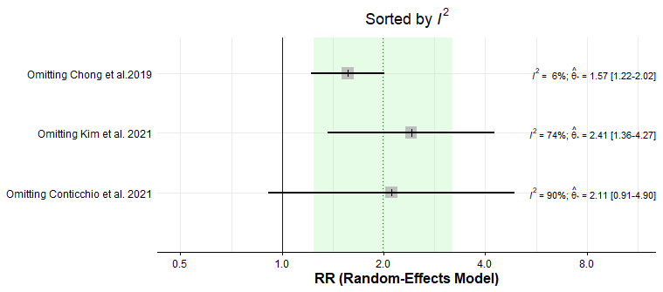

Supplementary file Figure S19: Sensitivity analysis of recurrence-free survival at 1 year
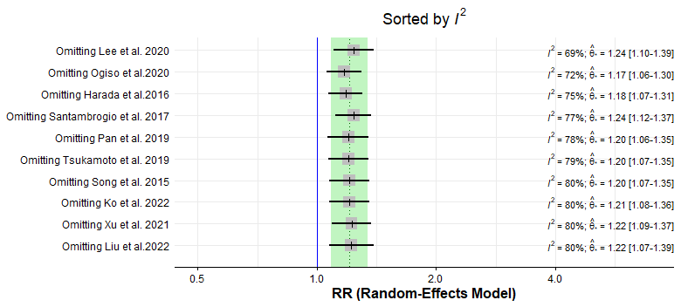

Supplementary file Figure S20:Sensitivity analysis of recurrence-free survival at 3 years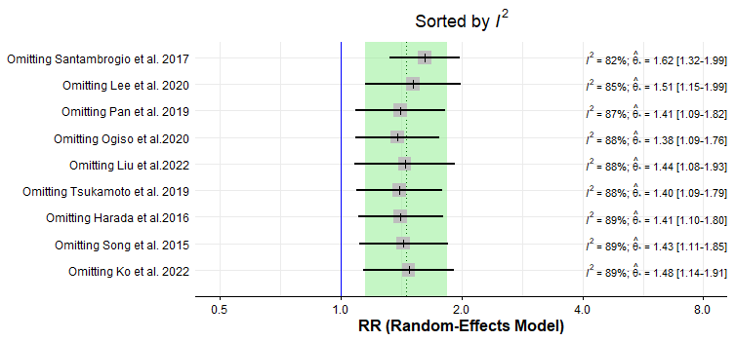

Supplementary file Figure S21:Sensitivity analysis of recurrence-free survival at 5 years
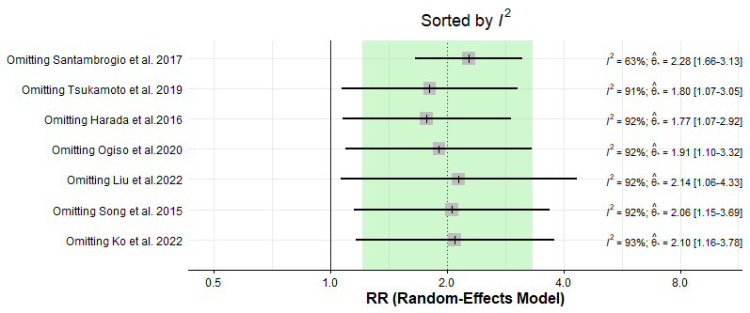

Supplementary file Figure S22: Forrest plot illustrating subgroup analysis for 1-year recurrence-free survival based on RFA type
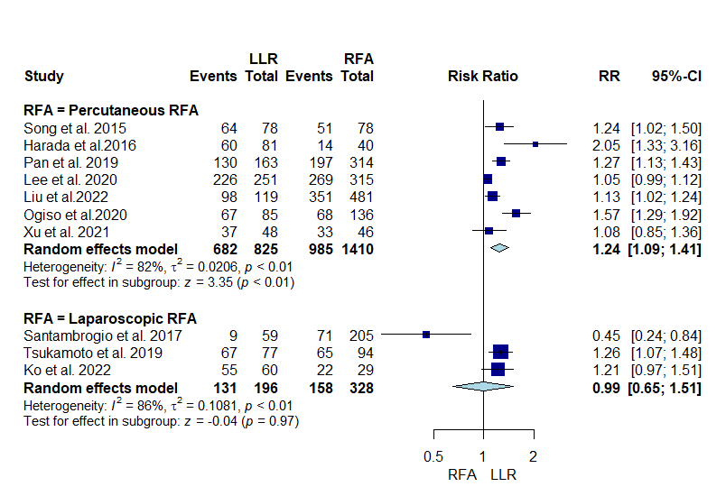

Supplementary file Figure S23: Forrest plot illustrating subgroup analysis for 3-years recurrence-free survival based on RFA type 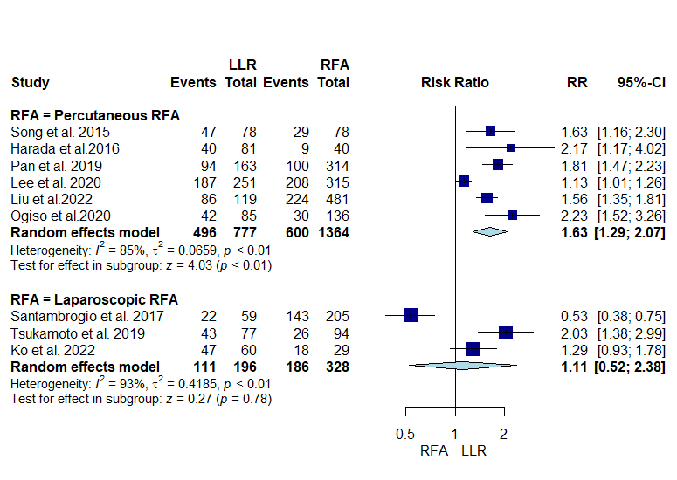

Supplementary file Figure S24: Sensitivity analysis of percutaneous subgroup recurrence free survival at 1 year
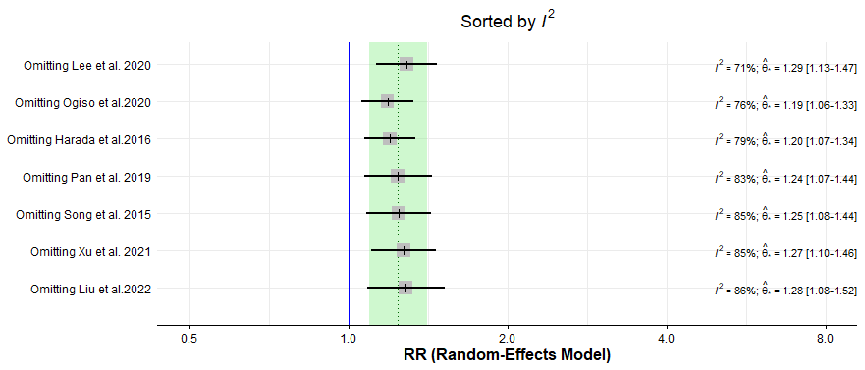

Supplementary file Figure S25:Sensitivity analysis of percutaneous subgroup recurrence free survival at 3 years
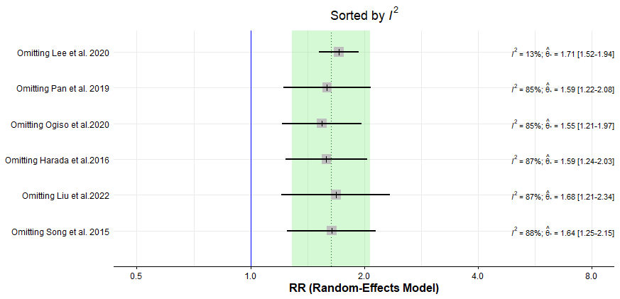

Supplementary file Figure S26 :Sensitivity analysis of laparoscopic subgroup recurrence free survival at 1 year
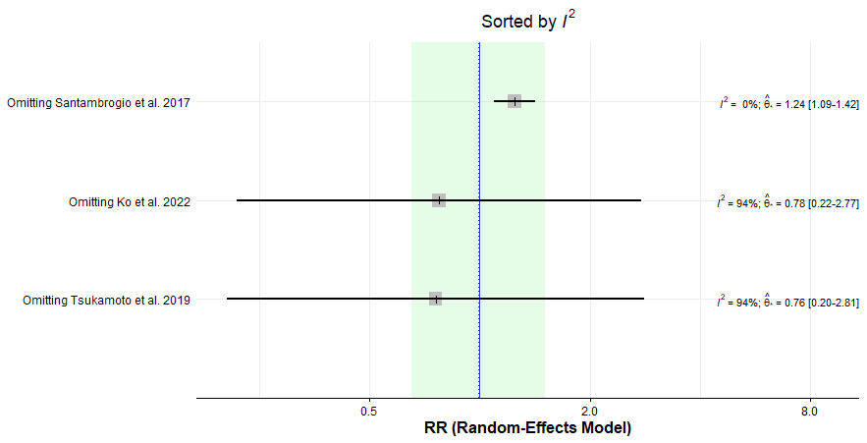
Supplementary file Figure S27 :Sensitivity analysis of laparoscopic subgroup recurrence free survival at 3 years
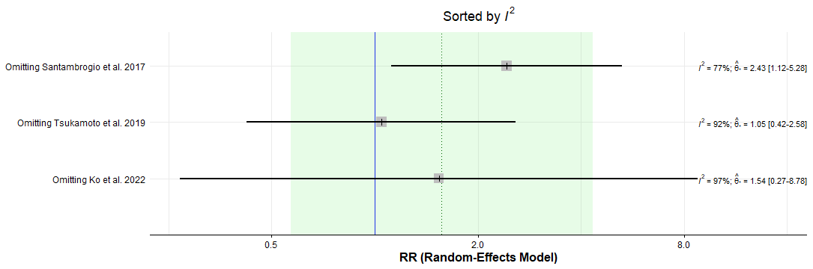

Supplementary file Figure S28; Forrest plot illustrating Subgroup analysis for 5-years Recurrence-free survival based on RFA type
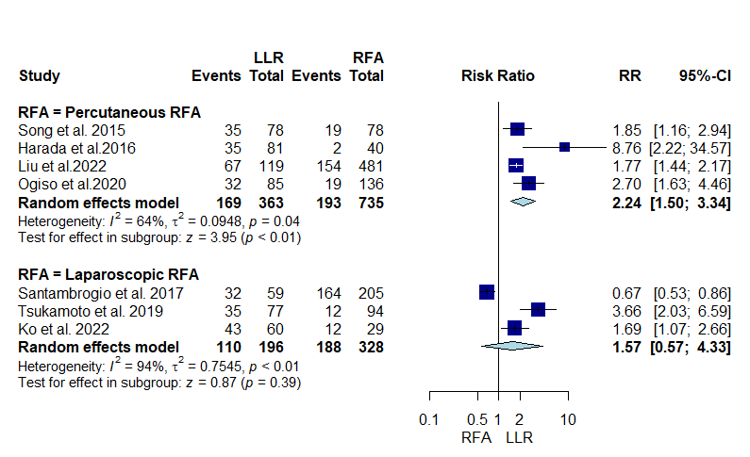

Supplementary file Figure S29:Sensitivity analysis of percutaneous subgroup recurrence free survival at 5 years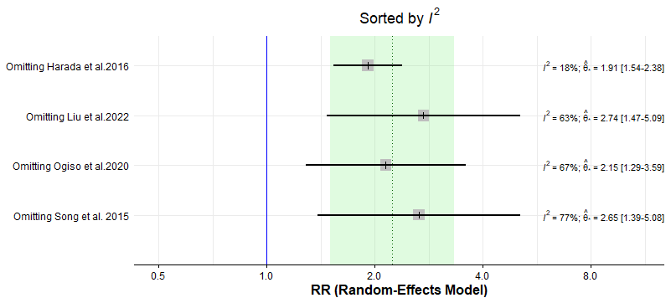

Supplementary file Figure S30: Sensitivity analysis of laparoscopic subgroup recurrence free survival at 5 years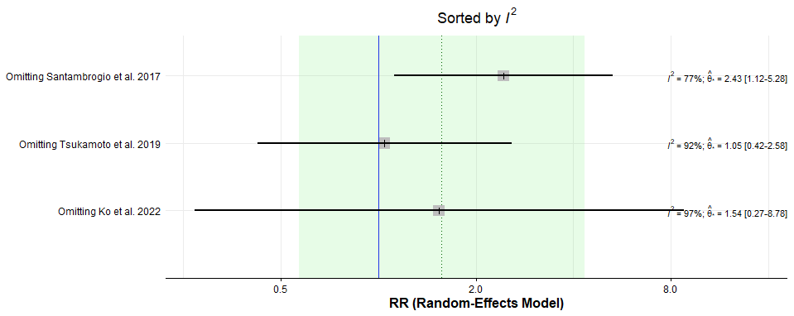

Supplementary file Figure S31: Forrest plot illustrating recurrence-free survival PSM
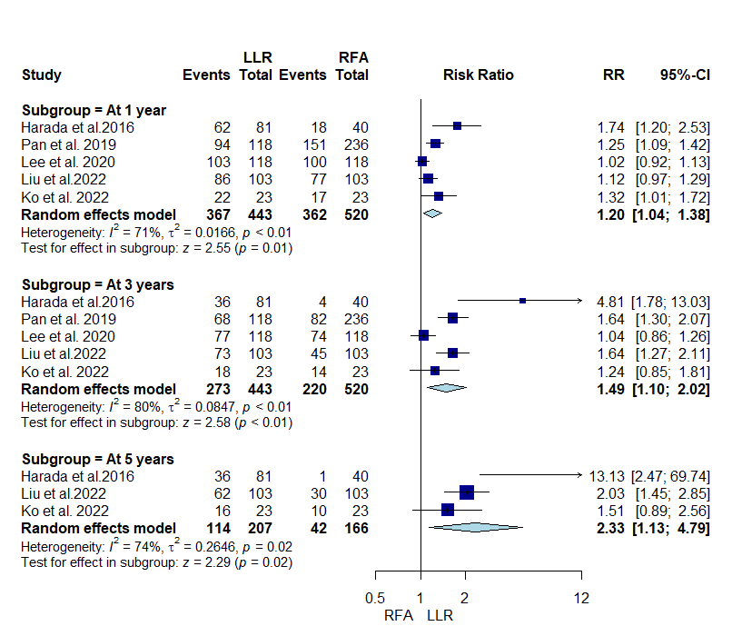

Supplementary file Figure S32:Sensitivity analysis of recurrence-free survival PSM at 1 year
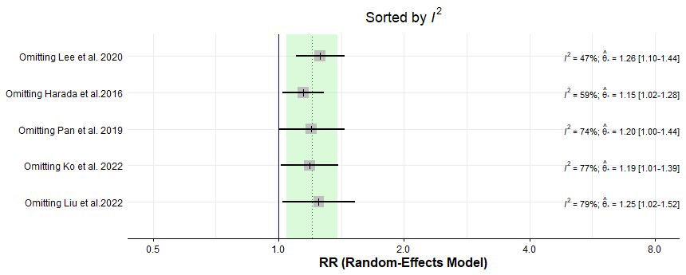

Supplementary file Figure S33: Sensitivity analysis of recurrence-free survival PSM at 5 years
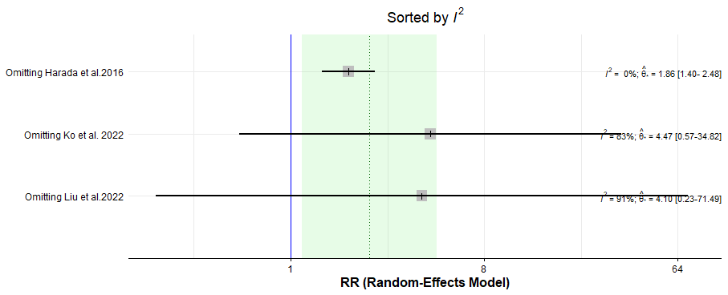

Supplementary file Figure S34: Sensitivity analysis of recurrence-free survival PSM at 3 years
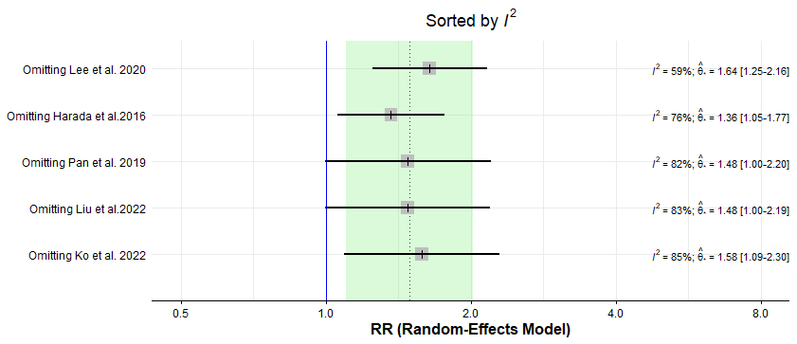

Supplementary file Figure S35:Sensitivity analysis of local recurrence
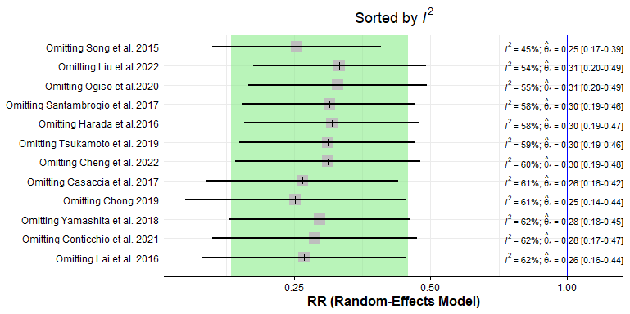

Supplementary file Figure S36: Forrest plot illustrating Subgroup analysis for local recurrence based on RFA type
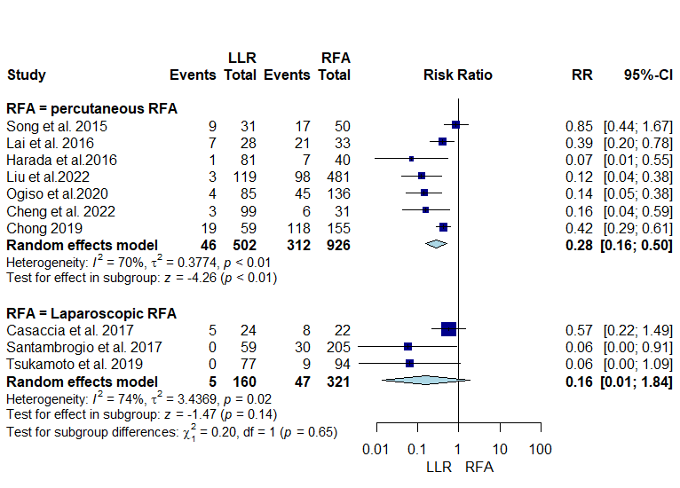

Supplementary file Figure S37:Sensitivity analysis of percutaneous subgroup local recurrence
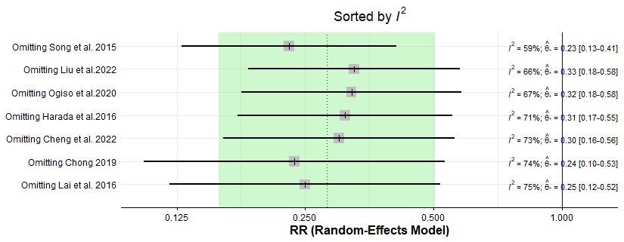

Supplementary file Figure S38:Sensitivity analysis of laparoscopic subgroup local recurrence
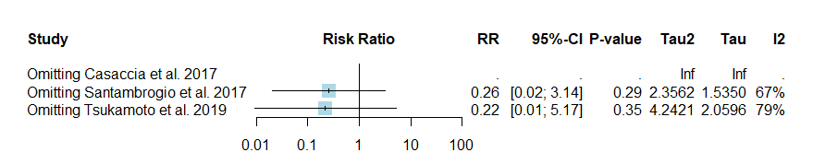

Supplementary file Figure S39: Forrest plot illustrating intrahepatic recurrence
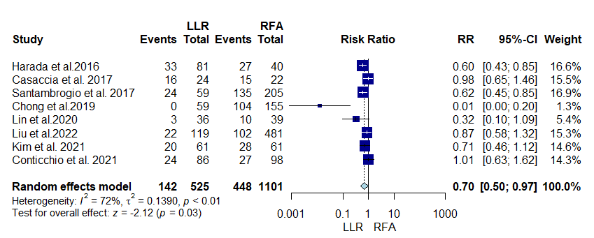

Supplementary file Figure S40:Sensitivity analysis of intrahepatic recurrence
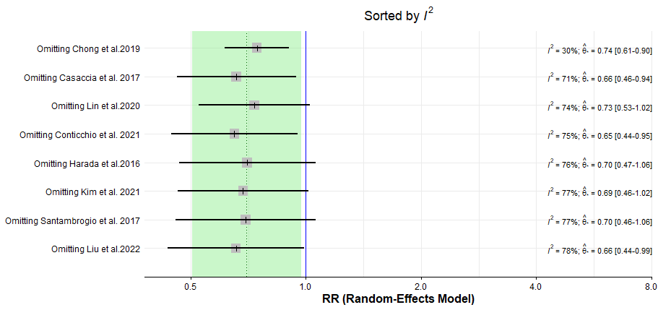

Supplementary file Figure S41:Forrest plot illustrating extrahepatic recurrence
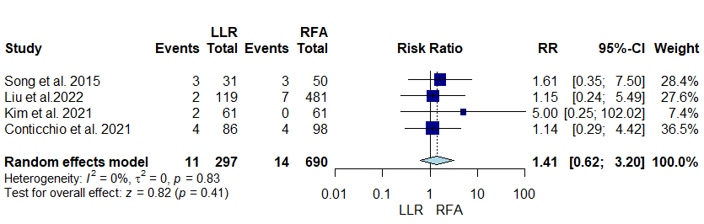

Supplementary file Figure S42:Forrest plot illustrating duration of surgery
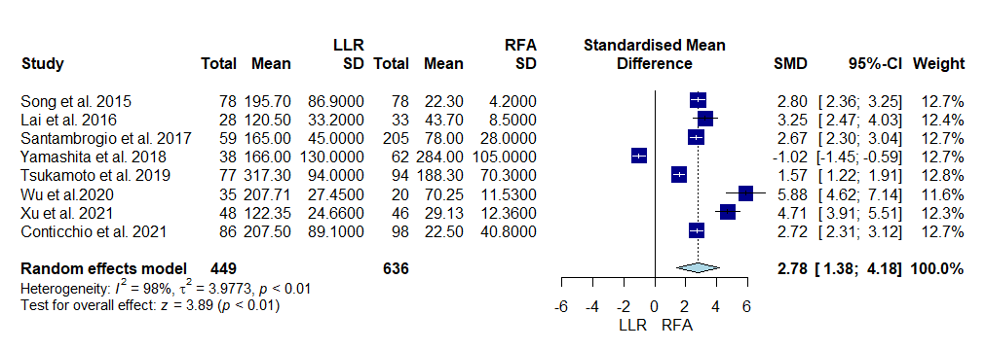

Supplementary file Figure S43:Sensitivity analysis of duration of surgery
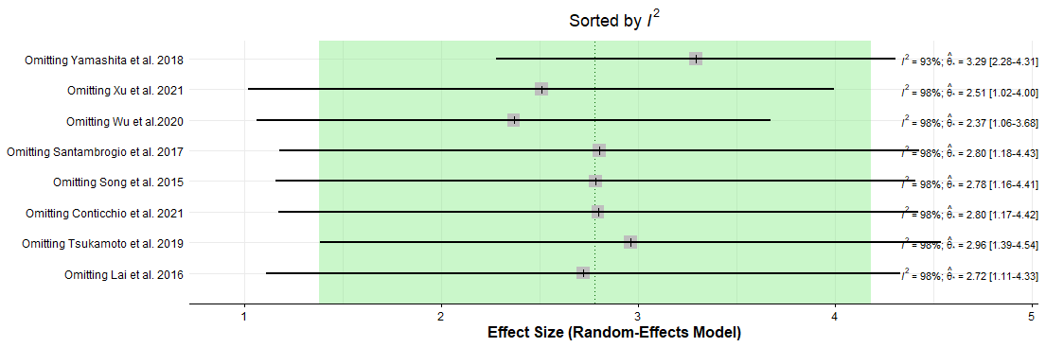

Supplementary file Figure S44: Forrest plot illustrating incidence of blood transfusion during surgery
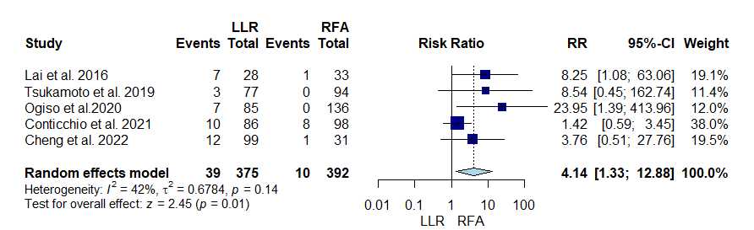

Supplementary file Figure S45:Forrest plot illustrating all complications
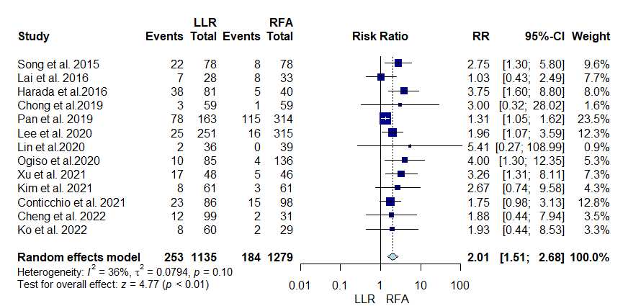

Supplementary file Figure S46:Forrest plot illustrating 90-days mortality
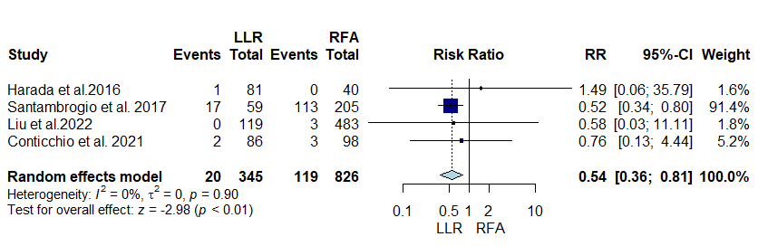

Supplementary file Figure S47:Forrest plot illustrating 30-days mortality
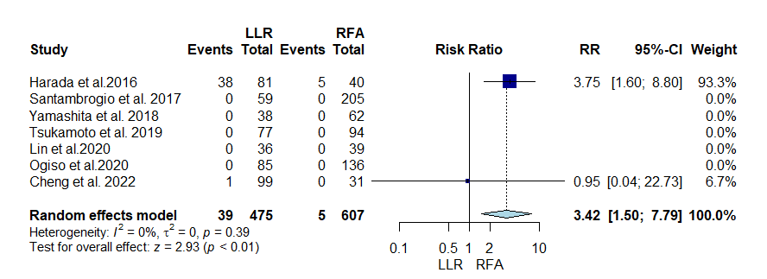

Supplementary file Figure S48:Forrest plot illustrating major complications
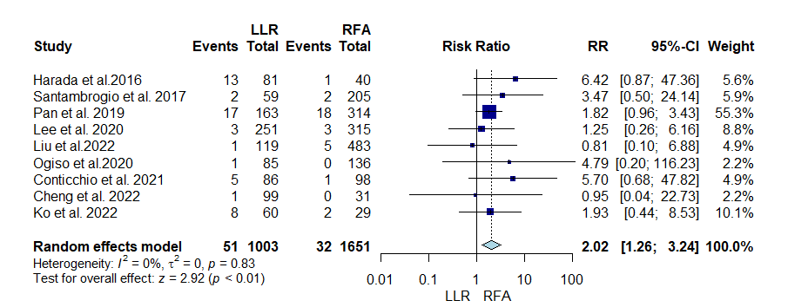

Supplementary file Figure S49:Forrest plot illustrating duration of hospital stay
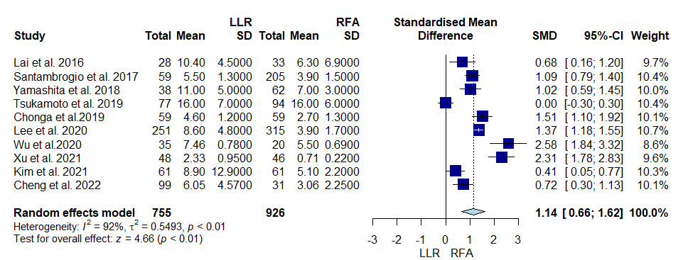

Supplementary file Figure S50:Sensitivity analysis of duration of hospital stay
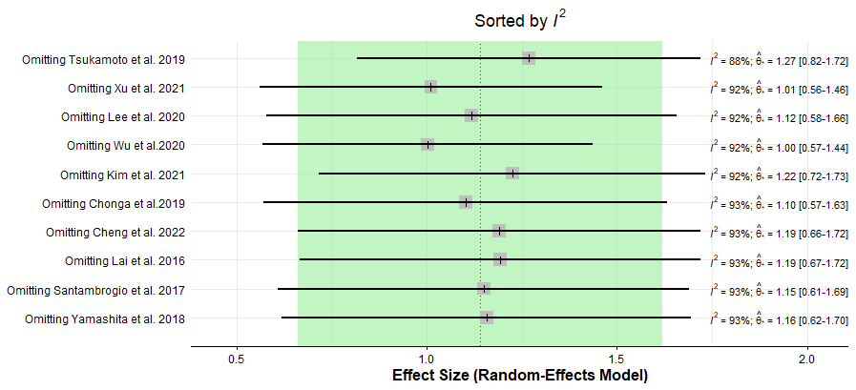
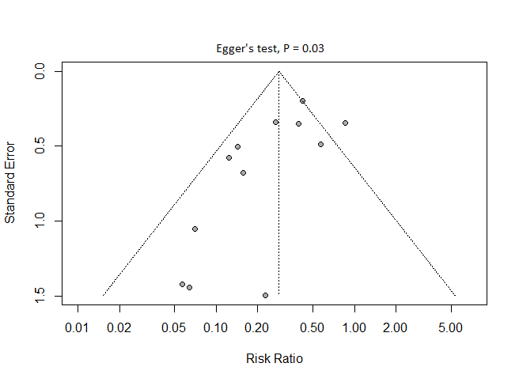
Supplementary file Figure S51:Funnel plot for the local recurrence
Supplementary file Figure S52:Funnel plot (trim and fill method) for the local recurrence
