Supplementary figure 1-4: The forest plots of each factor.
Supplementary figures 1A-Q: Forest plot of the meta-analysis in univariate analysis of OS
Supplementary figure 1A: Forest plot of gender
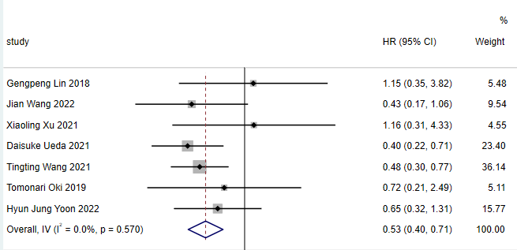
Supplementary figure 1B: Forest plot of age
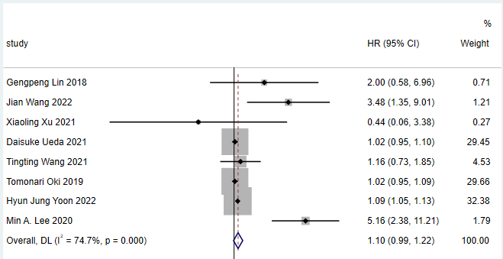
Supplementary figure 1C: Forest plot of TNM stage
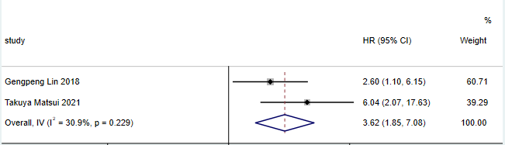
Supplementary figure 1D: Forest plot of smoking status
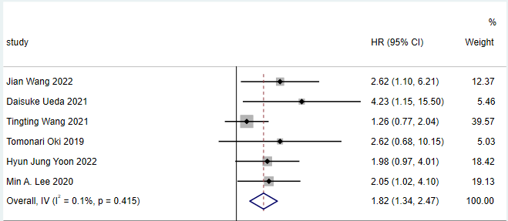
Supplementary figure 1E: Forest plot of lymph node metastasis
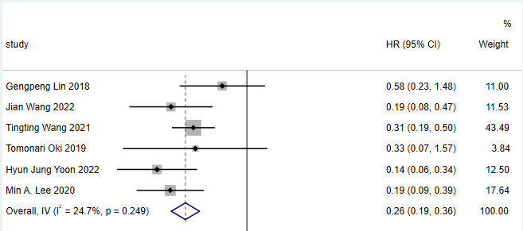
Supplementary figure 1F: Forest plot of pleural invasion
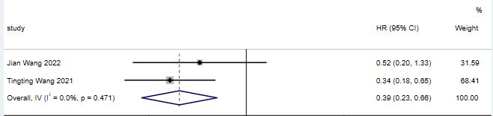
Supplementary figure 1G: Forest plot of STAS
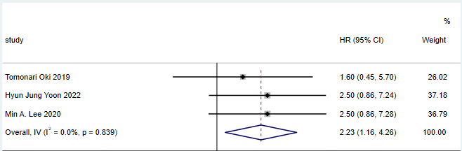
Supplementary figure 1H: Forest plot of pathological grade
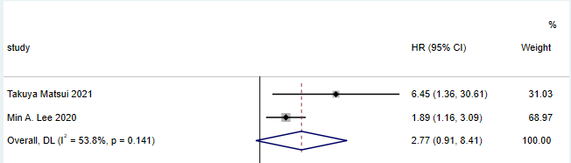
Supplementary figure 1I: Forest plot of EGFR mutations
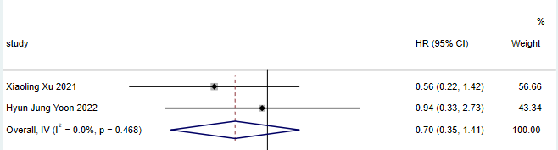
Supplementary figure 1J: Forest plot of ALK mutations
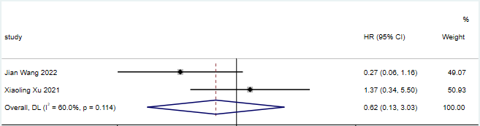
Supplementary figure 1K: Forest plot of tumor size
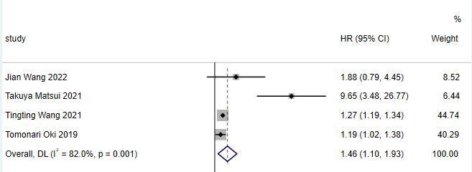
Supplementary figure 1L: Forest plot of CT morphology
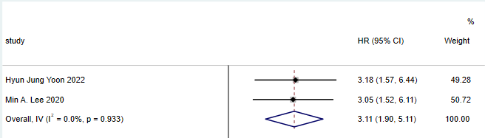
Supplementary figure 1M: Forest plot of pneumonia type
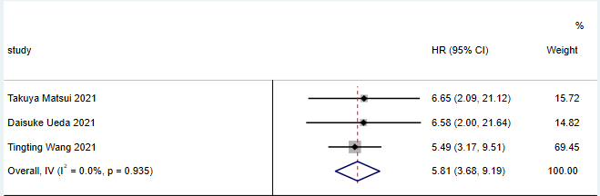
Supplementary figure 1N: Forest plot of well-defined heterogeneous GGOs
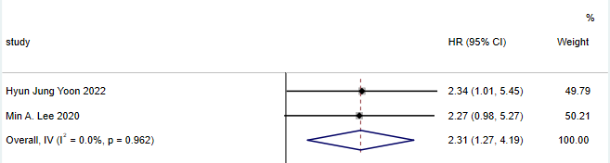
Supplementary figure 1O: Forest plot of spiculated margin
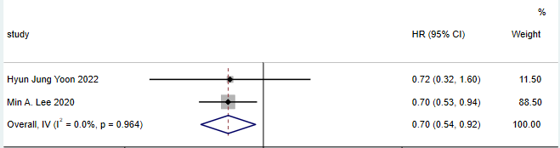
Supplementary figure 1P: Forest plot of lobulated margin
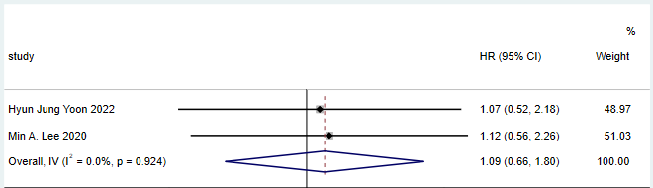
Supplementary figure 1Q: Forest plot of air bronchogram
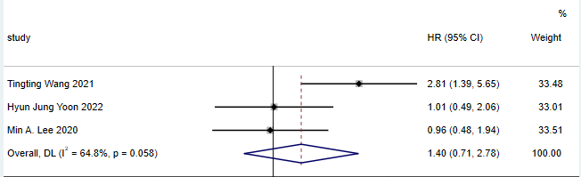
Supplementary figures 2A-K: Forest plot of the meta-analysis in multivariate analysis of OS
Supplementary figure 2A: Forest plot of gender
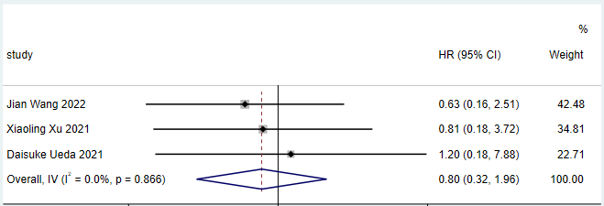
Supplementary figure 2B: Forest plot of age
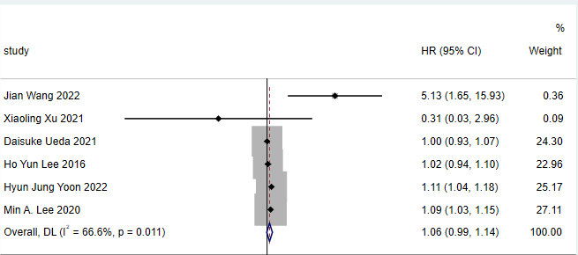
Supplementary figure 2C: Forest plot of smoking status
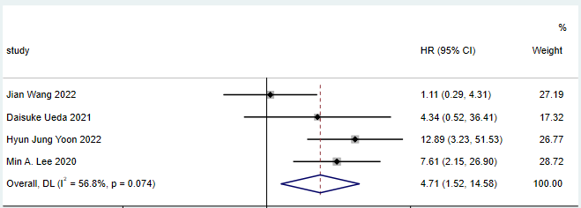
Supplementary figure 2D: Forest plot of lymph node metastasis
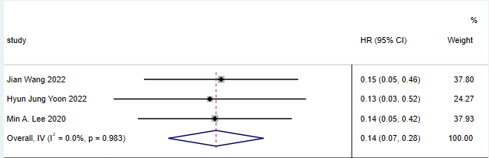
Supplementary figure 2E: Forest plot of STAS
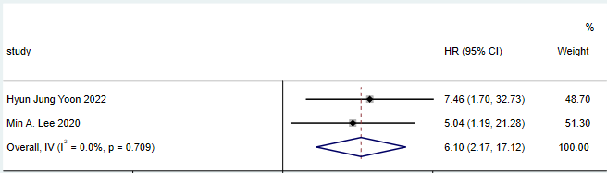
Supplementary figure 2F: Forest plot of pathological grade
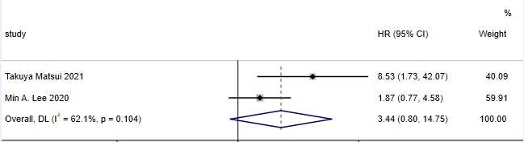
Supplementary figure 2G: Forest plot of ALK mutations
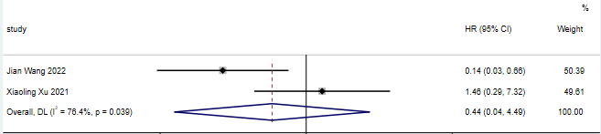
Supplementary figure 2H: Forest plot of tumor size
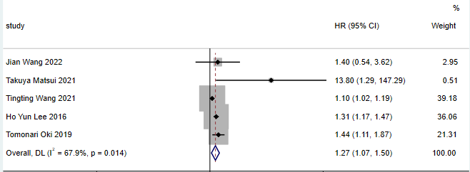
Supplementary figure 2I: Forest plot of CT morphology
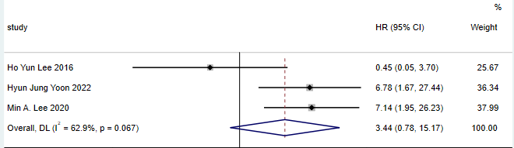
Supplementary figure 2J: Forest plot of pneumonia type
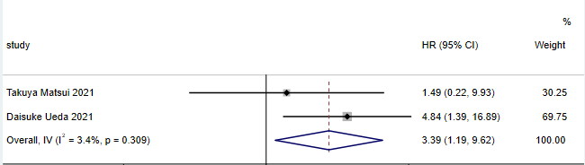
Supplementary figure 2K: Forest plot of well-defined heterogeneous GGOs
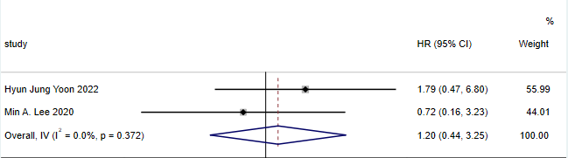
Supplementary figures 3A-J: Forest plot of the meta-analysis in univariate analysis of the DFS
Supplementary figure 3A: Forest plot of gender
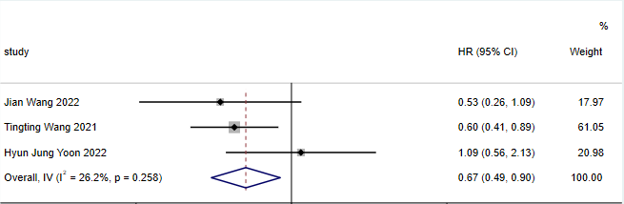
Supplementary figure 3B: Forest plot of age
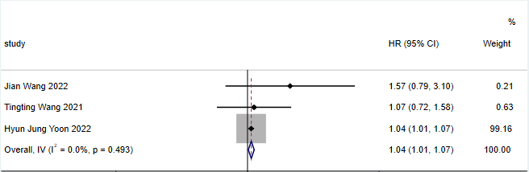
Supplementary figure 3C: Forest plot of smoking status
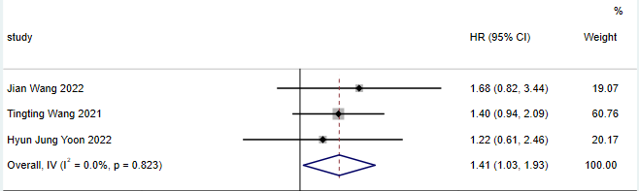
Supplementary figure 3D: Forest plot of lymph node metastasis
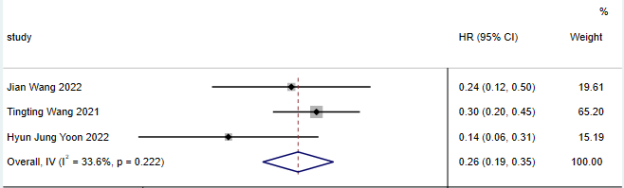
Supplementary figure 3E: Forest plot of pleural invasion
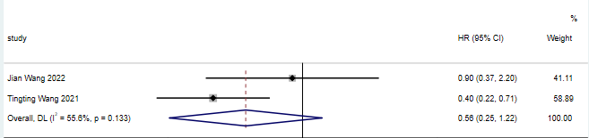
Supplementary figure 3F: Forest plot of pathological grade
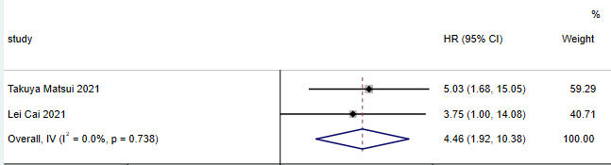
Supplementary figure 3G: Forest plot of EGFR mutations
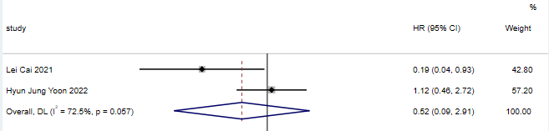
Supplementary figure 3H: Forest plot of tumor size
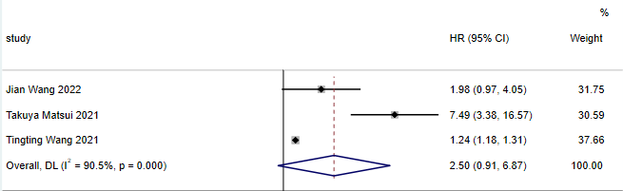
Supplementary figure 3I: Forest plot of pneumonia type
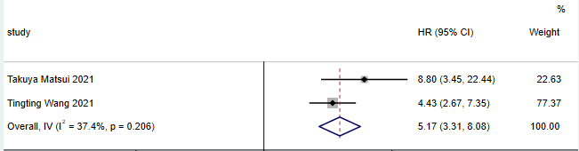
Supplementary figure 3J: Forest plot of air bronchogram
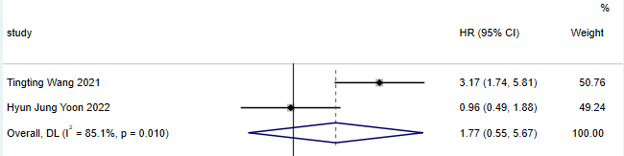
Supplementary figures 4A-G: Forest plot of the meta-analysis in multivariate analysis of DFS
Supplementary figure 4A: Forest plot of age
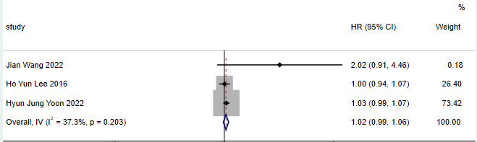
Supplementary figure 4B: Forest plot of smoking status
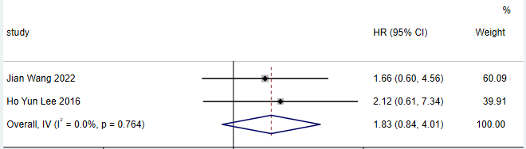
Supplementary figure 4C: Forest plot of lymph node metastasis
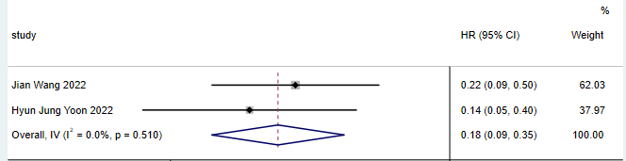
Supplementary figure 4D: Forest plot of pathological grade
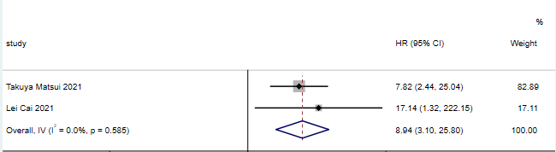
Supplementary figure 4E: Forest plot of tumor size
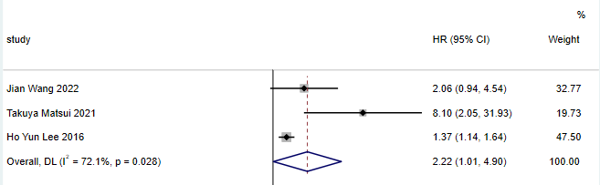
Supplementary figure 4F: Forest plot of CT morphology
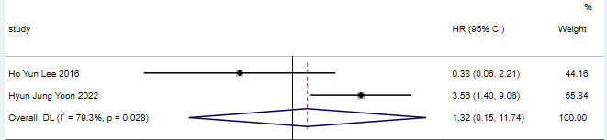
Supplementary figure 4G: Forest plot of pneumonia type
