Supplemental file 3. The detailed results of sensitivity analysis of OS and DFS.

OS
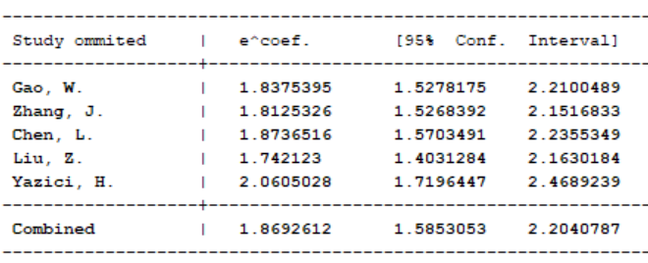

DFS
