cfDNA hydroxymethylcytosine profiling for detection metastasis and recurrence of Esophageal Squamous Cell Carcinoma

Subinuer Kuerban^{1†}, Hangyu Chen^{2,3†}, Long Chen^{2,3†}, Lei Zhang^{2,3}, Xuehui Li¹, Baixin Zhen¹, Hong Xiao⁴, Yingzhu Chen⁷, Haitao Zhou⁸, Zhen Liang⁸, Guobing Xu⁷, Yicun Tao^{1*}, Jian Lin^{2,3,4,5*}, Xiaozheng Kang^{6*}

Supplementary Table 1. Tumor Markers (average±standard error)

 | Metastasis | Non-metastasis | Recur | Non-recur
CEA | 3.99±9.27 | 2.49±1.65 | 5.18±13.03 | 2.75±3.20
CYFRA21-1 | 1.36±5.22 | 1.14±1.80 | 2.27±7.61 | 0.93±1.77
SCC | 0.37±0.85 | 0.46±0.73 | 0.63±1.16 | 0.33±0.62
CA125 | 0.79±3.27 | 1.17±4.32 | 0 | 1.25±4.26
CA199 | 10.96±7.38 | 15.80±22.51 | 11.37±6.74 | 13.46±17.62
NSE | 3.39±6.02 | 5.12±7.12 | 4.71±6.75 | 3.91±6.48
CA72.4 | 3.76±6.95 | 2.89±3.60 | 3.75±8.22 | 3.30±4.78
CA242 | 6.16±6.47 | 9.87±23.68 | 6.22±5.02 | 8.12±18.14

CEA: Carcinoembryonic Antigen; CYFRA21-1: Cytokeratin-19 Fragment Antigen 21-1; SCC: Squamous Cell Carcinoma Antigen; CA125: Carbohydrate Antigen 125; CA199: Carbohydrate Antigen 19-9; NSE: Neuron-Specific Enolase; CA72-4: Cancer Antigen 72-4; CA242: Cancer Antigen 242

Figure legends
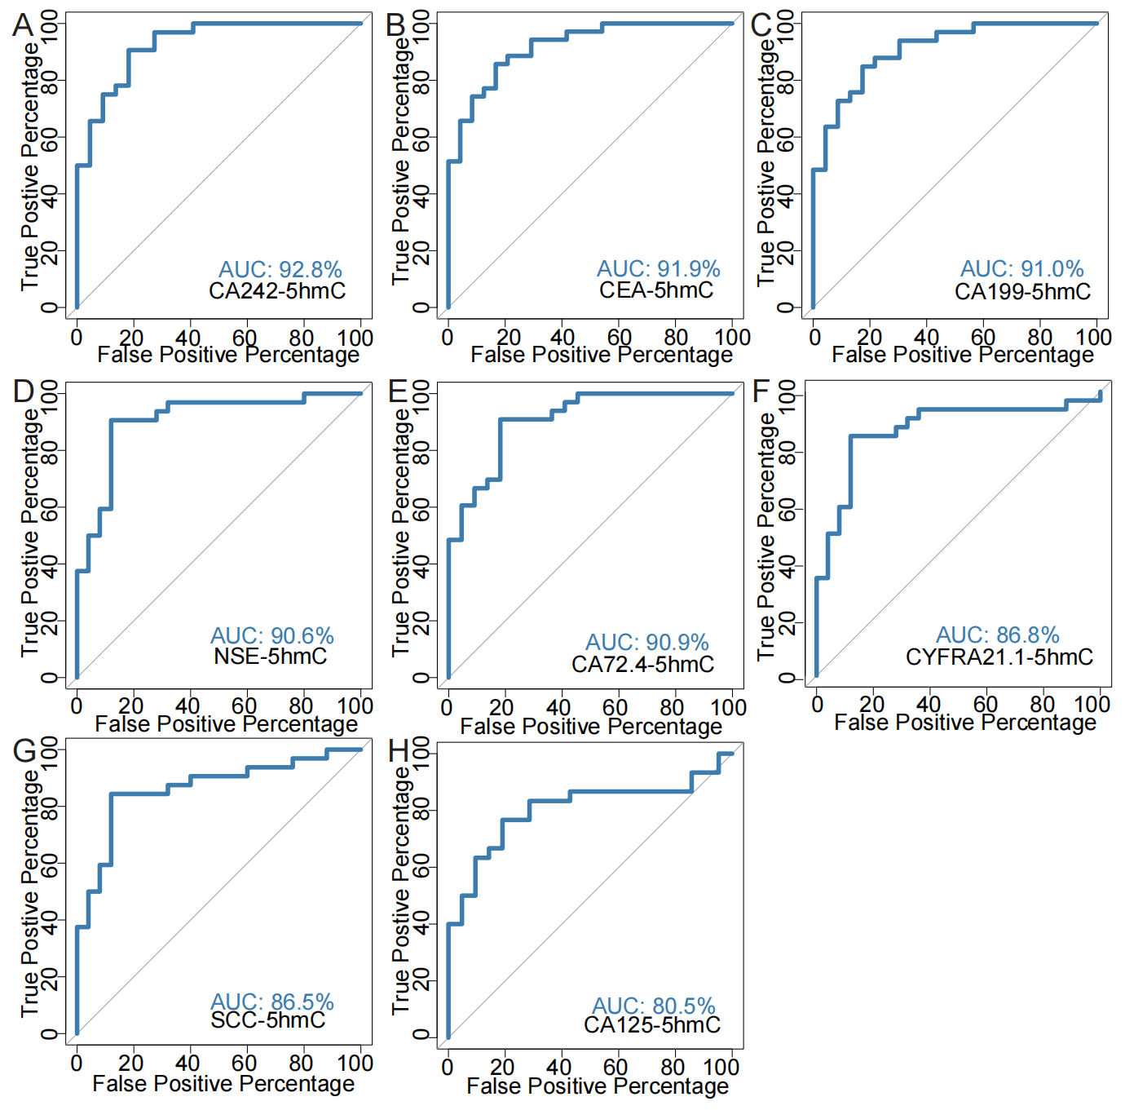
Supplementary Figure 1. The ROC curve of traditional tumor markers combined with 5hmC markers to predict metastasis. (A-H) Receiver operating characteristic (ROC) curve of CEA, CYFRA21-1, SCC, CA125, CA199, NSE, CA72.4, and CA242 combined with 5hmC markers in the validation cohort of ESCC patients with metastasis.

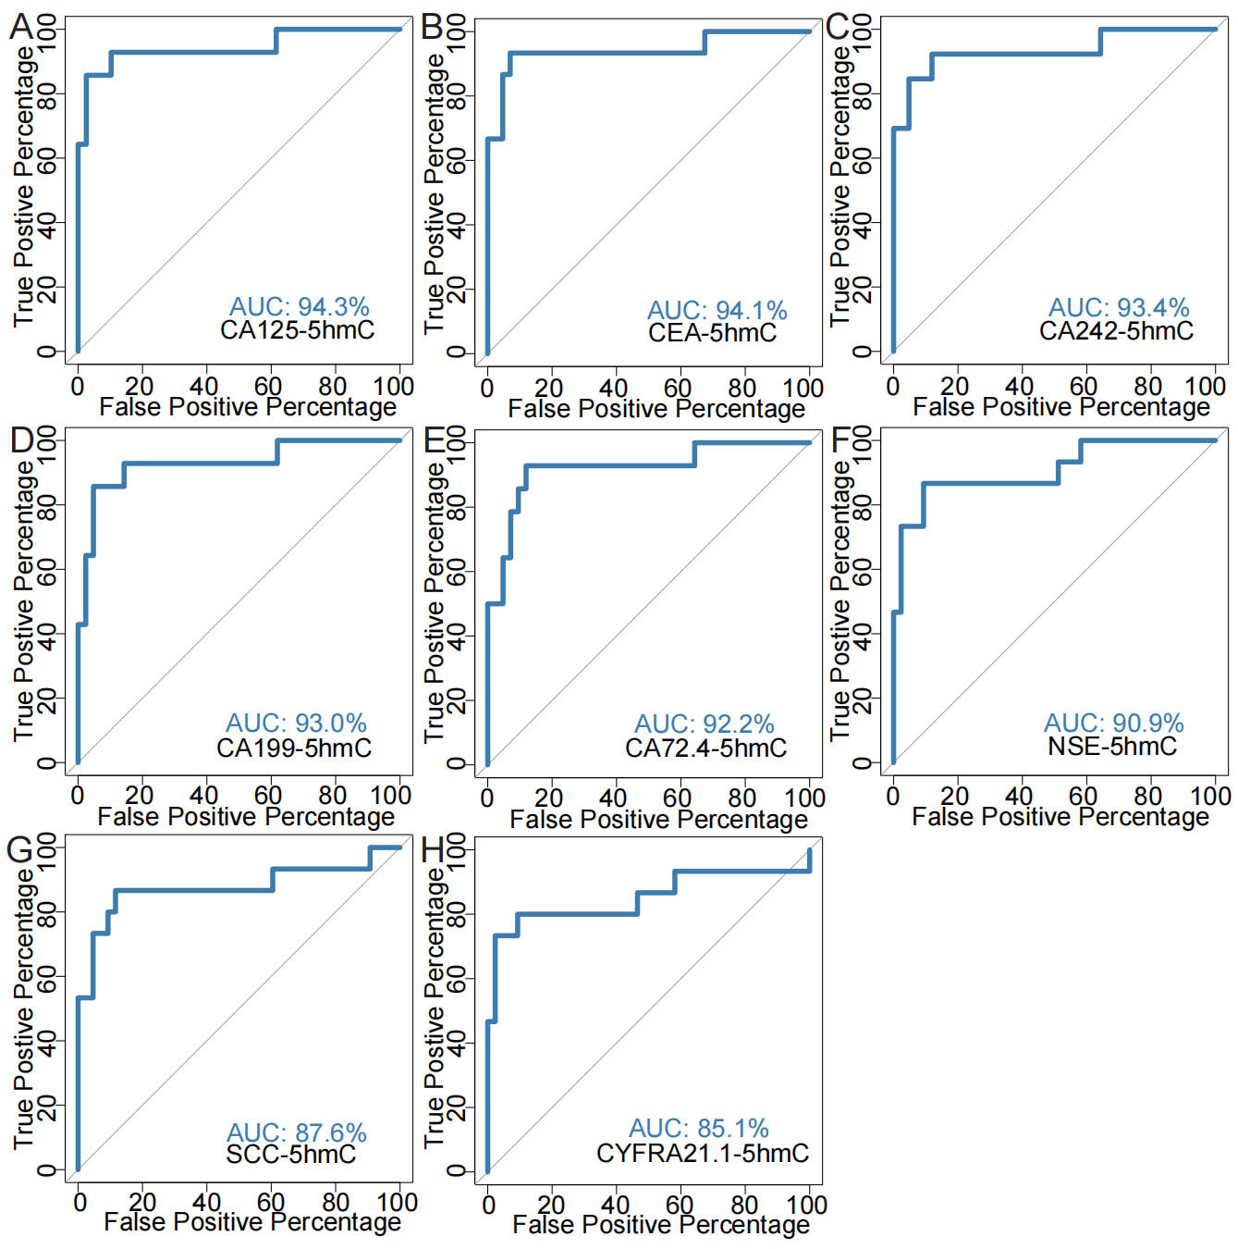
Supplementary Figure 2. The ROC curve of traditional tumor markers combined with 5hmC markers to predict recurrence. (A-H) Receiver operating characteristic (ROC) curve of CEA, CYFRA21-1, SCC, CA125, CA199, NSE, CA72.4, and CA242 combined with 5hmC markers in the validation cohort of ESCC patients with recurrence.

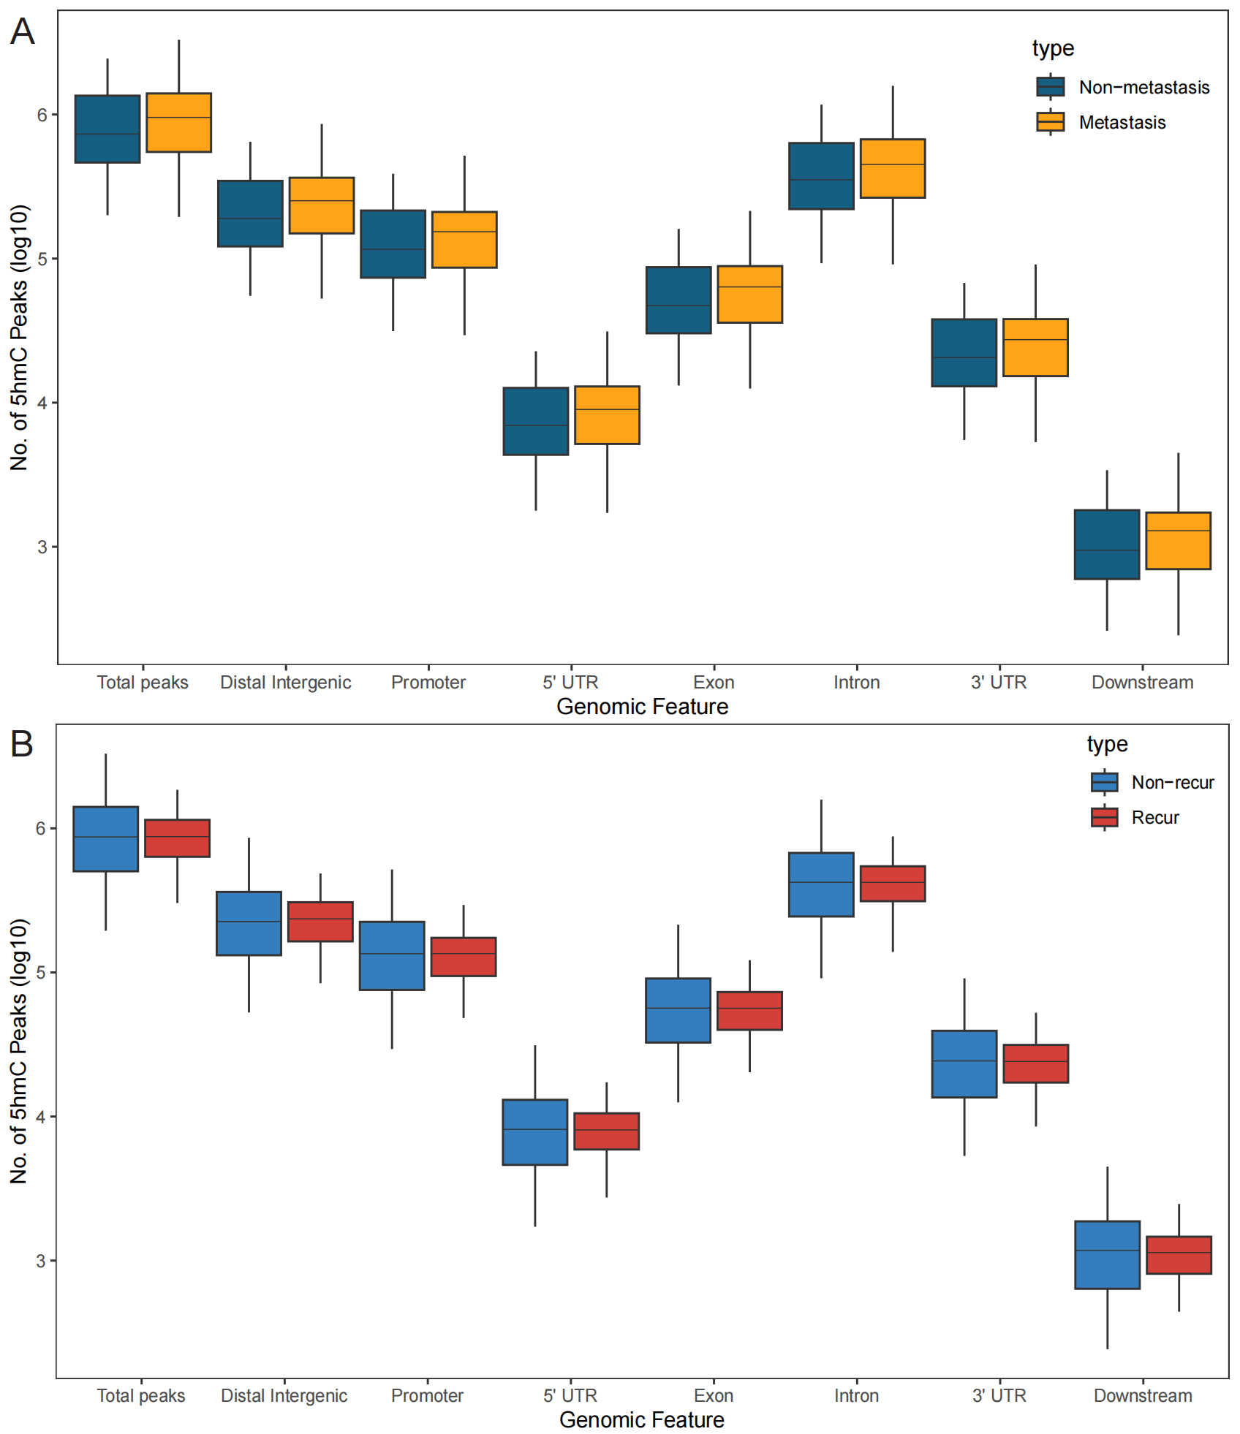
Supplementary Figure 3. Genome-wide 5hmC distribution in different groups. (A) Genome-wide 5hmC distribution in metastatic and non-metastatic group. (B) Genome-wide 5hmC distribution in recurrent and non-recurrent group.

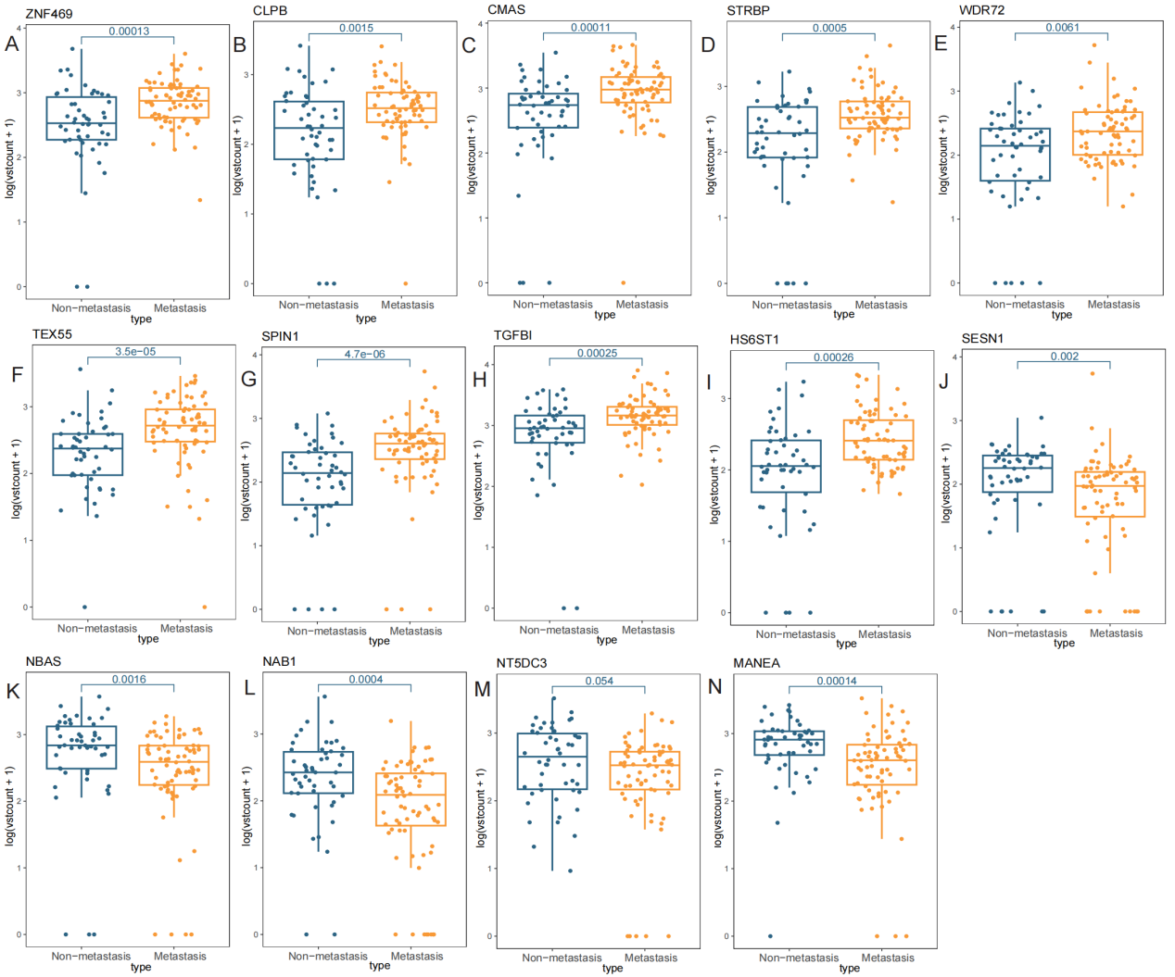
Supplementary Figure 4. Differences in hydroxymethylation levels of 14 5hmC markers between metastatic and non-metastatic groups. (A-N) The differences in the levels of hydroxymethylation modification of markers ZNF469, CLPB, CMAS, STRBP, WDR72, TEX55, SPIN1, TGFBI, HS6ST1, SESN1, NBAS, NAB1, NT5DC3, and MANEA between metastatic and non-metastatic groups.

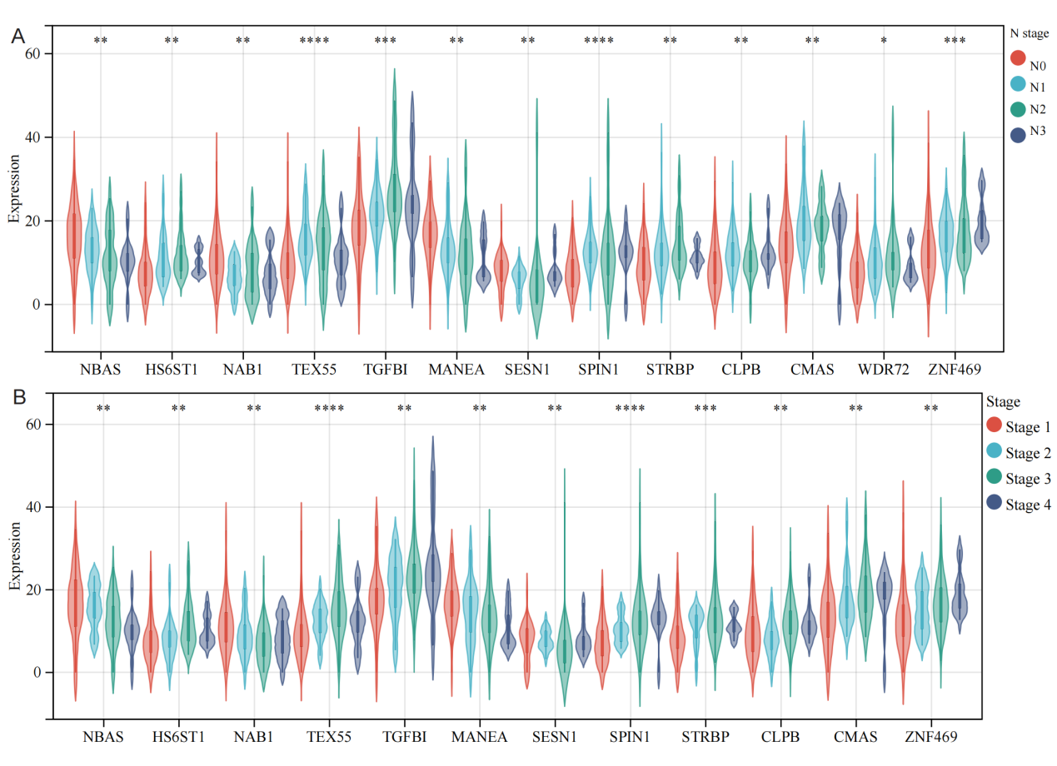
Supplementary Figure 5. The hydroxymethylation levels of 5hmC markers in the metastasis model were different among patients with different clinical stages and lymph node metastasis. (A-B) The difference of hydroxymethylation levels of markers ZNF469, CLPB, CMAS, STRBP, WDR72, TEX55, SPIN1, TGFBI, HS6ST1, SESN1, NBAS, NAB1, and MANEA in patients with different clinical stages and lymph node metastasis. *P<0.05, **P<0.01, ***P<0.001, ****P<0.0001

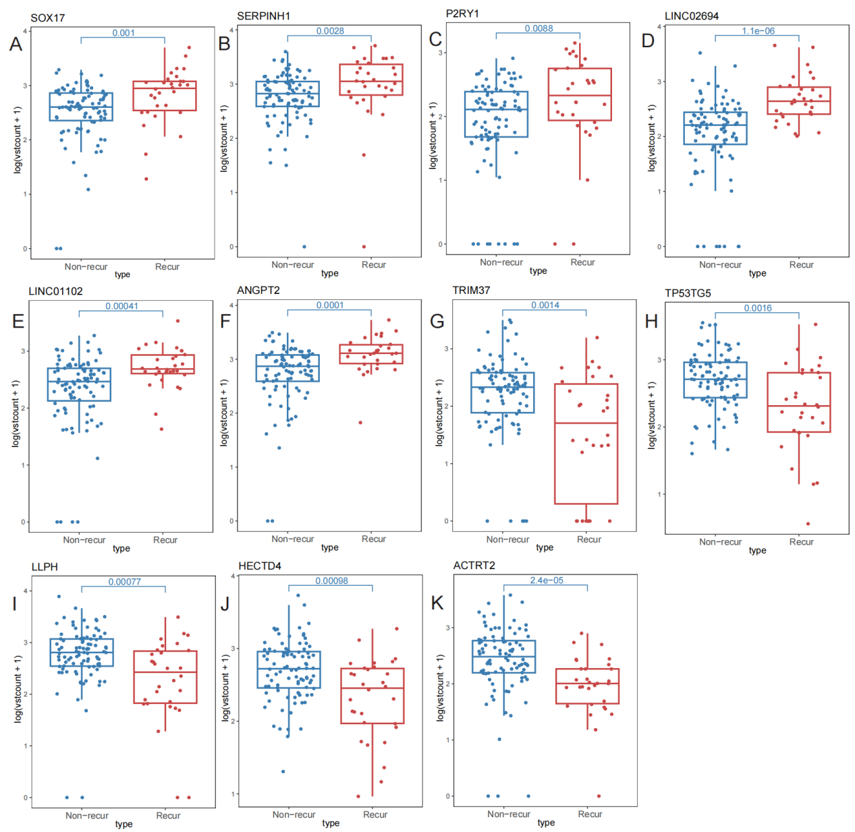
Supplementary Figure 6. Differences in hydroxymethylation levels of 11 5hmC markers between recurrent group and non-recurrent groups. (A-K) The differences in the levels of hydroxymethylation modification of markers SOX17, SERPINH1, P2RY1, LINC02694, LINC01102, ANGPT2, TRIM37, TP53TG5, LLPH, 4HECTD4, and ACTRT2 between recurrent and non-recurrent groups.

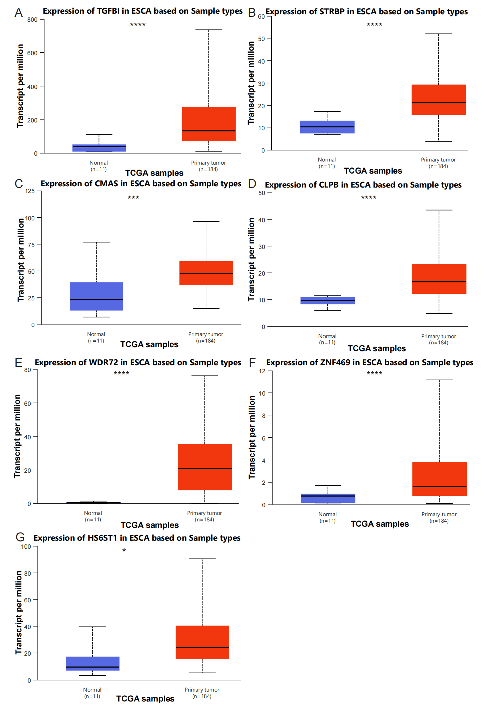
Supplementary Figure 7. The TCGA data from UALCAN was utilized to analyze the differences in expression levels of metastasis markers between esophageal cancer tissues and normal tissues. (A-G) The differential expression levels of ZNF469, CLPB, CMAS, STRBP, WDR72, TGFBI, and HS6ST1 between esophageal cancer tissues and normal tissues. *P<0.05, **P<0.01, ***P<0.001, ****P<0.0001
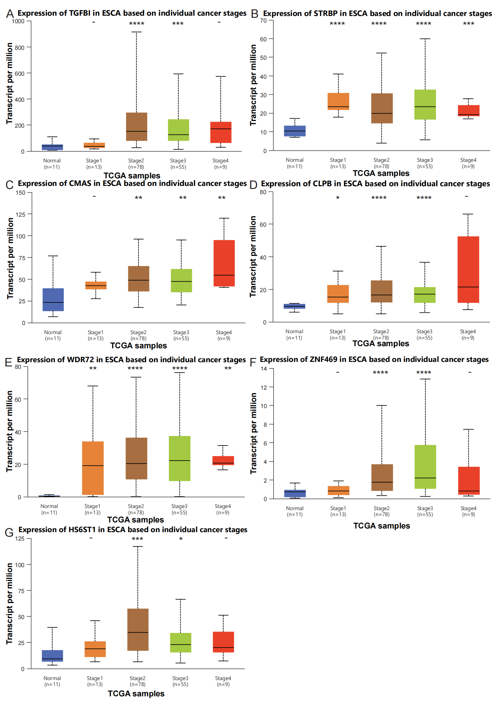
Supplementary Figure 8. The TCGA data from UALCAN was utilized to analyze the expression levels of metastasis markers in various clinical stages of esophageal cancer tissues compared to normal tissues. (A-G) The differential expression levels of ZNF469, CLPB, CMAS, STRBP, WDR72, TGFBI, and HS6ST1 in esophageal cancer tissues compared to normal tissues at various clinical stages. *P<0.05, **P<0.01, ***P<0.001, ****P<0.0001
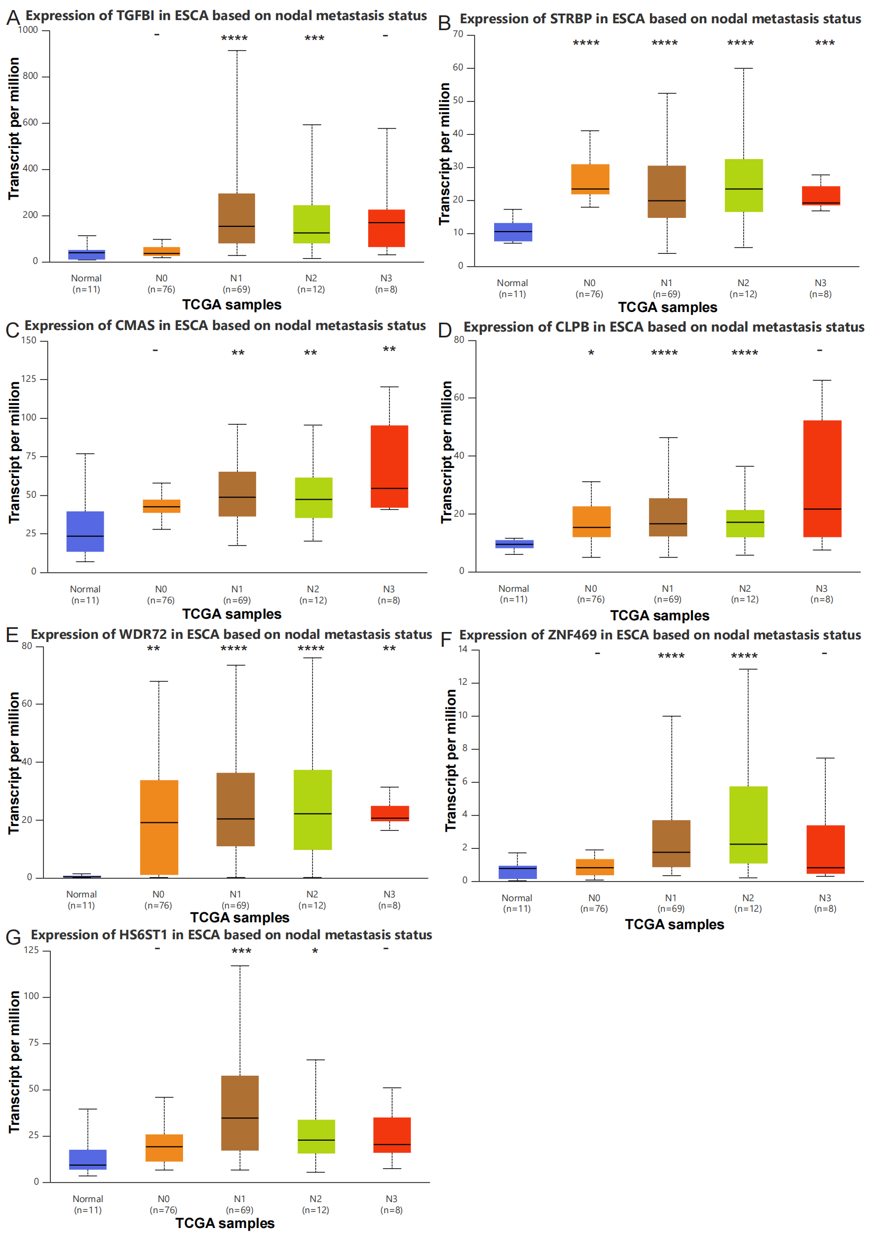
Supplementary Figure 9. The TCGA data from UALCAN was utilized to analyze the expression levels of metastasis markers in different lymph node metastasis of esophageal cancer tissues compared to normal tissues. (A-G) The differential expression levels of ZNF469, CLPB, CMAS, STRBP, WDR72, TGFBI, and HS6ST1 in esophageal cancer tissues compared to normal tissues at different lymph node metastasis. *P<0.05, **P<0.01, ***P<0.001, ****P<0.0001
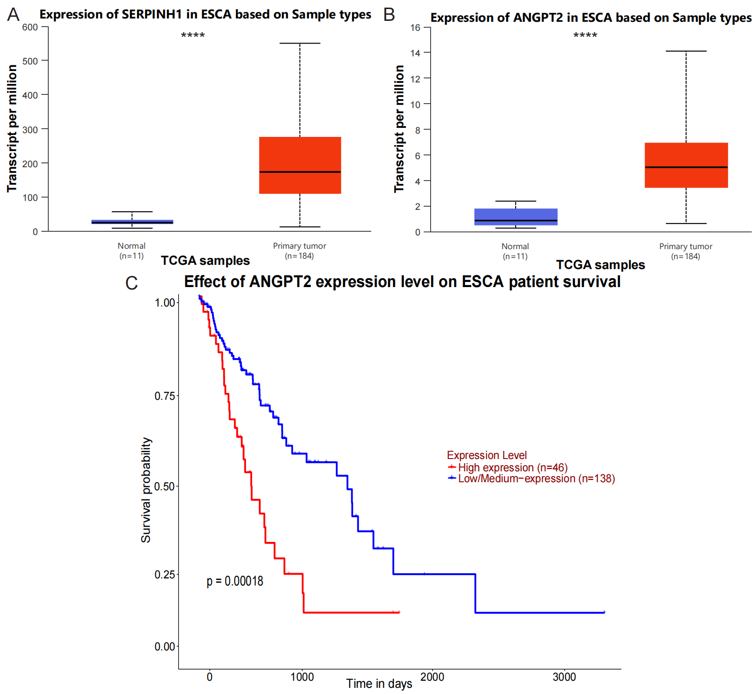
Supplementary Figure 10. The TCGA data from UALCAN was utilized to analyze the differences in the expression levels of recurrence markers between esophageal cancer tissues and normal tissues and the differences in prognosis. (A-B) The differential expression levels of SERPINH1 and ANGPT2 between esophageal cancer tissues and normal tissues. (C) Survival curves for esophageal cancer patients categorized by high or low expression of ANGPT2, displaying overall survival (OS) time (days) versus survival probability. *P<0.05, **P<0.01, ***P<0.001, ****P<0.0001

