Supplementary file_full uncropped western blot

Figure 1_AEBP1_Huh7
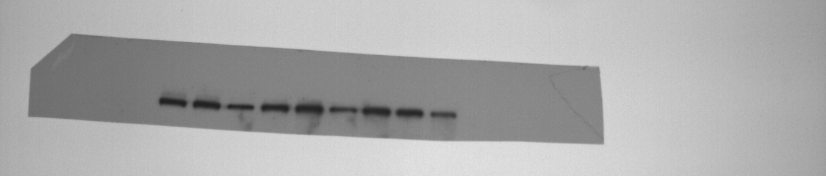
Figure 1_AEBP1_MHCC-97H
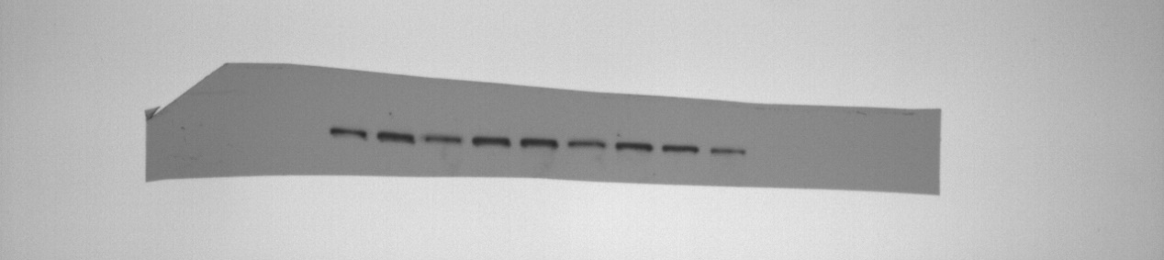
Figure 1_GAPDH_Huh7
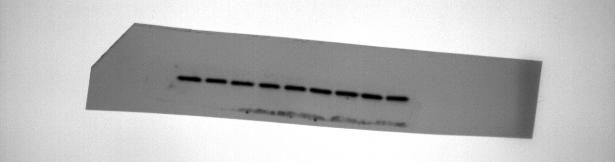
Figure 1_GAPDH_MHCC-97H
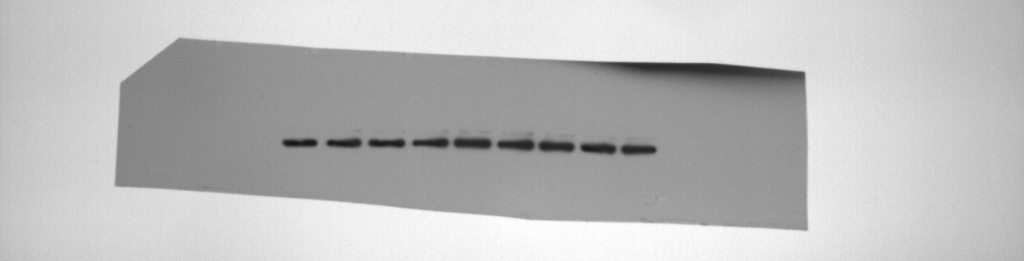
Figure 5_AKT_Huh7
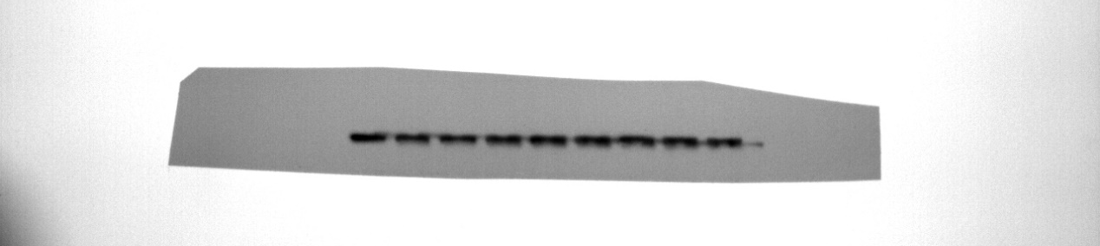

Figure 5_GAPDH_Huh7
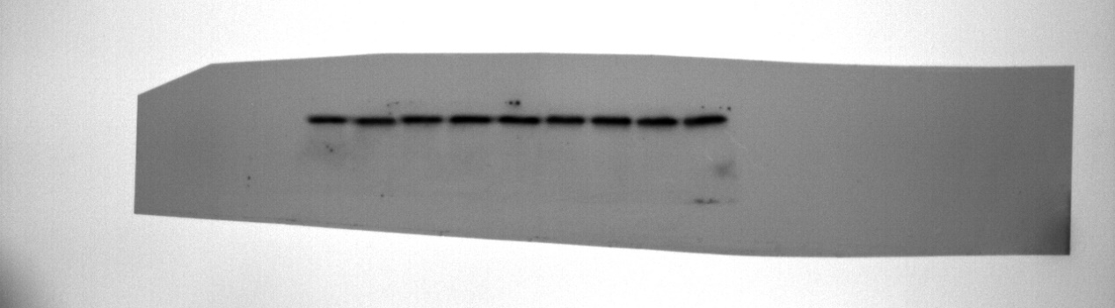
Figure 5_p-AKT_Huh7
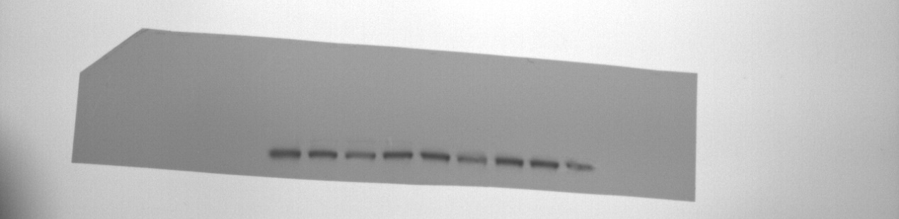
Figure 5_PI3K_Huh7
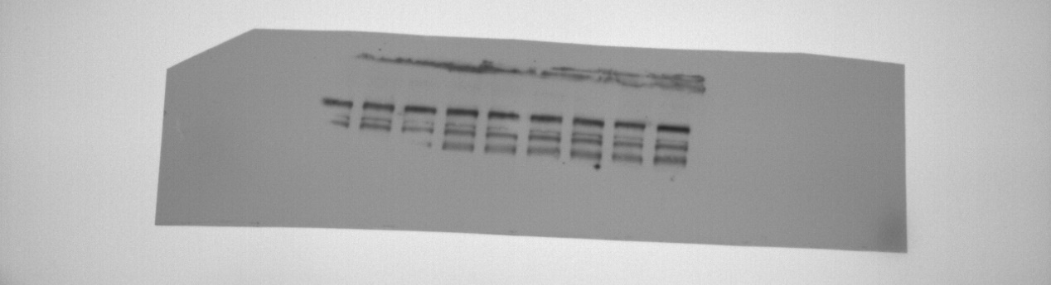
Figure 5_p-PI3K_Huh7
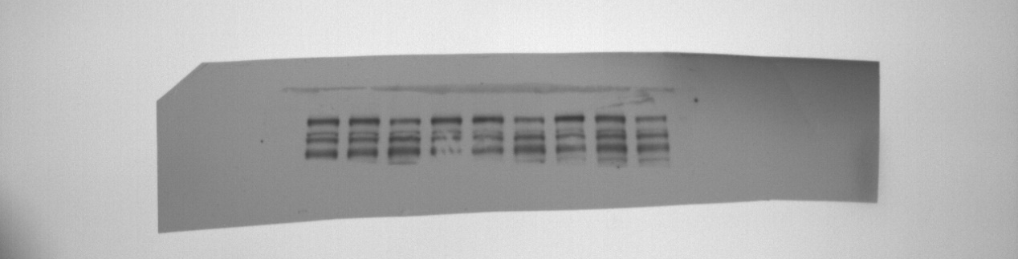
Figure 5_AKT_MHCC-97H
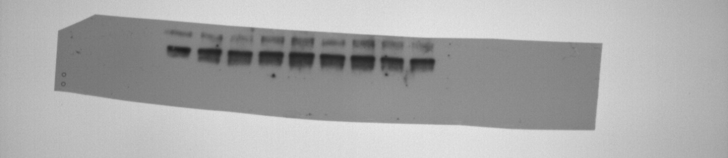

Figure 5_GAPDH_MHCC-97H
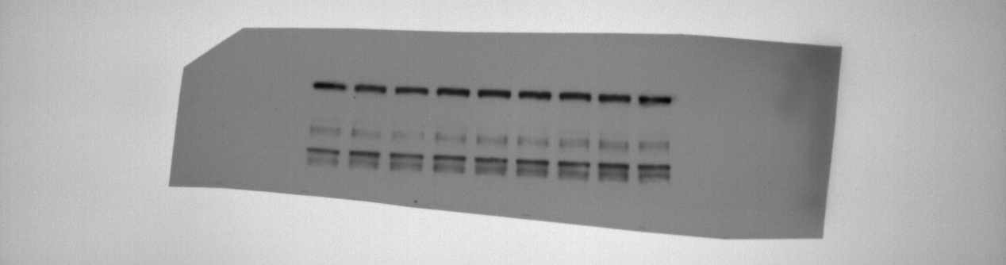
Figure 5_p-AKT_MHCC-97H
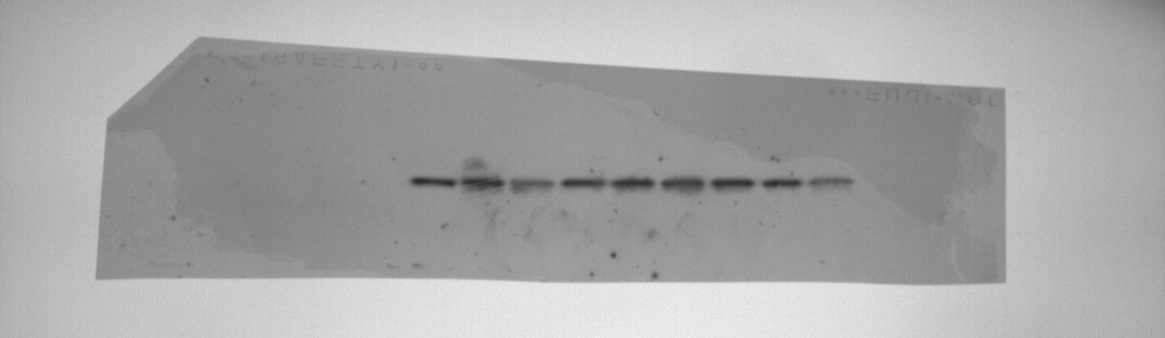
Figure 5_PI3K_MHCC-97H
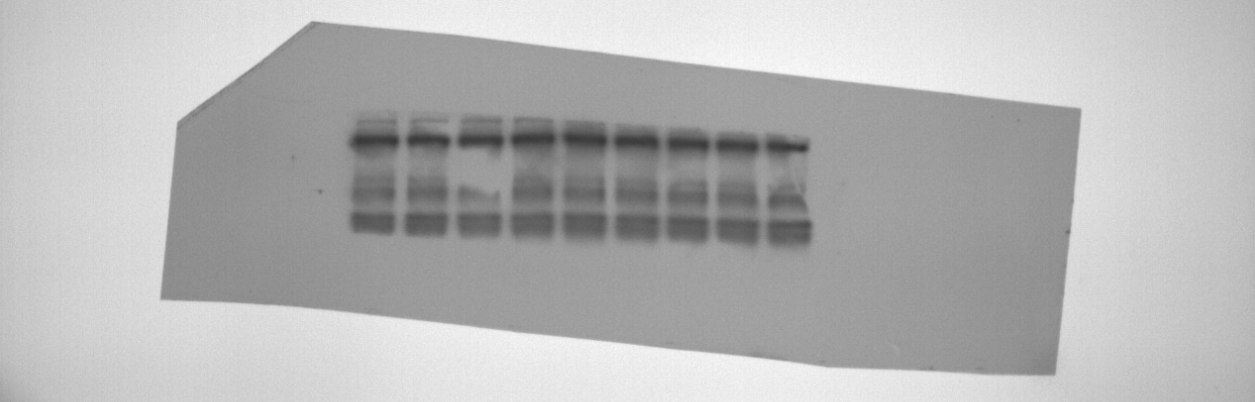
Figure 5_p-PI3K_MHCC-97H
