Supplementary Figure S1.
GO and KEGG enrichment analyses of differentially expressed genes (DEGs) between P2RX4-high and P2RX4-low expression groups in the TCGA-LIHC cohort.
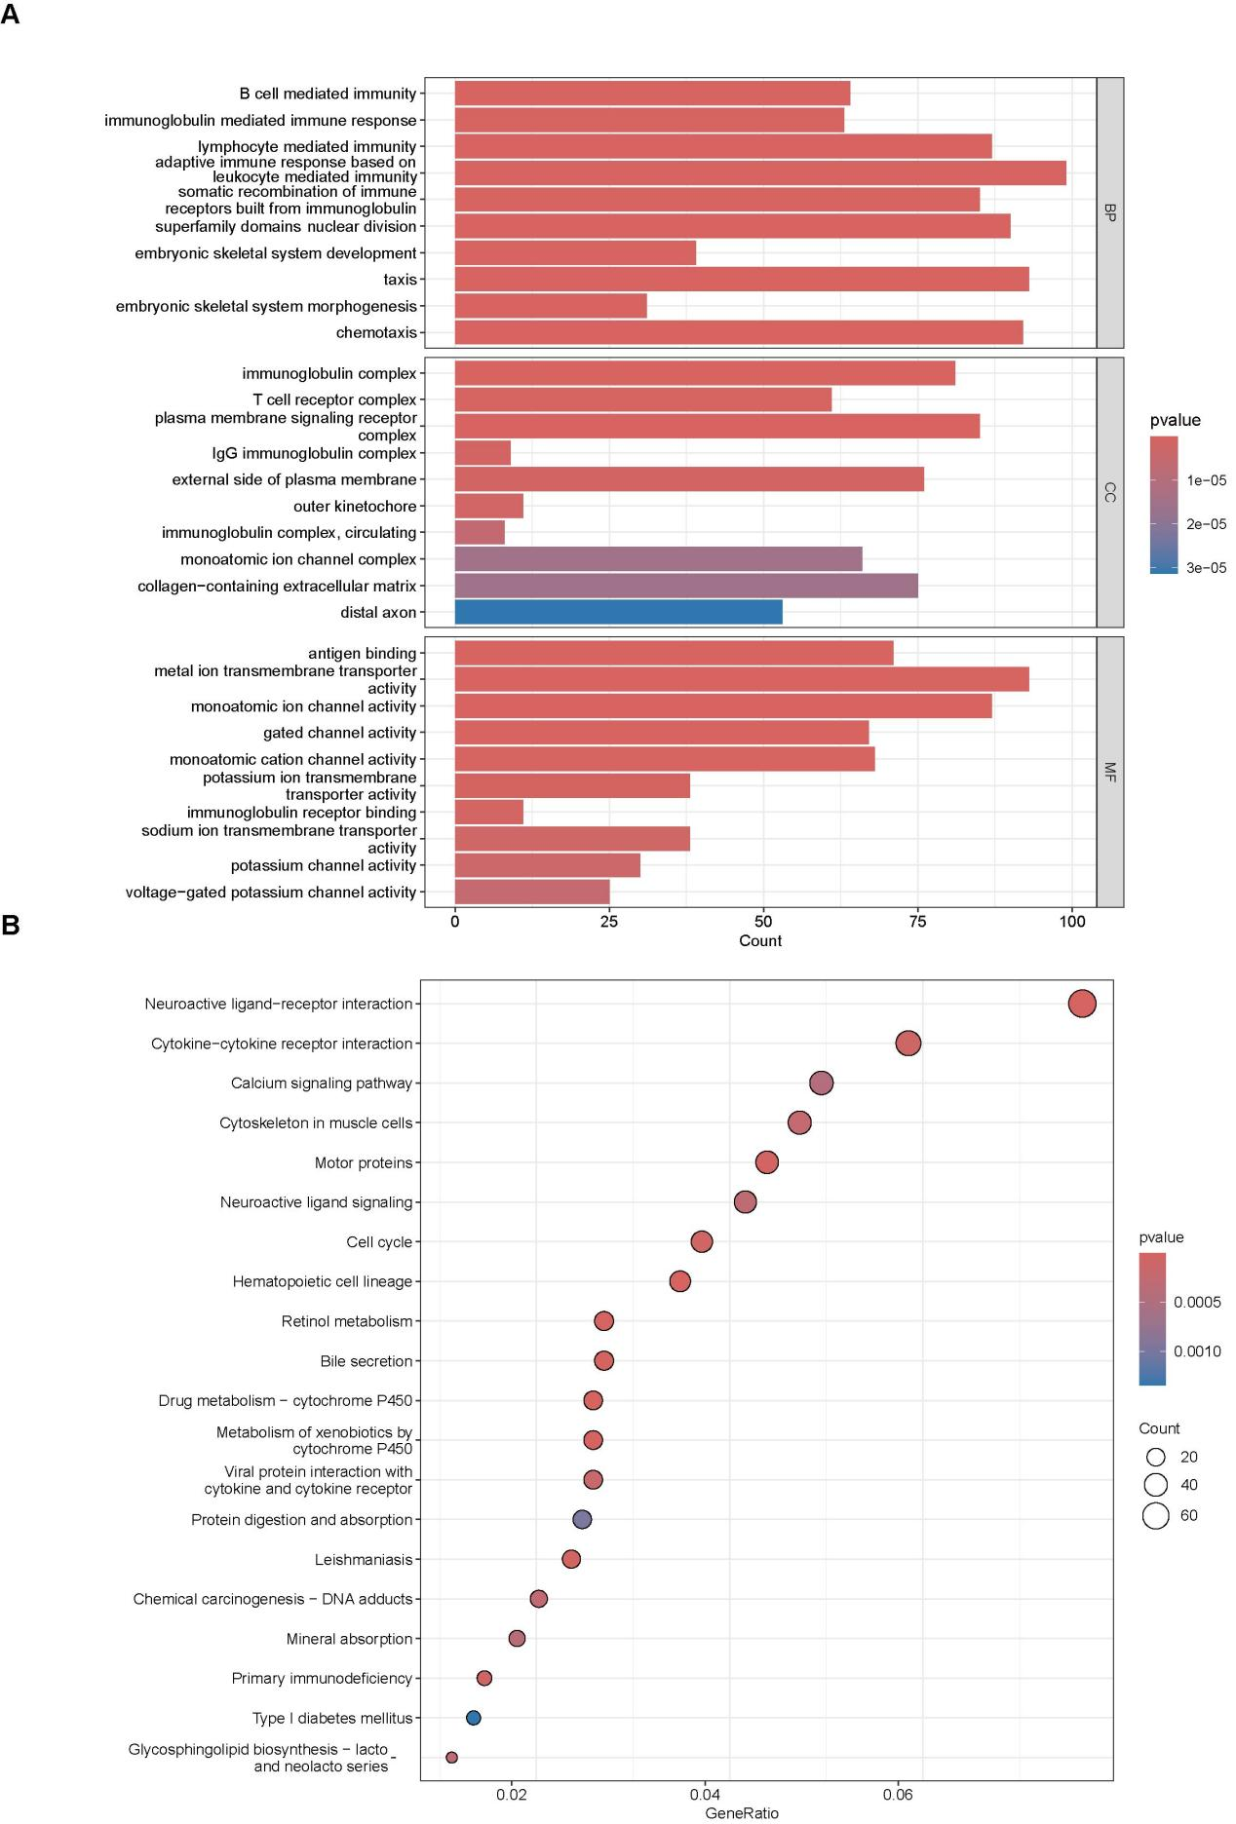
(A)GO analysis results are categorized into biological process (BP), cellular component (CC), and molecular function (MF). The DEGs were enriched in immune-related processes (B cell mediated immunity, leukocyte activation), ion channel complexes, and cation channel activity.
(B)KEGG pathway analysis revealed significant enrichment in calcium signaling, cytokine–cytokine receptor interaction, cell cycle, and other immune-related pathways. Dot size represents gene count; color gradient reflects p-values.

Supplementary Figure S2.
Co-expression analysis of P2RX4 with selected genes in hepatocellular carcinoma (HCC) based on TCGA-LIHC transcriptome data.

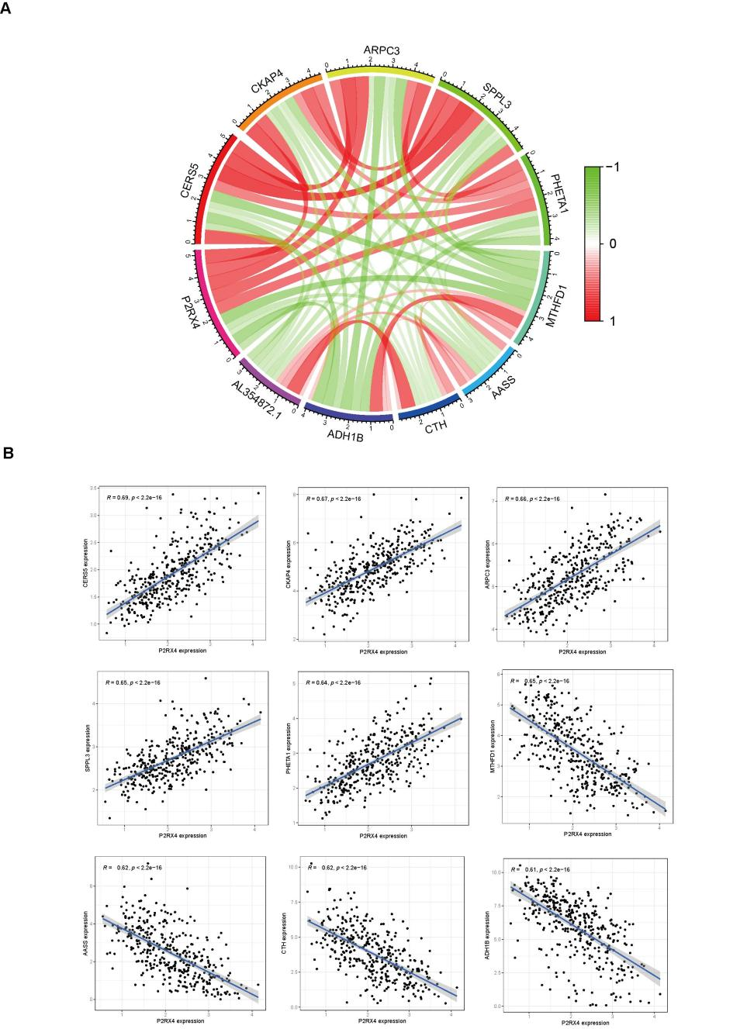
- Circos plot showing pairwise Pearson correlation coefficients among P2RX4 and ten co-expressed genes. Red ribbons indicate positive correlations; green ribbons indicate negative correlations. Color intensity reflects correlation strength (range: -1 to 1).
(B)Scatter plots showing the correlation between P2RX4 and each gene. Regression lines with 95% confidence intervals are shown. Pearson’s R and p-values are indicated. All correlations are statistically significant.The included genes and their known or predicted functions are:
CERS5: ceramide synthesis and lipid metabolism.
CKAP4: PI3K/AKT signaling and ER membrane regulation.
ARPC3: actin cytoskeleton organization and cell motility.
SPPL3: glycosylation control and intramembrane proteolysis.
PHETA1: endosomal trafficking and membrane transport.
MTHFD1: folate metabolism and nucleotide biosynthesis.
CTH: cysteine metabolism and redox homeostasis.
AASS: lysine degradation and amino acid metabolism.
ADH1B: alcohol metabolism and liver function.
AL354872.1: uncharacterized long non-coding RNA annotated in TCGA GENCODE; potential regulatory role is unknown.

Supplementary Figure S3
P2RX4 Promotes Proliferation and Invasion of LM3 Cells
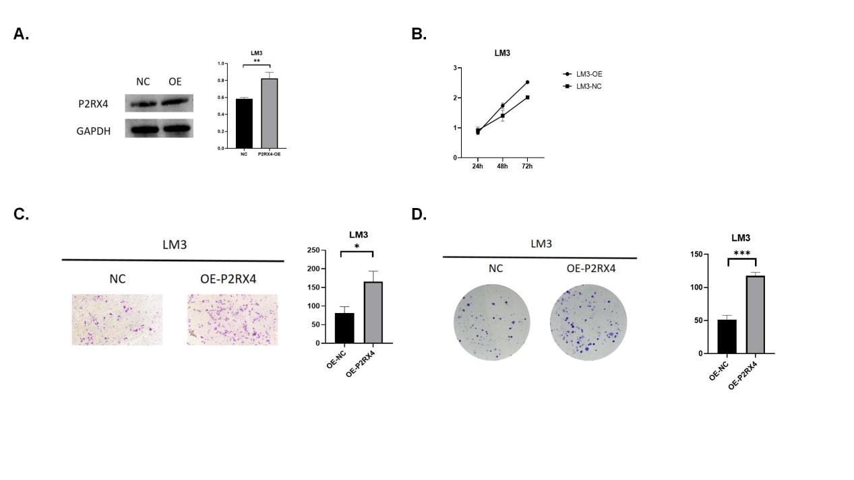
A. Establishment of LM3 cells with stable overexpression
B. LM3 overexpression promotes HCC cell proliferation
C. LM3 overexpression enhances HCC cell invasion
D. LM3 overexpression increases colony formation ability of HCC cells

