Supplementary Figures
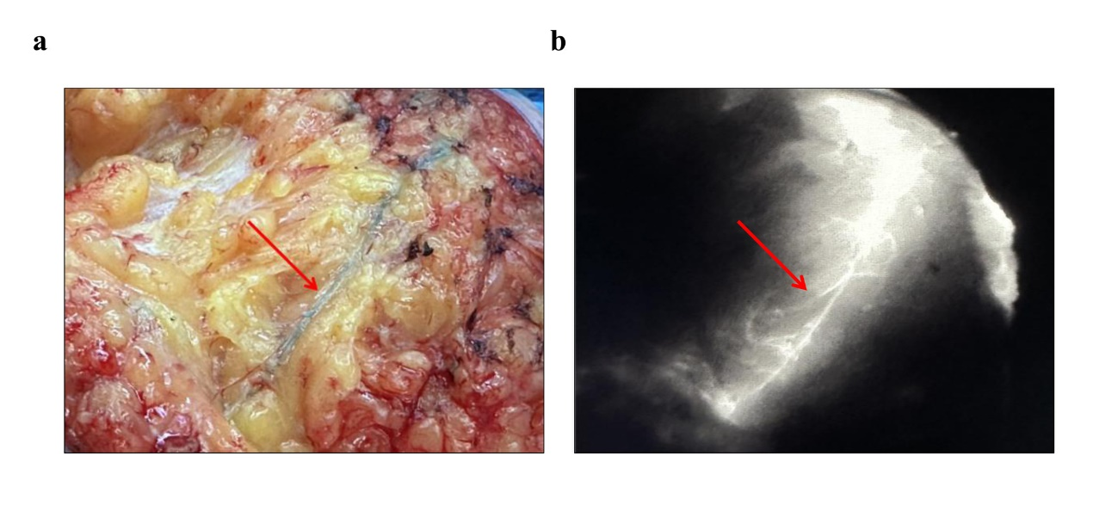
Fig. S1 Lymphatic vessel imaging following MHI injection.
(a) The blue-stained lymphatic vessels.
(b) The fluorescent lymphatic vessels under near-infrared fluorescence.

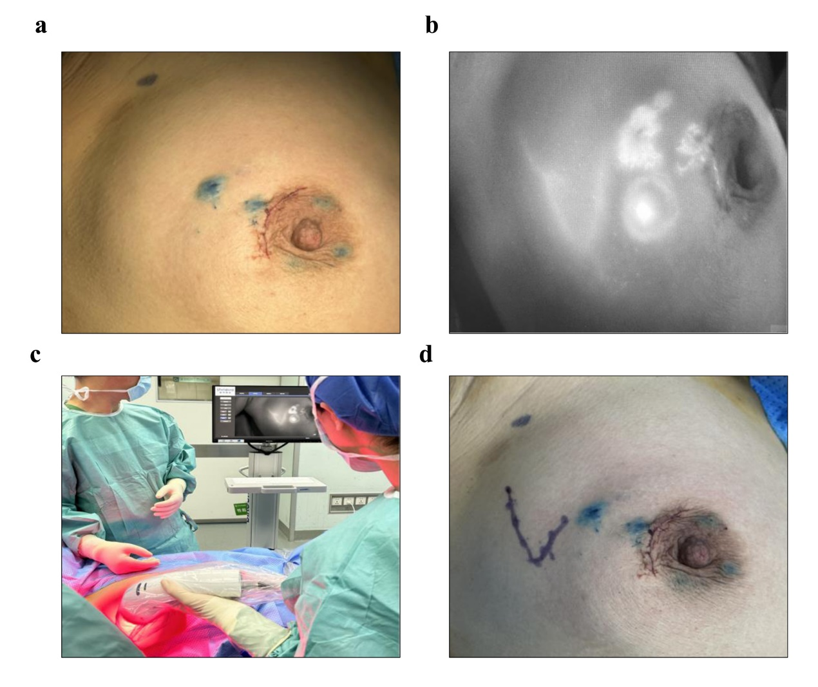
Fig. S2 Procedure for fluorescence imaging using MHI.
(a) Intracutaneous injection of MHI at five points.
(b) The fluorescent lymphatic drainage pathways under near-infrared fluorescence.
(c) Lymphatic vessel imaging in real time on the monitor screen.
(d) Outlining lymphatic drainage pathways on the body surface.

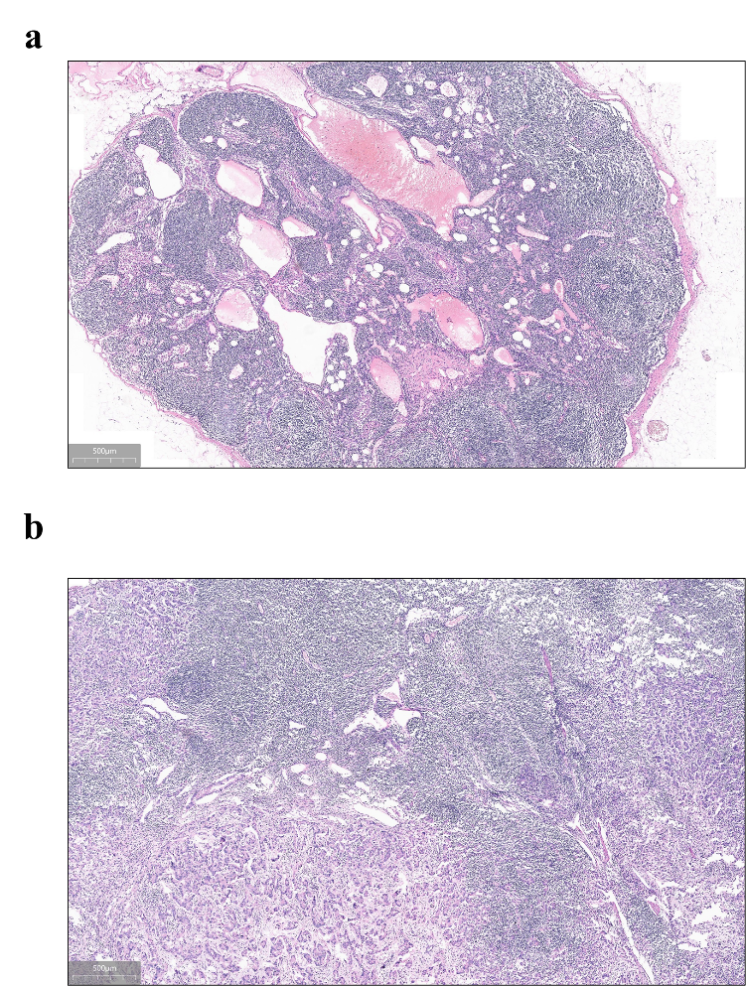
Fig. S3 Representative histopathological confirmation of sentinel lymph node (SLN) status in patients receiving MHI.
(a) True negative case: Histological examination of the SLN shows no metastasis (H&E staining, scale bar = 500 μm), and no metastatic deposits are found in the remaining axillary lymph nodes after axillary lymph node dissection.
(b) True positive case: Metastatic tumor cells are identified in the SLN (H&E staining, scale bar = 500 μm).

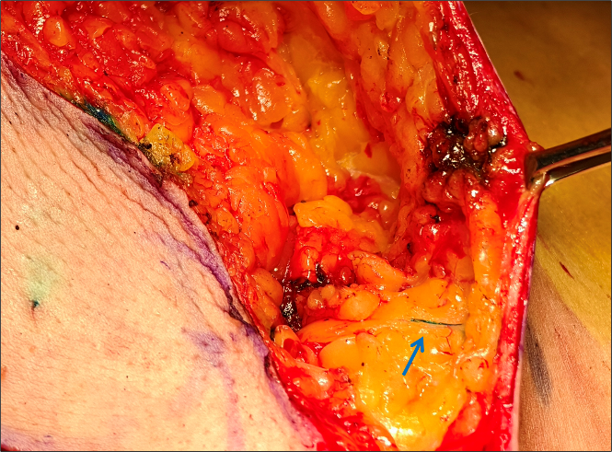
Fig. S4 Methylene blue (MB) staining of lymphatic vessels after intracutaneous injection.
Representative intraoperative images show that MB can stain lymphatic vessels (blue arrows), confirming its lymphatic tracer capability.

