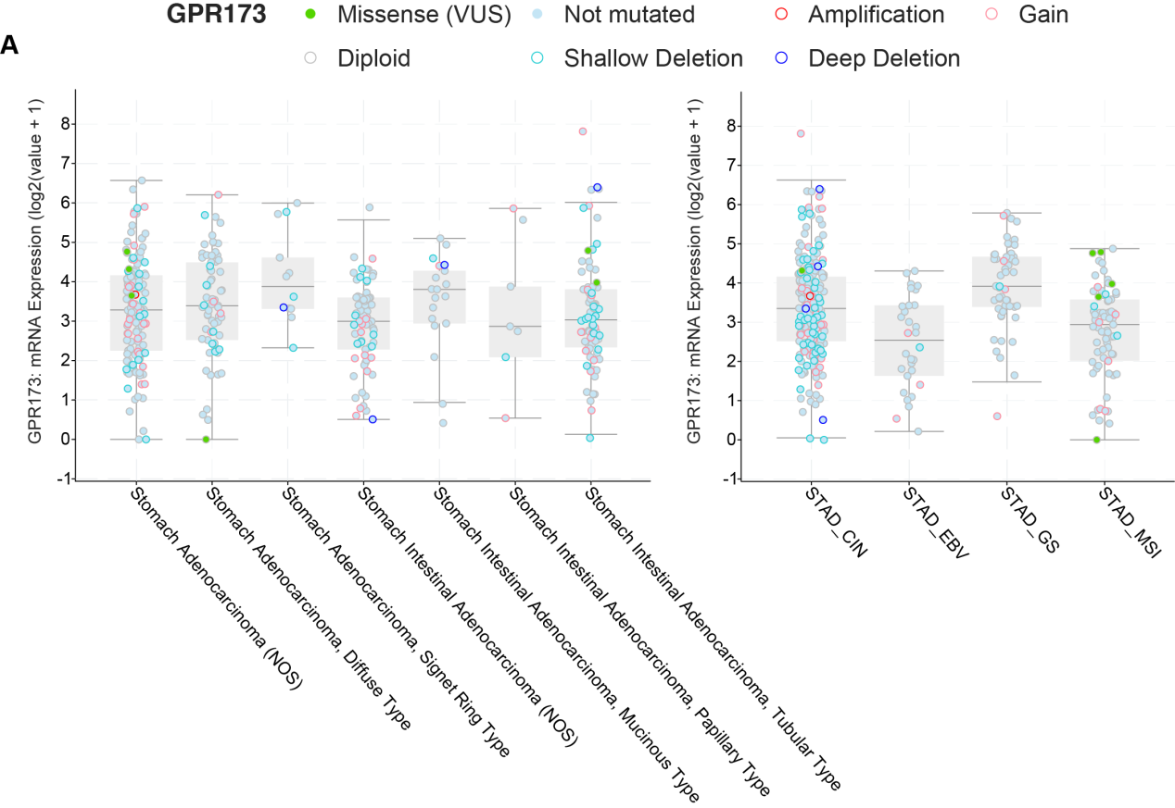
Supplementary Figure 1. Association of GPR173 mRNA expression with histological patterns and molecular subtypes in gastric cancer.
The GPR173 mRNA expression data (log2(value + 1)) from the TCGA Pan-Cancer Atlas dataset were analyzed using the cBioPortal for Cancer Genomics. (Left panel) Distribution of GPR173 expression levels across different WHO histological subtypes of gastric adenocarcinoma. The plot illustrates expression patterns in specific subtypes, including Diffuse Type and Signet Ring Cell Carcinoma. (Right panel) Distribution of GPR173 expression levels stratified by the four standard TCGA molecular subtypes: Chromosomal Instability (STAD_CIN), Epstein-Barr Virus (STAD_EBV), Genomically Stable (STAD_GS), and Microsatellite Instability (STAD_MSI). The dot colors represent the specific genetic alteration status of GPR173 (e.g., amplification, mutation, diploid) for each patient as indicated in the key.

