Table 1. Diagnostic performance of the primary or externally validated radiomics models for predicting MSI-H status in colorectal cancer.
Study ID | Year | Total N | MSI-H (n) | MSS (n) | MSI Proportion (%) | Sensitivity | Specificity | TP | FN | TN | FP | AUC
Bodalal2024 | 2024 | 52 | 13 | 39 | 25 | 0.64 | 0.7 | 8 | 5 | 27 | 12 | 0.78
Chen2023 | 2023 | 441 | 56 | 385 | 12.7 | 0.732 | 0.725 | 41 | 15 | 279 | 106 | 0.775
Chen2024 | 2024 | 732 | 147 | 585 | 20.1 | 0.77 | 0.78 | 113 | 34 | 456 | 129 | 0.83
Chen2025 | 2025 | 46 | 7 | 39 | 15.2 | 0.71 | 0.8 | 5 | 2 | 31 | 8 | 0.84
Jing2022 | 2022 | 65 | 11 | 54 | 16.9 | 0.909 | 0.815 | 10 | 1 | 44 | 10 | 0.874
Li2023 | 2023 | 120 | 32 | 88 | 26.7 | 0.74 | 0.75 | 24 | 8 | 66 | 22 | 0.86
Yao2025 | 2025 | 120 | 22 | 98 | 18.3 | 1 | 0.867 | 22 | 0 | 85 | 13 | 0.974
ZLi2023 | 2023 | 99 | 32 | 67 | 32.3 | 0.41 | 0.91 | 13 | 19 | 61 | 6 | 0.78
ZhiLi2021 | 2021 | 142 | 71 | 71 | 50 | 0.67 | 0.72 | 48 | 23 | 51 | 20 | 0.73

Table 2. Two-by-two contingency tables of the 34 included studies for radiomics-based prediction of MSI-H status in colorectal cancer.

author | Year | TP | FP | FN | TN
Fan 2019 | 2019 | 20 | 14 | 10 | 75
J. Wu 2019 | 2019 | 23 | 9 | 0 | 37
Jj Wu 2019 | 2019 | 31 | 14 | 7 | 62
Pernicka 2020 | 2020 | 59 | 2 | 75 | 62
W. Zhang 2021 | 2021 | 42 | 0 | 0 | 353
Zhi Li 2021 | 2021 | 48 | 20 | 23 | 51
Pei 2021 | 2021 | 72 | 139 | 18 | 305
Cao 2021 | 2021 | 55 | 60 | 12 | 314
J Li 2021 | 2021 | 11 | 38 | 2 | 122
Z. Li 2021 | 2021 | 29 | 14 | 1 | 46
Liu 2021 | 2021 | 13 | 10 | 1 | 20
G Jing 2022 | 2022 | 10 | 10 | 1 | 44
Yuan 2022 | 2022 | 219 | 17 | 62 | 50
Ying 2022 | 2022 | 44 | 24 | 10 | 116
Ma 2022 | 2022 | 45 | 23 | 5 | 157
Li 2023 | 2023 | 24 | 22 | 8 | 66
Yq Ma 2023 | 2023 | 66 | 214 | 31 | 477
Z. Li 2023 | 2023 | 13 | 6 | 19 | 61
Chen 2023 | 2023 | 41 | 106 | 15 | 279
Kim 2023 | 2023 | 13 | 37 | 2 | 87
Y. Zhang 2023 | 2023 | 36 | 88 | 3 | 141
Li Zhang 2023 | 2023 | 16 | 16 | 3 | 53
Bodalal,2024 | 2024 | 8 | 12 | 5 | 27
Xing 2024 | 2024 | 40 | 50 | 11 | 207
Chen 2024 | 2024 | 113 | 129 | 34 | 456
Cai 2024 | 2024 | 28 | 56 | 6 | 292
Y. Ma 2024 | 2024 | 65 | 37 | 3 | 202
Bian 2024 | 2024 | 158 | 9 | 35 | 41
Y. Wang 2024 | 2024 | 7 | 5 | 1 | 62
Yao 2025 | 2025 | 22 | 13 | 0 | 85
Chen 2025 | 2025 | 5 | 8 | 2 | 31
Wang 2025 | 2025 | 34 | 40 | 5 | 153
Mallardi 2025 | 2025 | 26 | 7 | 5 | 16
Peng 2025 | 2025 | 28 | 35 | 5 | 198

Figure 3. Forest plots of pooled sensitivity and specificity of radiomics-based models for predicting MSI-H status in colorectal cancer.
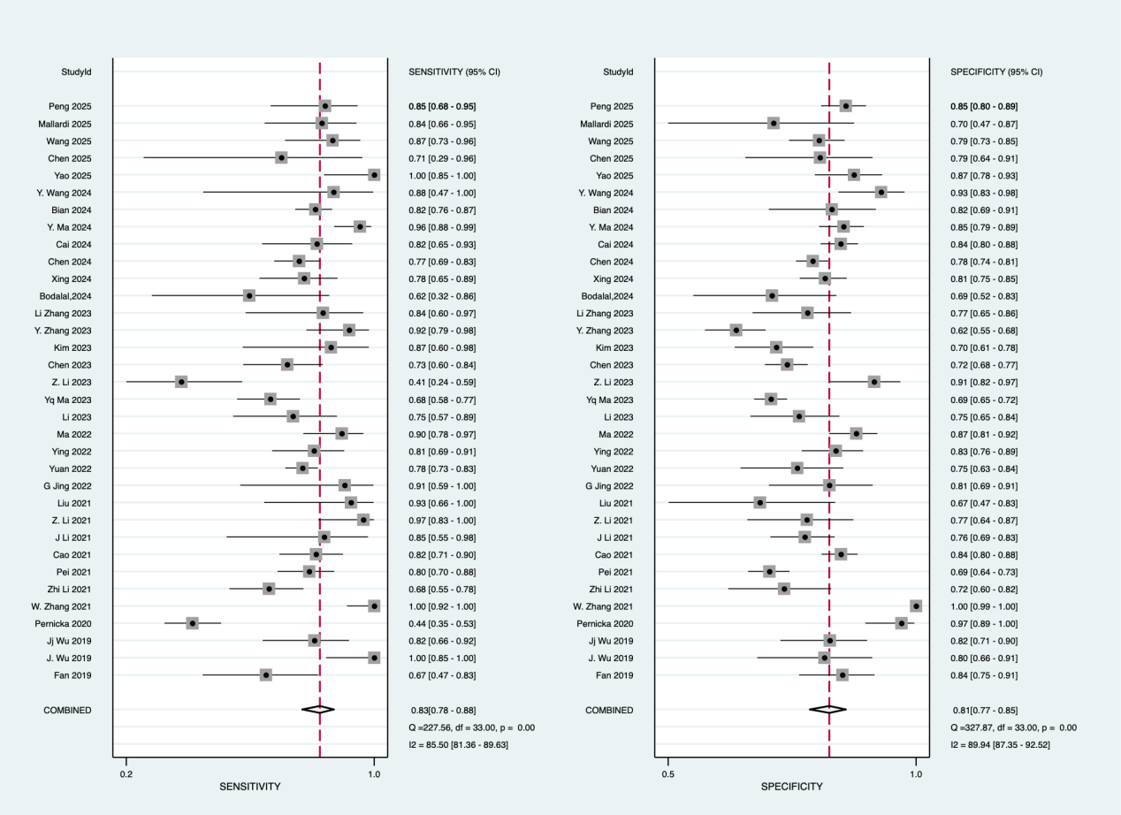

Figure 4. Forest plots of pooled positive likelihood ratio (PLR) and negative likelihood ratio (NLR) of radiomics-based models for predicting MSI-H status in colorectal cancer.

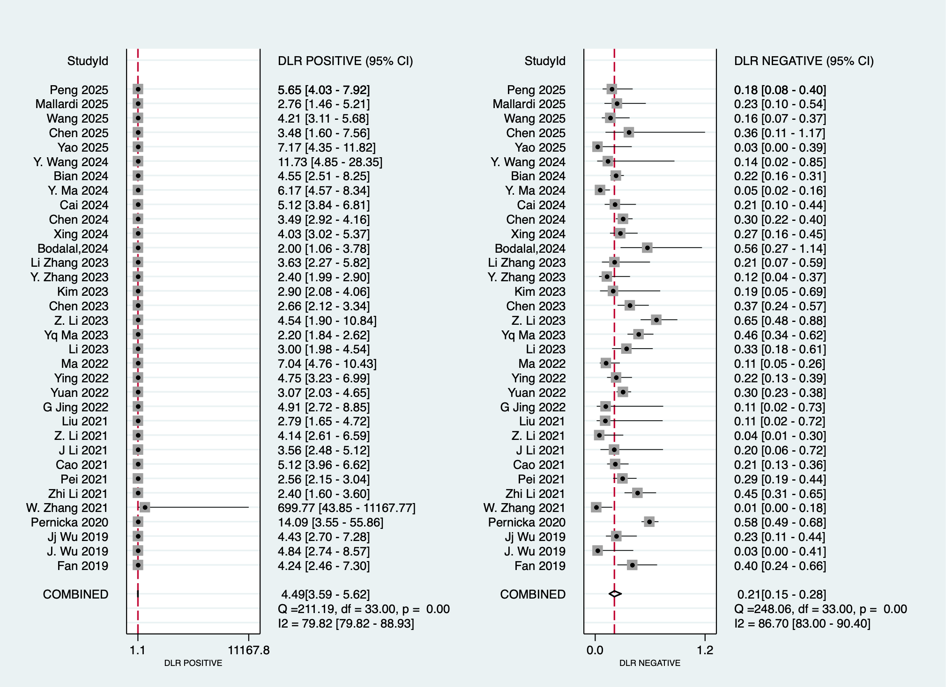

Figure 5. Summary receiver operating characteristic (SROC) curve of radiomics-based models for predicting MSI-H status in colorectal cancer.

