Table S2 Subgroup Analysis of Overall Survival
Indicator/  Subgroup | Number of Studies (N) | Heterogeneity I² (%) | Heterogeneity P  -value | Model | HR (95% CI)
Overall Survival (OS) | 6 | 0 | 0.688 | Random | 1.00(0.89, 1.13)
Age
60-70 years | 5 | 0 | 00.546 | Random | 0.99 (0.88, 1.13)
70-80 years | 1 | - | - | Random | 1.07(0.74, 1.54)
Country
The Americas | 4 | 1.4 | 0.385 | Random | 0.99 (0.86, 1.13)
Australia | 1 | - | - | Random | 1.02 (0.72, 1.44)
Europe | 1 | - | - | Random | 1.07 (0.74, 1.54)
lymph
N0 | 5 | 0 | 0.699 | Random | 0.95(0.82, 1.11)
N0/N1 | 1 | - | - | Random | 1.08 (0.89, 1.31)
Endocrine therapy
TAM | 5 | 0 | 0.812 | Random | 1.01(0.90, 1.14)
AI | 1 | - | - | Random | 0.62(0.29, 131)
Radiotherapy therapy
WBRT | 5 | 0 | 0.525 | Random | 1.00 (0.88, 1.13)
FRT | 1 | - | - | Random | 1.02 (0.72, 1.44)

Table S3 Subgroup Analysis of Local Recurrence
Indicator/  Subgroup | Number of Studies (N) | Heterogeneity I² (%) | Heterogeneity P-value | Model | HR (95% CI)
Local Recurrence | 7 | 73.5 | <0.01 | Random | 0.33(0.18, 0.60)
Age
60-70years group | 5 | 57.9 | 0.05 | Random | 0.36 (0.21, 0.61)
70-80 years group | 2 | 91.2 | <0.01 | Random | 0.35 (0.03,4.28)
Country
The Americas | 5 | 65.0 | 0.02 | Random | 0.23 (0.12, 0.41)
Europe | 1 | - | - | Random | 1.30 (0.38, 4.41)
Australia | 1 | - | - | Random | 0.84 (0.40, 1.77)
lymph
N0 | 6 | 77.6 | <0.01 | Random | 0.32(0.14, 0.72)
N0/N1 | 1 | - | - | Random | 0.39 (0.26, 0.58)
Endocrine therapy
TAM | 5 | 77.2 | <0.01 | Random | 0.42 (0.21, 0.84)
AI | 2 | 0 | 0.591 | Random | 0.16(0.07, 0.35)
Radiotherapy therapy
WBRT | 5 | 72.5 | <0.01 | Random | 0.25 (0.11, 0.59)
FRT | 2 | 68.7 | 0.074 | Random | 0.54 (0.26, 1.12)

Table S4 Subgroup Analysis of Distant Metastasis
Indicator/  Subgroup | Number of Studies (N) | Heterogeneity I² (%) | Heterogeneity P-value | Model | HR (95% CI)
Distant Metastasis | 6 | 64.3 | 0.016 | Random | 1.12 (0.67, 1.87)
Age
60-70 years | 3 | 4.3 | 0.352 | Random | 0.88 (0.56, 1.39)
70-80 years | 3 | 25.2 | 0.263 | Random | 1.61 (0.96, 2.72)
Country
Europe | 1 | - | - | Random | 0.50 (0.05, 5.00)
The Americas | 5 | 69.2 | 0.011 | Random | 1.16 (0.68, 1.97)
lymph
N0 | 6 | 64.3 | 0.016 | Random | 1.12 (0.67, 1.87)
N0/N1 | - | - | - | - | -
Endocrine therapy
TAM | 5 | 70.1 | <0.01 | Random | 1.12 (0.63, 1.99)
AI | 1 | - | - | Random | 1.01 (0.29, 3.48)
Radiotherapy therapy
WBRT | 6 | 64.3 | 0.016 | Random | 1.12 (0.67, 1.87)
FRT | - | - | - | - | -

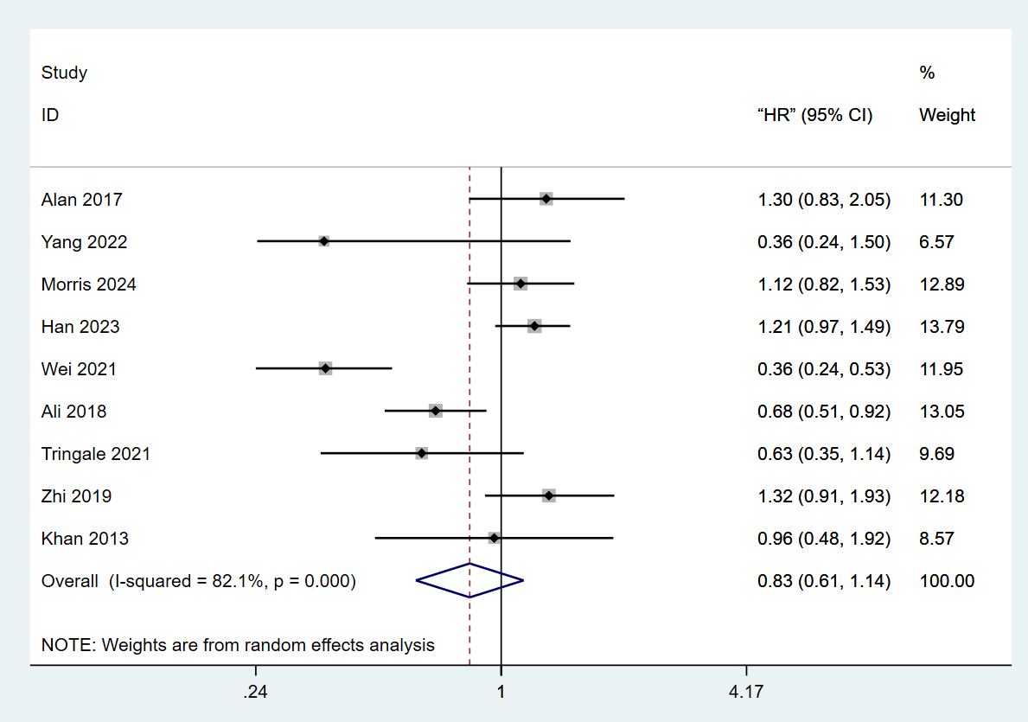
Figure S1 Overall effect for OS based on cohort studies

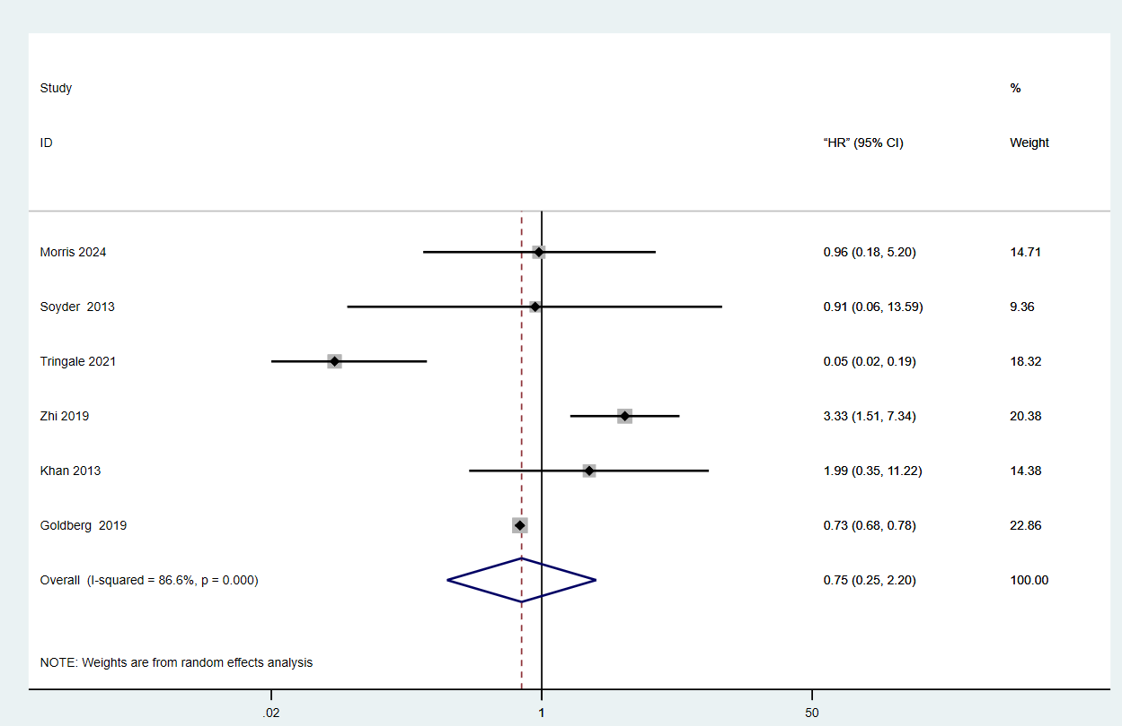
Figure S2 Overall effect for LRR based on cohort studies

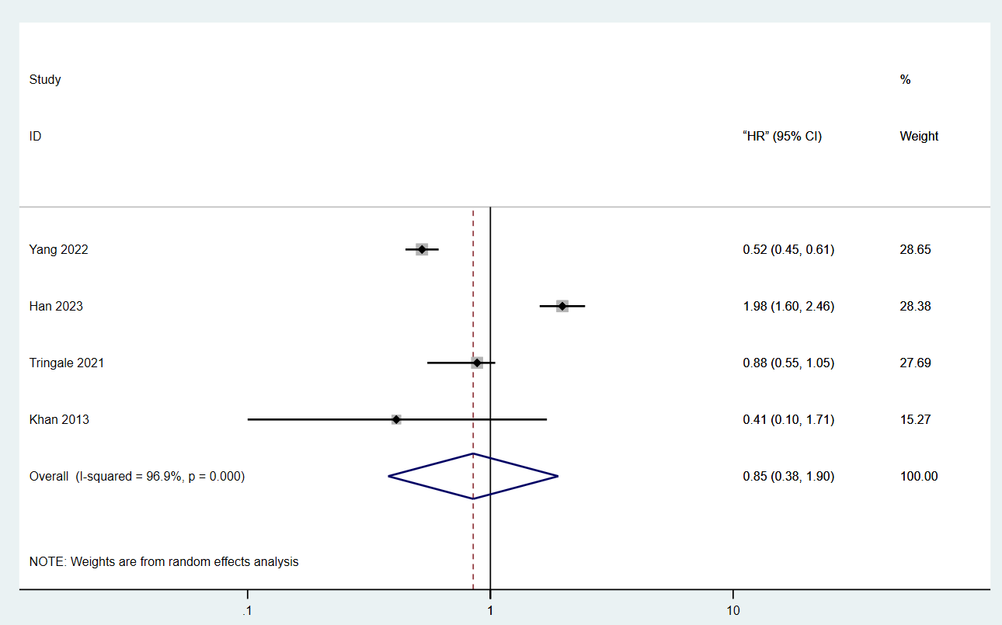
Figure S3 Overall effect for BCSS based on cohort studies
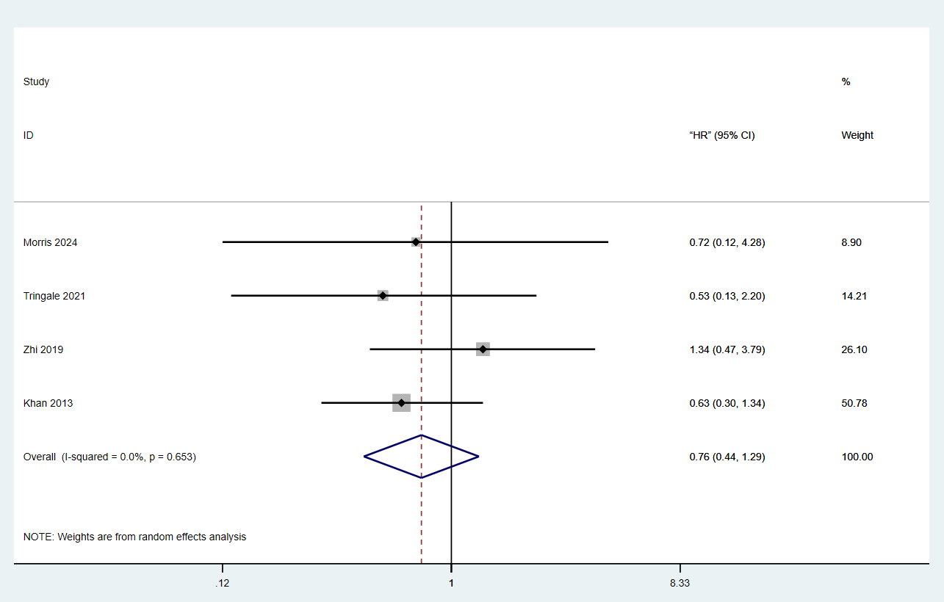
Figure S4 Overall effect for DMR based on cohort studies

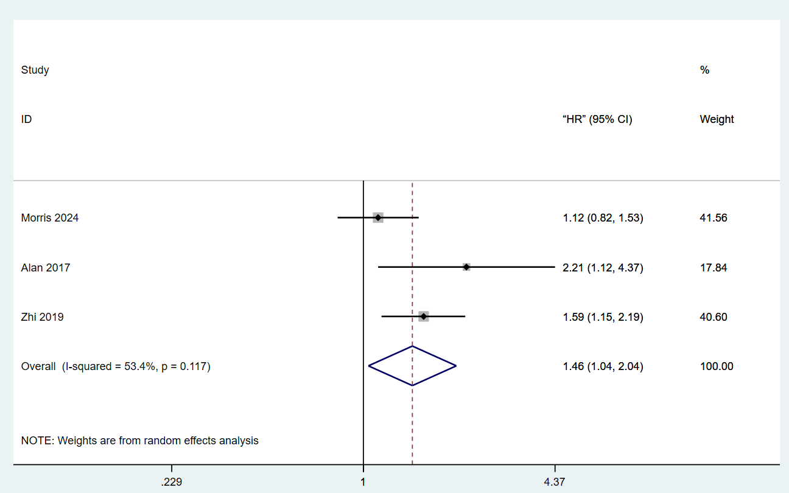
Figure S5 Overall effect for 5-year DFS based on cohort studies

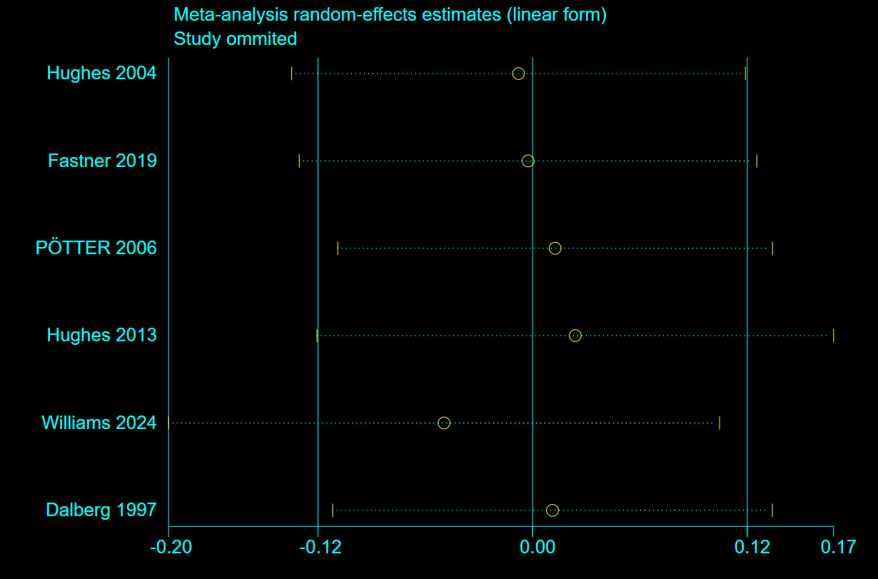
Figure S6 Sensitivity analysis of OS

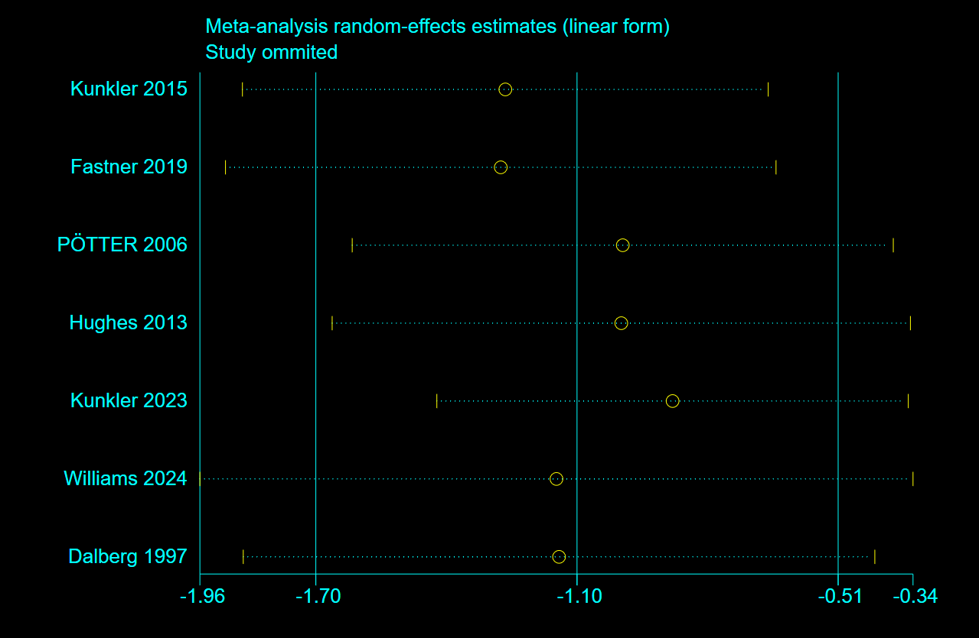
Figure S7 Sensitivity analysis of LRR

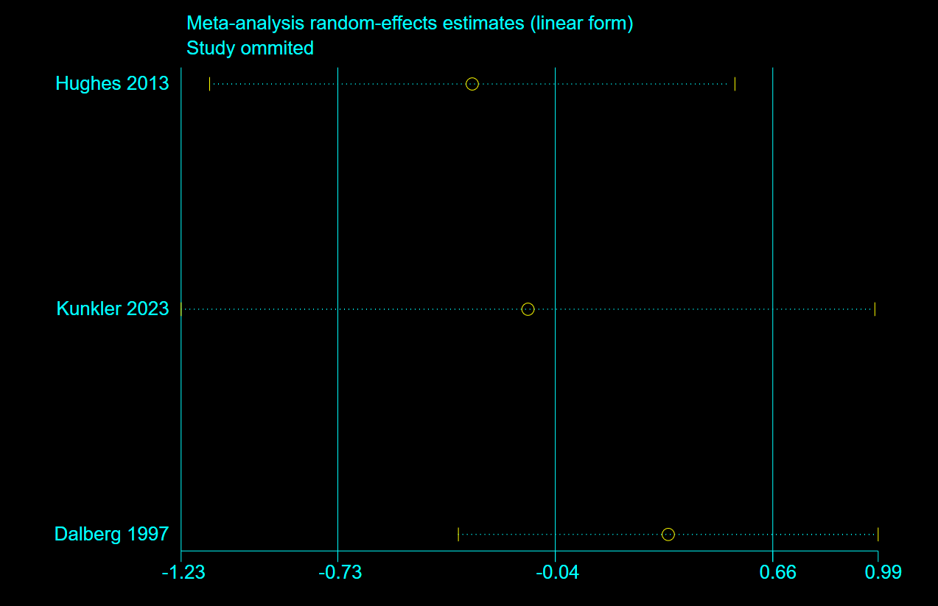
Figure S8 Sensitivity analysis of BCSS

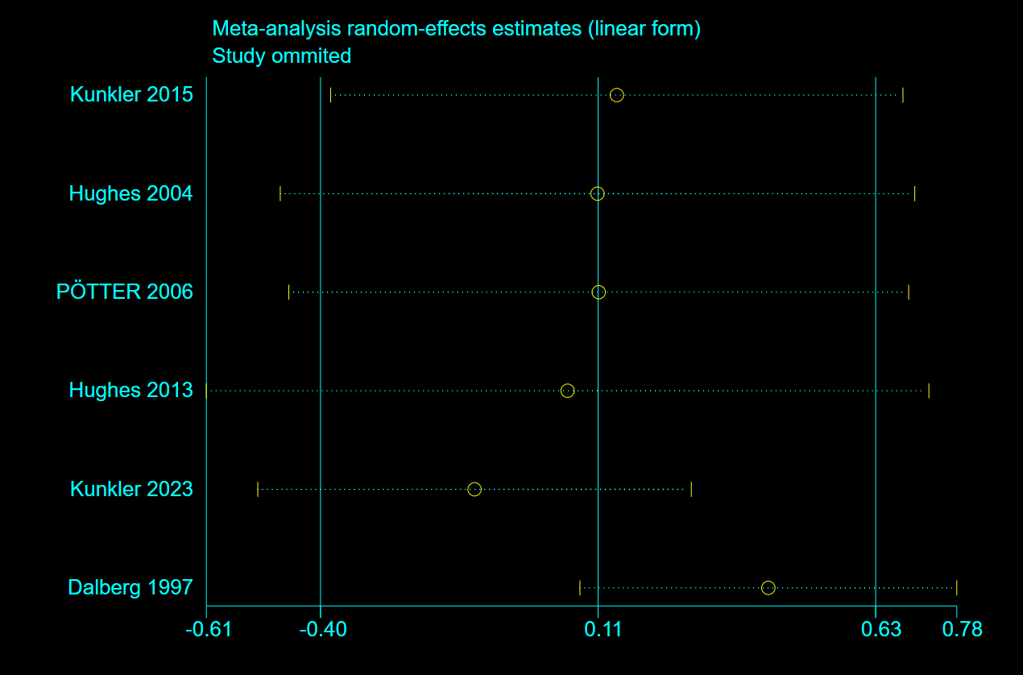
Figure S9 Sensitivity analysis of DMR
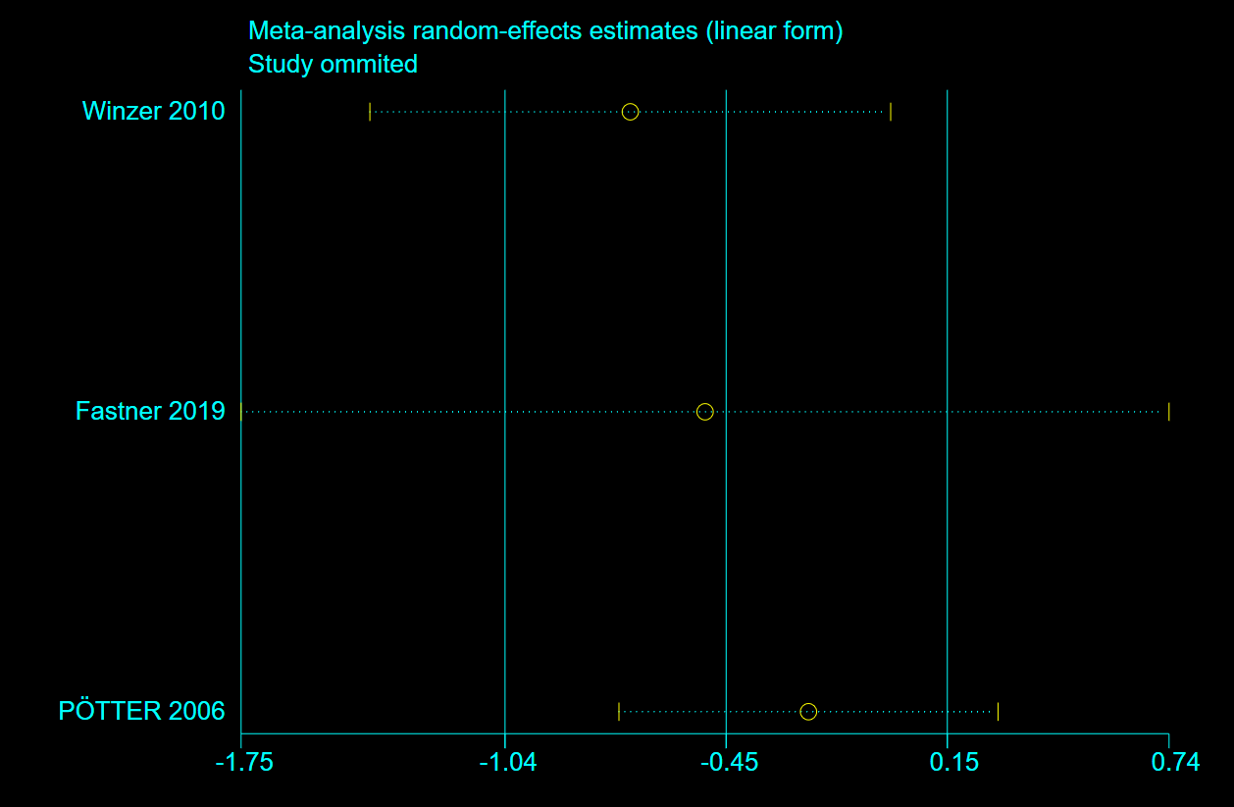
Figure S10 Sensitivity analysis of 5-year DFS

