Supplementary Table 1. Database search strategy and search yield
Databases searched | Search strings used | Results returned, n
PubMed/MEDLINE | (“distal ureterectomy” OR “segmental ureterectomy” OR “ureteral reimplantation”) AND (“radical nephroureterectomy” OR “nephroureterectomy”) AND (“distal ureter” OR “distal ureteral”) AND (“upper tract urothelial carcinoma” OR “urothelial carcinoma” OR “transitional cell carcinoma”) | 33
Embase | (‘distal ureterectomy’ OR ‘segmental ureterectomy’ OR ‘ureteral reimplantation’) AND (‘radical nephroureterectomy’ OR ‘nephroureterectomy’) AND (‘distal ureter’) AND (‘upper tract urothelial carcinoma’ OR ‘urothelial carcinoma’) | 61
Scopus | TITLE-ABS-KEY (“distal ureterectomy” OR “segmental ureterectomy” OR “ureteral reimplantation”) AND TITLE-ABS-KEY (“radical nephroureterectomy” OR “nephroureterectomy”) AND TITLE-ABS-KEY (“distal ureter” AND (“urothelial carcinoma” OR “upper tract urothelial carcinoma”)) | 74
Web of Science | TS=(“distal ureterectomy” OR “segmental ureterectomy” OR “ureteral reimplantation”) AND TS=(“radical nephroureterectomy” OR “nephroureterectomy”) AND TS=(“distal ureter” AND (“urothelial carcinoma” OR “upper tract urothelial carcinoma”)) | 49
Cochrane Library | (“distal ureterectomy” OR “segmental ureterectomy”) AND (“radical nephroureterectomy”) AND (“distal ureter” OR “upper tract urothelial carcinoma”) | 8

Supplementary Figure 1. Study-level ROBINS-I domain judgments and overall risk-of-bias assessment across included non-randomized comparative studies
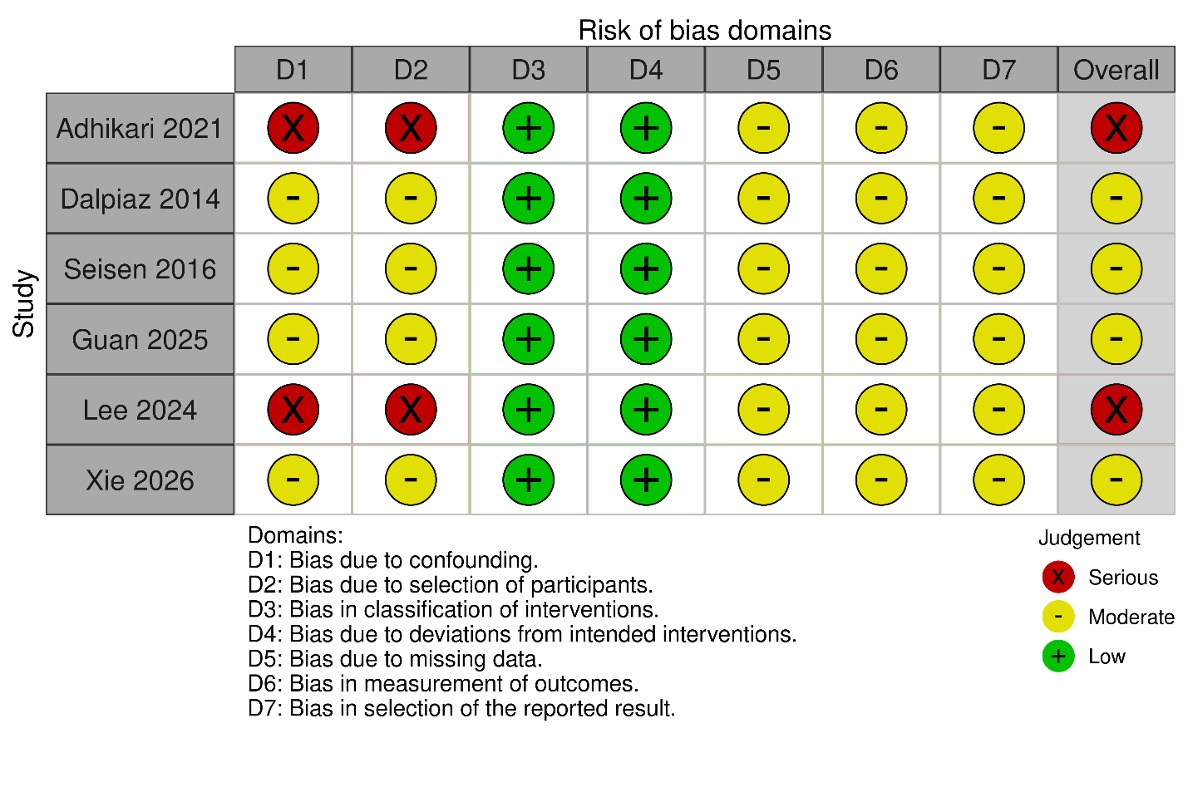
Supplementary Figure 2. Distribution of ROBINS-I judgments across bias domains and overall study-level risk of bias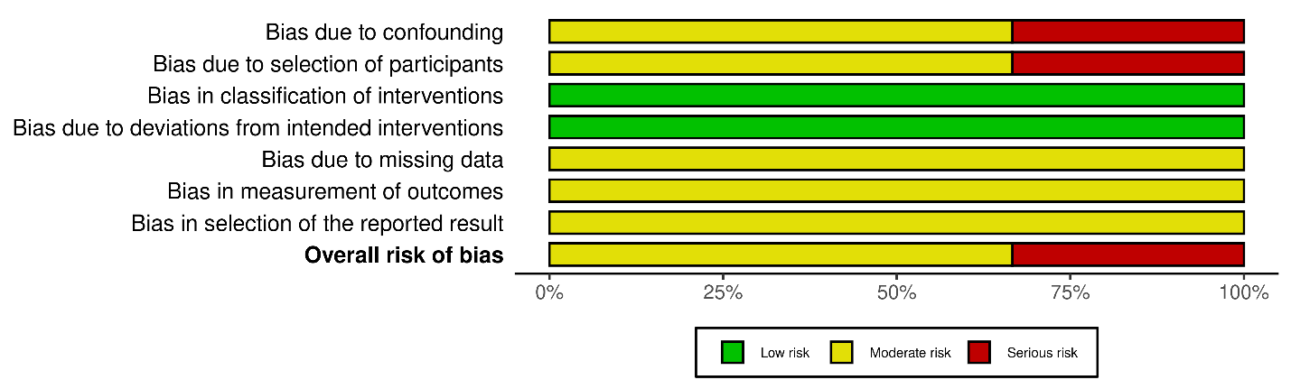

Supplementary Table 2. Leave-one-out sensitivity analysis for outcomes with the greatest heterogeneity, showing pooled estimates before and after exclusion of the heterogeneity-influencing study
Outcome | Effect Estimate (Before) | P-value (Before) | I²% (Before) | Study Removed | Effect Estimate (After) | P-value (After) | I²% (After)
Intravesical recurrence | HR 1.36 (95% CI 0.89–2.07) | 0.16 | 75 | Seisen 2016 | HR 1.68 (95% CI 1.26–2.24) | 0.0004 | 0
High-grade disease | RR 0.97 (95% CI 0.86–1.09) | 0.62 | 13 | Lee 2024 | RR 1.00 (95% CI 0.91–1.10) | 0.99 | 0

Supplementary Table 3. GRADE certainty-of-evidence assessment for the primary and secondary outcomes comparing distal ureterectomy versus radical nephroureterectomy
Outcome | Risk of Bias | Inconsistency | Indirectness | Imprecision | Publication Bias | Effect Estimate | Absolute Effect (per 1,000) | GRADE Certainty
Positive surgical margin | Serious | Not serious | Not serious | Serious | Not serious | RR 1.24 (95% CI 0.64–2.43) | 7 more per 1,000 (from 10 fewer to 39 more) | ⊕◯◯◯ Very low
Intravesical recurrence | Serious | Serious | Not serious | Serious | Not serious | HR 1.36 (95% CI 0.89–2.07) | Not applicable | ⊕◯◯◯ Very low
Cancer-specific survival | Serious | Not serious | Not serious | Serious | Not serious | HR 0.97 (95% CI 0.72–1.29) | Not applicable | ⊕◯◯◯ Very low
Lymph node metastasis | Serious | Not serious | Not serious | Serious | Not serious | RR 0.85 (95% CI 0.40–1.80) | 7 fewer per 1,000 (from 28 fewer to 38 more) | ⊕◯◯◯ Very low
Muscle-invasive disease (≥pT2) | Not serious | Not serious | Not serious | Not serious | Not serious | RR 0.96 (95% CI 0.86–1.08) | 23 fewer per 1,000 (from 79 fewer to 45 more) | ⊕⊕◯◯ Low
High-grade disease | Not serious | Not serious | Not serious | Not serious | Not serious | RR 0.97 (95% CI 0.86–1.09) | 17 fewer per 1,000 (from 81 fewer to 52 more) | ⊕⊕◯◯ Low
Certainty key
- ⊕⊕⊕⊕ High
- ⊕⊕⊕◯ Moderate
- ⊕⊕◯◯ Low
- ⊕◯◯◯ Very low
Downgrading key
- Not serious = no downgrade
- Serious = downgraded by 1 level
- Very serious = downgraded by 2 levels
Justification for downgrading
- Risk of bias
  - Downgraded as serious for positive surgical margin, intravesical recurrence, cancer-specific survival, and lymph node metastasis because these outcomes were derived from retrospective non-randomized cohorts with residual confounding and selection bias demonstrated on ROBINS-I.
  - Rated not serious for muscle-invasive disease and high-grade disease because these were objective pathologic endpoints with more consistent ascertainment and less susceptibility to differential outcome measurement.
- Inconsistency
  - Downgraded as serious only for intravesical recurrence, which showed the highest heterogeneity (I² = 75%).
  - Rated not serious for the remaining outcomes because heterogeneity was low or absent.
- Indirectness
  - Rated not serious across outcomes because the included studies directly addressed the review question, population, intervention, comparator, and clinically relevant endpoints.
- Imprecision
  - Downgraded as serious for positive surgical margin, intravesical recurrence, cancer-specific survival, and lymph node metastasis because the confidence intervals crossed the line of no effect and remained sufficiently wide to include potentially important benefit or harm.
  - Rated not serious for muscle-invasive disease and high-grade disease because the pooled estimates were precise and confidence intervals were relatively narrow around the null.
- Publication bias
  - Rated not serious for all outcomes because no clear signal of publication bias was detected, although formal assessment was limited by the small number of studies per outcome.

