Supplementary Appendix:
Contents
Supplementary S1: Research Strategy 2
Supplementary S2: Cochrane Risk of Bias tool 5
Supplementary S3: Quality assessment Form 6
Supplementary S4: GRADE Summary 7
Supplementary S5: Subgroup analysis 8
Supplementary S6: Prognostic factor analysis for overall survival 9
Supplementary S7: Grade ≥3 treatment-related adverse events 10
Supplementary S8: Sensitivity Analysis Diagram 11
Supplementary S9: Assessment of publication bias 17

Supplementary S1: Research Strategy
All search results are limited to the time period between the establishment of the database and February 20, 2026.

PUBMED
1 | Search: "Colorectal Neoplasms"[Mesh]
2 | Search: ((((((((((((((Colorectal Neoplasm) OR (Neoplasm, Colorectal)) OR (Colorectal Tumors)) OR (Colorectal Tumor)) OR (Tumor, Colorectal)) OR (Tumors, Colorectal)) OR (Neoplasms, Colorectal)) OR (Colorectal Cancer)) OR (Cancer, Colorectal)) OR (Cancers, Colorectal)) OR (Colorectal Cancers)) OR (Colorectal Carcinoma)) OR (Carcinoma, Colorectal)) OR (Carcinomas, Colorectal)) OR (Colorectal Carcinomas)
3 | #1 OR #2
4 | "Immune Checkpoint Inhibitors"[Mesh]
5 | (((((((((((((((((((((Checkpoint Inhibitors, Immune) OR (Immune Checkpoint Blockers)) OR (Checkpoint Blockers, Immune)) OR (Immune Checkpoint Inhibitor)) OR (Checkpoint Inhibitor, Immune)) OR (PD-1 Inhibitors)) OR (PD 1 Inhibitors)) OR (Programmed Cell Death Protein 1 Inhibitor)) OR (Programmed Cell Death Protein 1 Inhibitors)) OR (PD-1 Inhibitor)) OR (Inhibitor, PD-1)) OR (PD 1 Inhibitor)) OR (Immune Checkpoint Blockade)) OR (Checkpoint Blockade, Immune)) OR (Immune Checkpoint Inhibition)) OR (Checkpoint Inhibition, Immune)) OR (PD-L1 Inhibitors)) OR (PD L1 Inhibitors)) OR (Programmed Death-Ligand 1 Inhibitors)) OR (Programmed Death Ligand 1 Inhibitors)) OR (PD-L1 Inhibitor)) OR (PD L1 Inhibitor)
6 | #4 OR #5
7 | "regorafenib" [Supplementary Concept]
8 | Search: (((BAY 73-4506) OR (BAY-73-4506)) OR (BAY73-4506)) OR (Stivarga)
9 | 7# OR #8
10 | #3 AND #6 AND # 8

Cochrane Library
1 | MeSH descriptor: [Colorectal Neoplasm] explode all trees
2 | (Colorectal Neoplasm):ti,ab,kw OR (Neoplasm,Colorectal):ti,ab,kw OR (Colorectal Tumors):ti,ab,kw OR (Colorectal Tumor):ti,ab,kw OR (Tumor, Colorectal):ti,ab,kw OR (Tumors, Colorectal):ti,ab,kw OR (Neoplasms, Colorectal):ti,ab,kw OR (Colorectal Cancer):ti,ab,kw OR (Cancer, Colorectal):ti,ab,kw OR (Cancers, Colorectal):ti,ab,kw OR (Colorectal Cancers):ti,ab,kw OR (Colorectal Carcinoma):ti,ab,kw OR (Carcinoma, Colorectal):ti,ab,kw OR (Carcinomas, Colorectal):ti,ab,kw OR (Colorectal Carcinomas):ti,ab,kw
3 | #1 OR #2
4 | MeSH descriptor: [lmmune Checkpoint Inhibitors] explode all trees
5 | (Checkpoint Inhibitors, Immune):ti,ab,kw OR (Immune Checkpoint Blockers):ti,ab,kw OR (Checkpoint Blockers, Immune):ti,ab,kw OR (Immune Checkpoint Inhibitor):ti,ab,kw OR (Checkpoint Inhibitor, Immune):ti,ab,kw OR (PD1 Inhibitors):ti,ab,kw OR (PD-1 Inhibitors):ti,ab,kw OR (Programmed Cell Death Protein 1 Inhibitor):ti,ab,kw OR (Programmed Cell Death Protein 1 Inhibitors):ti,ab,kw OR (PD-1 Inhibitor):ti,ab,kw OR (Inhibitor, PD-1):ti,ab,kw OR (PD 1 Inhibitor):ti,ab,kw OR (Immune Checkpoint Blockade):ti,ab,kw OR (Checkpoint Blockade, Immune):ti,ab,kw OR (Immune Checkpoint Inhibition):ti,ab,kw OR (Checkpoint Inhibition, Immune):ti,ab,kw OR (PD-L1 Inhibitors):ti,ab,kw OR (PD L1 Inhibitors):ti,ab,kw OR (Programmed Death-Ligand 1 Inhibitors):ti,ab,kw OR (Programmed Death Ligand 1 Inhibitors):ti,ab,kw
6 | #4 OR #5
7 | (regorafenib):ti,ab,kw OR (Stivarga)ti,ab,kw
8 | #3 AND #6 AND #7

WOS
Colorectal Neoplasms (Topic) or Colorectal Neoplasm (Topic) or Neoplasm, Colorectal(Topic) or Colorectal Tumors (Topic) or Colorectal Tumor (Topic) or Tumor, Colorectal(Topic) or Tumors, Colorectal(Topic)or Neoplasms, Colorectal (Topic) or ColorectalCancer (Topic) or Cancer, Colorectal(Topic)or Cancers, Colorectal (Topic)or ColorectalCancers (Topic)or Colorectal Carcinoma(Topic) or Carcinoma, Colorectal (Topic) orCarcinomas,Colorectal(Topic)or Colorectal Carcinomas (Topic)
Immune Checkpoint Inhibitors (Topic) or Checkpoint Inhibitors, lmmune (Topic) orlmmune Checkpoint Blockers (Topic) or Checkpoint Blockers, lmmune (Topic) or lmmuneCheckpoint Inhibitor (Topic) or Checkpoint Inhibitor, immune (Topic) or PD-1 inhibitors(Topic) or PD 1 Inhibitors (Topic)or Programmed Cell Death Protein 1 Inhibitor (Topic) orProgrammed Cell Death Protein 1 inhibitors (Topic) or PD-1 Inhibitor (Topic) or Inhibitor.PD-1 (Topic) or PD 1 inhibitor (Topic) or lmmune Checkpoint Blockade (Topic) orCheckpoint Blockade, lmmune (Topic) or lmmune Checkpoint inhibition (Topic) orCheckpoint Inhibition, lmmune (Topic) or PD-L1 Inhibitors (Topic) or PD L1 inhibitors(Topic) or Programmed Death-Ligand 1 inhibitors (Topic) or Programmed Death Ligand 1Inhibitors (Topic) or PD-L1 Inhibitor (Topic) or PD L1 Inhibitor (Topic)
regorafenib (Topic)or BAY 73-4506(Topic)or BAY-73-4506(Topic)or BAY73-4506(Topic) orStivarga(Topic)
#1 AND #2 AND #3

Embase
1 | 'Colorectal Neoplasms'/exp
2 | colorectal neoplasia'ab,ti OR 'colorectal neoplasm'ab,ti OR 'colorectal neoplasms'ab,ti OR 'colorectal tumorigenesis'"ab,t OR 'colorectal tumour'.ab.ti OR 'neoplastic colorectal'.ab.i OR "tumor, colorectal'.ab.i ORtumour, colorectal"ab,ti OR 'colorectal tumor .ab,ti
3 | #1 OR #2
4 | immune checkpoint inhibitor'/exp
5 | immune checkpoint blocker'.ab,ti OR 'immune checkpoint inhibitors"ab,ti OR 'immune checkpoint inhibitors"ab,ti
6 | #4 OR #5
7 | regorafenib'/exp
8 | ((('1 [4 chloro 3'ab.ti AND trifluoromethyl:ab,ti AND 'phenyll 3 [2 fluoro 4 [2'.ab,ti AND methylcarbamyl:ab,ti AND 'pyridin 4 yloxy] phenyll urea'ab, ti OR '4 [4 [3'"ab,til) AND '4 chloro 3 trifluoromethylpheny!'ab,ti ANDureido] 3 fluorophenoxy] pyridine 2 carboxylic acid methylamide'ab,ti OR '4 [4 [3 [4 chloro 3'.ab.ti) /ND trifluoromethyl:ab,ti AND 'phenyll ureido] 3 fluorophenoxy] n methylpicolinamide'.ab,ti OR '4 [4 [ [f4 chloro3'.ab .ti) AND trifluoromethyl ab,.ti AND 'phenyll carbamoyll aminol 3 fluorophenoxyl n methylpyridine2 carboxamide"ab,ti OR '4 [4 [ ll[4 chloro 3'.ab,ti) AND trifluoromethylab,ti AND 'phenyll amino] carbonyll amino] 3fluorophenoxy] n methyl 2 pyridinecarboxamide'ab,ti OR 'bay 73 4506'ab,i OR 'bay 73-4506'ab.ti O"bay 734506'ab,ti OR "bay73 4506'ab,ti OR "bay73-4506'ab,i OR "bay734506'ab,i OR 'resihance'ab, ti OR 'ro7069680'ab ti OR 'ro7069680'ab,ti OR 'stivarga' ab,ti OR 'regorafenib' ab,ti
9 | #7 OR #8
10 | #3 AND #6 AND #9

CNKI
(篇关摘:结直肠肿瘤(精确))OR(篇关摘:结肠直肠癌(精确))OR(篇关摘:结直肠癌(精确))OR(篇关摘:大肠肿瘤(精确))AND(篇关摘:免疫检查点抑制剂(精确))OR(篇关摘:PD-1(精确))OR(篇关摘:PD-L1(精确))OR(篇关摘:PD-1/PD-L1(精确))AND(篇关摘:瑞戈非尼(精确))OR(篇关摘:瑞格非尼(精确))OR(篇关摘:瑞格菲尼(精确))

VIP
(((任意字段=结直肠肿瘤 OR 任意字段=结肠直肠瘟) OR 任意字段=结直肠瘟) OR 任意字段=大肠肿痛) AND((任意字段=免疫检査点抑制剂 OR(任意字段=PD AND(NOT 任意字段=1)OR(任意字段=PD AND(NOT 任意字段=L1))OR((任意字段=PD AND(NOT 任意字段=1/PD))AND(NOT 任意字段=L1))AND((任意字段瑞戈非尼 OR 任意字段=瑞格非尼) OR 任意字段=瑞格菲尼))

Wanfang Data
全部:(结直肠肿瘤 or结肠直肠癌 or 结直肠癌 or 大肠肿瘤) and 全部:(免疫检查点抑制剂or PD-1抑制剂 or PD-L1抑制剂 or PD-1/PD-L1抑制剂) and全部:(瑞戈非尼 or 瑞格非尼 or瑞格菲尼)

CBM
1 | "结直肠肿瘤"[不加权:扩展]
2 | "结肠直肠癌"[常用字段:智能] OR"结直肠癌"[常用字段:智能] AND"大肠肿瘤"[常用字段:智能]
3 | (#1) OR (#2)
4 | "免疫检查点抑制剂"[不加权:扩展]
5 | "PD-1"[常用字段:智能] OR "PD-L1"[常用字段:智能]OR"PD-1/PD-L1"[常用字段:智能]
6 | (#4) OR (#5)
7 | "瑞戈非尼"[常用字段:智能] OR"瑞格非尼"[常用字段:智能]OR"瑞格菲尼“[常用字段:智能]
8 | (#7)AND (#6) AND (#3)

Supplementary S2: Cochrane Risk of Bias tool
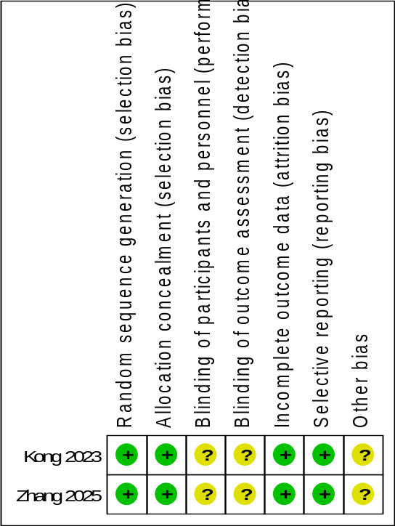
Fig. 1 Assessment of publication bias for the Cochrane Risk of Bias tool
Two randomized controlled trials (RCTs) demonstrated a low risk of bias in the domains of randomization, allocation concealment, outcome completeness, and selective reporting. However, an unclear risk of bias was noted in the domains of blinding and other biases.

Supplementary S3: Quality assessment Form
Table. 1 Quality assessment of cohort studies using the Newcastle–Ottawa Scale (NOS)
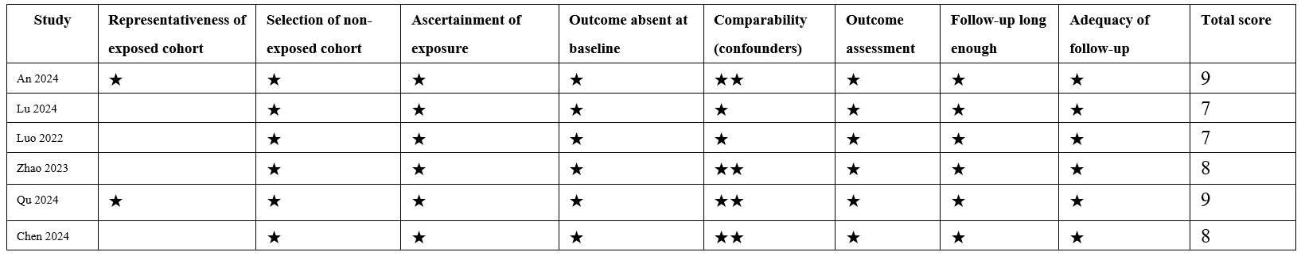
This table presents the quality assessment of included cohort studies using the NOS

Supplementary S4: GRADE Summary of Findings for Key Outcomes
Table. 2 GRADE certainty of evidence for the key efficacy outcomes
Outcome | Studies, n | Participants, n | Pooled effect | Certainty of evidence | Main considerations
Disease control rate | 5 | 299 | RR = 1.38, 95% CI: 1.05–1.82 | Low ⨁⨁◯◯ | Evidence was derived predominantly from retrospective cohort studies. Statistical heterogeneity was low to moderate (I² = 32%), and the confidence interval did not indicate serious imprecision.
Objective response rate | 4 | 307 | RR = 1.81, 95% CI: 1.15–2.85 | Low ⨁⨁◯◯ | Evidence was derived predominantly from retrospective studies and was downgraded for imprecision because of the limited number of response events.
Progression-free survival | 6 | 405 | HR = 0.57, 95% CI: 0.37–0.87 | Very low ⨁◯◯◯ | Evidence was derived predominantly from retrospective studies and was downgraded for serious inconsistency because of substantial statistical heterogeneity (I² = 66%) and clinical variation in treatment regimens and patient characteristics.
Overall survival | 6 | 896 | HR = 0.73, 95% CI: 0.54–1.00 | Very low ⨁◯◯◯ | Evidence was derived predominantly from retrospective studies and was downgraded for serious imprecision. The confidence interval reached the null value, the P value was borderline, and sensitivity analyses indicated that statistical significance was dependent on study composition.
Note. Effect estimates compare combination therapy with regorafenib monotherapy; RR > 1 for response outcomes and HR < 1 for time-to-event outcomes favor combination therapy. Certainty of evidence was assessed according to the GRADE framework and categorized as high, moderate, low, or very low. Because the evidence base was predominantly composed of retrospective cohort studies and randomized evidence was limited, the initial certainty was rated as low and was further downgraded for serious inconsistency or imprecision, where applicable. Publication bias was not formally assessed because fewer than 10 studies contributed to each outcome. ⨁⨁◯◯, low certainty; ⨁◯◯◯, very low certainty. CI, confidence interval; DCR, disease control rate; GRADE, Grading of Recommendations Assessment, Development and Evaluation; HR, hazard ratio; ORR, objective response rate; OS, overall survival; PFS, progression-free survival; RR, risk ratio.

Supplementary S5. Subgroup analysis
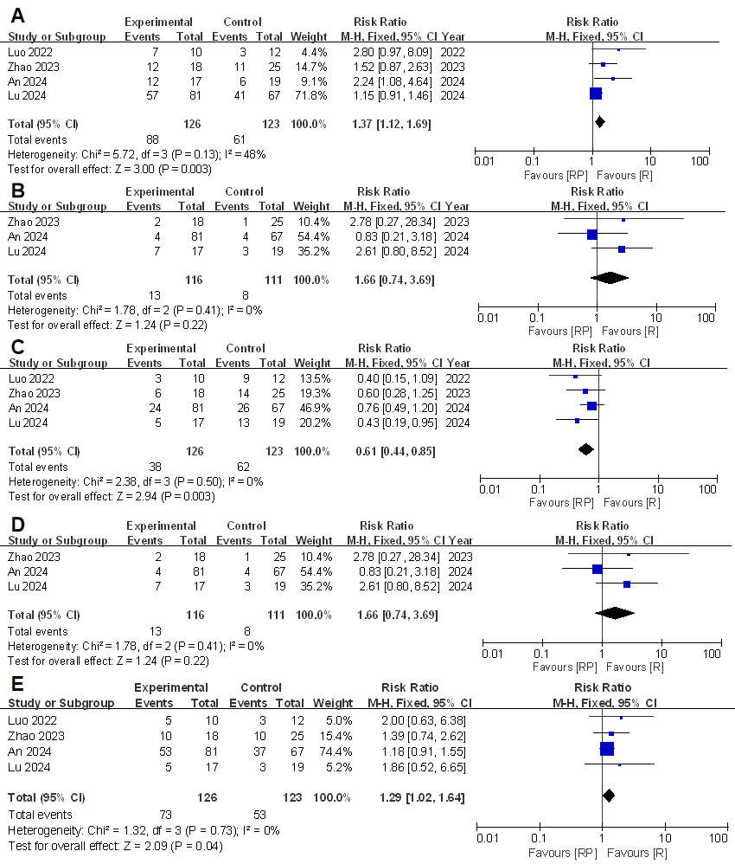
Fig. 2 Forest plot: (A) Disease control rate (DCR); (B) Objective response rate (ORR); (C) Progressive disease (PD); (D) Partial response (PR); (E) Stable disease (SD).
In patients with MSS metastatic colorectal cancer, regorafenib combined with PD-1/PD-L1 inhibitors can improve disease control rate (RR=1.37, 95% CI: 1.12–1.69, P=0.003) and disease stabilization rate (RR=1.29, 95% CI: 1.02–1.64, P=0.04), and reduce the risk of disease progression (RR=0.61, 95% CI: 0.44–0.85, P=0.003), while the objective response rate (RR=1.66, 95% CI: 0.74–3.69, P=0.22) shows no statistically significant difference.

Supplementary S6. Prognostic factor analysis for overall survival
Table. 3 Prognostic factor analysis for overall survival
 | Analysis of OS
Factor | NO. | HR {95%CI} | P
Liver metastasis | 2 | 1.54[1.15,2.08] | 0.004

Supplementary 7: Grade ≥3 treatment-related adverse events
Table. 4 Study-level incidence of grade ≥3 treatment-related adverse events
Study | Toxicity grading system | Treatment group | Patients, n | Grade ≥3 hypertension, n/N (%) | Grade ≥3 HFSR, n/N (%) | Grade ≥3 liver toxicity, n/N (%) | Other reported grade ≥3 events (%)
Luo 2022 | [CTCAE version/NR] | Combination | 10 | 0.00 | 10.00 | 20.00 | 40.00
 |  | Regorafenib | 12 | 0.00 | 8.33 | 0.00 | 41.67
Lu 2024 |  | Combination | 17 | 0.00 | 17.65 | 0.00 | 11.76
 |  | Regorafenib | 19 | 0.00 | 0.00 | 0.00 | 26.32
Zhao 2023 |  | Combination | 20 | 0.00 | 5.00 | 0.00 | 0.00
 |  | Regorafenib | 26 | 0.00 | 0.00 | 3.85 | 7.69
Chen2024 |  | Combination | 30 | 16.67 | 16.67 | 3.33 | 36.67
 |  | Regorafenib | 43 | 4.65 | 6.98 | 0.00 | 20.93
An2024 |  | Combination | 81 | 1.23 | 3.70 | 9.88 | 7.41
 |  | Regorafenib | 67 | 2.99 | 7.46 | 7.46 | 11.94
Values are study-level incidences. Percentages were calculated using the number of patients evaluable for safety in each treatment arm. "Other reported grade ≥3 events" includes additional grade ≥3 treatment-related adverse events reported by the original study; event definitions and reporting may differ across studies. Owing to incomplete arm-specific reporting and clinical heterogeneity, these data are presented descriptively and were not quantitatively pooled. CTCAE, Common Terminology Criteria for Adverse Events; HFSR, hand-foot skin reaction; NR, not reported.

Supplementary 8: Sensitivity Analysis Diagram
Table. 5 Leave-one-out sensitivity analyses for OS
Outcome | Study omitted | Studies remaining, n | Model | Effect measure | Pooled effect | 95% CI | P value | I² (%)
Overall survival rate | Luo 2022 | 5 | Random | HR | 0.70 | 0.49–1.0 | 0.05 | 52
Overall survival rate | An 2024 | 5 | Fixed | HR | 0.72 | 0.60–0.86 | 0.0004 | 19
Overall survival rate | Chen 2024 | 5 | Random | HR | 0.78 | 0.56–1.09 | 0.14 | 46
Overall survival rate | Lu 2024 | 5 | Fixed | HR | 0.77 | 0.64–0.92 | 0.004 | 37
Overall survival rate | Qu 2024 | 5 | Random | HR | 0.71 | 0.44–1.14 | 0.16 | 54
Overall survival rate | Zhang 2025 | 5 | Random | HR | 0.76 | 0.51–1.13 | 0.18 | 51
Each row represents a leave-one-out sensitivity analysis in which the indicated study was omitted and the pooled overall survival estimate was recalculated using the model shown. An HR < 1 favors the combination group. CI, confidence interval; HR, hazard ratio; I², inconsistency statistic; OS, overall survival.

Fig. 3 Leave-one-out sensitivity analyses for progression-free survival (A) PFS (B) OS.
Note: After excluding the study by AN 2024, heterogeneity was significantly reduced, with I2 decreasing to 0% for PFS and 19% for OS, respectively.

Fig. 4 Sensitivity analysis excluding randomized controlled trials (RCTs) and including only retrospective cohort studies.
(A) Disease control rate (DCR). (B) Objective response rate (ORR). (C) Progressive disease (PD). (D) Partial response (PR). (E) Stable disease (SD).

Fig. 5 Sensitivity analysis excluding RCTs and including only retrospective cohort studies for survival outcomes.
(A) Progression-free survival (PFS). (B) Overall survival (OS). (C) 6-month PFS rate. (D) 1-year PFS rate. (E) 1-year OS rate.

Fig. 6 Forest plots of tumor response outcomes in the sensitivity analysis restricted to studies reporting MSI/MMR status.
Studies that did not report microsatellite instability or mismatch repair status were excluded from this analysis. The assessed outcomes were: (A) disease control rate; (B) objective response rate; (C) progressive disease; (D) partial response; and (E) stable disease. CI, confidence interval; DCR, disease control rate; M-H, Mantel-Haenszel; MMR, mismatch repair; MSI, microsatellite instability; ORR, objective response rate; PD, progressive disease; PR, partial response; R, regorafenib monotherapy; RP, regorafenib plus PD-1/PD-L1 inhibitors; RR, risk ratio; SD, stable disease.

Fig. 7 Forest plots of survival outcomes in the sensitivity analysis restricted to studies reporting MSI/MMR status.
Studies that did not report microsatellite instability or mismatch repair status were excluded from this analysis. The assessed outcomes were: (A) progression-free survival; (B) overall survival; and (C) 1-year overall survival rate. CI, confidence interval; HR, hazard ratio; IV, inverse variance; M-H, Mantel-Haenszel; MMR, mismatch repair; MSI, microsatellite instability; OS, overall survival; PFS, progression-free survival; R, regorafenib monotherapy; RP, regorafenib plus PD-1/PD-L1 inhibitors; RR, risk ratio.

Supplementary S9: Publication bias analysis
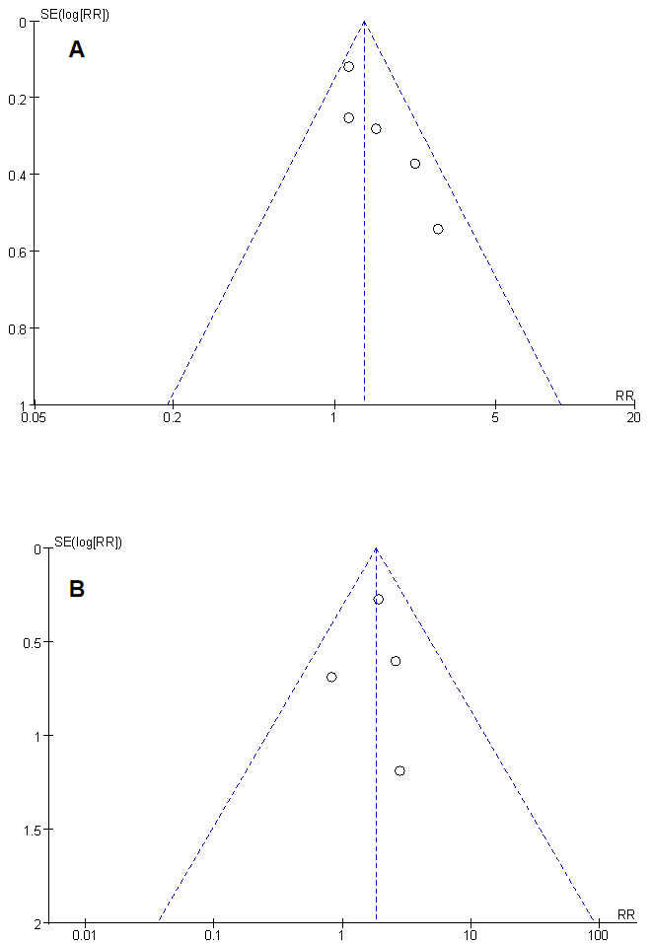
Fig. 8 Funnel plots assessing publication bias in the meta-analysis.
(A) Funnel plot of DCR for studies evaluating the efficacy of regorafenib combined with PD-1/PD-L1 inhibitors in metastatic colorectal cancer.
(B) Funnel plot of ORR for the same included studies. Each point represents an individual study; the dashed lines indicate the pseudo 95% confidence limits, and the vertical line represents the pooled effect estimate.

