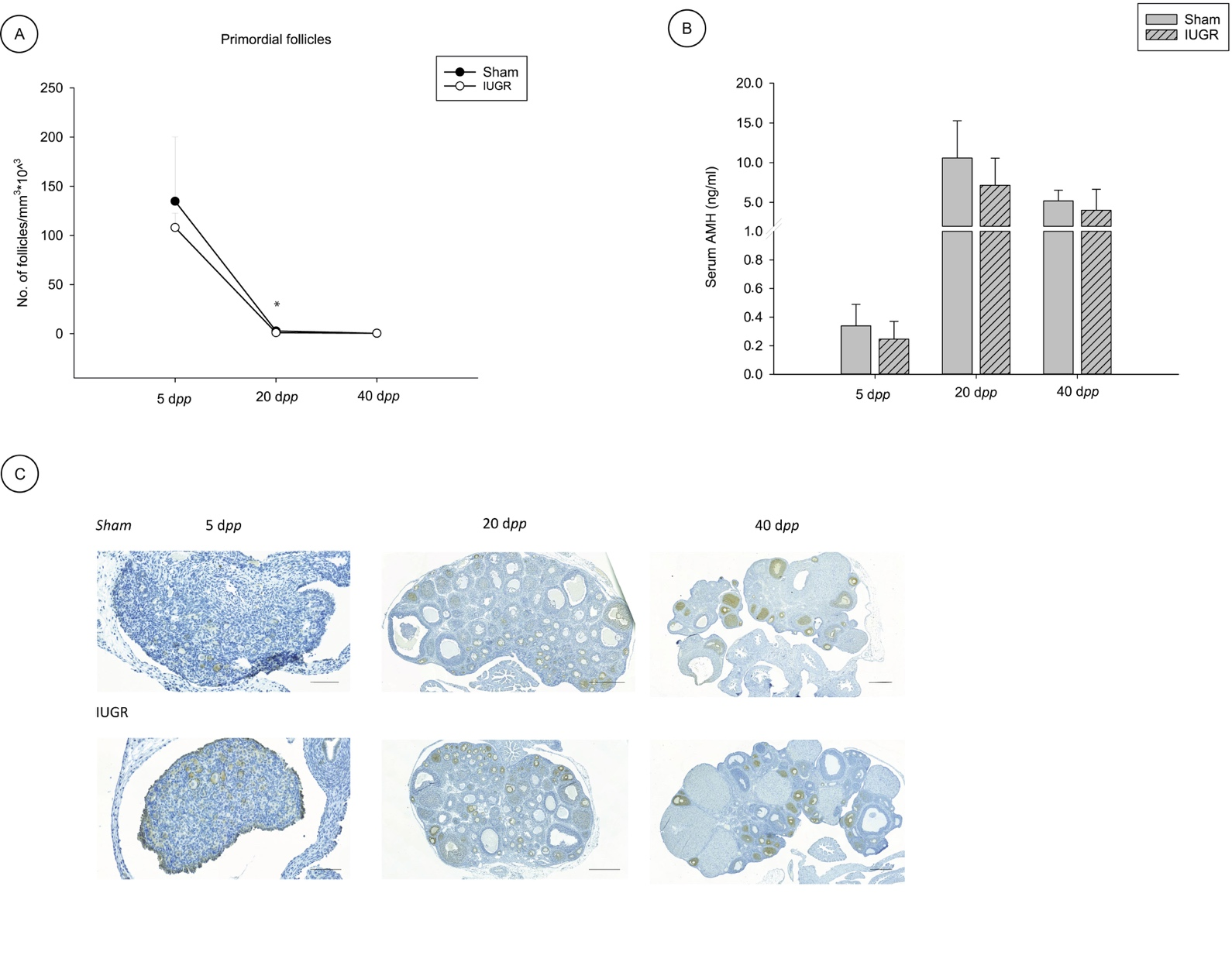

Figure S1. A) Density of primordial follicles in intrauterine growth restricted (IUGR) and sham rats at 5, 20 and 40 days post-partum (dpp). Student T-test, * P < 0.05. B) Serum levels of anti-Müllerian hormone (AMH) (ng/ml) in IUGR and sham rats at 5, 20 and 40 dpp. At 5 dpp 4 and 7 animals were included in the sham and IUGR group, respectively. At 20 dpp 6 animals were included in each group. At 40 dpp 2 and 6 animals were included in the sham and IUGR group, respectively. C) Immunohistochemical images of AMH in two representative sections for each age (5, 20 and 40 dpp) in ovaries from IUGR and sham rats. Scale bars correspond to 100 µm for 5 dpp animals and to 500 µm for 20 and 40 dpp animals.

