Supplementary file 1
Quality assessment
Author | SELECTION |  |  |  | COMPARABILITY | Outcome |  | Total scores
Author | Representativeness of the samples | Sample size | Non-responders | Ascertainment of the exposure (risk factor) | A: study controls for age and/or BMI  B: control for any additional factor | Assessment of the outcome  a) Independent blind assessment. **  b) Record linkage. **  c) Self report. * | Statistical test | Total scores
Chang, 2011 | * | * | - | * | ** | ** | * | 8
Lo, 2006 | * | - | - | * | ** | ** | * | 7
Okoroh, 2015 | * | * | * | * | * | ** | * | 8
Sirmans, 2014 | * | * | - | * | - | ** | * | 6
Chang, 2016 | - | - | - | * | * | ** | * | 5
Vrbíková, 2003 | - | - | * | * | - | ** | * | 5
Gateva, 2012 | - | - | - | * | - | ** | * | 4
Li, 2013 | * | * | * | * | - | ** | * | 7
Ramezani Tehrani, 2011 | * | * | * | * | - | ** | * | 7
Ramezani Tehrani, 2014 | * | * | * | * | * | ** | * | 8
Marchesan, 2019 | * | - | * | * | * | ** | * | 7
Table S1. Quality assessment of included studies using the Newcastle–Ottawa Quality Assessment Scale for cross-sectional studies.

 | SELECTION |  |  |  | COMPARABILITY | Outcome |  |  | Total scores
Author | Representativeness of the exposed cohort | Selection of the non-exposed cohort | Ascertainment of exposure | No outcome of interest at start of study | A: Study controls for age and/or BMI  B: Study controls for other confounders | A: doctor’s diagnosis OR objective measurements  B: parent/self-reported doctor’s diagnosis OR use of medication | follow-up long enough for outcomes ( at least 10 year) | Adequacy of follow up of cohorts | Total scores
Calderon-Margalit, 2014 | * | * | * | * | ** | * | * | * | 9
Ding, 2018 | * | * | * | * | ** | * | * | * | 9
Glintborg, 2015 | * | * | * | * | - | * | - | - | 5
Hart, 2014 (98) | * | * | * | * | - | * | * | * | 7
Merz, 2016 | * | * | * | * | - | * | * | * | 7
Meun, 2018 | * | * | * | * | ** | * | * | * | 9
Wild, 2000 | * | * | * | * | - | * | * | * | 7
Dahlgren, 1992 | * | - | * | * | - | * | * | * | 6
Iftikhar, 2012 | * | - | * | * | ** | * | * | * | 8
Lunde, 2007 | * | - | * | * | - | * | * | * | 6
Schmidt, 2011 | * | - | * | * | - | * | * | * | 6
Shi, 2014 | * | * | * | * | - | * | - | - | 5
Bird, 2012 | * | * | * | * | - | * | - | - | 5
Ramezani Tehrani, 2015 | * | * | * | * | ** | * | * | * | 9
Behboudi Gandevani, 2018 | * | * | * | * | ** | * | * | * | 9
Table S2. Quality assessment of included studies using the Newcastle–Ottawa Quality Assessment Scale for cohort studies.

Table S3. Quality assessment of included studies using the Newcastle–Ottawa Quality Assessment Scale for case-control studies.
First author, year  (reference) | SELECTION |  |  |  | COMPARABILITY | EXPOSURE |  |  | Total scores
First author, year  (reference) | adequate case definition | Representativeness of the cases | Community selection of controls | no history of disease among controls | A: study controls for age and/or BMI  B: study control for any additional factors | A: secure record for clinical outcome  B: structured interview where blind to case/control status | Same method of ascertainment for cases and controls | Same Non-response rate for cases and controls | Total scores
Chan, 2013 | * | * | - | * | - | * | * | - | 5
Haakova, 2003 | * | * | - | * | - | * | * | - | 5
Shroff , 2007 | * | * | - | * | - | * | * | * | 6
Luque-Ramirez, 2007 | * | * | - | * | - | * | * | * | 6

Risk of bias
Figure S1. Risk of bias in cross-sectional and case- control studies.
Study design | First author, date | Bias in assessment of exposure | Bias in development of outcome of interest in case and controls | Bias in selection of cases | Bias in selection of controls | Bias in control of prognostic variable (without case and control matching or adjustment in statistical methods )
cross-sectional | Chang, 2011
cross-sectional | Lo, 2006
cross-sectional | Okoroh, 2015
cross-sectional | Sirmans, 2014
cross-sectional | Chang, 2016
cross-sectional | Vrbíková, 2003
cross-sectional | Li, 2013
cross-sectional | Gateva, 2012
cross-sectional | Ramezani Tehrani, 2011
cross-sectional | Ramezani Tehrani, 2014
cross-sectional | Marchesan, 2019
case-control | Chan, 2013
case-control | Haakova, 2003
case-control | Shroff , 2007
case-control | Luque-Ramirez, 2007

Definitely No (low risk of bias) probably no

Definitely yes (high risk of bias) probably Yes

A.

B.

Figure S2. Risk of bias in cohort studies.
A.
Author, date | Bias in selection of exposed and non‐exposed cohorts | Bias in assessment of exposure | Bias in present of outcome of interest at start of study | Bias in control of prognostic variables (with matching or adjusting) | Bias in in the assessment of the presence or absence of prognostic factors | Bias in in the assessment of outcome | Bias in adequacy about follow up of cohorts
Ding, 2018
Calderon-Margalit, 2014
Glintborg, 2015
Hart, 2014
Merz, 2016
Meun, 2018
Wild, 2000
Dahlgren, 1992
Iftikhar, 2012
Lunde, 2007
Schmidt, (2011)
Shi, 2014
Bird, 2012
Ramezani Tehrani, 2015
Behboudi Gandevani, 2018

Definitely No (low risk of bias) probably no

Definitely yes (high risk of bias) probably Yes

B.

Figure S3. Sensitivity analysis for RR in reproductive age group for all studies.
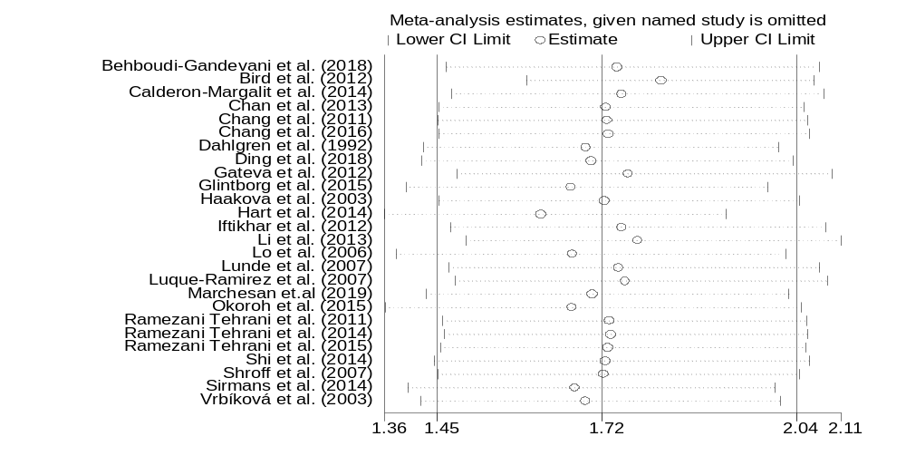

Table S4. sensitivity analysis for RR in reproductive age group for all studies.
Study omitted | Estimate [95% Conf. Interval]
Behboudi-Gandevani et al. (2018)| 1.7438776 1.4631997 2.0783963
Bird et al. (2012)| 1.8163466 1.5948005 2.0686698
Calderon-Margalit et al. (2014)| 1.7517917 1.4715889 2.0853477
Chan et al. (2013)| 1.7252944 1.4503318 2.0523858
Chang et al. (2011)| 1.7273015 1.4492077 2.0587597
Chang et al. (2016)| 1.7294208 1.4510241 2.0612314
Dahlgren et al. (1992)| 1.6926078 1.424938 2.0105584
Ding et al. (2018)| 1.7009031 1.4226078 2.0336394
Gateva et al. (2012)| 1.7626334 1.480405 2.0986667
Glintborg et al. (2015)| 1.667802 1.3956908 1.9929655
Haakova et al. (2003)| 1.722587 1.4507524 2.0453565
Hart et al. (2014)| 1.6180612 1.3608732 1.9238546
Iftikhar et al. (2012)| 1.7519197 1.4696397 2.0884185
Li et al. (2013) | 1.7781277 1.4952075 2.1145813
Lo et al. (2006) | 1.6705562 1.3799804 2.0223169
Lunde et al. (2007)| 1.7465718 1.4672309 2.0790954
Luque-Ramirez et al. (2007)| 1.7580776 1.4777819 2.091538
Marchesan et.al (2019)| 1.7026174 1.4301388 2.0270104
Okoroh et al. (2015)| 1.6700399 1.3616711 2.0482428
Ramezani Tehrani et al. (2011)| 1.7311074 1.4567262 2.0571694
Ramezani Tehrani et al. (2014)| 1.7339586 1.4601969 2.059046
Ramezani Tehrani et al. (2015)| 1.7283132 1.4528985 2.0559361
Shi et al. (2014) | 1.7245083 1.4427273 2.0613244
Shroff et al. (2007)| 1.7211879 1.4489206 2.0446172
Sirmans et al. (2014)| 1.6747276 1.399421 2.004195
Vrbíková et al. (2003)| 1.6920248 1.4211771 2.0144906
-------------------+----------------------------------------------------------
Combined | 1.7192039 1.4484419 2.0405803

Figure S4. Sensitivity analysis for RR in menopause aging group for all studies.

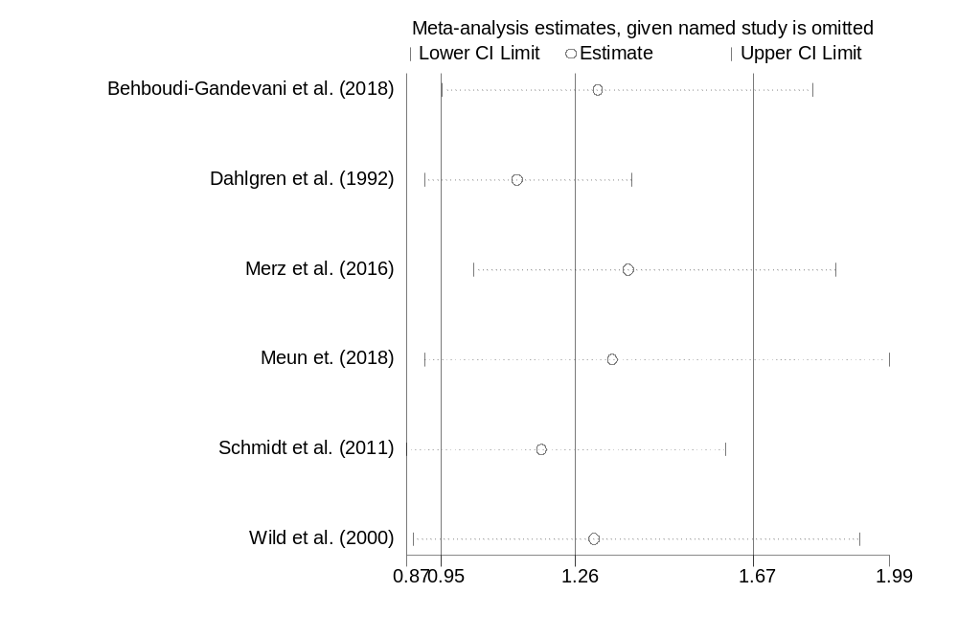

Table S5. Sensitivity analysis for RR in menopause aging group for all studies.
------------------------------------------------------------------------------
Study omitted | Estimate [95% Conf. Interval]
-------------------+----------------------------------------------------------
Behboudi-Gandevani et al. (2018)| 1.3151557 .95511866 1.8109109
Dahlgren et al. (1992)| 1.1271049 .91285157 1.3916451
Merz et al. (2016)| 1.3841956 1.0279515 1.8638988
Meun et. (2018) | 1.3481351 .91374004 1.9890431
Schmidt et al. (2011)| 1.1852014 .87225527 1.6104256
Wild et al. (2000)| 1.3050203 .88736391 1.9192555
-------------------+----------------------------------------------------------
Combined | 1.2624501 .95244965 1.6733485
------------------------------------------------------------------------------

Figure S5. Sensitivity analysis for Prevalence in patients with PCOS of reproductive ages.

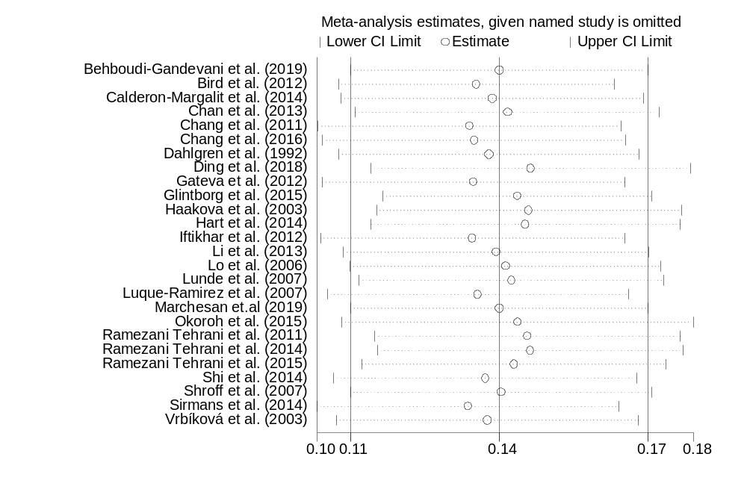

Table S6. Sensitivity analysis for Prevalence in patients with PCOS in reproductive ages.
------------------------------------------------------------------------------
Study omitted | Estimate [95% Conf. Interval]
-------------------+----------------------------------------------------------
Behboudi-Gandevani et al. (2019)|.13882443.10768192.16996695
Bird et al. (2012)| .13402987 .10511241 .16294733
Calderon-Margalit et al. (2014)|.13738079.10572061.16904098
Chan et al. (2013)| .1405253 .10868426 .17236634
Chang et al. (2011)| .13263194 .10089932 .16436456
Chang et al. (2016)| .13359208 .10187376 .16531041
Dahlgren et al. (1992)|.13662526 .10523987 .16801064
Ding et al. (2018)| .1454097 .11199498 .17882441
Gateva et al. (2012)| .13343471 .10178331 .16508612
Glintborg et al. (2015)|.14260861 .11446112 .17075612
Haakova et al. (2003)|.14502619 .11309789 .17695449
Hart et al. (2014)| .14434238 .11196198 .17672278
Iftikhar et al. (2012)|.13321559 .10140928 .1650219
Li et al. (2013) | .13813789 .10620543 .17007037
Lo et al. (2006) | .14011283 .10756706 .17265861
Lunde et al. (2007)| .1413971 .10952041 .1732738
Luque-Ramirez et al. (2007)|.13435052.10286281 .16583823
Marchesan et.al (2019)|.13882443 .10768192 .16996695
Okoroh et al. (2015)| .14271627 .10586881 .17956375
Ramezani Tehrani et al. (2011)|.14476731.11281621 .17671841
Ramezani Tehrani et al. (2014)|.14531368.1133662 .17726114
Ramezani Tehrani et al. (2015)|.14191486.11006496 .17376475
Shi et al. (2014) | .13594127 .10417929 .16770324
Shroff et al. (2007)| .13919833 .10763681 .17075987
Sirmans et al. (2014)|.13232347 .10068957 .1639574
Vrbíková et al. (2003)|.13633762 .10472579 .16794947
-------------------+----------------------------------------------------------
Combined | .13882443 .10768191 .16996694
------------------------------------------------------------------------------

Figure S6. Sensitivity analysis for Prevalence in patients with PCOS in menopause aging group.
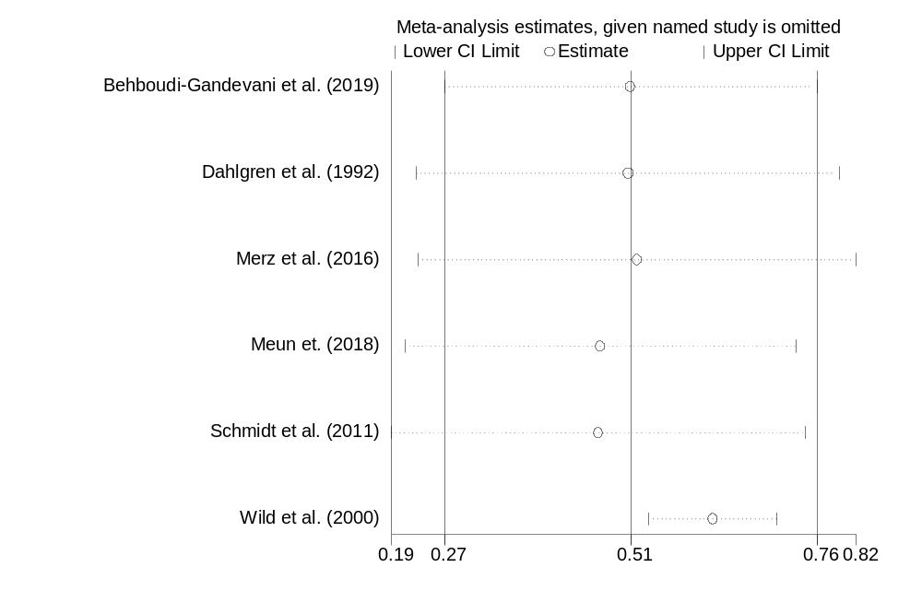
Table S7. Sensitivity analysis for Prevalence in patients with PCOS in menopause aging group.
------------------------------------------------------------------------------
Study omitted | Estimate [95% Conf. Interval]
-------------------+----------------------------------------------------------
Behboudi-Gandevani et al. (2019)|.51420444.26584604.76256281
Dahlgren et al. (1992)|.51026291 .22779246 .79273337
Merz et al. (2016)| .52284539 .23031107 .81537974
Meun et. (2018) | .47367305 .21294805 .73439807
Schmidt et al. (2011)|.47078729 .1944975 .74707705
Wild et al. (2000)| .62384993 .53844118 .70925862
-------------------+----------------------------------------------------------
Combined | .51420442 .26584603 .7625628
------------------------------------------------------------------------------

Figure S7. Sensitivity analysis for Prevalence in healthy controls of reproductive ages.
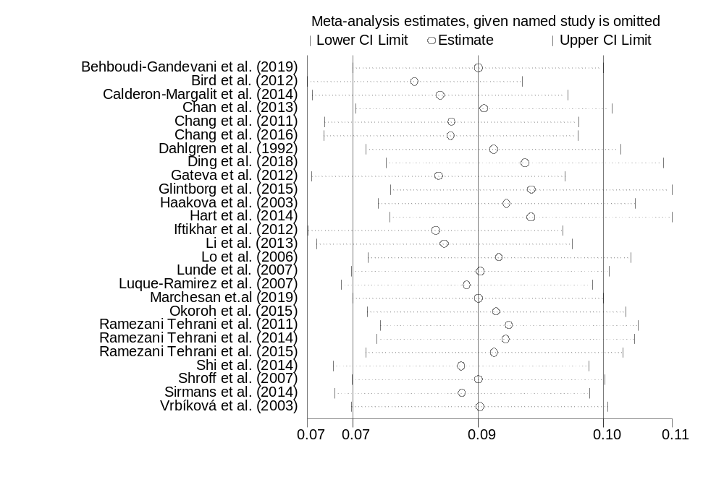
Table S8. Sensitivity analysis for Prevalence in healthy control of reproductive ages.

------------------------------------------------------------------------------
Study omitted | Estimate [95% Conf. Interval]
-------------------+----------------------------------------------------------
Behboudi-Gandevani et al. (2019)|.08524524.07134463.09914585
Bird et al. (2012)| .07824372 .06631624 .0901712
Calderon-Margalit et al. (2014)|.08103725.06686623.09520828
Chan et al. (2013)| .08589393 .07173926 .10004859
Chang et al. (2011)| .08233398 .06825068 .09641728
Chang et al. (2016)| .08223884 .0681367 .09634098
Dahlgren et al. (1992)|.0869493 .07281358 .10108502
Ding et al. (2018)| .09043039 .07504443 .10581635
Gateva et al. (2012)| .08085126 .06683648 .09486604
Glintborg et al. (2015)|.09112757 .07550433 .10675082
Haakova et al. (2003)|.08841346 .07419998 .10262694
Hart et al. (2014)| .0911129 .07544126 .10678453
Iftikhar et al. (2012)|.08055217 .06642903 .0946753
Li et al. (2013) | .08148562 .06735143 .09561982
Lo et al. (2006) | .08759554 .07305969 .10213138
Lunde et al. (2007)| .0854909 .07124943 .09973235
Luque-Ramirez et al. (2007)|.08401233.07008898 .09793567
Marchesan et.al (2019)|.08524524 .07134463 .09914585
Okoroh et al. (2015)| .0872822 .0729471 .10161731
Ramezani Tehrani et al. (2011)|.08869115.07441192 .10297038
Ramezani Tehrani et al. (2014)|.08832135.07405568 .10258701
Ramezani Tehrani et al. (2015)|.08702902.07277189 .10128615
Shi et al. (2014) | .08337203 .069165 .09757907
Shroff et al. (2007)| .08526898 .07128266 .09925531
Sirmans et al. (2014)|.08348458 .06935064 .09761851
Vrbíková et al. (2003)|.0854518 .07124299 .09966063
-------------------+----------------------------------------------------------
Combined | .08524524 .07134463 .09914585
------------------------------------------------------------------------------

Figure S8. Sensitivity analysis for Prevalence in healthy control of menopause aging group.
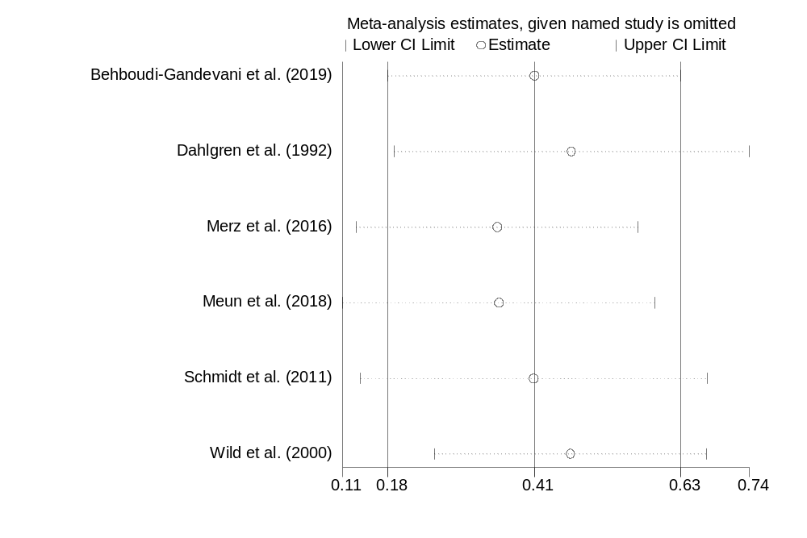
Table S9. Sensitivity analysis for Prevalence in healthy control of menopause aging group.

------------------------------------------------------------------------------
Study omitted | Estimate [95% Conf. Interval]
-------------------+----------------------------------------------------------
Behboudi-Gandevani et al. (2019)|.40640807.18044683.63236928
Dahlgren et al. (1992)|.4641901 .18987897 .73850125
Merz et al. (2016)| .34890303 .1314237 .56638235
Meun et al. (2018)| .35157928 .11043011 .5927285
Schmidt et al. (2011)|.40541449 .13798599 .67284304
Wild et al. (2000)| .46239108 .25267416 .67210799
-------------------+----------------------------------------------------------
Combined | .40640807 .18044683 .63236931
------------------------------------------------------------------------------

Figure S9. The result of sensitivity analysis for all age subgroups.
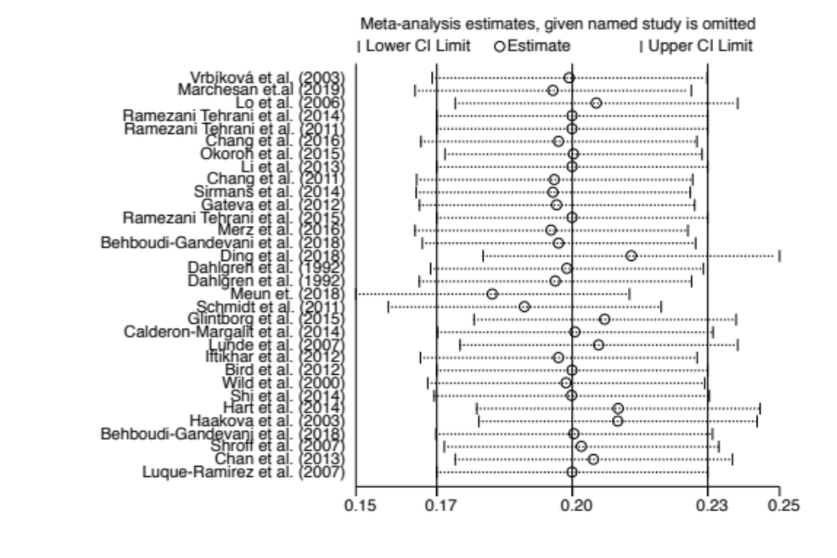

Figure S10. The result of sensitivity analysis for reproductive age subgroup.
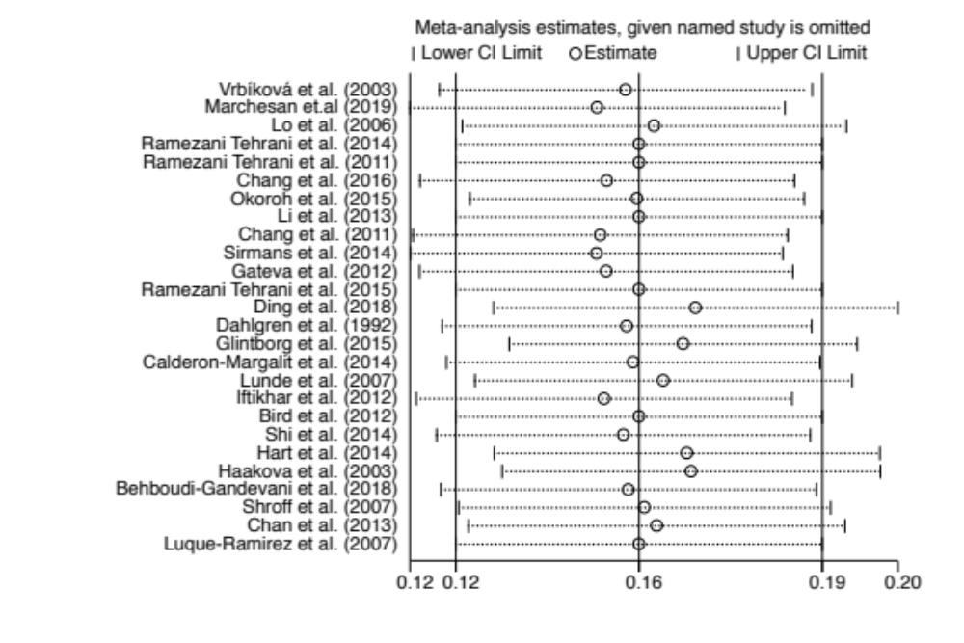

Figure S11. The result of sensitivity analysis for menopause/aging subgroup.
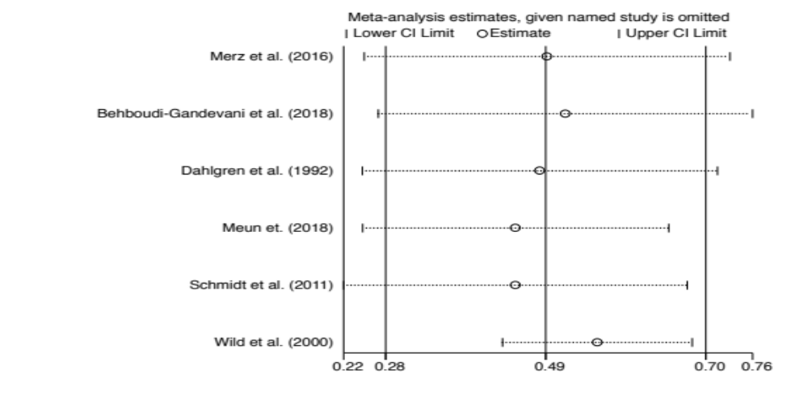

Figure S12. Forest plot of pooled relative risk of HTN for all studies except those with Rotterdam criteria.
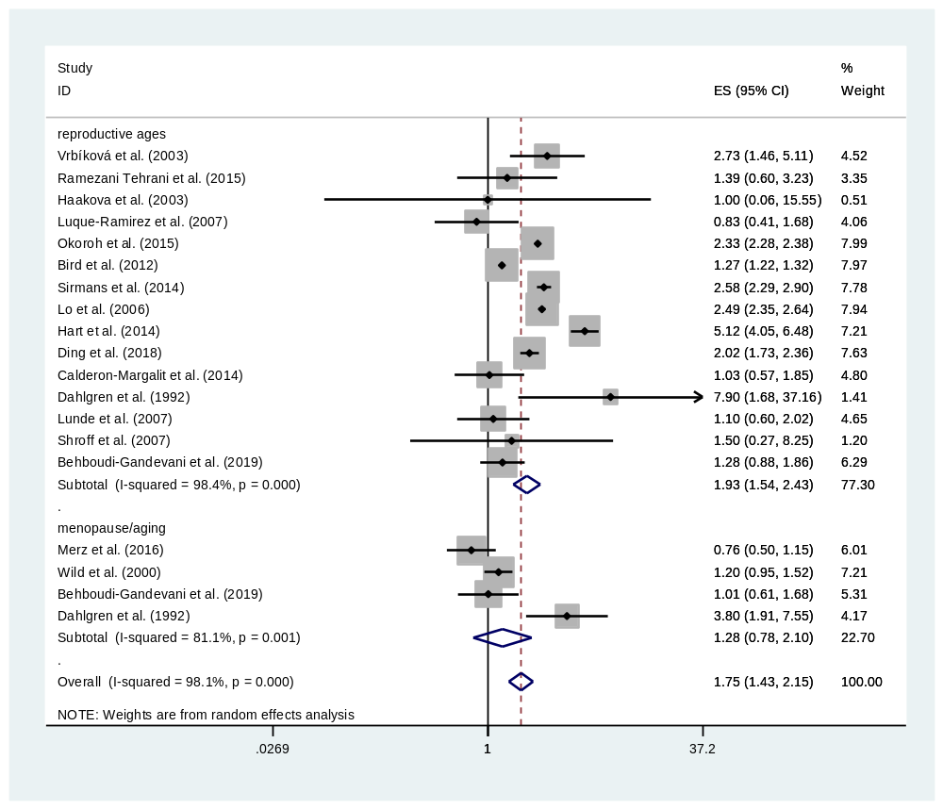

Figure S13. Forest plot of pooled relative risk of HTN for all population based studies except those with Rotterdam criteria.
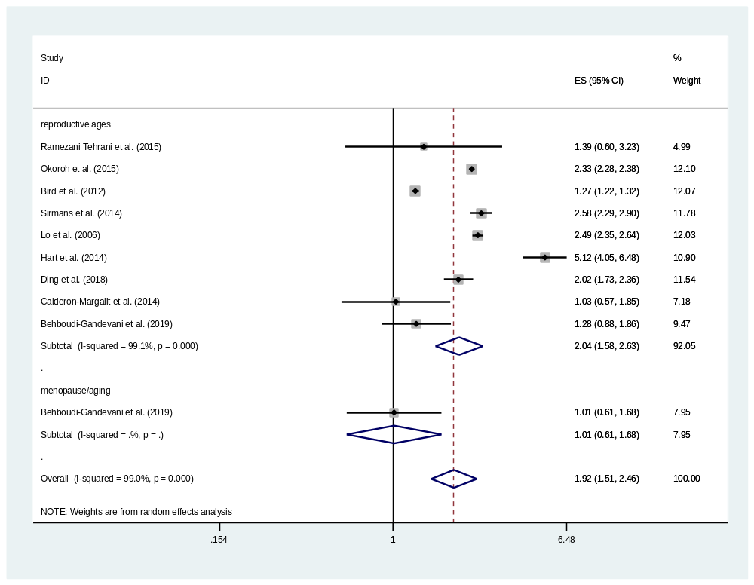

Figure S14. Forest plot of pooled relative risk of HTN for all non-population based studies except those with Rotterdam criteria.
