Supplementary material
1. The full western blots of Figure 8.
(1)The expression of proteins in KGN cell by irisin treatment.
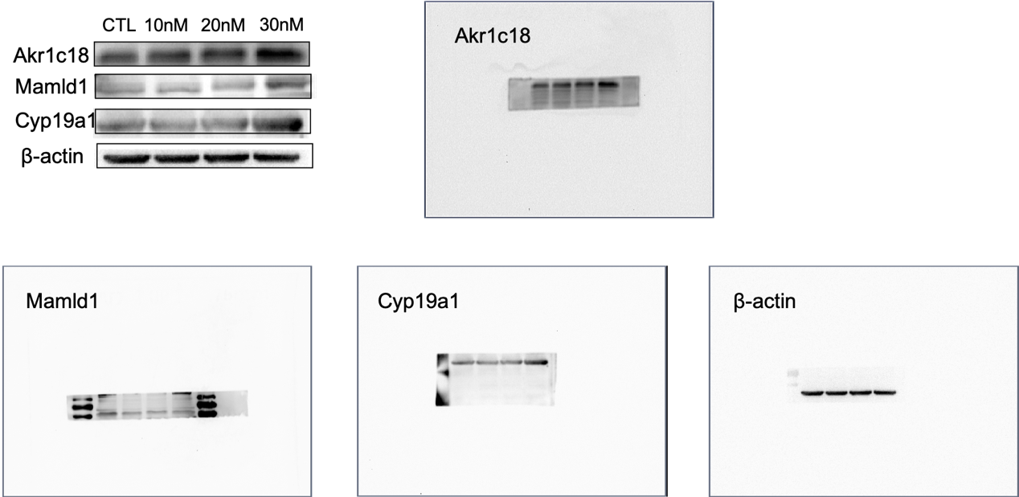

(2) The expression of proteins in KGN cell by Fndc5-siRNA treatment.
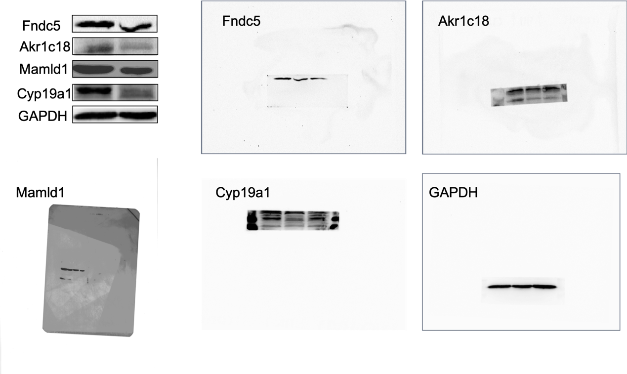

2. Supplementary Figure 1.
