Additional file 1: Supplementary (docx)
- Supplementary Table 1. Satisfaction on usability and quality of life patient questionnaire
- Supplementary Table 2. Adverse events (Study group)

Appendix
Supplementary Table 1. Satisfaction on usability and quality of life patient questionnaire
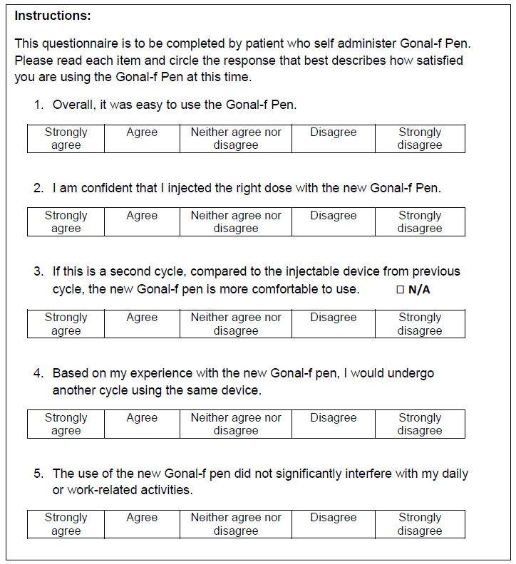

Supplementary Table 2. Adverse events (Study group)
 | Study group (N=1783)
Number of patients with, n (%)  At least one AE  At least one SAE  At least one SAE requiring hospitalization  At least one treatment-related AE  At least one AE leading to study termination  At least one AE leading to death | 89 (5.0)  33 (1.9)  31 (1.7)  26 (1.5)  20 (1.1)  0 (0.0)
Congenital, familial and genetic disorders
Anencephaly | 1 (0.1)
Congenital heart disease | 1 (0.1)
Pulmonary hypoplasia | 1 (0.1)
General disorders and administration site conditions
Cyst | 1 (0.1)
Injury, poisoning and procedural complications
Post-procedural haemorrhage | 1 (0.1)
Pregnancy, puerperium and perinatal conditions
Abortion | 1 (0.1)
Spontaneous abortion | 35 (2.0)
Ectopic pregnancy | 10 (0.6)
Foetal death | 1 (0.1)
Hyperemesis gravidarum | 1 (0.1)
Induced labour | 2 (0.1)
Multiple pregnancy | 1 (0.1)
Premature delivery | 2 (0.1)
Premature labour | 4 (0.2)
Premature rupture of membranes | 1 (0.1)
Stillbirth | 3 (0.2)
Reproductive system and breast disorders
OHSS | 27 (1.5)
Skin and subcutaneous tissue disorders
Dermatitis | 1 (0.1)
Surgical and medical procedures
Selective abortion | 2 (0.1)
Most common SAEs  Ectopic pregnancy  OHSS  Spontaneous abortion | 10 (0.6)  7 (0.4)  6 (0.3)

AE, adverse event; SAE, serious AE; OHSS, ovarian hyperstimulation syndrome.

