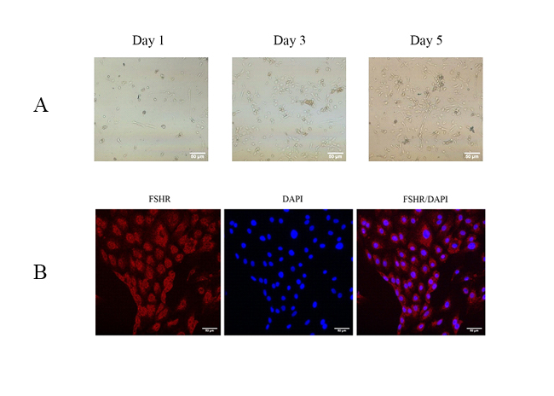
Figure S1 Granulosa cells identification. A Granulosa cells culture (Scale: 50 μm). B Granulosa cells FSHR immunofluorescence staining (red: FSHR staining; blue: DAPI staining). The red fluorescence expression in cytoplasm indicated that the cells were granulosa cells specifically expressing FSHR (Scale: 50 μm).

