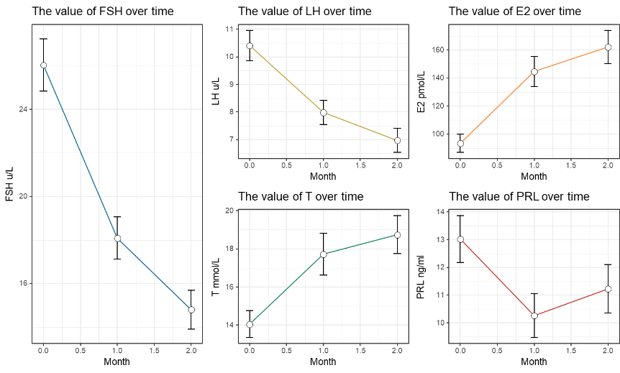
(A)

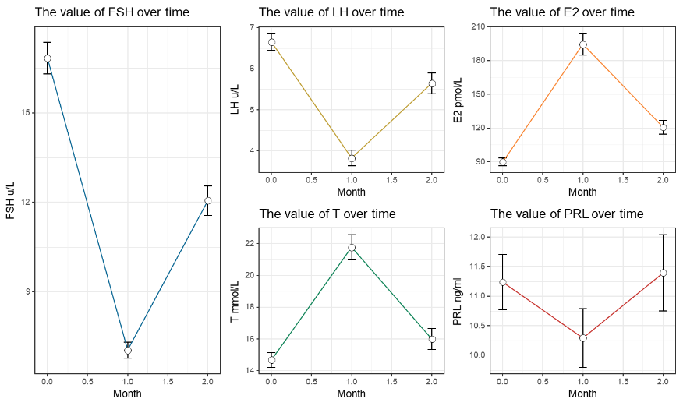

(B)
Supplemental Fig. 1 Follow-up records of sex hormone levels in hCG (A) and hCG plus uFSH (B) treatment groups.
Abbreviations: FSH: Follicle-stimulating hormone; LH, Luteinizing hormone; T, Testosterone; E₂, Estradiol; PRL, Prolactin.

