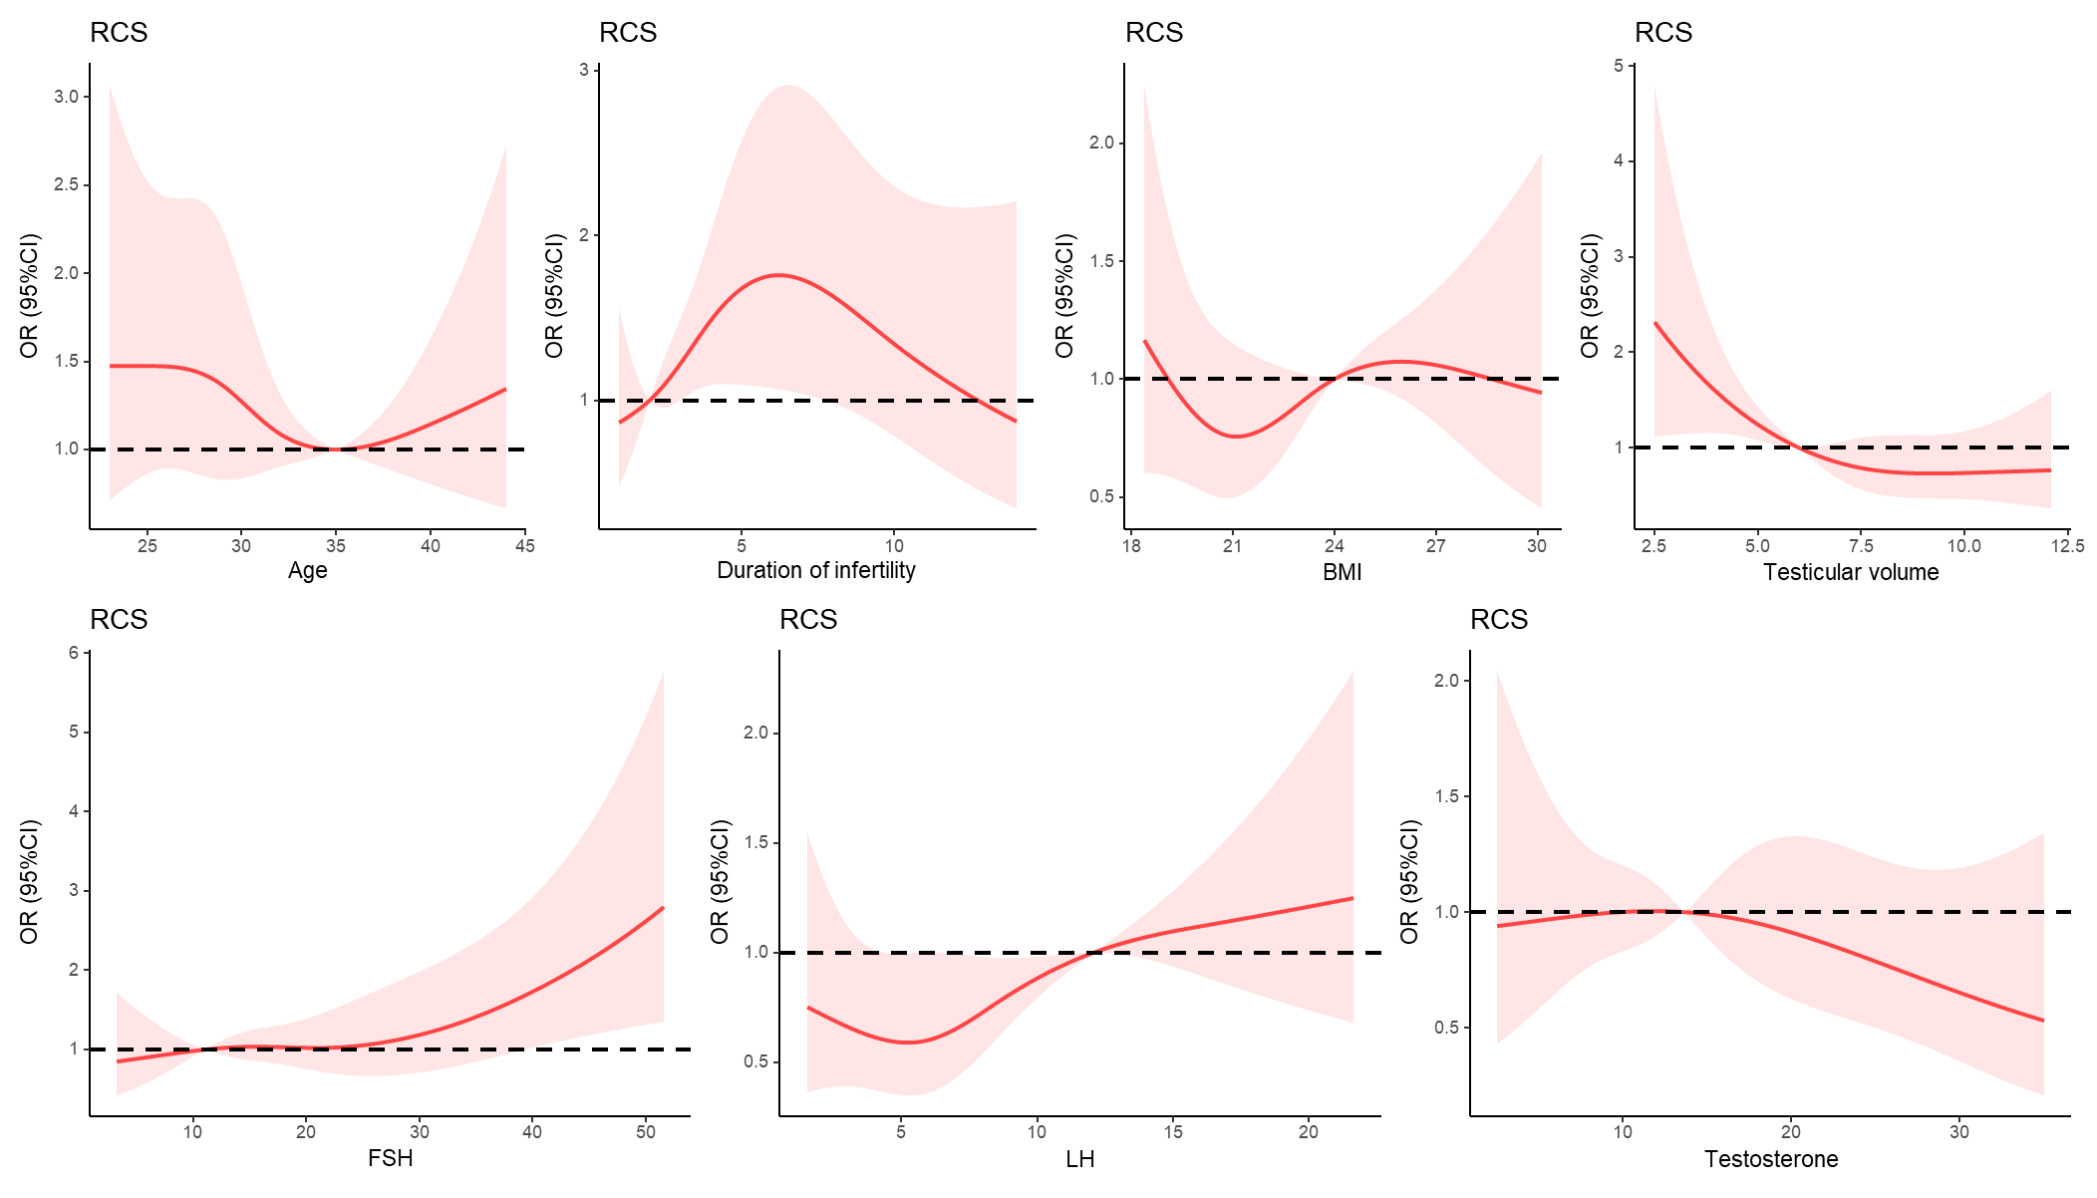
Supplemental Fig. 4 Association of clinical characteristics
with SRR in NOA men.

