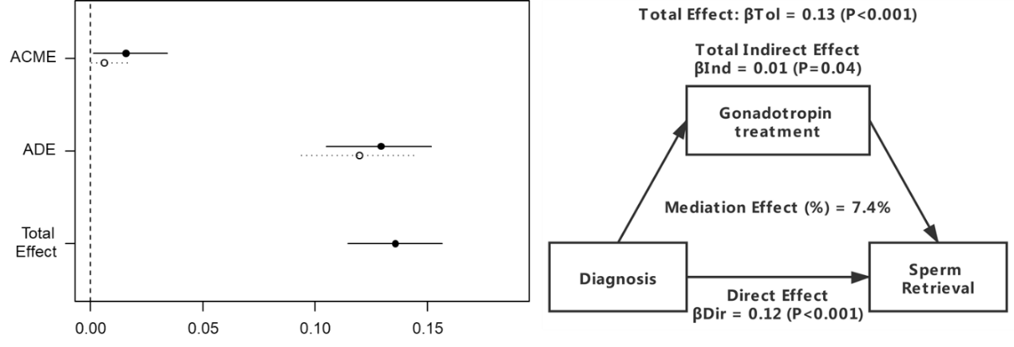
Supplemental Fig. 5 Causal mediation analysis for gonadotropin therapy. The solid line represents the non-idiopathic NOA men, and the dashed line represents the idiopathic NOA.
Abbreviations: ACME: Average causal mediation effects; ADE: Average direct effects. β_{Tot}: Total effect; β_{Ind}: Total indirect; β_{Dir}: Direct effect.

