Supplemental Data
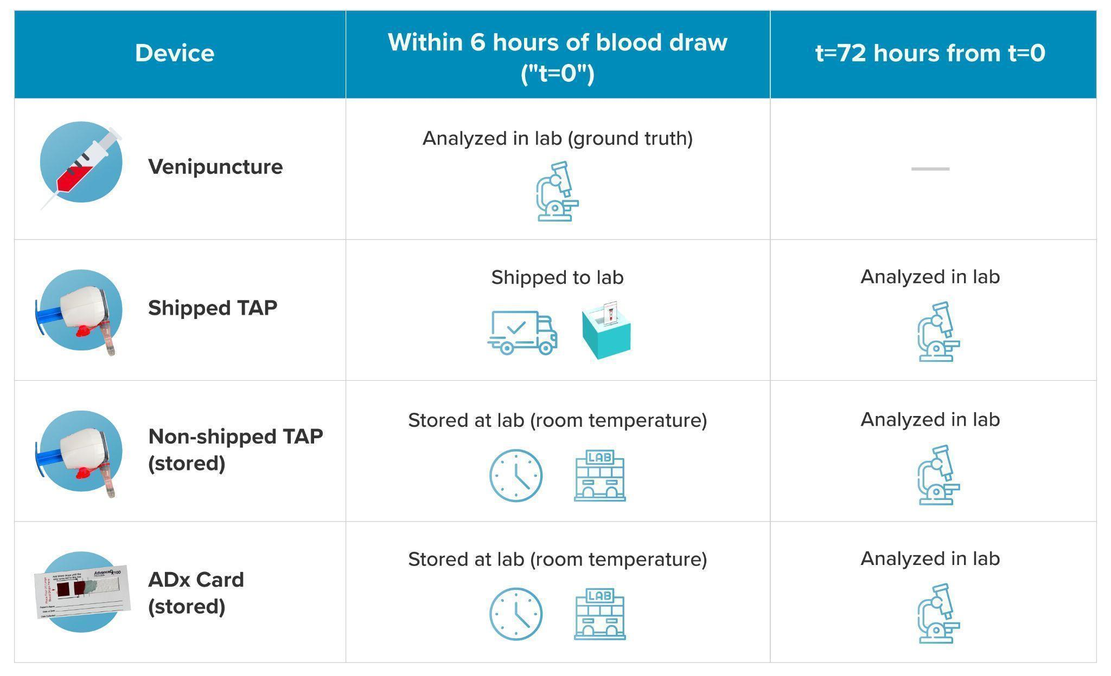
Figure 5: Study Procedure. Head-to-head comparison of study procedure, including timeline and analysis between samples collected via venipuncture, shipped TAP, non-shipped TAP (stored) and ADx Card (stored) at t=0 (within 6 hours of sample collection) and t=72 hours. Note: TAP = TAP II Device

