Supplementary material 4. Funnel plots

Dysmenorrhea

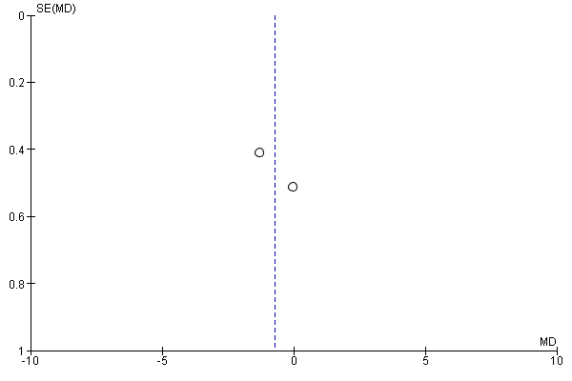

Pelvic Pain

