A Bayesian Network Model for prediction of low or failed fertilization in assisted reproductive technology based on a large clinical real-world data
Running title: Bayesian network model for fertilization failure in IVF
Tian Tian ^{1,2,3,4}, Fei Kong ^{1,2,3,4}, Rui Yang ^{1,2,3,4}, Xiaoyu Long ^{1,2,3,4}, Lixue Chen ^{1,2,3,4}, Ming Li ^{1,2,3,4}, Qin Li ^{1,2,3,4}, Yongxiu Hao ^{1,2,3,4}, Yangbo He ⁵, Yunjun Zhang ⁶, Rong Li ^{1,2,3,4}, Yuanyuan Wang ^{1,2,3,4} *, Jie Qiao ^{1,2,3,4,7,8}*

- Center for Reproductive Medicine, Department of Obstetrics and Gynecology, Peking University Third Hospital
- National Clinical Research Center for Obstetrics and Gynecology (Peking University Third Hospital)
- Key Laboratory of Assisted Reproduction (Peking University), Ministry of Education
- Beijing Key Laboratory of Reproductive Endocrinology and Assisted Reproductive Technology (Peking University Third Hospital)
- School of Mathematical Sciences, LMAM, LMEQF, and Center of Statistical Science, Peking University, Beijing, China
- School of public health, Peking University, Beijing, China
- Beijing Advanced Innovation Center for Genomics, Beijing, China
- Peking-Tsinghua Center for Life Sciences, Peking University, Beijing, China
Correspondence:
Jie Qiao, Ph.D., M.D., Department of Obstetrics and Gynecology, Peking University Third Hospital, China (e-mail: jie.qiao@263.net).
Yuanyuan Wang, Ph.D., Department of Obstetrics and Gynecology, Peking University Third Hospital, China (e-mail: yyuanwang@163.com).

Table S1 The information of involved variables.
 | Predictors | Description
Female
1 | Female age (years) | “≤29”=0; “30-34”=1; “35-37”=2; “38-40”=3; “41-42”=4; “≥43”=5
2 | Female BMI (kg/m²) | “18.5-24.0”= 0; “< 18.5”=1; “24.0-28.0”=2;  "≥ 28" = 3
3 | Gravidity | “0”=0; “1”=1; “≥2”=2
4 | Parity | “0”=0; “≥1”=1
5 | Fallopian tube disorders | "No" = 0; "Yes" = 1
6 | Uterine disorders | "No" = 0; "Yes" = 1
7 | Hyperprolactinemia | "No" = 0; "Yes" = 1
8 | Ovulatory disorders | "No" = 0; "Yes" = 1
9 | Ovarian cyst surgery | "No" = 0; "Yes" = 1
10 | DOR_history | "No" = 0; "Yes" = 1
11 | Endometriosis | "No" = 0; "Yes" = 1
12 | Genetic disorders | "No" = 0; "Yes" = 1
13 | Abnormal gestational history | "No" = 0; "Yes" = 1
Male
14 | Male age | "< 45" = 0；"≥ 45" = 1
15 | Male BMI (kg/m²) | "18.5-24.0" = 0; "< 18.5" = 1; "24.0-28.0" = 2; "≥ 28" = 3
16 | Ejaculatory dysfunction | "No" = 0; "Yes" = 1
17 | Teratozoospermia | "No" = 0; "Yes" = 1
18 | Sperm quality | "Normal" = 0; "Oligoaasthenozoospermia" = 1; "severe oligoaasthenozoospermia" = 2; "azoospermia" = 3
ART Treatment-related
19 | Infertility type | "Secondary" = 0; "Primary" = 1
20 | ART failure history | "No" = 0; "Yes" = 1
21 | Ovulating induction protocol | "Stimulation cycle" = 0; "Minimal-stimulation cycle" = 1; "Natural cycle" = 2
22 | Antral follicle count | ">12" = 0; "5-12" = 1; "<5" = 2
23 | Number of oocytes retrieved | ">20" = 0; "5-20" = 1; "<5" = 2
24 | Insemination method | "ICSI" = 0; "IVF" =1

Table S2 Predictor selection
 |  | Ctrl | LFR | TFF | χ² | P
 |  | N = 97,102 | N = 4,339 | N = 5,199
Female age | ≤29 | 26244 (27.0) | 1221 (28.1) | 994 (19.1) | 1706.4 | <0.001
 | 30-34 | 38326 (39.5) | 1752 (40.4) | 1774 (34.1)
 | 35-37 | 16471 (17.0) | 732 (16.9) | 862 (16.6)
 | 38-40 | 9415 (9.7) | 402 (9.3) | 760 (14.6)
 | 41-42 | 3619 (3.7) | 126 (2.9) | 373 (7.2)
 | ≥43 | 3027 (3.1) | 106 (2.4) | 436 (8.4)
Female BMI (kg/m2) | 18.5-24.0 | 60632 (62.4) | 2680 (61.8) | 3151 (60.6) | 13.197 | 0.012
 | < 18.5 | 7706 (7.9) | 325 (7.5) | 392 (7.5)
 | 24.0-28 | 21297 (21.9) | 968 (22.3) | 1215 (23.4)
 | ≥ 28 | 7467 (7.7) | 366 (8.4) | - (8.5)
Female gravidity | 0 | 57073 (58.8) | 2713 (62.5) | 3176 (61.1) | 13.197 | 0.001
 | 1 | 21560 (22.2) | 916 (21.1) | 1103 (21.2)
 | 2 | 18469 (19.0) | 710 (16.4) | 920 (17.7)
Female parity | 0 | 90445 (93.1) | 4077 (94.0) | 4757 (91.5) | 78.907 | <0.001
 | 1 | 6657 (6.9) | 262 (6.0) | 442 (8.5)
In_Fallopian tube disorders | No | 76240 (78.5) | 3411 (78.6) | 4140 (80.0) | 7.260 | 0.026
 | Yes | 20862 (21.5) | 928 (21.4) | 1029 (20.0)
In_Uterine disorders | No | 89894 (92.6) | 3995 (92.1) | 4710 (90.6) | 60.664 | <0.001
 | Yes | 7208 (7.4) | 344 (7.9) | 489 (9.4)
In_Hyperprolactinemia | No | 96716 (99.6) | 4323 (99.6) | 5177 (99.6) | 0.17 | 0.915
 | Yes | 386 (0.4) | 16 (0.4) | 22 (0.4)
In_Ovulatory disorders | No | 84330 (86.8) | 3761 (86.7) | 4632 (89.1) | 43.537 | <0.001
 | Yes | 12772 (13.2) | 578 (13.3) | 567 (10.9)
In_Ovarian cyst surgery | No | 96823 (99.7) | 4326 (99.7) | 5186 (99.7) | 1.237 | 0.874
 | Yes | 279 (0.3) | 13 (0.3) | 13 (0.3)
In_DOR history | No | 88326 (91.0) | 4028 (92.8) | 3974 (76.4) | 2235.4 | <0.001
 | Yes | 8776 (9.0) | 311 (7.2) | 1225 (23.6)
In_Endometriosis | No | 91915 (94.7) | 4079 (94.0) | 4829 (92.9) | 60.015 | <0.001
 | Yes | 5187 (5.3) | 260 (6.0) | 370 (7.1)
In_Genetic disorders | No | 96153 (99.0) | 4323 (99.6) | 5187 (99.8) | 53.688 | <0.001
 | Yes | 949 (1.0) | 16 (0.4) | 12 (0.2)
In_Abnormal_gestationhistory | No | 96212 (99.1) | 4308 (99.3) | 5172 (99.5) | 8.592 | 0.006
 | Yes | 890 (0.9) | 31 (0.7) | 27 (0.5)
Male age | ≤ 45 | 93144 (95.9) | 4182 (96.4) | 4780 (91.9) | 399.72 | <0.001
 | > 45 | 3958 (4.1) | 157 (3.6) | 419 (8.1)
Male BMI (kg/m2) | 18.5-24.0 | 33966 (35.0) | 1483 (34.2) | 1791 (34.4) | 13.898 | 0.041
 | < 18.5 | 1392 (1.4) | 62 (1.4) | 59 (1.1)
 | 24-28 | 41045 (42.3) | 1849 (42.6) | 2293 (44.1)
 | ≥ 28.0 | 20699 (21.3) | 945 (21.8) | 1056 (20.3)
Ejaculation disorders | No | 96960 (99.9) | 4335 (99.9) | 5196 (99.9) | 3.63 | 0.163
 | Yes | 142 (0.1) | 4 (0.1) | 3 (0.1)
Teratozoospermia | No | 92860 (95.7) | 4116 (94.9) | 4971 (95.6) | 5.869 | 0.053
 | Yes | 4242 (4.3) | 223 (5.1) | 228 (4.4)
Sperm quality | Normal | 51479 (53.0) | 2320 (53.5) | 2989 (57.5) | 202.2 | <0.001
 | OAZ | 35241 (36.3) | 1518 (35.0) | 1916 (36.9)
 | Severe OAZ | 3137 (3.2) | 162 (3.7) | 99 (1.9)
 | Azoospermia | 7245 (7.5) | 339 (7.8) | 195 (3.8)
Infertility type | Primary | 53055 (54.6) | 2550 (58.8) | 2940 (56.5) | 40.479 | <0.001
 | Secondary | 44047 (45.4) | 1789 (41.2) | 2259 (43.5)
ART failure history | No | 64088 (66.0) | 2821 (65.0) | 3131 (60.2) |  | <0.001
 | Yes | 33014 (34.0) | 1518 (35.0) | 2068 (39.8)
Ovulation induction protocol | Natural cycle | 547 (0.6) | 16 (0.4) | 89 (1.7) | 2741.800 | <0.001
 | Minimal-stimulation | 3860 (4.0) | 111 (2.6) | 668 (12.8)
 | Stimulation cycle | 92695 (95.5) | 4212 (97.1) | 4442 (85.4)
Antral follicle count | <5 | 7051 (7.3) | 226 (5.2) | 1098 (21.1)
 | 5-12 | 56223 (57.9) | 2589 (59.7) | 2974 (57.2)
 | >12 | 33828 (34.8) | 1524 (35.1) | 1127 (21.7)
Number of oocytes retrieved | <5 | 11146 (11.5) | 1 (0.0) | 2325 (44.7) |  | <0.001
 | 5-20 | 71081 (73.2) | 3688 (85.0) | 2629 (50.6)
 | >20 | 14875 (15.3) | 650 (15.0) | 245 (4.7)
Insemination method | ICSI | 44215 (45.5) | 1502 (34.6) | 1420 (27.3) | 997.28 | <0.001
 | IVF | 52887 (54.5) | 2837 (65.4) | 3779 (72.7)

Note: In_ refers to “Infertility factor_”

Table S3. Comparison between included and excluded data
Characteristics | Levels | Complete data (N=106,640) |  | Incomplete data (n= 38080) |  | χ² | P
 |  | N | % | N | %
Age (y) | ≤29 | 28459 | 26.7 | 10030 | 26.4 | 11.50 | 0.070
 | 30-34 | 41852 | 39.2 | 14912 | 39.2
 | 35-37 | 18065 | 16.9 | 6420 | 16.8
 | 38-40 | 10577 | 9.9 | 3790 | 10
 | 41-42 | 4118 | 3.9 | 1490 | 3.9
 | ≥43 | 3569 | 3.5 | 1407 | 3.7
BMI (kg/m²) | 18.5-24.0 | 66463 | 62.3 | 21269 | 63.1 | 11.11 | 0.012
 | < 18.5 | 8423 | 7.9 | 2664 | 7.9
 | 24.0-28 | 23480 | 22 | 7256 | 21.5
 | ≥ 28 | 8274 | 7.8 | 2509 | 7.4
Gravidity | 0 | 62692 | 59 | 22500 | 60 | 13.87 | 0.001
 | 1 | 23579 | 22.1 | 8090 | 21.6
 | ≥2 | 20099 | 18.8 | 6887 | 18.4
Fallopian tube disorders |  | 22874 | 21.4 | 6683 | 17.6 | 262.6 | < 0.001
Uterine disorders |  | 8041 | 7.5 | 3415 | 9 | 78.46 | < 0.001
Hyperprolactinemia |  | 424 | 0.4 | 115 | 0.3 | 5.728 | 0.017
Ovulatory disorders |  | 13917 | 13.1 | 3919 | 10.3 | 197.67 | < 0.001
Ovarian cyst surgery |  | 305 | 0.3 | 207 | 0.5 | 52.811 | < 0.001
Diminished ovarian function |  | 10312 | 9.7 | 3769 | 9.9 | 1.656 | 0.198
Endometriosis |  | 5817 | 5.5 | 3190 | 8.4 | 405.99 | < 0.001
Genetic disorders |  | 977 | 0.9 | 284 | 0.7 | 8.564 | 0.003
Abnormal gestational history |  | 948 | 0.9 | 305 |  | 2.533 | 0.111
Age (y) | ≤45 | 102106 | 95.7 | 35979 | 95.6 | 0.789 | 0.374
 | > 45 | 4534 | 4.3 | 1640 | 4.4
BMI (kg/m²) | < 18.5 | 1513 | 1.4 | 382 | 1.4 | 13.7 | 0.003
 | 18.5-24.0 | 37240 | 34.9 | 9137 | 34.5
 | 24.0-28.0 | 45187 | 42.4 | 11519 | 43.5
 | ≥ 28.0 | 22700 | 21.3 | 5428 | 20.5
Ejaculatory disorders |  | 149 | 0.1 | 46 | 0.1 | 0.747 | 0.387
Teratozoospermia |  | 4680 | 4.4 | 912 | 2.4 | 300.23 | < 0.001
Sperm quality | Normal | 56788 | 53.2 | 20290 | 53.4 | 2.184 | 0.535
 | OAZ | 38675 | 36.3 | 13800 | 26.3
 | Severe OAZ | 3398 | 3.2 | 1218 | 3.2
 | Azoospermia | 7779 | 7.3 | 2682 | 7.1
Infertility type | Primary | 58545 | 54.9 | 20741 | 54.6 | 1.25 | 0.263
 | Secondary | 48095 | 45.1 | 17269 | 45.4
ART failure history | No | 70040 | 65.7 | 25096 | 66 | 1.126 | 0.289
 | Yes | 36600 | 34.3 | 12940 | 34
Ovulation induction protocols | Stimulation cycle | 101349 | 95 | 36053 | 94.9 | 1.09 | 0.580
 | Minimal-stimulation cycle | 4639 | 4.4 | 1672 | 4.4
 | Natural cycle | 652 | 0.6 | 249 | 0.7
Antral follicle count | >12 | 36479 | 34.2 | 3306 | 34.3 | 0.161 | 0.923
 | 5-12 | 61786 | 57.9 | 5580 | 57.8
 | < 5 | 8337 | 7.9 | 765 | 7.9
Number of oocytes retrieved | ≥ 20 | 15770 | 14.8 | 5668 | 14.9 | 0.211 | 0.900
 | 5-20 | 77398 | 72.6 | 27661 | 72.5
 | < 5 | 13472 | 12.6 | 4792 | 12.7
Insemination method | ICSI | 47137 | 44.2 | 16697 | 43.9 | 1.044 | 0.307
 | IVF | 59503 | 55.8 | 21338 | 57.1

Figure S1 Bayesian Network model based on all predictors
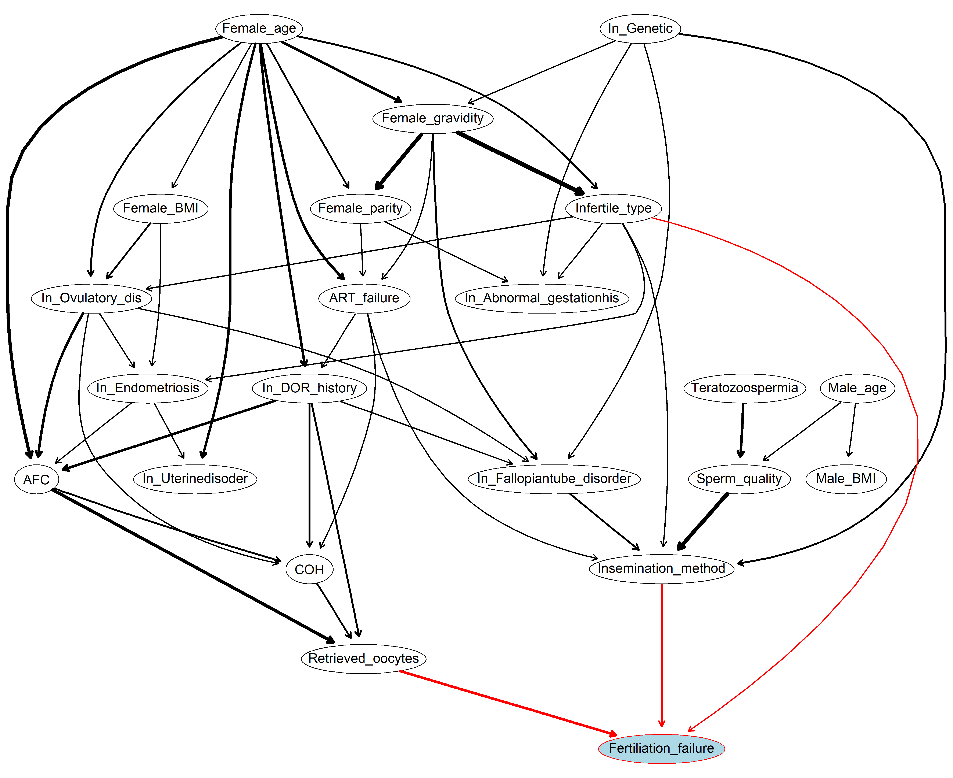

Figure S2 Tenfold ten-cross validation

